[logstash설치]

* wget https://artifacts.elastic.co/downloads/logstash/logstash-5.1.1.rpm
* rpm -ivh logstash-5.1.1.rpm
* sudo systemctl enable logstash
* sudo systemctl start logstash

[logstash 인구데이터 분석설정]

* cd /etc/logstash
* vi logstash.conf
* input {
* file {
* path => "/etc/logstash/data/populationbycountry19802010millions.csv"
* start_position => "beginning"
* sincedb_path => "/dev/null"
* }
* }
* filter {
* csv {
* separator => ","
* columns => ["Country","1980","1981","1982","1983","1984","1985","1986","1987","1988","1989","1990","1991","1992","1993","1994","1995","1996","1997","1998","1999","2000","2001","2002","2003","2004","2005","2006","2007","2008","2009","2010"]
* }
* mutate {convert => ["1980", "float"]}
* mutate {convert => ["1981", "float"]}
* mutate {convert => ["1982", "float"]}
* mutate {convert => ["1983", "float"]}
* mutate {convert => ["1984", "float"]}
* mutate {convert => ["1985", "float"]}
* mutate {convert => ["1986", "float"]}
* mutate {convert => ["1987", "float"]}
* mutate {convert => ["1988", "float"]}
* mutate {convert => ["1989", "float"]}
* mutate {convert => ["1990", "float"]}
* mutate {convert => ["1991", "float"]}
* mutate {convert => ["1992", "float"]}
* mutate {convert => ["1993", "float"]}
* mutate {convert => ["1994", "float"]}
* mutate {convert => ["1995", "float"]}
* mutate {convert => ["1996", "float"]}
* mutate {convert => ["1997", "float"]}
* mutate {convert => ["1998", "float"]}
* mutate {convert => ["1999", "float"]}
* mutate {convert => ["2000", "float"]}
* mutate {convert => ["2001", "float"]}
* mutate {convert => ["2002", "float"]}
* mutate {convert => ["2003", "float"]}
* mutate {convert => ["2004", "float"]}
* mutate {convert => ["2005", "float"]}
* mutate {convert => ["2006", "float"]}
* mutate {convert => ["2007", "float"]}
* mutate {convert => ["2008", "float"]}
* mutate {convert => ["2009", "float"]}
* mutate {convert => ["2010", "float"]}
* }
* output {
* elasticsearch {
* hosts => "localhost"
* index => "population"
* }
* stdout {}
* }
* mkdir –p /etc/logstash/data
* vi populationbycountry19802010millions.csv -> 엑셀데이타 파일생성
* sudo systemctl restart logstash

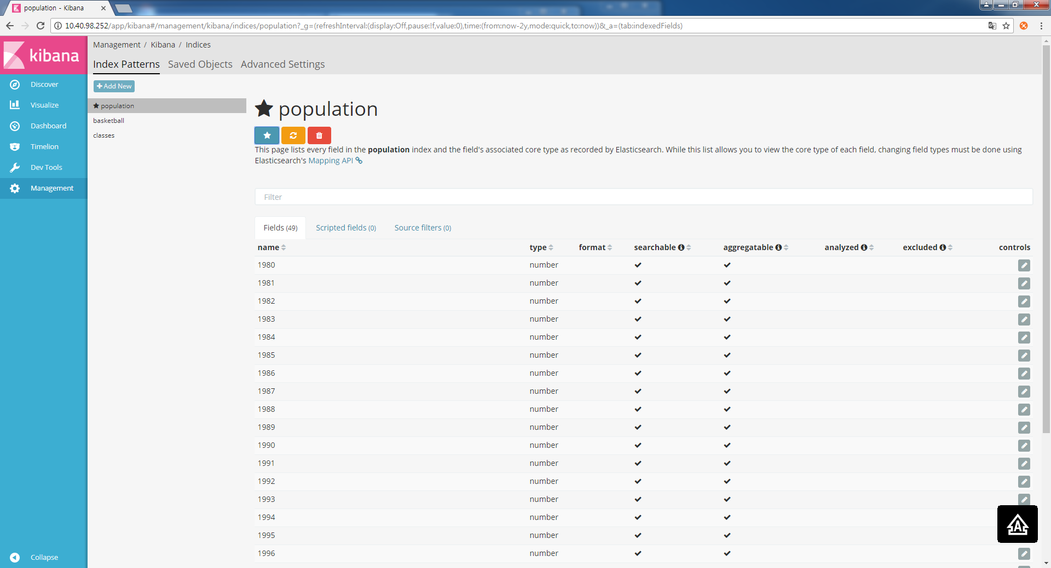

[Visualize] bar차트에서 Y축연도, X축 Country

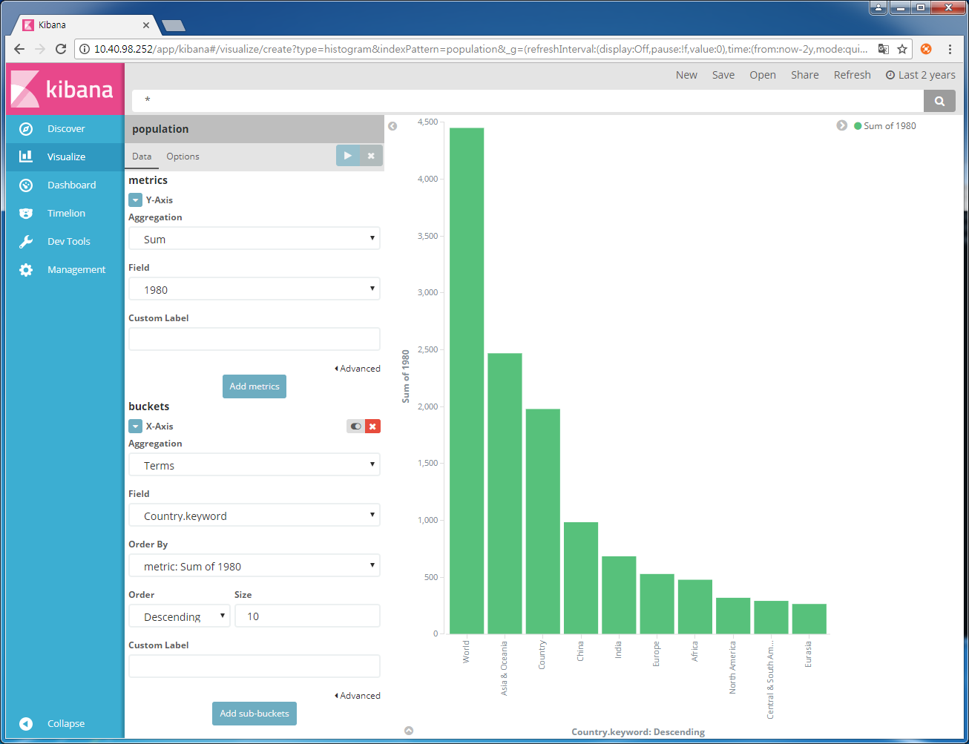

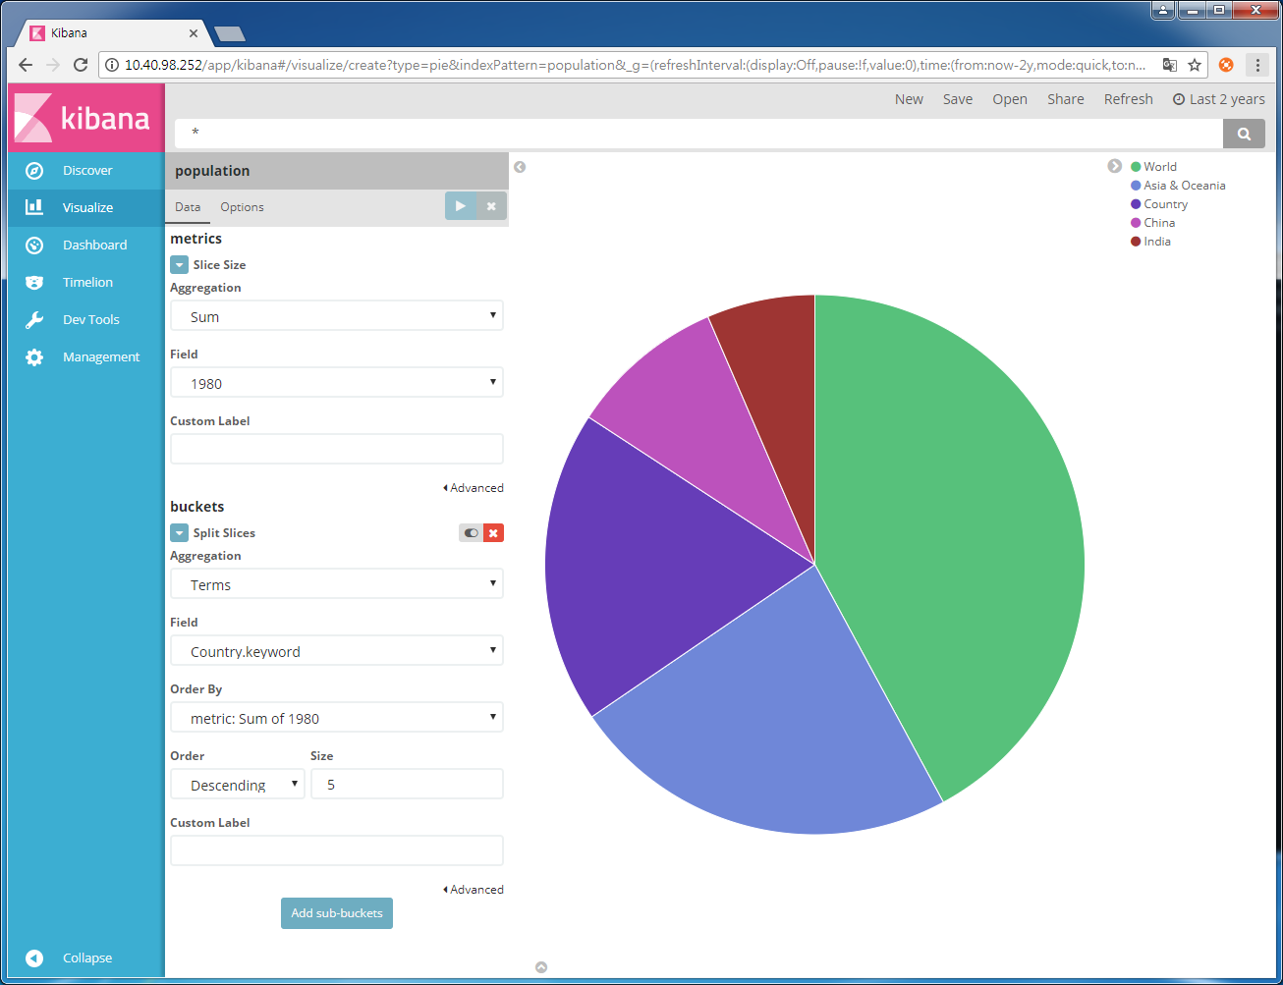

[logstash 주식데이터 분석설정]

- cd /etc/logstash

- vi logstash_stock.conf

input {

file {

path => "/etc/logstash/data/table.csv"

start_position => "beginning"

sincedb_path => "/dev/null"

}

}

filter {

csv {

separator => ","

columns => ["Date","Open","High","Low","Close","Volume","Adj Close"]

}

mutate {convert => ["Open", "float"]}

mutate {convert => ["High", "float"]}

mutate {convert => ["Low", "float"]}

mutate {convert => ["Close", "float"]}

}

output {

elasticsearch {

hosts => "localhost"

index => "stock"

}

stdout {}

}

- mkdir –p /etc/logstash/data

- vi table.csv -> 엑셀데이타 파일생성

- sudo systemctl restart logstash

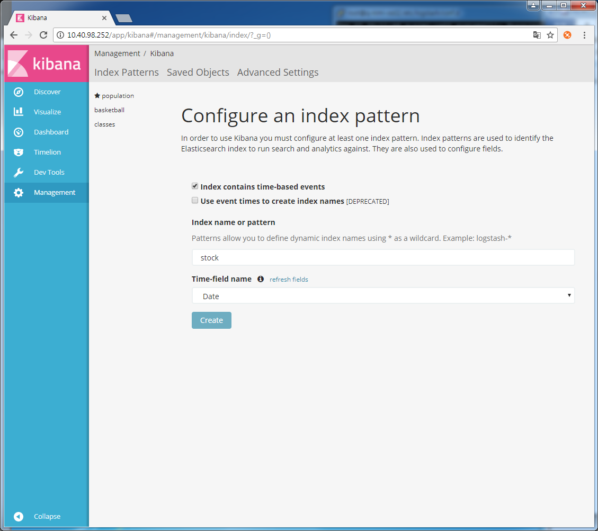

[Discover] timestamp, open ,close선택하고 stock_toggled로 저장

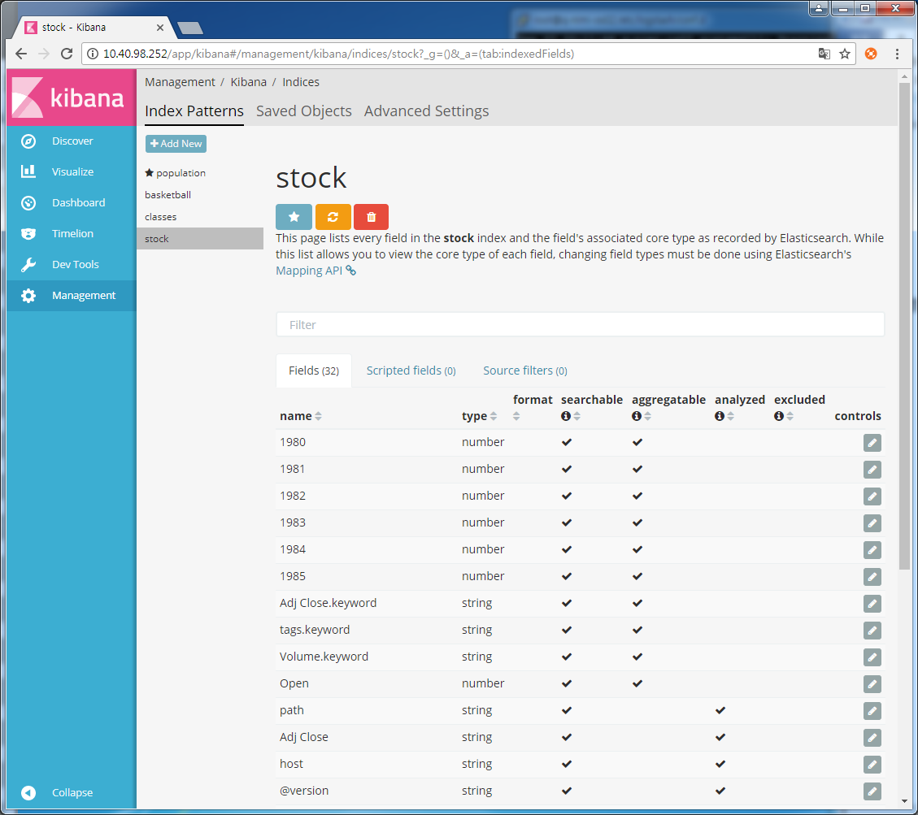

[Visualize] line차트에서 Y축: Average Close, X축: Date -->stock_linechart로 저장

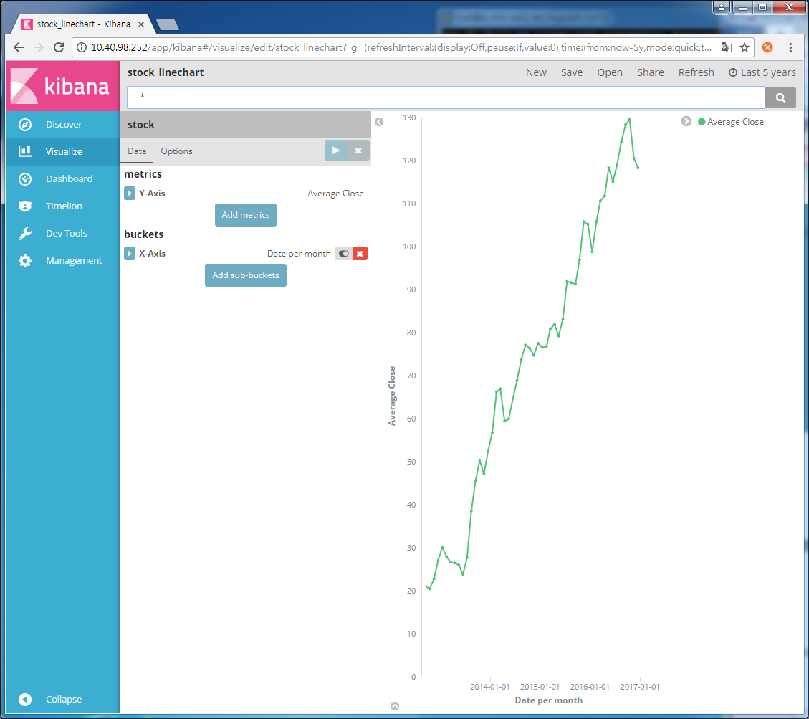

[Visualize] metric차트에서 -->stock_metricchart로 저장

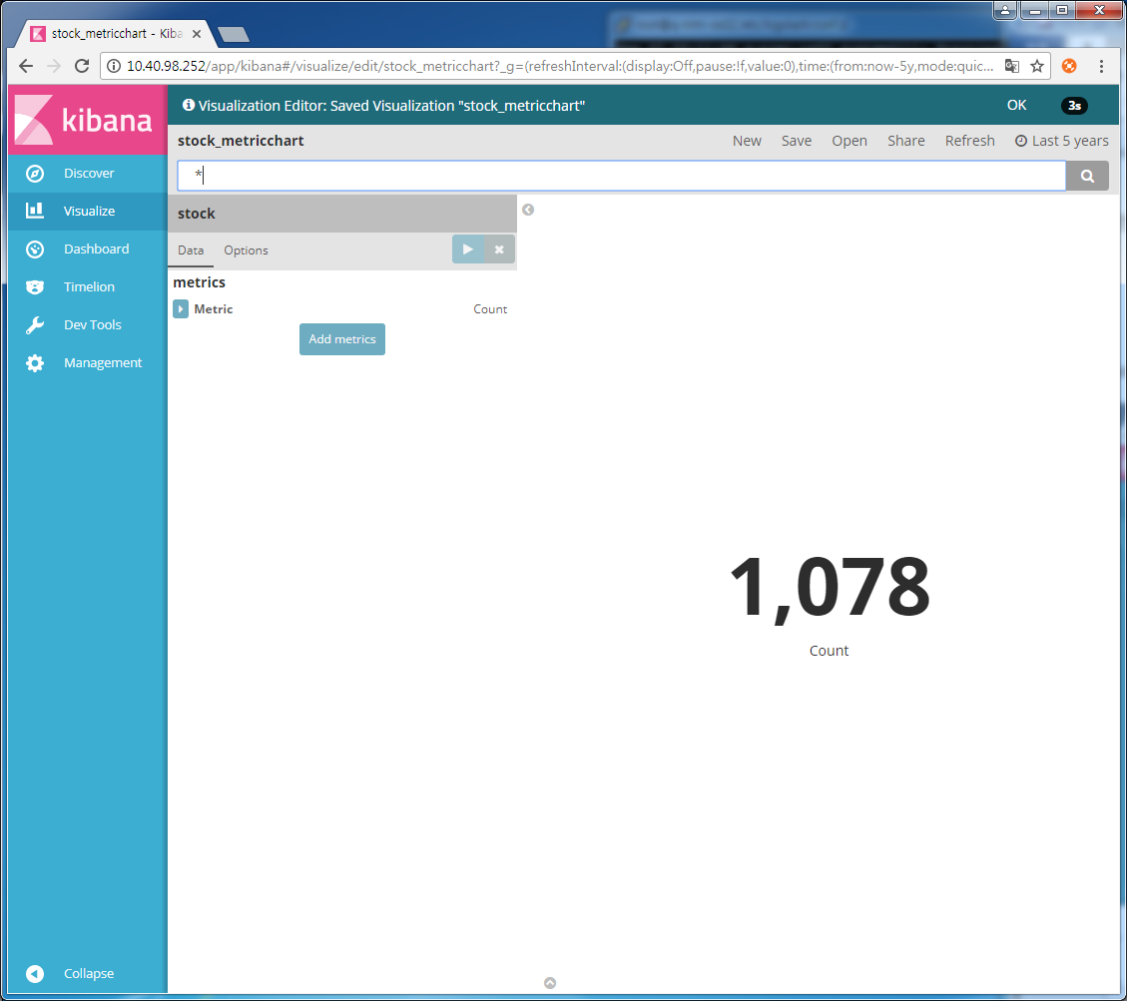

[Dashboard] 차트선택후 -->stock_dashboard로 저장

