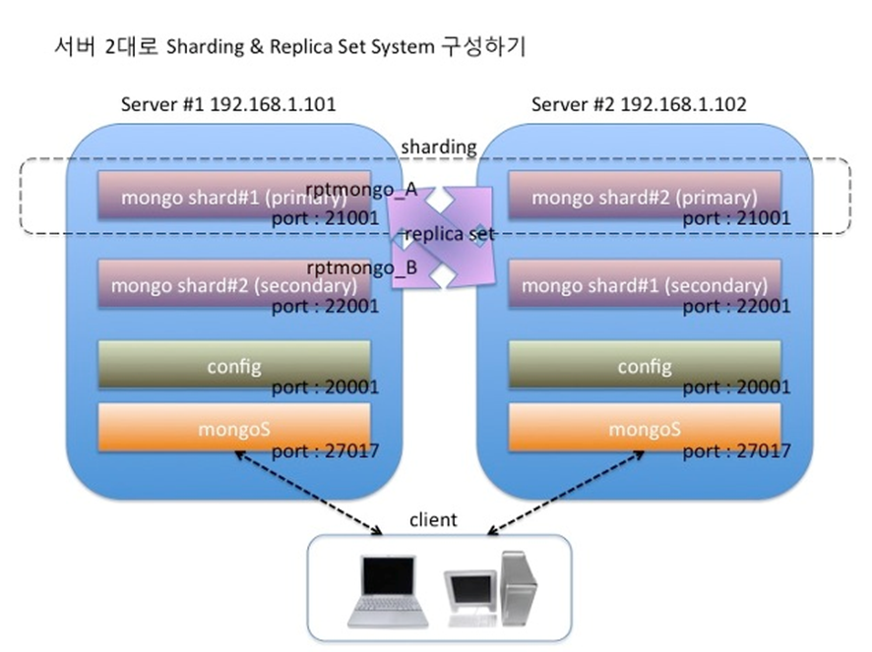

[Sharded Cluster]

MongoDB shards data at the collection level, distributing the collection data across the shards in the cluster

A MongoDB sharded cluster consists of the following components:

•shard: Each shard contains a subset of the sharded data. Each shard can be deployed as a replica set.

•mongos: The mongos acts as a query router, providing an interface between client applications and the sharded cluster.

•config servers: Config servers store metadata and configuration settings for the cluster. As of MongoDB 3.4, config servers must be deployed as a replica set (CSRS).

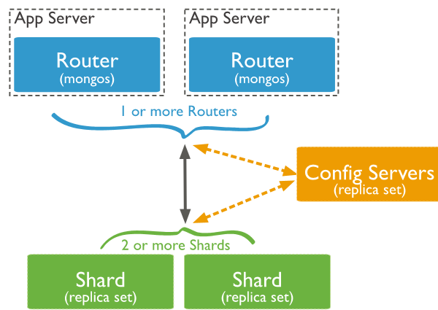

[Start Sharded Cluster]

[root@centos-minion-1 ~]# **mongod --replSet "rs0" --shardsvr --port 27018 --dbpath /var/lib/mongo**

2017-10-23T08:06:10.896-0400 I CONTROL [initandlisten] MongoDB starting : pid=26042 port=27017 dbpath=/var/lib/mongo 64-bit host=centos-minion-1

2017-10-23T08:06:10.896-0400 I CONTROL [initandlisten] db version v3.4.9

2017-10-23T08:06:10.896-0400 I CONTROL [initandlisten] git version: 876ebee8c7dd0e2d992f36a848ff4dc50ee6603e

2017-10-23T08:06:10.896-0400 I CONTROL [initandlisten] OpenSSL version: OpenSSL 1.0.1e-fips 11 Feb 2013

[root@centos-master ~]# **mongod --replSet "rs0" --shardsvr --port 27018 --dbpath /var/lib/mongo**

2017-10-20T12:15:27.393-0400 I CONTROL [initandlisten] MongoDB starting : pid=3645 port=27017 dbpath=/var/lib/mongo 64-bit host=centos-master

2017-10-20T12:15:27.393-0400 I CONTROL [initandlisten] db version v3.4.9

2017-10-20T12:15:27.393-0400 I CONTROL [initandlisten] git version:

rs0:PRIMARY**> rs.initiate( {**

**... _id : "rs0",**

**... members: [ { _id : 0, host : "centos-master:27018" } ]**

... })

{

"info" : "try querying local.system.replset to see current configuration",

"ok" : 0,

"errmsg" : "already initialized",

"code" : 23,

"codeName" : "AlreadyInitialized"

}

**rs0:PRIMARY> rs.add("centos-minion-1")**

[Start Config server]

**[root@centos-master ~]# mkdir -p /data/configdb**

**[root@centos-master ~]# mongod --configsvr --replSet configReplSet --port 27019**

2017-10-20T12:21:23.208-0400 I CONTROL [initandlisten] MongoDB starting : pid=3753 port=27019 dbpath=/data/configdb 64-bit host=centos-master

**[root@centos-minion-1 ~]# mkdir -p /data/configdb**

**[root@centos-minion-1 ~]# mongod --configsvr --replSet configReplSet --port 27019**

2017-10-23T08:16:51.037-0400 I CONTROL [initandlisten] MongoDB starting : pid=33173 rs0:PRIMARY**> rs.initiate( {**

**_id: "configReplSet",**

**configsvr: true,**

**members: [**

**{ _id: 0, host: "centos-master:27019" },**

**{ _id: 1, host: "centos-minion-1:27019" }**

**]**

**} )**

{

"info" : "try querying local.system.replset to see current configuration",

"ok" : 0,

"errmsg" : "already initialized",

"code" : 23,

"codeName" : "AlreadyInitialized"

}

[root@centos-master ~]# **mongos --configdb configReplSet/centos-master:27019,centos-minion-1:27019**

[root@centos-master ~]# **mongo centos-master:27017/admin**

* **sh.addShard( "rs0/ centos-master:27018, centos-minion-1:27018”)**

[Test Sharding]

**>sh.enableSharding( "test" )**

{ "ok" : 1 }

**>use test**

**>db.test_collection.createIndex( { number : 1 } )**

**>sh.shardCollection( "test.test_collection", { "number" : 1 } )**

{ "collectionsharded" : "test.test_collection", "ok" : 1 }

**>use test**

**>db.stats()**

**>db.printShardingStatus()**