[사전준비]

•2 core CPU

•2 GB RAM

•10 GB hdd

ubuntu16.04 server 설치

[PORT 설정]

•8181 for REST API and GUI

•8101 to access the ONOS CLI

•9876 for intra-cluster communication (communication between target machines)

•6653 optional, for OpenFlow

•6640 optional, for OVSDB

* setenforce 0
* systemctl stop firewalld.service
* apt-get install ssh zip curl python
* apt install git
* sudo adduser sdn --system –group
* sudo apt-get install software-properties-common -y
* sudo add-apt-repository ppa:webupd8team/java -y
* sudo apt-get update &&
* echo "oracle-java8-installer shared/accepted-oracle-license-v1-1 select true" | sudo debconf-set-selections
* sudo apt-get install oracle-java8-installer oracle-java8-set-default
* cd /opt
* sudo wget -c <http://downloads.onosproject.org/release/onos-1.11.0.tar.gz>
* sudo tar xzf onos-1.11.0.tar.gz
* sudo mv onos-1.11.0 onos
* /opt/onos/bin/onos-service start
* root@ubuntu:/opt# /opt/onos/bin/onos-service start
* Welcome to Open Network Operating System (ONOS)!
* ____ _ ______ ____
* / __ \/ |/ / __ \/ __/
* / /_/ / / /_/ /\ \
* \____/_/|_/\____/___/
* Documentation: wiki.onosproject.org
* Tutorials: tutorials.onosproject.org
* Mailing lists: lists.onosproject.org
* Come help out! Find out how at: contribute.onosproject.org
* Hit '<tab>' for a list of available commands
* and '[cmd] --help' for help on a specific command.
* Hit '<ctrl-d>' or type 'system:shutdown' or 'logout' to shutdown ONOS.
* onos> apps –a
* onos> apps –a –s
* sudo cp /opt/onos/init/onos.initd /etc/init.d/onos
* sudo cp /opt/onos/init/onos.service /etc/systemd/system/
* sudo systemctl daemon-reload
* sudo systemctl enable onos
* [옵션설정하는 경우] – 생략
* vi /opt/onos/options
* ONOS_USER=sdn
* # Optional: add any apps here that you wish to activate by default
* ONOS_APPS=
* [클러스터로 설정하는 경우] –생략
* /opt/onos/bin/onos-form-cluster $TARGET_MACHINE_1_IP $TARGET_MACHINE_2_IP $TARGET_MACHINE_N_IP
* systemctl start onos.service
* ssh -p 8101 karaf@localhost --> karaf
* ssh -p 8101 onos@localhost --> rocks

<http://localhost:8181/onos/ui> (GUI PASSWORD: CLI 접속패스워드와 동일)

* 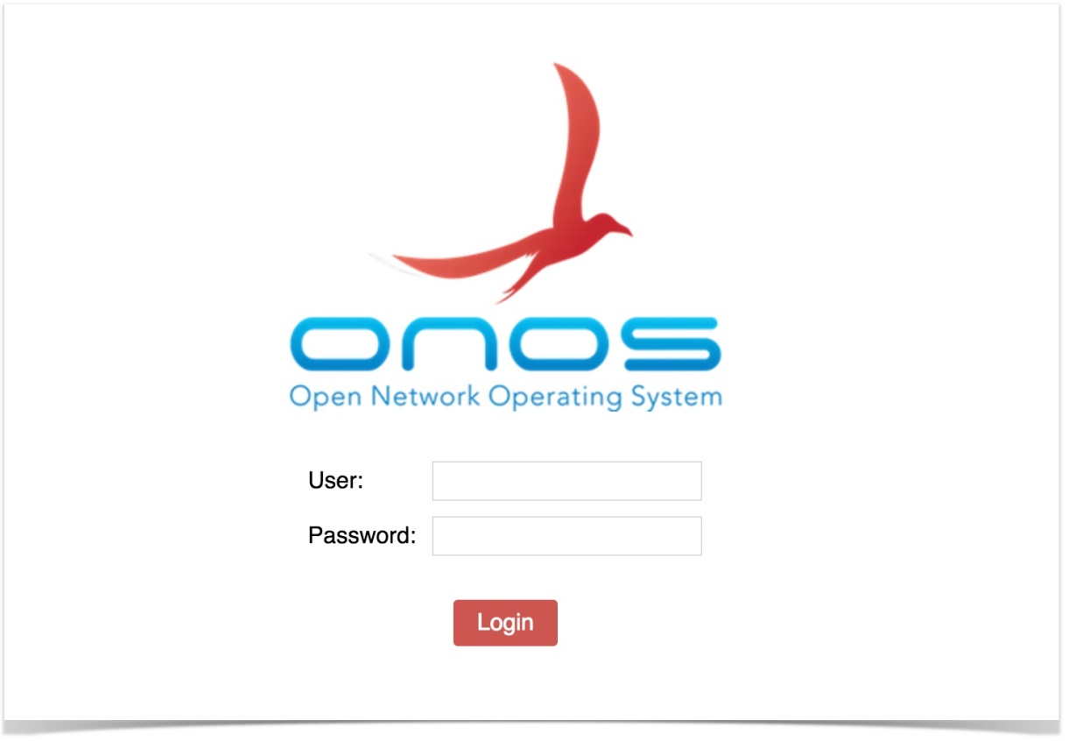

onos> **apps -s -a**

* 20 org.onosproject.optical-model 1.11.0 Optical Network Model

* 33 org.onosproject.drivers 1.11.0 Default Drivers

* 46 org.onosproject.hostprovider 1.11.0 Host Location Provider

* 47 org.onosproject.lldpprovider 1.11.0 LLDP Link Provider

* 48 org.onosproject.openflow-base 1.11.0 OpenFlow Base Provider

* 49 org.onosproject.openflow 1.11.0 OpenFlow Provider Suite

* 87 org.onosproject.pathpainter 1.11.0 Path Visualization

* 123 org.onosproject.fwd 1.11.0 Reactive Forwarding

**[CLI 실습]**

**root@ubuntu:~# mn --topo linear,3 --mac --switch ovsk --controller remote**

*** Creating network

*** Adding controller

*** Adding hosts:

h1 h2 h3

*** Adding switches:

s1 s2 s3

*** Adding links:

(h1, s1) (h2, s2) (h3, s3) (s2, s1) (s3, s2)

*** Configuring hosts

h1 h2 h3

*** Starting controller

c0

*** Starting 3 switches

s1 s2 s3 ...

*** Starting CLI:

mininet>

**root@ubuntu:~# ssh -p 8101 karaf@localhost**

**onos> apps -s -a**

* 20 org.onosproject.optical-model 1.11.0 Optical Network Model

* 33 org.onosproject.drivers 1.11.0 Default Drivers

* 46 org.onosproject.hostprovider 1.11.0 Host Location Provider

* 47 org.onosproject.lldpprovider 1.11.0 LLDP Link Provider

* 48 org.onosproject.openflow-base 1.11.0 OpenFlow Base Provider

* 49 org.onosproject.openflow 1.11.0 OpenFlow Provider Suite

* 87 org.onosproject.pathpainter 1.11.0 Path Visualization

**mininet> h1 ping h3**

PING 10.0.0.3 (10.0.0.3) 56(84) bytes of data.

From 10.0.0.1 icmp_seq=1 Destination Host Unreachable

From 10.0.0.1 icmp_seq=2 Destination Host Unreachable

From 10.0.0.1 icmp_seq=3 Destination Host Unreachable

From 10.0.0.1 icmp_seq=4 Destination Host Unreachable

From 10.0.0.1 icmp_seq=5 Destination Host Unreachable

From 10.0.0.1 icmp_seq=6 Destination Host Unreachable

From 10.0.0.1 icmp_seq=7 Destination Host Unreachable

From 10.0.0.1 icmp_seq=8 Destination Host Unreachable

From 10.0.0.1 icmp_seq=9 Destination Host Unreachable

64 bytes from 10.0.0.3: icmp_seq=10 ttl=64 time=2028 ms **--> onos> app activate org.onosproject.fwd**

64 bytes from 10.0.0.3: icmp_seq=11 ttl=64 time=1035 ms

64 bytes from 10.0.0.3: icmp_seq=12 ttl=64 time=42.8 ms

64 bytes from 10.0.0.3: icmp_seq=13 ttl=64 time=0.293 ms

64 bytes from 10.0.0.3: icmp_seq=14 ttl=64 time=0.056 ms

64 bytes from 10.0.0.3: icmp_seq=15 ttl=64 time=0.042 ms

64 bytes from 10.0.0.3: icmp_seq=16 ttl=64 time=0.054 ms

64 bytes from 10.0.0.3: icmp_seq=17 ttl=64 time=0.043 ms

64 bytes from 10.0.0.3: icmp_seq=18 ttl=64 time=0.080 ms

64 bytes from 10.0.0.3: icmp_seq=27 ttl=64 time=12.8 ms

64 bytes from 10.0.0.3: icmp_seq=28 ttl=64 time=0.031 ms

64 bytes from 10.0.0.3: icmp_seq=29 ttl=64 time=0.044 ms

**onos> help onos**

COMMANDS

onos:add-host-intent Installs host-to-host connectivity int

onos:add-multi-to-single-intent Installs connectivity intent between m

onos:add-optical-intent Installs optical connectivity intent

onos:add-point-intent Installs point-to-point connectivity i

onos:add-protected-transport Adds ProtectedTransportIntent

onos:add-single-to-multi-intent Installs connectivity intent between a

onos:add-test-flows Installs a number of test flow rules -

onos:add-vnet-intent Installs virtual network connectivity

onos:allocations Lists allocated resources

onos:annotate-device Annotates network model entities

onos:annotate-link Annotates network model entities

onos:annotate-port Annotates port entities

onos:app Manages application inventory

onos:app-ids Lists application ID information

onos:apps Lists application information

**onos> apps --help**

DESCRIPTION

onos:apps

Lists application information

SYNTAX

onos:apps [options]

OPTIONS

--help

Display this help message

-a, --active

Show active only

-j, --json

Output JSON

-n, --name

Sort by application ID name

-s, --short

Show short output only

**onos> nodes**

id=192.168.17.209, address=192.168.17.209:9876, state=READY, version=1.11.0, updated=10d6h ago *

**onos> devices**

id=of:0000000000000001, available=true, local-status=connected 1m32s ago, role=MASTER, type=SWITCH, mfr=Nicira, Inc., hw=Open vSwitch, sw=2.5.2, serial=None, driver=ovs, channelId=127.0.0.1:56178, managementAddress=127.0.0.1, protocol=OF_13

id=of:0000000000000002, available=true, local-status=connected 1m32s ago, role=MASTER, type=SWITCH, mfr=Nicira, Inc., hw=Open vSwitch, sw=2.5.2, serial=None, driver=ovs, channelId=127.0.0.1:56182, managementAddress=127.0.0.1, protocol=OF_13

id=of:0000000000000003, available=true, local-status=connected 1m32s ago, role=MASTER, type=SWITCH, mfr=Nicira, Inc., hw=Open vSwitch, sw=2.5.2, serial=None, driver=ovs, channelId=127.0.0.1:56180, managementAddress=127.0.0.1, protocol=OF_13

**onos> links**

src=of:0000000000000001/2, dst=of:0000000000000002/2, type=DIRECT, state=ACTIVE, expected=false

src=of:0000000000000002/2, dst=of:0000000000000001/2, type=DIRECT, state=ACTIVE, expected=false

src=of:0000000000000002/3, dst=of:0000000000000003/2, type=DIRECT, state=ACTIVE, expected=false

src=of:0000000000000003/2, dst=of:0000000000000002/3, type=DIRECT, state=ACTIVE, expected=false

**onos> hosts**

id=00:00:00:00:00:01/None, mac=00:00:00:00:00:01, locations=[of:0000000000000001/1], vlan=None, ip(s)=[10.0.0.1], provider=of:org.onosproject.provider.host, configured=false

id=00:00:00:00:00:02/None, mac=00:00:00:00:00:02, locations=[of:0000000000000002/1], vlan=None, ip(s)=[10.0.0.2], provider=of:org.onosproject.provider.host, configured=false

id=00:00:00:00:00:03/None, mac=00:00:00:00:00:03, locations=[of:0000000000000003/1], vlan=None, ip(s)=[10.0.0.3], provider=of:org.onosproject.provider.host, configured=false

[flow 상태종류]

•PENDING_ADD - The flow has been submitted and forwarded to the switch.

•ADDED - The flow has been added to the switch.

•PENDING_REMOVE - The request to remove the flow has been submitted and forwarded to the switch.

•REMOVED - The rule has been removed.

**onos> flows**

deviceId=of:0000000000000001, flowRuleCount=7

id=100007a585b6f, state=ADDED, bytes=18225, packets=225, duration=695, liveType=UNKNOWN, priority=40000, tableId=0, appId=org.onosproject.core, payLoad=null, selector=[ETH_TYPE:bddp], treatment=DefaultTrafficTreatment{immediate=[OUTPUT:CONTROLLER], deferred=[], transition=None, meter=None, cleared=true, metadata=null}

id=100009465555a, state=ADDED, bytes=18225, packets=225, duration=695, liveType=UNKNOWN, priority=40000, tableId=0, appId=org.onosproject.core, payLoad=null, selector=[ETH_TYPE:lldp], treatment=DefaultTrafficTreatment{immediate=[OUTPUT:CONTROLLER], deferred=[], transition=None, meter=None, cleared=true, metadata=null}

id=10000ea6f4b8e, state=ADDED, bytes=546, packets=13, duration=695, liveType=UNKNOWN, priority=40000, tableId=0, appId=org.onosproject.core, payLoad=null, selector=[ETH_TYPE:arp], treatment=DefaultTrafficTreatment{immediate=[OUTPUT:CONTROLLER], deferred=[], transition=None, meter=None, cleared=true, metadata=null}

id=7b00008d053164, state=ADDED, bytes=3822, packets=39, duration=39, liveType=UNKNOWN, priority=10, tableId=0, appId=org.onosproject.fwd, payLoad=null, selector=[IN_PORT:1, ETH_DST:00:00:00:00:00:03, ETH_SRC:00:00:00:00:00:01], treatment=DefaultTrafficTreatment{immediate=[OUTPUT:2], deferred=[], transition=None, meter=None, cleared=false, metadata=null}

id=7b0000d134d2a8, state=ADDED, bytes=3822, packets=39, duration=39, liveType=UNKNOWN, priority=10, tableId=0, appId=org.onosproject.fwd, payLoad=null, selector=[IN_PORT:2, ETH_DST:00:00:00:00:00:01, ETH_SRC:00:00:00:00:00:03], treatment=DefaultTrafficTreatment{immediate=[OUTPUT:1], deferred=[], transition=None, meter=None, cleared=false, metadata=null}

id=1000000ea1bfb, state=ADDED, bytes=0, packets=0, duration=695, liveType=UNKNOWN, priority=5, tableId=0, appId=org.onosproject.core, payLoad=null, selector=[ETH_TYPE:arp], treatment=DefaultTrafficTreatment{immediate=[OUTPUT:CONTROLLER], deferred=[], transition=None, meter=None, cleared=true, metadata=null}

id=10000021b41dc, state=ADDED, bytes=882, packets=9, duration=695, liveType=UNKNOWN, priority=5, tableId=0, appId=org.onosproject.core, payLoad=null, selector=[ETH_TYPE:ipv4], treatment=DefaultTrafficTreatment{immediate=[OUTPUT:CONTROLLER], deferred=[], transition=None, meter=None, cleared=true, metadata=null}

deviceId=of:0000000000000002, flowRuleCount=7

id=1000002bbd8d4, state=ADDED, bytes=36288, packets=448, duration=695, liveType=UNKNOWN, priority=40000, tableId=0, appId=org.onosproject.core, payLoad=null, selector=[ETH_TYPE:lldp], treatment=DefaultTrafficTreatment{immediate=[OUTPUT:CONTROLLER], deferred=[], transition=None, meter=None, cleared=true, metadata=null}

id=10000c70edd85, state=ADDED, bytes=672, packets=16, duration=695, liveType=UNKNOWN, priority=40000, tableId=0, appId=org.onosproject.core, payLoad=null, selector=[ETH_TYPE:arp], treatment=DefaultTrafficTreatment{immediate=[OUTPUT:CONTROLLER], deferred=[], transition=None, meter=None, cleared=true, metadata=null}

id=10000dc56d70b, state=ADDED, bytes=36288, packets=448, duration=695, liveType=UNKNOWN, priority=40000, tableId=0, appId=org.onosproject.core, payLoad=null, selector=[ETH_TYPE:bddp], treatment=DefaultTrafficTreatment{immediate=[OUTPUT:CONTROLLER], deferred=[], transition=None, meter=None, cleared=true, metadata=null}

id=7b0000664b01ce, state=ADDED, bytes=3822, packets=39, duration=39, liveType=UNKNOWN, priority=10, tableId=0, appId=org.onosproject.fwd, payLoad=null, selector=[IN_PORT:2, ETH_DST:00:00:00:00:00:03, ETH_SRC:00:00:00:00:00:01], treatment=DefaultTrafficTreatment{immediate=[OUTPUT:3], deferred=[], transition=None, meter=None, cleared=false, metadata=null}

id=7b0000c204a428, state=ADDED, bytes=3822, packets=39, duration=39, liveType=UNKNOWN, priority=10, tableId=0, appId=org.onosproject.fwd, payLoad=null, selector=[IN_PORT:3, ETH_DST:00:00:00:00:00:01, ETH_SRC:00:00:00:00:00:03], treatment=DefaultTrafficTreatment{immediate=[OUTPUT:2], deferred=[], transition=None, meter=None, cleared=false, metadata=null}

id=100002341485c, state=ADDED, bytes=1274, packets=13, duration=695, liveType=UNKNOWN, priority=5, tableId=0, appId=org.onosproject.core, payLoad=null, selector=[ETH_TYPE:ipv4], treatment=DefaultTrafficTreatment{immediate=[OUTPUT:CONTROLLER], deferred=[], transition=None, meter=None, cleared=true, metadata=null}

id=1000092242520, state=ADDED, bytes=0, packets=0, duration=695, liveType=UNKNOWN, priority=5, tableId=0, appId=org.onosproject.core, payLoad=null, selector=[ETH_TYPE:arp], treatment=DefaultTrafficTreatment{immediate=[OUTPUT:CONTROLLER], deferred=[], transition=None, meter=None, cleared=true, metadata=null}

deviceId=of:0000000000000003, flowRuleCount=7

id=10000464e5575, state=ADDED, bytes=18225, packets=225, duration=695, liveType=UNKNOWN, priority=40000, tableId=0, appId=org.onosproject.core, payLoad=null, selector=[ETH_TYPE:bddp], treatment=DefaultTrafficTreatment{immediate=[OUTPUT:CONTROLLER], deferred=[], transition=None, meter=None, cleared=true, metadata=null}

id=10000646f55aa, state=ADDED, bytes=18225, packets=225, duration=695, liveType=UNKNOWN, priority=40000, tableId=0, appId=org.onosproject.core, payLoad=null, selector=[ETH_TYPE:lldp], treatment=DefaultTrafficTreatment{immediate=[OUTPUT:CONTROLLER], deferred=[], transition=None, meter=None, cleared=true, metadata=null}

id=10000a6288ee9, state=ADDED, bytes=546, packets=13, duration=695, liveType=UNKNOWN, priority=40000, tableId=0, appId=org.onosproject.core, payLoad=null, selector=[ETH_TYPE:arp], treatment=DefaultTrafficTreatment{immediate=[OUTPUT:CONTROLLER], deferred=[], transition=None, meter=None, cleared=true, metadata=null}

id=7b00000baf0cae, state=ADDED, bytes=3822, packets=39, duration=39, liveType=UNKNOWN, priority=10, tableId=0, appId=org.onosproject.fwd, payLoad=null, selector=[IN_PORT:1, ETH_DST:00:00:00:00:00:01, ETH_SRC:00:00:00:00:00:03], treatment=DefaultTrafficTreatment{immediate=[OUTPUT:2], deferred=[], transition=None, meter=None, cleared=false, metadata=null}

id=7b00006d919fd3, state=ADDED, bytes=3822, packets=39, duration=39, liveType=UNKNOWN, priority=10, tableId=0, appId=org.onosproject.fwd, payLoad=null, selector=[IN_PORT:2, ETH_DST:00:00:00:00:00:03, ETH_SRC:00:00:00:00:00:01], treatment=DefaultTrafficTreatment{immediate=[OUTPUT:1], deferred=[], transition=None, meter=None, cleared=false, metadata=null}

id=10000278359e2, state=ADDED, bytes=0, packets=0, duration=695, liveType=UNKNOWN, priority=5, tableId=0, appId=org.onosproject.core, payLoad=null, selector=[ETH_TYPE:arp], treatment=DefaultTrafficTreatment{immediate=[OUTPUT:CONTROLLER], deferred=[], transition=None, meter=None, cleared=true, metadata=null}

id=10000be641e06, state=ADDED, bytes=1176, packets=12, duration=695, liveType=UNKNOWN, priority=5, tableId=0, appId=org.onosproject.core, payLoad=null, selector=[ETH_TYPE:ipv4], treatment=DefaultTrafficTreatment{immediate=[OUTPUT:CONTROLLER], deferred=[], transition=None, meter=None, cleared=true, metadata=null}

**onos> paths of:0000000000000001 of:0000000000000003**

of:0000000000000001/2-of:0000000000000002/2==>of:0000000000000002/3-of:0000000000000003/2; cost=2.0

[ Intent 상태]

•SUBMITTED - The intent has been submitted and will be processed soon.

•COMPILING - The intent is being compiled. This is a transient state.

•INSTALLING - The intent is in the process of being installed.

•INSTALLED - The intent has been installed.

•RECOMPILING - The intent is being recompiled after a failure.

•WITHDRAWING - The intent is being withdrawn.

•WITHDRAWN - The intent has been removed.

•FAILED - The intent is in a failed state because it cannot be satisfied.

**onos> intents --> 매커니즘이 아닌 정책으로 경로를 설정하는 경우 (PBR과 유사)**

**[GUI 실습]**

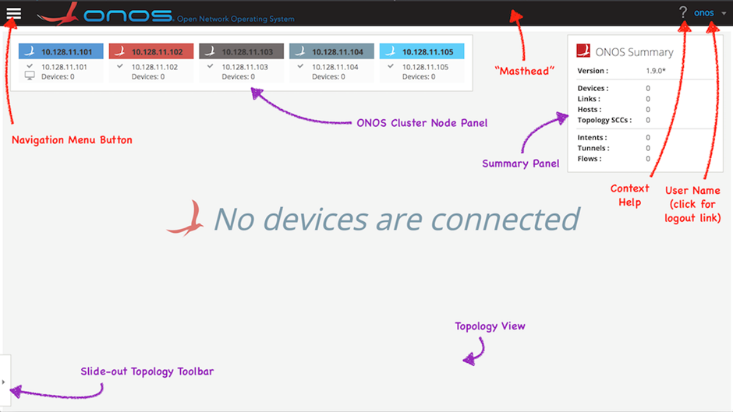

**PLATFORM->Applications**

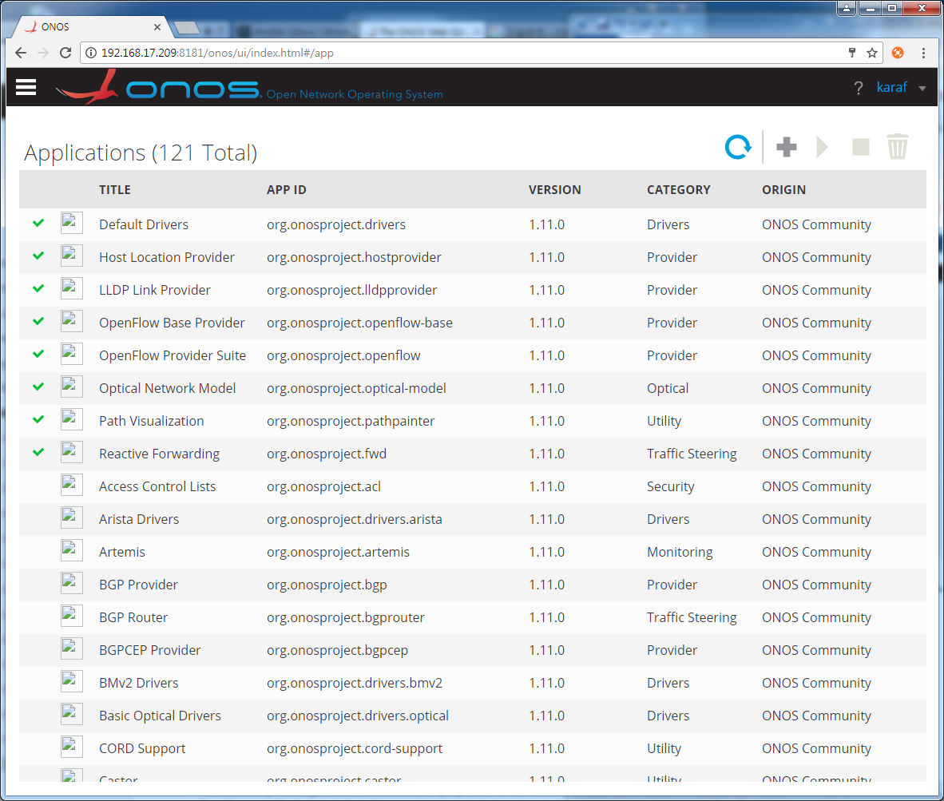

**PLATFORM->Settings**

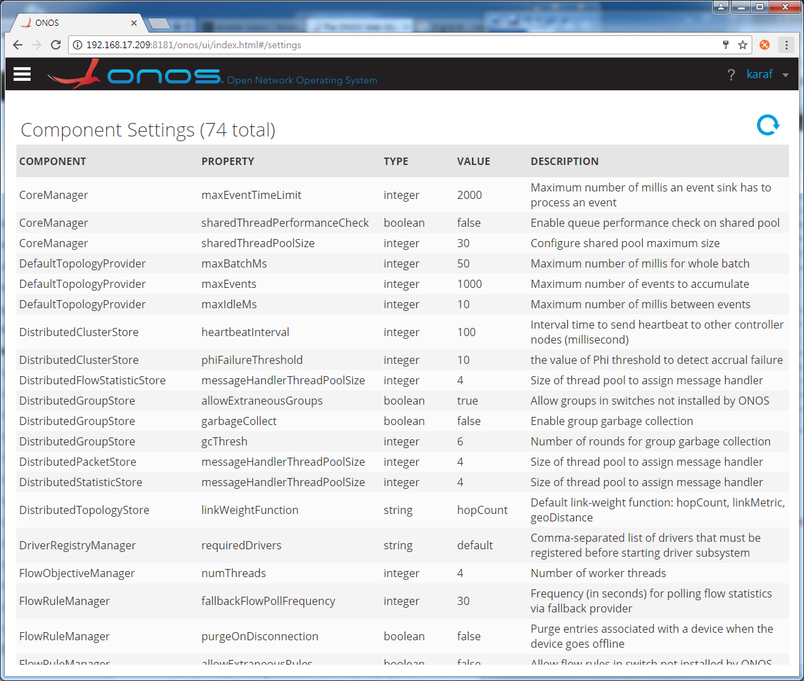

**PLATFORM->Cluster Nodes**

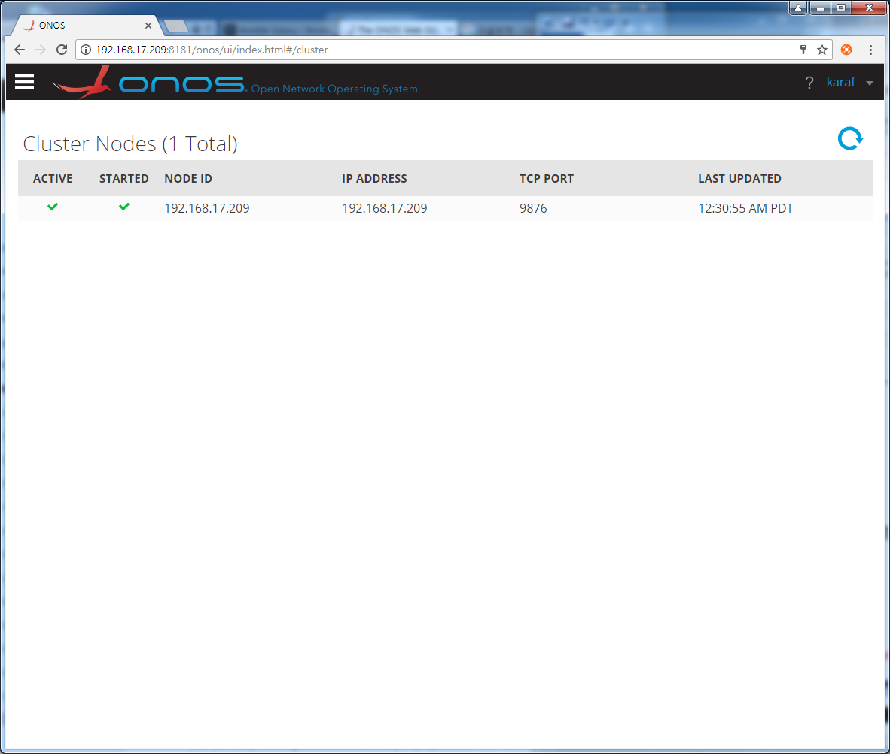

**PLATFORM->Packet Processors**

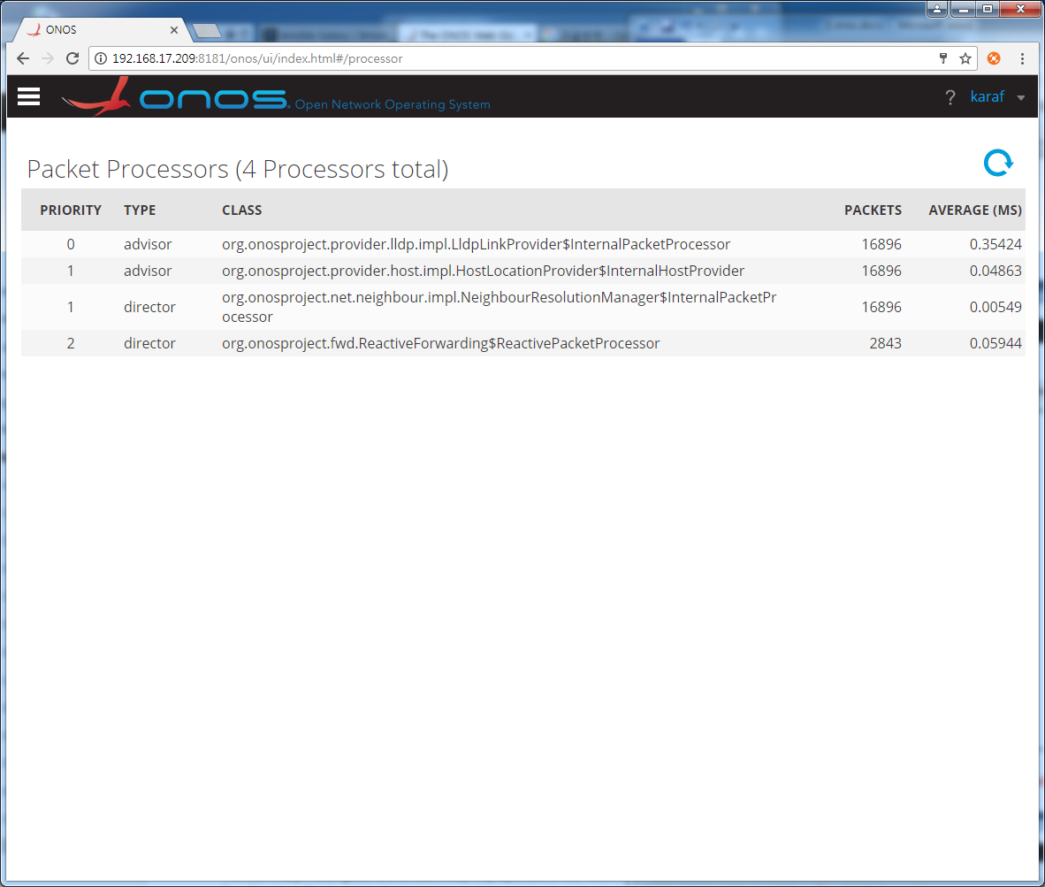

**PLATFORM->Partitinos**

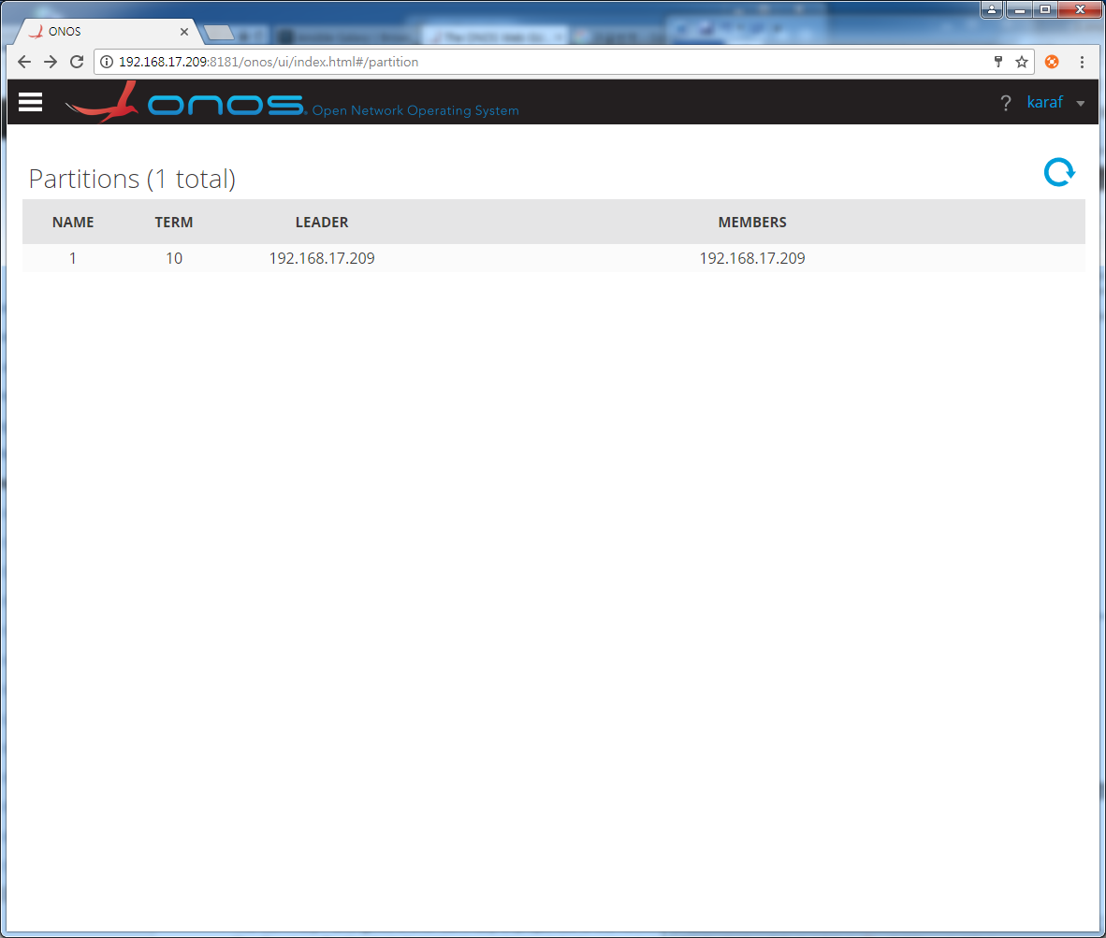

**NETWORK->Topology**

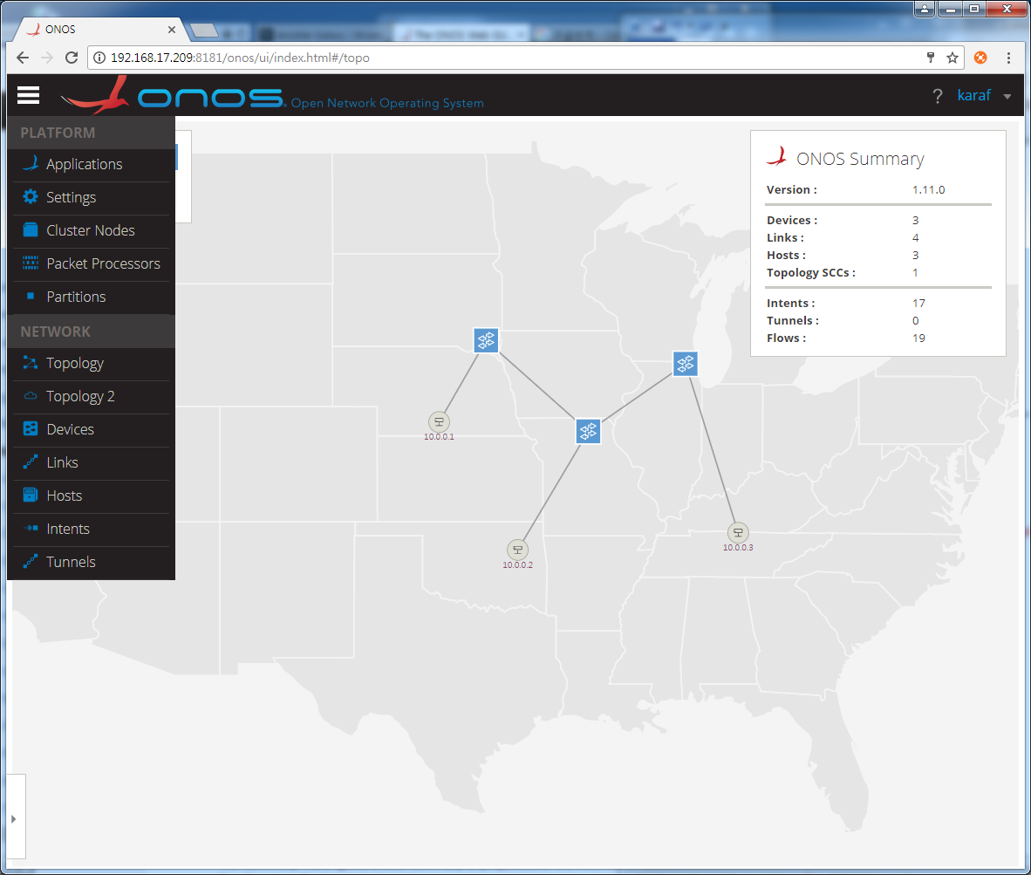

**NETWORK->Topology2**

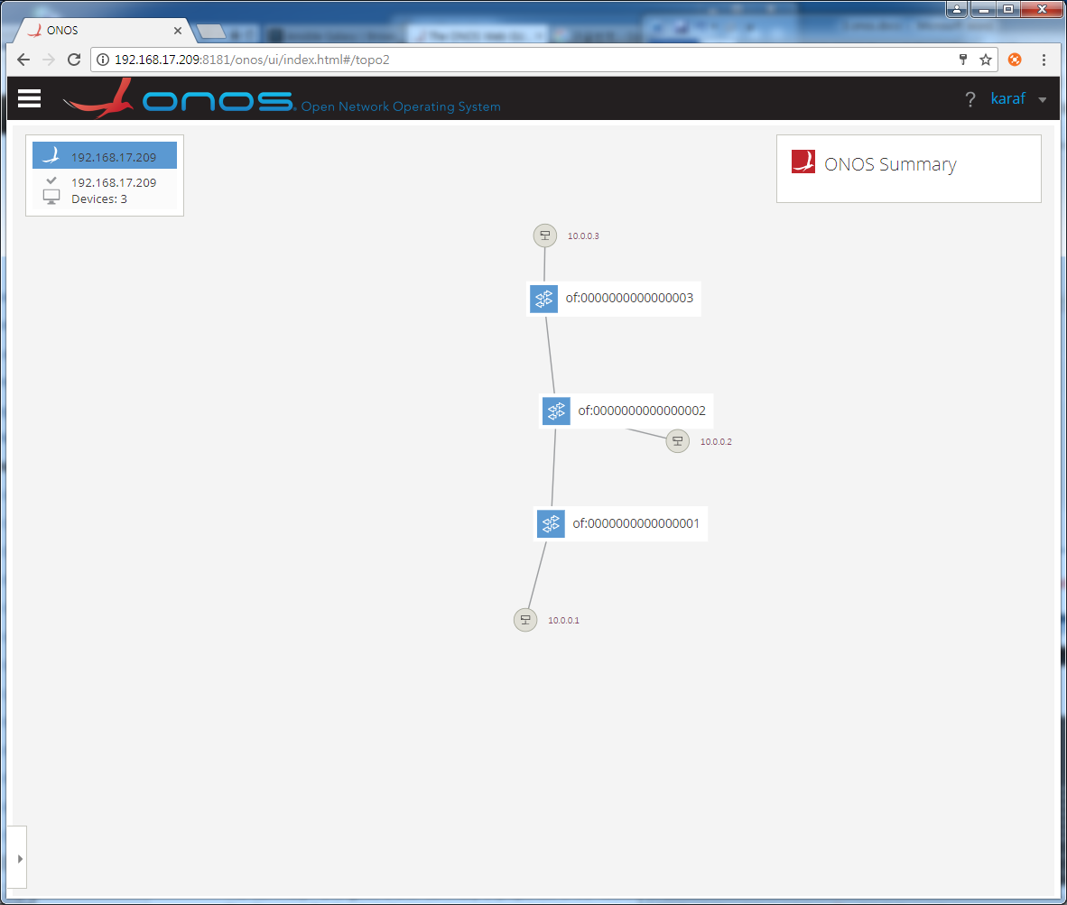

**NETWORK->Devices**

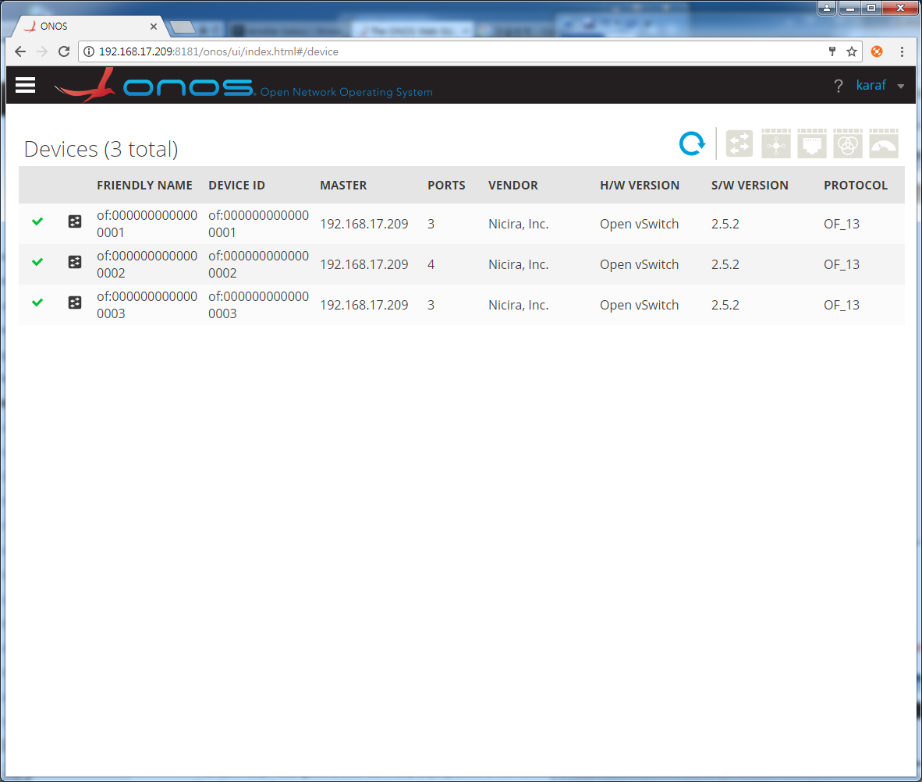

**NETWORK->Links**

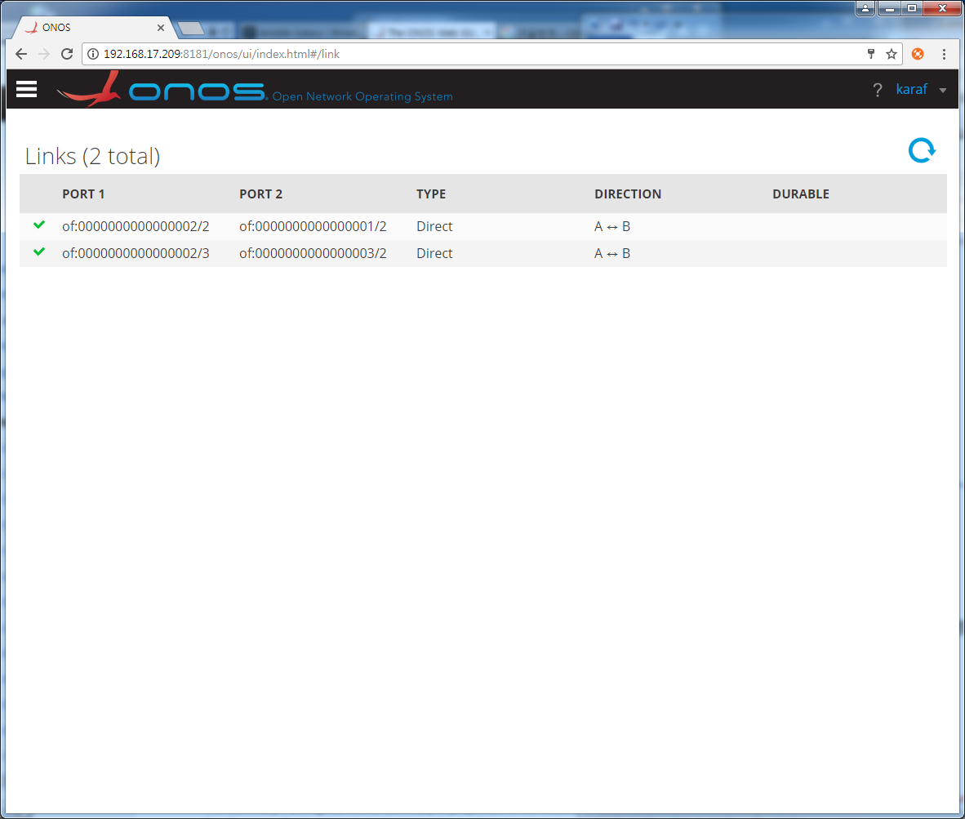

**NETWORK->Hosts**

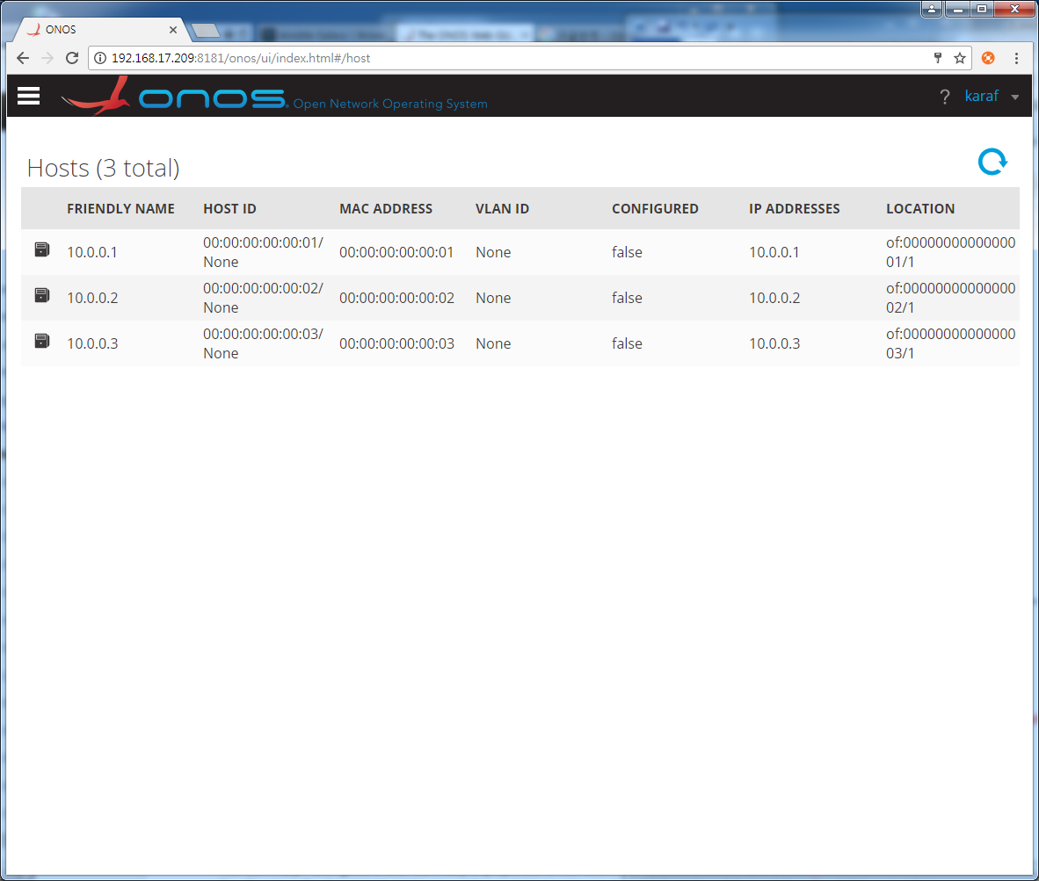

**NETWORK->Intents**

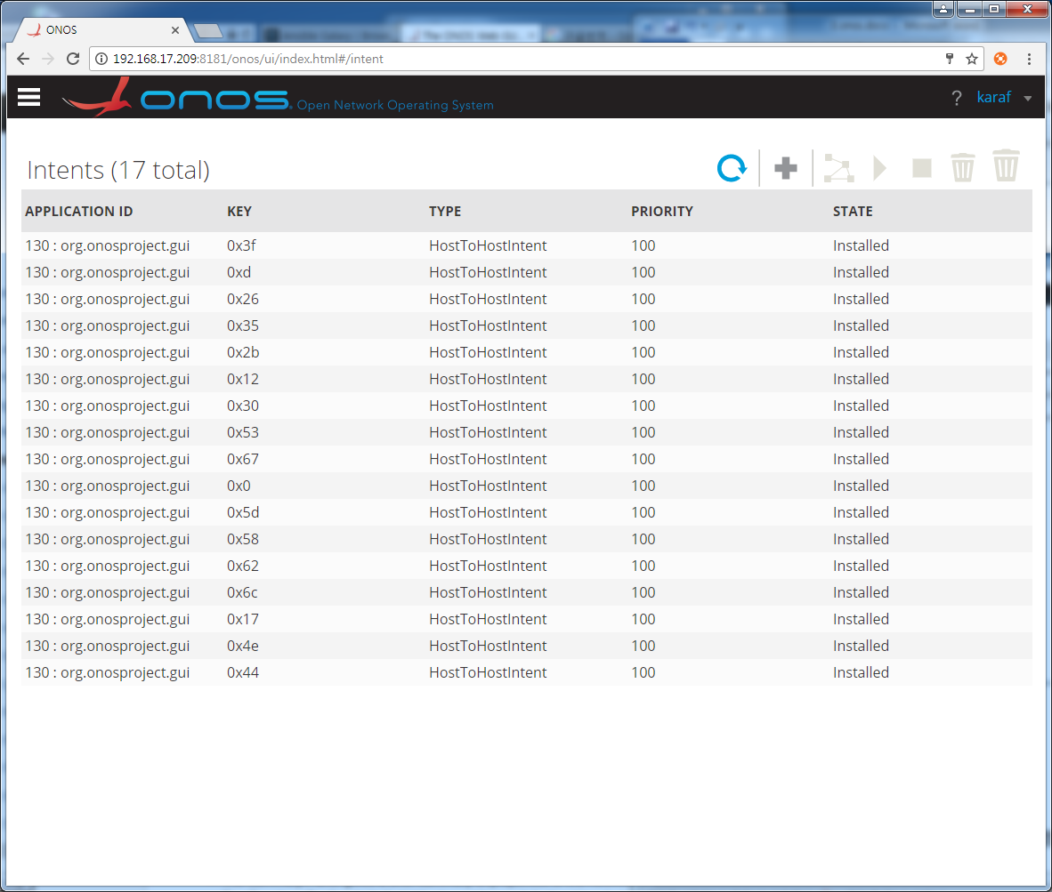

**/키 (instance의 색깔 파란색이 controller하는 device는 동일한 색)**

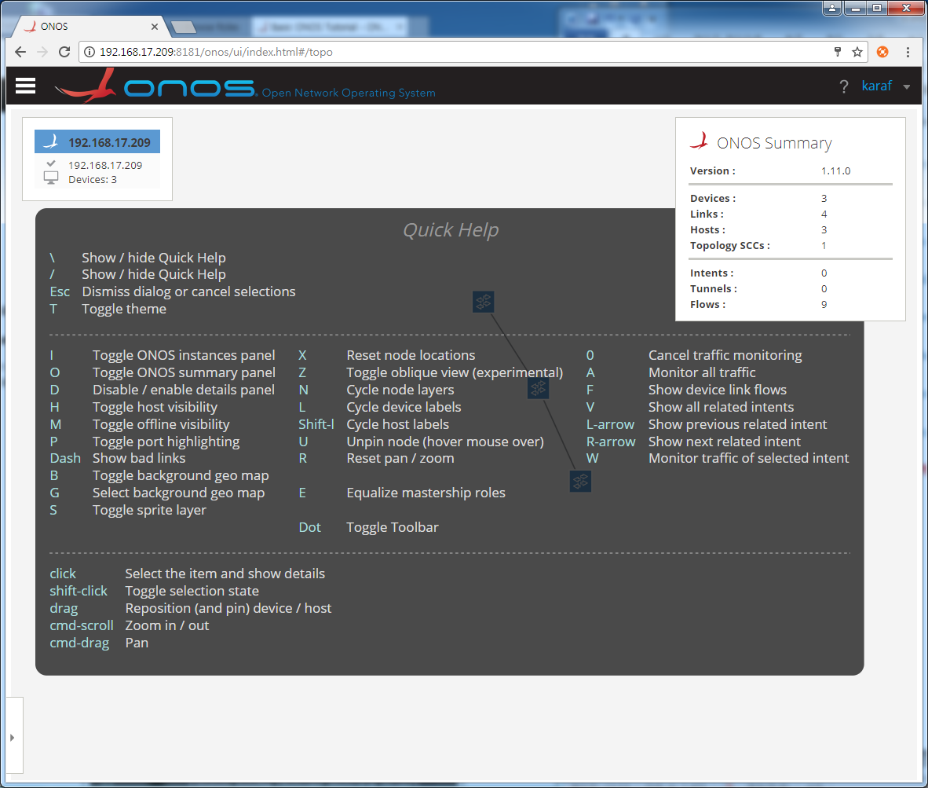

**device클릭 (스위치의 가상 port때문에 port개수가 보이는 것보다 1개 많음)**

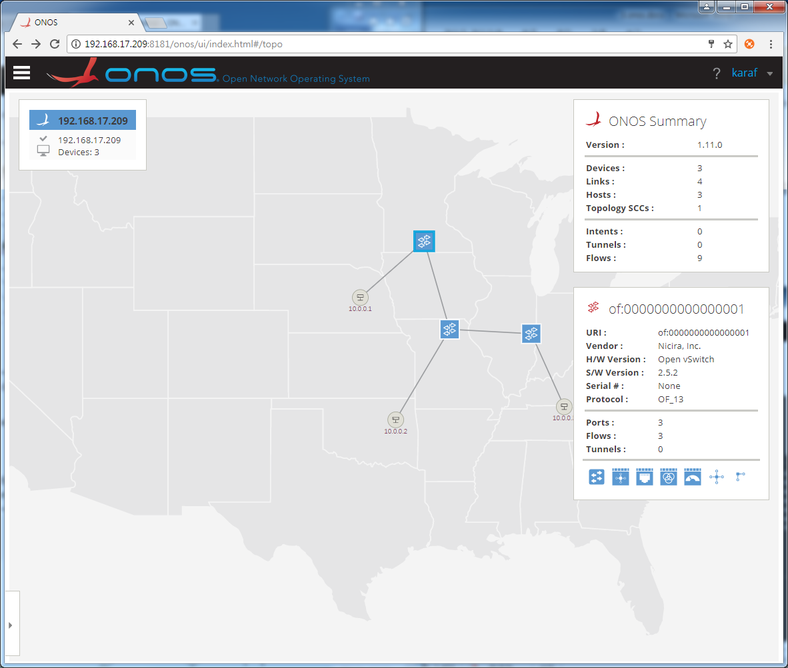

**host1과 host3(shift키)를 찌고 create host-to-host flow 선택**

**(intents에 의한 경로로 색깔이 주황색으로 변함)**

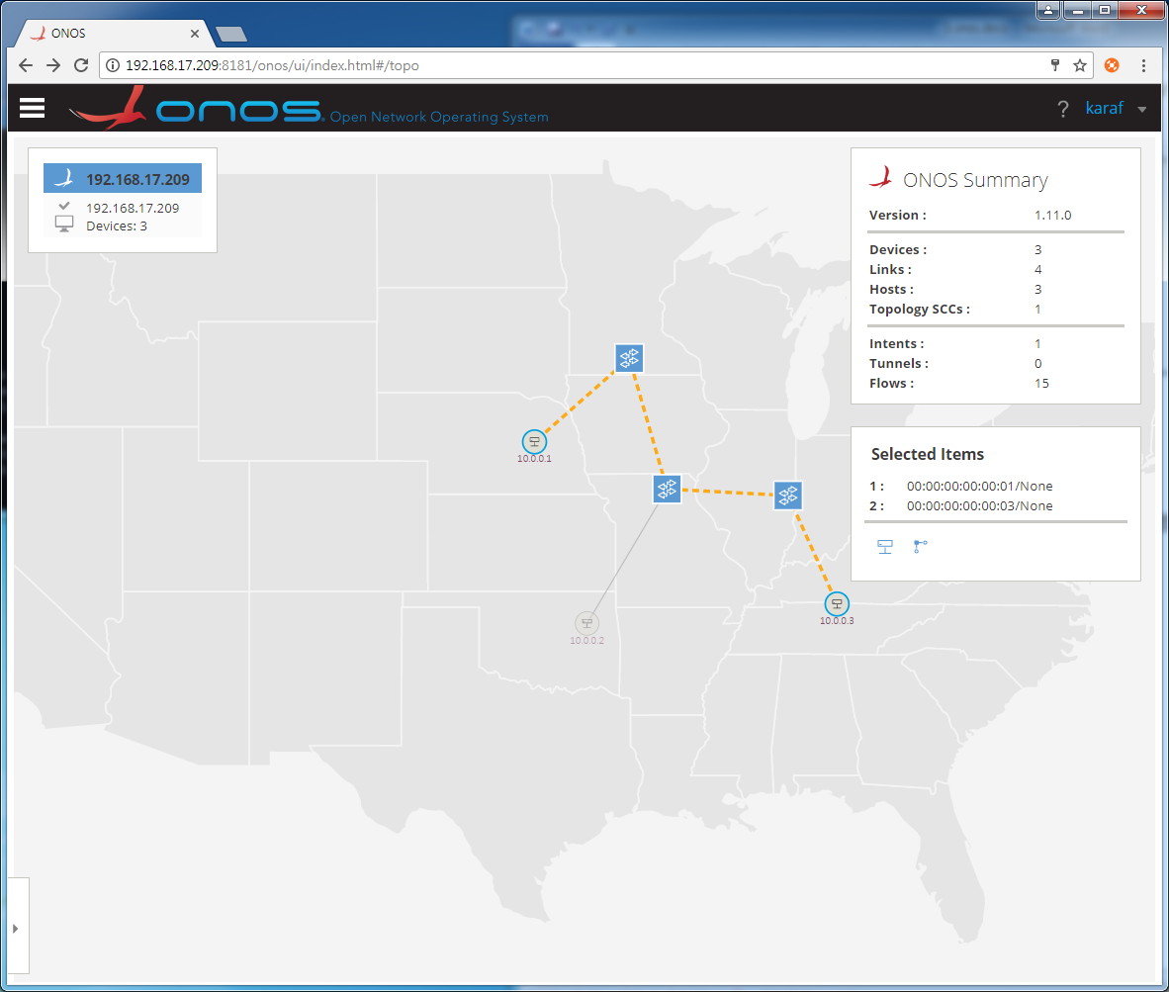

**onos> intents**

Id: 0x0

State: INSTALLED

Key: 0x0

Intent type: HostToHostIntent

Application Id: org.onosproject.gui

Resources: [00:00:00:00:00:01/None, 00:00:00:00:00:03/None]

Treatment: [NOACTION]

Constraints: [LinkTypeConstraint{inclusive=false, types=[OPTICAL]}]

Source host: 00:00:00:00:00:01/None

Destination host: 00:00:00:00:00:03/None

**mininet> h1 ping h3**

PING 10.0.0.3 (10.0.0.3) 56(84) bytes of data.

64 bytes from 10.0.0.3: icmp_seq=1 ttl=64 time=0.298 ms

64 bytes from 10.0.0.3: icmp_seq=2 ttl=64 time=0.071 ms

64 bytes from 10.0.0.3: icmp_seq=3 ttl=64 time=0.046 ms

64 bytes from 10.0.0.3: icmp_seq=4 ttl=64 time=0.056 ms

64 bytes from 10.0.0.3: icmp_seq=5 ttl=64 time=0.054 ms

64 bytes from 10.0.0.3: icmp_seq=6 ttl=64 time=0.044 ms

**host1과 host3(shift키)를 찌고 create host-to-host flow 선택 (전송량이 표시됨)**

**또는 a 키를 누르면 pps와 bits로 표시됨**

