centos 7 설치 (cpu 1, memory 3G, nic 1개 이상)

systemctl disable firewalld

systemctl stop firewalld

systemctl disable NetworkManager

systemctl stop NetworkManager

systemctl enable network

systemctl start network

yum install -y <https://rdoproject.org/repos/rdo-release.rpm>

yum install -y centos-release-openstack-ocata

yum update -y

yum install -y openstack-packstack

packstack --allinone **--provision-demo=n** **--os-neutron-ovs-bridge-mappings=extnet:br-ex** **--os-neutron-ovs-bridge-interfaces=br-ex:eno16777736** **--os-neutron-ml2-type-drivers=vxlan,flat**

실패발생시 ip a로 ip확인후

ifdown eno16777736

ifup eno16777736

**<provider 네트워크 생성=external>**

[root@localhost network-scripts(keystone_admin)]# cat ifcfg-eno16777736

DEVICE=eno16777736

TYPE=OVSPort

DEVICETYPE=ovs

OVS_BRIDGE=br-ex

ONBOOT=yes

[root@localhost network-scripts(keystone_admin)]# cat ifcfg-br-ex

DEVICE=br-ex

DEVICETYPE=ovs

TYPE=OVSBridge

BOOTPROTO=static

IPADDR=192.168.17.160

NETMASK=255.255.255.0

GATEWAY=192.168.17.2

DNS1=192.168.17.2

ONBOOT=yes

service network restart

source keystonerc_admin

**<이미지 생성>**

wget http://download.cirros-cloud.net/0.3.4/cirros-0.3.4-x86_64-disk.img

glance image-create --name='cirros image' --file= cirros-0.3.4-x86_64-disk.img --visibility=public --container-format=bare –disk-format=qcow2

**<provider 네트워크 생성=external>**

neutron net-create external_network --provider:network_type flat --provider:physical_network extnet --router:external

neutron subnet-create --name public_subnet --enable_dhcp=False --allocation-pool=start=192.168.17.10,end=192.168.17.20 \

--gateway=192.168.17.2 external_network 192.168.17.0/24

**<라우터 생성>**

neutron router-create router1

neutron router-gateway-set router1 external_network

**<테넌트 네트워크=private 생성>**

neutron net-create private_network

neutron subnet-create --name private_subnet private_network 192.168.100.0/24

neutron router-interface-add router1 private_subnet

**<인스턴스 생성>**

**nova boot --flavor=m1.tiny --image=cirros --nic net-id=afaebfaf-8d8c-4f14-9546-a9b5ad173fe8 test**

**<접근보안>**

1. **보안그룹 : ALL ICMP, SSH 추가**
2. **키페어 : keypair 생성후 인스턴스 생성시 추가**
3. **플로팅IP : 플로팅 IP 생성후 인스턴스에 할당**

* 2개 이상의 instance는 자원부족으로 생성되지 않음

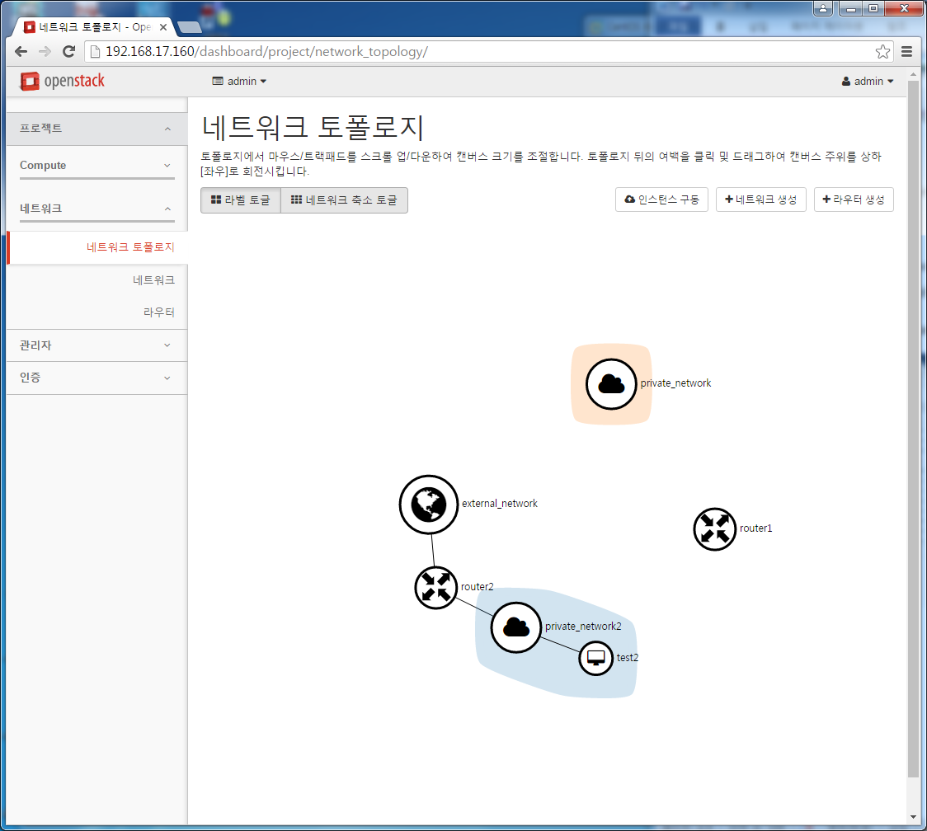

HOST NODE 추가

1. CONTROLLER, COMPUTE NODE 인터페이스 추가
2. answer 파일에 COMPUTE NODE IP추가 (컴퓨트노드 hostname 변경)
3. answer 파일에 추가인터페이스를 TUNNEL INFERFACE로 설정후 PACKSTACK 설치