Catena Retail
Environment used: Databricks Free Edition.
PySpark was used for the pipelines and Spark SQL for the modelling.
Raw files were loaded into a Unity Catalog volume, and cleaned output was written as Parquet, partitioned by order year and month.

1. Approach and assumptions
I read each file as text first and looked at what was actually wrong before fixing anything.
In the orders and customers files I found currency symbols in the amount, dates in two different formats, some missing values, duplicate rows, and one order linked to a customer who was not in the customer file. When I could fix a value safely I kept the row. For example, a missing region was set to "Unknown". I only removed rows I could not use, like an order with no amount or a negative quantity.
The clickstream was trickier. The session ids in the file grouped events that were days apart, so they were not real sessions. I rebuilt them instead. If a customer was inactive for more than thirty minutes, the next event starts a new session.
Key assumptions
- The amount is the total for the order, not the price of one item, so I add it up to get revenue.
- The order linked to a missing customer is kept and flagged, not deleted, so its money is not lost.
- "No orders in the last 90 days" is counted from the latest order date in the data, not today, because the data is from 2024.

2. Task 3: running event processing in production
Here the clickstream was just a file on disk, but in real life it would be a live stream. I would run it as a scheduled micro-batch, every few minutes, rather than an always on streaming job.
The reason is simple. Session metrics do not need to be up to the second, so an always on cluster is not worth the cost. A micro-batch with Spark Structured Streaming gives near real time results for a lot less money.
Structured Streaming also handles the harder parts. Late events and out of order events are dealt with using watermarking and checkpoints, so the sessions still come out right.
And if the business ever needed true real time, like live dashboards, the same logic would move over to continuous streaming without a rewrite.

3. Task 5: Orchestration design
I would orchestrate Tasks 1 to 3 as an Airflow DAG. Airflow fits well here because the work has clear dependencies, needs scheduling, and benefits from built in retries and alerting. On Azure the same design could run on Azure Data Factory or Fabric Pipelines, but I will describe it with Airflow because the logic maps cleanly to tasks and dependencies.

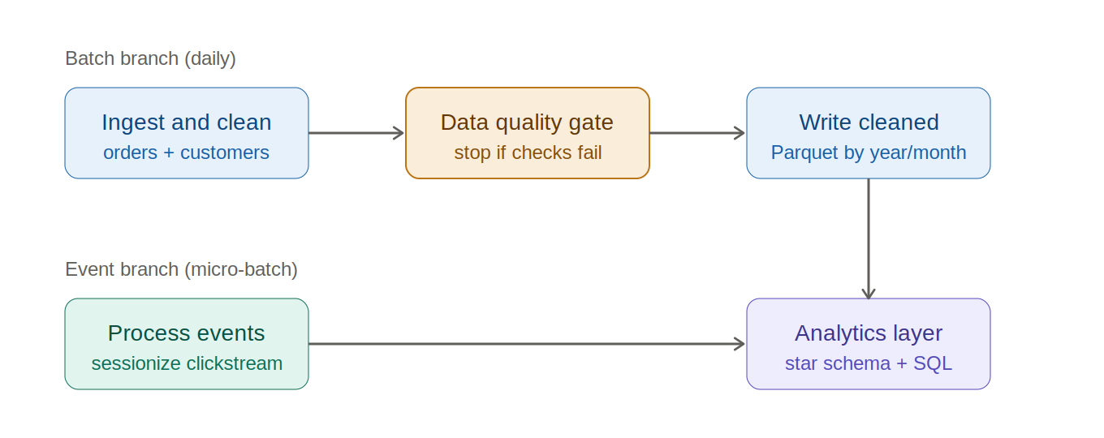

Scheduling and dependencies
The batch sources, orders and customers, arrive as daily extracts, so the batch pipeline runs on a daily schedule. The DAG has four steps. It ingests and cleans orders and customers, runs the data quality checks, and only then writes the cleaned Parquet output.
The data quality step acts as a gate. If the critical checks fail, the pipeline stops before publishing, so bad data never reaches the output tables.
Event processing reads a different source, the clickstream, so it runs as its own branch and does not depend on the orders pipeline. Since it is the near real time source, I would schedule it more frequently as a short micro-batch rather than once a day.

Failure handling and retries
For transient failures such as a temporary storage or network issue, each task retries a few times with exponential backoff, so a brief outage does not fail the whole run.
Data quality failures are handled differently. If a check fails, the pipeline does not retry, because running the same bad data again will not fix it. Instead it stops and raises an alert for a person to review.
The writes are idempotent, so output is overwritten by partition. This means re-running a day is safe and does not create duplicate records.

Alerting
I would alert on three conditions:
- A task failing after its retries are used up.
- A data quality check breaching its threshold, for example a spike in nulls or a referential integrity break.
- An SLA miss, where a job does not finish by its expected time.
Alerts route by severity. Lower priority ones go to a Slack channel or email, and pipeline down or repeated failures go to an on-call path such as PagerDuty, so the right person is notified quickly.

4. Task 6: Short answers

CI/CD for data pipelines
I keep all pipeline code, notebooks and SQL in Git and work on feature branches. When a change is ready I open a pull request into the main branch.
The pull request triggers a CI pipeline in Azure DevOps to lint the code and run unit tests on the transformation logic against a small sample dataset. Once the PR is reviewed and merged, a release pipeline runs automatically and deploys the code through environments, dev, then staging, then production, with an approval step before production.
Environment specific settings like paths and table names live in config, so the same code runs in each stage.

Monitoring in production
I would monitor both whether the job ran and whether the data it produced is correct.
For the job itself I would track run status, run duration against its normal baseline, and record counts at each stage, the same raw to cleaned to written counts this pipeline already logs. For the data I would keep the data quality checks running on every load.
Alerts should trigger when a job fails after its retries, when a run takes far longer than usual or misses its SLA, when record counts drop or spike unexpectedly, or when a data quality check breaches its threshold such as a jump in nulls or a referential integrity break.

Microsoft Fabric and Synapse experience
I have used Microsoft Fabric mainly on the consumption side, connecting Power BI to a Fabric SQL and Warehouse endpoint as the reporting source, so I am familiar with how the SQL layer serves data to Power BI.
I have not yet built end to end pipelines in Fabric or worked with Synapse dedicated pools, but the main concepts are similar to my Databricks, Azure and SQL work.
To ramp up quickly I would start with Fabric notebooks and Lakehouse for ingestion and transformation, since these map closely to the Spark and Delta work I already do, then move to Fabric Pipelines for orchestration

