

姓名：蔡鎮偉

學號：F74045026

班別：乙班

UML Diagram

|  |
| --- |
| **Taiko** |
| -Taiko: *ui  -Play: pla |
| +<constructor>Taiko(QWidget: *parent)  -on_playButton_clicked()  -on_exitButton_clicked()  +<destructor>~Taiko() |

UML Diagram

|  |
| --- |
| **Play** |
| -Play: *ui  -double: time  -int: mark  -QTimer: *timer  -QKeyEvent: *event  -int: pos[8]  -int: scorenum |
| +<constructor>Play(QWidget: *parent)  +starttime()  +keyPressEvent(QKeyEvent: *event)  -timeoutEvent()  +<destructor>~Play() |

How to play & Screenshot

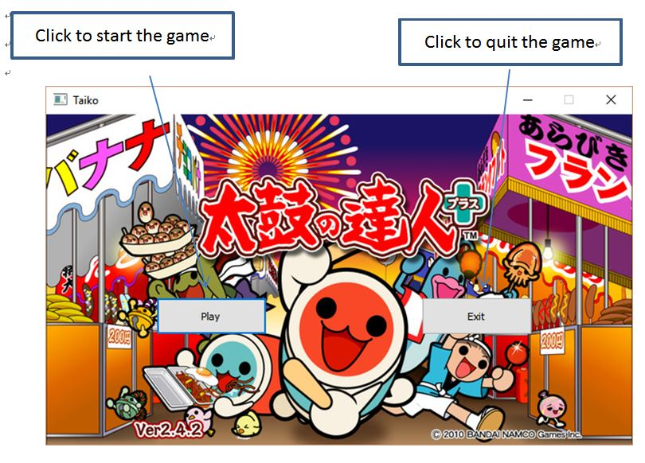

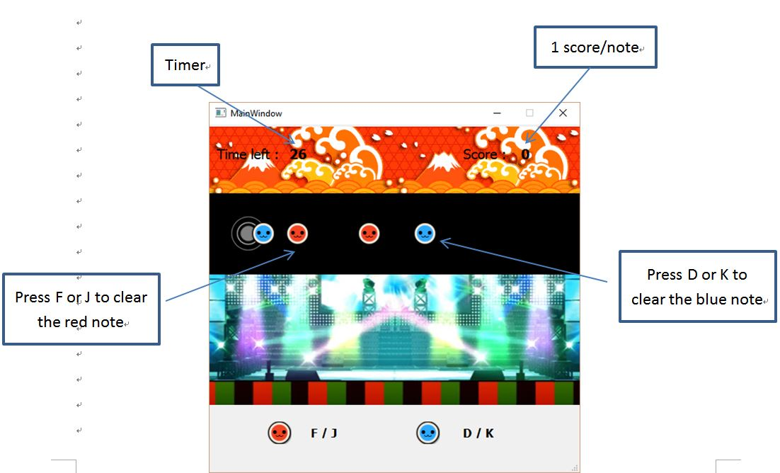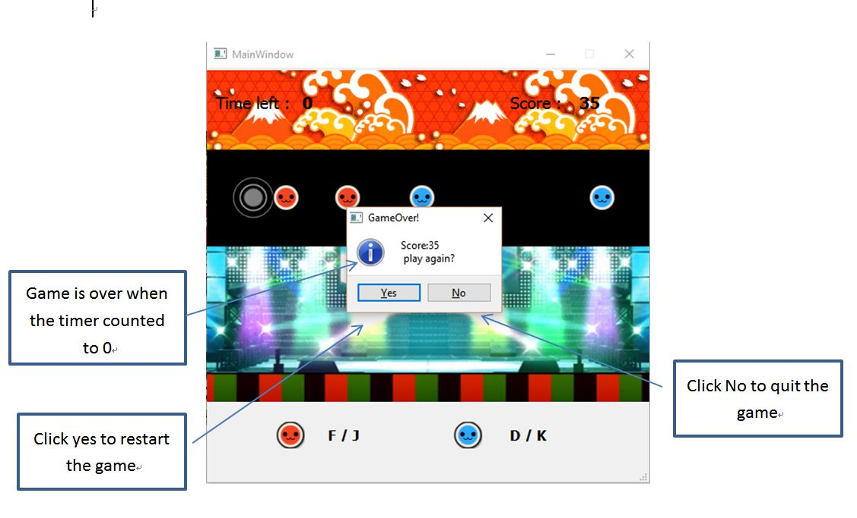

Program architecture

play.cpp

taiko.cpp

main.cpp