

姓名：蔡鎮偉

學號：F74045026

班別：乙班

UML Diagram

|  |
| --- |
| **Bird** |
|  |
| +<constructor>Bird(float x, float y, float radius, QTimer *timer, QPixmap pixmap, b2World *world, QGraphicsScene *scene)  +setLinearVelocity(b2Vec2 velocity)  +virtual *ability*(); |

|  |
| --- |
| Blackbird |
|  |
| +<constructor>Blackbird(float x, float y, float radius, QTimer *timer, QPixmap pixmap, b2World *world, QGraphicsScene *scene);  +void *ability*(); |
| Bluebird |
|  |
| +<constructor>Bluebird(float x, float y, float radius, QTimer *timer, QPixmap pixmap, b2World *world, QGraphicsScene *scene);  +void *ability*(); |

|  |
| --- |
| Yellowbird |
|  |
| +<constructor>Yellowbird(float x, float y, float radius, QTimer *timer, QPixmap pixmap, b2World *world, QGraphicsScene *scene);  +void *ability*(); |

|  |
| --- |
| GameItem |
| -QGraphicsPixmapItem g_pixmap;  - QSizeF g_size;  - b2World *g_world;  - static QSizeF g_worldsize, -g_windowsize; |
| +<constructor>GameItem(b2World *world);  +(deconstructor)~*GameItem*();  -static void setGlobalSize(QSizeF worldsize, QSizeF windowsize);  -b2Body *g_body; |

|  |
| --- |
| Land |
|  |
| +<constructor>Land(float x, float y, float w, float h, QPixmap pixmap, b2World *world, QGraphicsScene *scene); |

|  |
| --- |
| MainWindow |
| -Ui::MainWindow *ui;  -QGraphicsScene *scene;  -b2World *world;  -QList<GameItem *> itemList;  -QTimer timer;  -QPushButton *quit_button;  -QPushButton *restart_button;  -b2Vec2 vel;  -QLabel *score_label;  -Ob *block1;  -Ob *block2;  -Ob *block3;  -Land *bot_bound;  -Land *up_bound;  -Land *left_bound;  -Land *right_bound;  -Pig *pig;  -Bird *birdie;  -Yellowbird *yellowb;  -Blackbird *blackb;  -Bluebird *blueb;  +int ix=0,fx=0,iy=0,fy=0;  +int score=0;  +Int presstime=0; |
| +explicit MainWindow(QWidget *parent = 0);  +<deconstructor>~*MainWindow*();  +void *showEvent*(QShowEvent *);  +bool *eventFilter*(QObject *,QEvent *event);  + void *closeEvent*(QCloseEvent *);  -void tick();  -void QUITSLOT();  -void re();  void qquit(); |

|  |
| --- |
| Ob |
|  |
| +<constructor>Ob(float x, float y, float w, float h, QTimer *timer, QPixmap pixmap, b2World *world, QGraphicsScene *scene); |

|  |
| --- |
| Ob |
| b2BodyDef bodydef; |
| +<constructor>Pig(float x, float y, float radius, QTimer *timer, QPixmap pixmap, b2World *world, QGraphicsScene *scene);  +void setLinearVelocity(b2Vec2 velocity); |

How to play & Screenshot

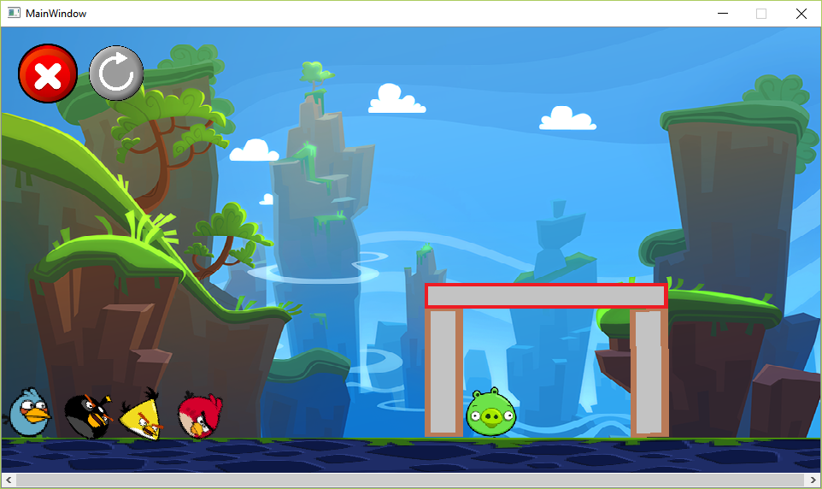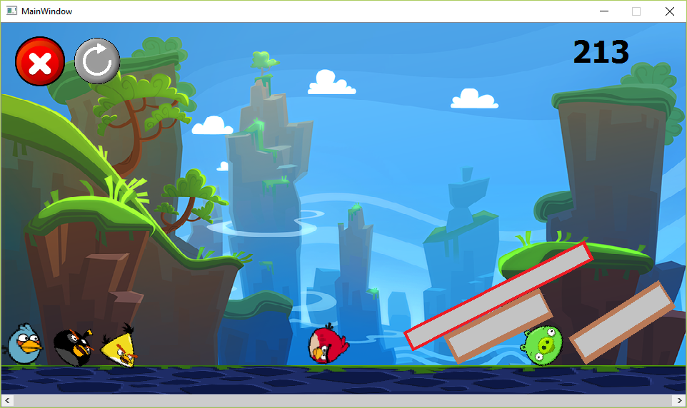

紅色鳥:沒有功能

黑色鳥:按一下會變大

藍色鳥:會直接向下加速

黃色鳥:向前進方向加速

右上角:當前分數

左上角第一個:關閉遊戲

左上角第二個:重新開始

Program architecture

pig.cpp

ob.cpp

gameitem.cpp

bluebird.cpp

yellowbird.cpp

blackbird.cpp

Bird.cpp

Mainwindow.cpp

main.cpp