Supercapacitor

**MoS2**

1. Chemically **exfoliated**-MoS2 (eMoS2) solution
   1. Add 15 mg of MoS2 powder and add it to 30 mL DMF (or NMP) in a tube.
   2. Block the top of it with the paraffin film.
   3. Tip sonication (50 % power) for 1 h.

Plates in the images => exfoliated MoS2.

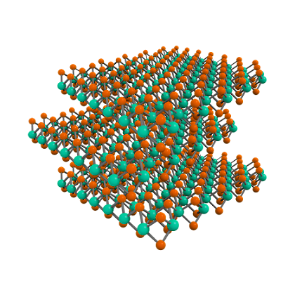

1. Solvothermal-synthesized **defect-free** MoS2 (pMoS2)
   1. Add ~1 mmol **(~36 mg)** hexaammonium heptamolybdate tetrahydrate ((NH4)6Mo7O24·4H2O, HHT, i.e. 7 mmol Mo) and ~14 mmol **(~58 mg)** thiourea in ~40 mL deionized water.
   2. Stirring for 15 min (use magnetic stirring device).
   3. Transfer the solution to Teflon-lined stainless steel autoclave (fasten everything tightly).
   4. Incubating the solution at 220 C (overnight).

Thick MoS2 plates, yield = ~30 % of Mo source.

1. Solvothermal-synthesized **defect-rich** MoS2 (nMoS2)
   1. Add ~0.9 mmol **(~30 mg)** hexaammonium heptamolybdate tetrahydrate ((NH4)6Mo7O24·4H2O, HHT, i.e. 7 mmol Mo) and ~27 mmol **(~100 mg)** thiourea in ~40 mL deionized water.
   2. Stirring for 15 min (use magnetic stirring device).
   3. Transfer the solution to Teflon-lined stainless steel autoclave (fasten everything tightly).
   4. Incubating the solution at 220 C (overnight).

**Carbon nanotube (CNT)-ZIF (Zeolitic imidazole framework)-MoS2**

1. **CNT**
   1. Add 5 mg of CNT powder in 30 mL DMF in a tube.
   2. Add 30 mg of dopamine hydrochloride in the solution.
   3. Block the top of it with the paraffin film.
   4. Tip sonication (50 % power) for 30 min.
   5. Stirring for 2 h (use magnetic stirring device).
      * Dopamine will be coated on CNT. Dopamine layer will act as a precursor for the growth of ZIF.

1. **CNT-ZIF**
   1. Add 30 mg of zinc chloride and 15 mg of 1h-1,2,4-triazole-3-thiol in the CNT solution
   2. Block the top of it with the paraffin film.
   3. Tip sonication (50 % power) for 10 min.
   4. Incubating the solution for over 44 h at 120 C.

1. CNT-ZIF-MoS2
   1. **CNT-ZIF-eMoS2**
      * Add 10 mg of MoS2 in the CNT-ZIF solution
      * Tip sonication (50 % power) for 30 min.
      * Incubating the solution at 80 C (overnight).

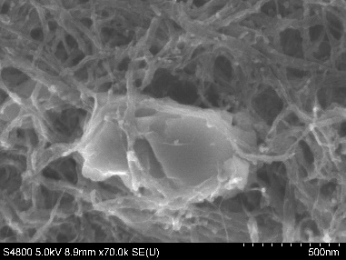

* 1. **CNT-ZIF-nMoS2**
     + Vacuum-filtrate the CNT-ZIF solution. CNT-ZIF will form a dark film.
     + Wash the film with excess amount of EtOH.
     + Bake the film at 110 C (overnight).
     + Grind the film with glass stick and get CNT-ZIF powder.
     + Mix the powder with 0.9 mmol (~30 mg) hexaammonium heptamolybdate tetrahydrate ((NH4)6Mo7O24·4H2O, HHT, i.e. 7 mmol Mo) and 27 mmol (~100 mg) thiourea in ~40 mL deionized water.
     + Tip sonication (50 % power) for 30 min.
     + Transfer the solution to Teflon-lined stainless steel autoclave (fasten everything tightly).
     + Incubating the solution for 24 h at 220 C.

MoS2 nanoflowers are woven with CNT-ZIF network.

yield = 30~40 % of Mo source.

* 1. **CNT-ZIF-pMoS2**
     + Vacuum-filtrate the CNT-ZIF solution. CNT-ZIF will form a dark film.
     + Wash the film with excess amount of EtOH.
     + Bake the film at 110 C (overnight).
     + Grind the film with glass stick and get CNT-ZIF powder.
     + Mix the powder with ~1 mmol (~36 mg) hexaammonium heptamolybdate tetrahydrate ((NH4)6Mo7O24·4H2O, HHT, i.e. 7 mmol Mo) and ~14 mmol (~58 mg) thiourea in ~40 mL deionized water.
     + Tip sonication (50 % power) for 30 min.
     + Transfer the solution to Teflon-lined stainless steel autoclave (fasten everything tightly).
     + Incubating the solution for 24 h at 220 C.

CNT-ZIF fibers are completely packed with MoS2 plates.

MoS2 nanoplate, yield = 30~40 % of Mo source.