Lecture 3 – Dynamic Web Sites
September 14, 2005
Including Multiple Files
index.html
<!DOCTYPE html PUBLIC "-//W3C//DTD XHTML 1.0 Transitional//EN"
"http://www.w3.org/TR/xhtml1/DTD/xhtml1-transitional.dtd">
<html xmlns="http://www.w3.org/1999/xhtml" xml:lang="en" lang="en">
<head>
<meta http-equiv="content-type" content="text/html; charset=iso-8859-1" />
<title>Welcome to this Site!</title>
<style type="text/css" media="all">@import "./includes/layout.css";</style>
</head>
<body>
<div id="wrapper"><!-- Goes with the CSS layout. -->
<div id="content"><!-- Goes with the CSS layout. -->
<div id="nav"><!-- Links section -->
<h3>Menu</h3>
<ul>
<li class="navtop"><a href="index.php" title="Go to the Home Page">Home</a></li>
<li><a href="calculator.php" title="Use the Sales Calculator">Calculator</a></li>
<li><a href="dateform.php" title="Check out the Date Form">Date Form</a></li>
<li><a href="register.php" title="Register">Register</a></li>
</ul>
</div>
<!-- Start of page-specific content. -->
<h1 id="mainhead">Big Header</h1>
<p>This is where you'll put the main page content. This content will differ for each page.</p>
<p>This is where you'll put the main page content. This content will differ for each page.</p>
<p>This is where you'll put the main page content. This content will differ for each page.</p>
<p>This is where you'll put the main page content. This content will differ for each page.</p>
<h2>Subheader</h2>
<p>This is where you'll put the main page content. This content will differ for each page.</p>
<p>This is where you'll put the main page content. This content will differ for each page.</p>
<p>This is where you'll put the main page content. This content will differ for each page.</p>
<p>This is where you'll put the main page content. This content will differ for each page.</p>
<!-- End of page-specific content. -->
</div><!-- End of "content" DIV. -->
<div id="footer"><p>&copy; Copyright 2005 by Larry E. Ullman &amp; DMCInsights, Inc.</p></div>
</div><!-- End of "wrapper" DIV. -->
</body>
</html>

layout.css

body {
font: 12px "Lucida Sans Unicode", Verdana, sans-serif;
color: #333333;
background: #FFF;
margin: 0;
padding: 0;
}
#wrapper {
margin: 0 auto;
width: 500px;
}
#content {
margin: 0 25px 0 25px;
padding: 10px;
}
#content p {
margin: 0 130px 6px 0;
text-align: justify;
}
#nav {
position: static;
float: right;
width: 100px;
}
#nav ul {
margin: 15px 0 15px 0;
padding: 0;
list-style: none;
border: 0;
}
#nav li {
text-align: center;
border-bottom: 1px solid #000;
width: 100px;
margin: 0;
padding: 0;
font: 10px/15px "Lucida Sans Unicode", Verdana, sans-serif;
color: #000;
background: #FFF;
}
.navtop {
border-top: 1px solid #000;
}
#nav li a {
display: block;
font-weight: normal;
padding: 0;
border-left: 1px solid #000;
border-right: 1px solid #000;
background: #FFF;
color: #000;
text-decoration: none;
width: 100px;
voice-family: "\"}\"";
voice-family: inherit;
width: 98px;
}
html>#nav li a {
width: 98px;
}
#nav li a:hover {
font-weight: normal;
background: #999;
color: #000;
text-decoration: none;
}
#nav h3 {
font-size: 120%;
text-decoration: underline;
background-image: none;
text-align: center;
padding: 0;
}
#footer {
border-bottom: 1px solid #000;
border-top: 1px solid #000;
margin: 0 25px 0 25px;
padding: 10px;
}

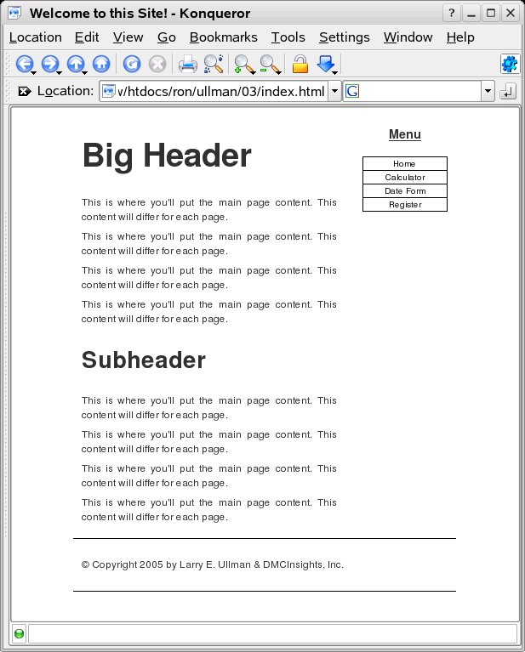
header.html

<!DOCTYPE html PUBLIC "-//W3C//DTD XHTML 1.0 Transitional//EN"
"http://www.w3.org/TR/xhtml1/DTD/xhtml1-transitional.dtd">
<html xmlns="http://www.w3.org/1999/xhtml" xml:lang="en" lang="en">
<head>
<meta http-equiv="content-type" content="text/html; charset=iso-8859-1" />
<title><?php echo $page_title; ?></title>
<style type="text/css" media="all">@import "./includes/layout.css";</style>
</head>
<body>
<div id="wrapper"><!-- Goes with the CSS layout. -->

<div id="content"><!-- Goes with the CSS layout. -->

<div id="nav"><!-- Links section -->
<h3>Menu</h3>
<ul>
<li class="navtop"><a href="index.php" title="Go to the Home Page">Home</a></li>
<li><a href="calculator.php" title="Use the Sales Calculator">Calculator</a></li>
<li><a href="dateform.php" title="Check out the Date Form">Date Form</a></li>
<li><a href="register.php" title="Register">Register</a></li>
</ul>
</div>
<!-- Script 3.2 - header.html -->

<!-- Start of page-specific content. -->
Menu
- Home
- Calculator
- Date Form
- Register

footer.html

<!-- End of page-specific content. -->
<!-- Script 3.3 - footer.html -->
</div><!-- End of "content" DIV. -->

<div id="footer"><p>&copy; Copyright 2005 by Larry E. Ullman &amp; DMCInsights, Inc.</p></div>

</div><!-- End of "wrapper" DIV. -->
</body>
</html>
© Copyright 2005 by Larry E. Ullman & DMCInsights, Inc.

index.php

<?php # Script 3.4 - index.php
$page_title = 'Welcome to this Site!';
include ('./includes/header.html');
?>
<h1 id="mainhead">Big Header</h1>
<p>This is where you'll put the main page content. This content will differ for each page.</p>
<p>This is where you'll put the main page content. This content will differ for each page.</p>
<p>This is where you'll put the main page content. This content will differ for each page.</p>
<p>This is where you'll put the main page content. This content will differ for each page.</p>
<h2>Subheader</h2>
<p>This is where you'll put the main page content. This content will differ for each page.</p>
<p>This is where you'll put the main page content. This content will differ for each page.</p>
<p>This is where you'll put the main page content. This content will differ for each page.</p>
<p>This is where you'll put the main page content. This content will differ for each page.</p>
<?php
include ('./includes/footer.html');
?>

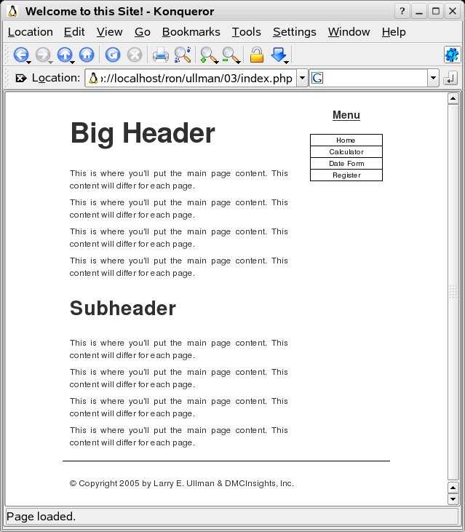
PHP Redux

<?php # Script 3.5 - calculator.php
$page_title = 'Widget Cost Calculator';
include ('./includes/header.html');

// Check if the form has been submitted.
if (isset($_POST['submitted'])) {

// Minimal form validation.
if ( is_numeric($_POST['quantity']) && is_numeric($_POST['price']) && is_numeric($_POST['tax']) ) {

// Calculate the results.
$taxrate = $_POST['tax'] / 100; // Turn 5% into .05.
$total = ($_POST['quantity'] * $_POST['price']) * ($taxrate + 1);

// Print the results.
echo '<h1 id="mainhead">Total Cost</h1>
<p>The total cost of purchasing ' . $_POST['quantity'] . ' widget(s) at $' . number_format ($_POST['price'], 2) . ' each, including a tax rate of ' . $_POST['tax'] . '%, is $' . number_format ($total, 2) . '.</p><p><br /></p>';

} else { // Invalid submitted values.
echo '<h1 id="mainhead">Error!</h1>
<p class="error">Please enter a valid quantity, price, and tax.</p><p><br /></p>';
}

} // End of main isset() IF.

// Leave the PHP section and create the HTML form.
?>
<h2>Widget Cost Calculator</h2>
<form action="calculator.php" method="post">
<p>Quantity: <input type="text" name="quantity" size="5" maxlength="10" /></p>
<p>Price: <input type="text" name="price" size="5" maxlength="10" /></p>
<p>Tax (%): <input type="text" name="tax" size="5" maxlength="10" /></p>
<p><input type="submit" name="submit" value="Calculate!" /></p>
<input type="hidden" name="submitted" value="TRUE" />
</form>
<?php
include ('./includes/footer.html');
?>

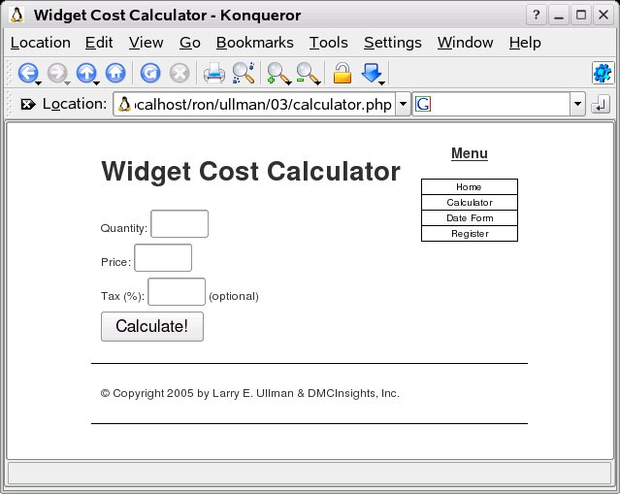

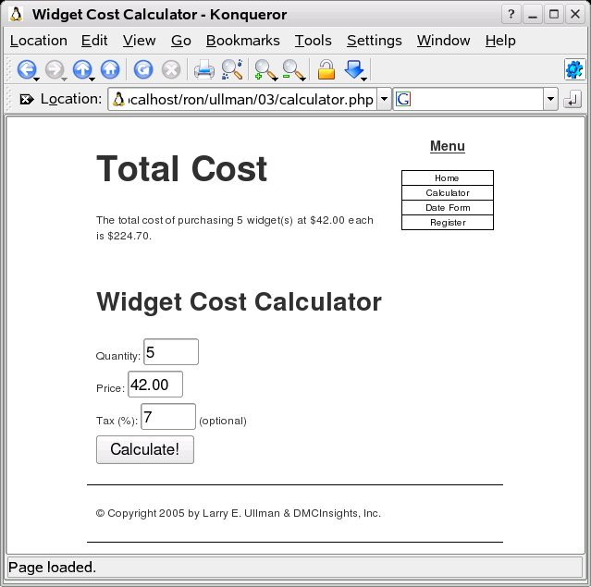
Sticky Forms

<?php # Script 3.6 - calculator.php (2nd version after Script 3.5)
$page_title = 'Widget Cost Calculator';
include ('./includes/header.html');

// Check if the form has been submitted.
if (isset($_POST['submitted'])) {

// Minimal form validation.
if ( is_numeric($_POST['quantity']) && is_numeric($_POST['price']) && is_numeric($_POST['tax']) ) {

// Calculate the results.
$taxrate = $_POST['tax'] / 100; // Turn 5% into .05.
$total = ($_POST['quantity'] * $_POST['price']) * ($taxrate + 1);

// Print the results.
echo '<h1 id="mainhead">Total Cost</h1>
<p>The total cost of purchasing ' . $_POST['quantity'] . ' widget(s) at $' . number_format ($_POST['price'], 2) . ' each, including a tax rate of ' . $_POST['tax'] . '%, is $' . number_format ($total, 2) . '.</p><p><br /></p>';

} else { // Invalid submitted values.
echo '<h1 id="mainhead">Error!</h1>
<p class="error">Please enter a valid quantity, price, and tax.</p><p><br /></p>';
}

} // End of main isset() IF.

// Leave the PHP section and create the HTML form.
?>
<h2>Widget Cost Calculator</h2>
<form action="calculator.php" method="post">
<p>Quantity: <input type="text" name="quantity" size="5" maxlength="10" value="<?php if (isset($_POST['quantity'])) echo $_POST['quantity']; ?>" /></p>
<p>Price: <input type="text" name="price" size="5" maxlength="10" value="<?php if (isset($_POST['price'])) echo $_POST['price']; ?>" /></p>
<p>Tax (%): <input type="text" name="tax" size="5" maxlength="10" value="<?php if (isset($_POST['tax'])) echo $_POST['tax']; ?>" /></p>
<p><input type="submit" name="submit" value="Calculate!" /></p>
<input type="hidden" name="submitted" value="TRUE" />
</form>
<?php
include ('./includes/footer.html');
?>

Creating and Calling Your Own Functions

<?php # Script 3.7 - dateform.php
$page_title = 'Calendar Form';
include ('./includes/header.html');

// This function makes three pull-down menus for the months, days, and years.
function make_calendar_pulldowns() {

// Make the months array.
$months = array (1 => 'January', 'February', 'March', 'April', 'May', 'June', 'July', 'August', 'September', 'October', 'November', 'December');

// Make the months pull-down menu.
echo '<select name="month">';
foreach ($months as $key => $value) {
echo "<option value=\"$key\">$value</option>\n";
}
echo '</select>';

// Make the days pull-down menu.
echo '<select name="day">';
for ($day = 1; $day <= 31; $day++) {
echo "<option value=\"$day\">$day</option>\n";
}
echo '</select>';

// Make the years pull-down menu.
echo '<select name="year">';
for ($year = 2005; $year <= 2015; $year++) {
echo "<option value=\"$year\">$year</option>\n";
}
echo '</select>';

} // End of the function definition.

// Create the form tags.
echo '<h1 id="mainhead">Select a Date:</h1>
<p><br /></p><form action="dateform.php" method="post">';

// Call the function.
make_calendar_pulldowns();

echo '</form><p><br /></p>'; // End of form.

include ('./includes/footer.html');
?>

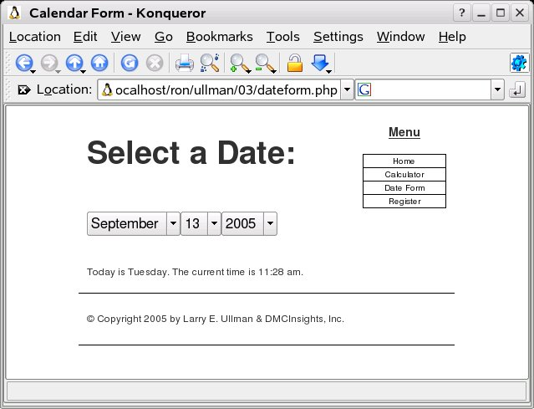

Functions With Arguments

<?php # Script 3.8 - calculator.php (3rd version after Scripts 3.5 & 3.6)
$page_title = 'Widget Cost Calculator';
include ('./includes/header.html');

/* This function calculates a total
and then prints the results. */
function calculate_total ($qty, $cost, $tax) {

$taxrate = $tax / 100; // Turn 5% into .05.
$total = ($qty * $cost) * ($taxrate + 1);
echo '<p>The total cost of purchasing ' . $qty . ' widget(s) at $' . number_format ($cost, 2) . ' each, including a tax rate of ' . $tax . '%, is $' . number_format ($total, 2) . '.</p>';

} // End of function.

// Check if the form has been submitted.
if (isset($_POST['submitted'])) {

// Minimal form validation.
if ( is_numeric($_POST['quantity']) && is_numeric($_POST['price']) && is_numeric($_POST['tax']) ) {

// Print the heading.
echo '<h1 id="mainhead">Total Cost</h1>';

// Call the function.
calculate_total ($_POST['quantity'], $_POST['price'], $_POST['tax']);

// Print some spacing.
echo '<p><br /></p>';

} else { // Invalid submitted values.
echo '<h1 id="mainhead">Error!</h1>
<p class="error">Please enter a valid quantity, price, and tax.</p><p><br /></p>';
}

} // End of main isset() IF.

// Leave the PHP section and create the HTML form.
?>

//HTML Form

<h2>Widget Cost Calculator</h2>
<form action="calculator.php" method="post">
<p>Quantity: <input type="text" name="quantity" size="5" maxlength="10" value="<?php if (isset($_POST['quantity'])) echo $_POST['quantity']; ?>" /></p>
<p>Price: <input type="text" name="price" size="5" maxlength="10" value="<?php if (isset($_POST['price'])) echo $_POST['price']; ?>" /></p>
<p>Tax (%): <input type="text" name="tax" size="5" maxlength="10" value="<?php if (isset($_POST['tax'])) echo $_POST['tax']; ?>" /></p>
<p><input type="submit" name="submit" value="Calculate!" /></p>
<input type="hidden" name="submitted" value="TRUE" />
</form>
<?php
include ('./includes/footer.html');
?>

Setting Default Argument Values

<?php # Script 3.9 - calculator.php (4th version after Scripts 3.5, 3.6 & 3.8)
$page_title = 'Widget Cost Calculator';
include ('./includes/header.html');

/* This function calculates a total
and then prints the results. */
function calculate_total ($qty, $cost, $tax = 5) {

$taxrate = $tax / 100; // Turn 5% into .05.
$total = ($qty * $cost) * ($taxrate + 1);
echo '<p>The total cost of purchasing ' . $qty . ' widget(s) at $' . number_format ($cost, 2) . ' each, including a tax rate of ' . $tax . '%, is $' . number_format ($total, 2) . '.</p>';

} // End of function.

// Check if the form has been submitted.
if (isset($_POST['submitted'])) {

if (is_numeric($_POST['quantity']) && is_numeric($_POST['price'])) {

// Print the heading.
echo '<h1 id="mainhead">Total Cost</h1>';

if (is_numeric($_POST['tax'])) {
calculate_total ($_POST['quantity'], $_POST['price'], $_POST['tax']);
} else {
calculate_total ($_POST['quantity'], $_POST['price']);
}

// Print some spacing.
echo '<p><br /></p>';

} else { // Invalid submitted values.
echo '<h1 id="mainhead">Error!</h1>
<p class="error">Please enter a valid quantity and price.</p><p><br /></p>';
}

} // End of main isset() IF.

// Leave the PHP section and create the HTML form.
?>
<h2>Widget Cost Calculator</h2>
<form action="calculator.php" method="post">
<p>Quantity: <input type="text" name="quantity" size="5" maxlength="10" value="<?php if (isset($_POST['quantity'])) echo $_POST['quantity']; ?>" /></p>
<p>Price: <input type="text" name="price" size="5" maxlength="10" value="<?php if (isset($_POST['price'])) echo $_POST['price']; ?>" /></p>
<p>Tax (%): <input type="text" name="tax" size="5" maxlength="10" value="<?php if (isset($_POST['tax'])) echo $_POST['tax']; ?>" /> (optional)</p>
<p><input type="submit" name="submit" value="Calculate!" /></p>
<input type="hidden" name="submitted" value="TRUE" />
</form>
<?php
include ('./includes/footer.html');
?>

Returning Values From a Function

<?php # Script 3.10 - calculator.php (5th version after Scripts 3.5, 3.6, 3.8 & 3.9)
$page_title = 'Widget Cost Calculator';
include ('./includes/header.html');

/* This function calculates a total
and then prints the results.
This function returns the calculated total. */
function calculate_total ($qty, $cost, $tax = 5) {

$taxrate = $tax / 100; // Turn 5% into .05.
$total = ($qty * $cost) * ($taxrate + 1);
return number_format ($total, 2);

} // End of function.

// Check if the form has been submitted.
if (isset($_POST['submitted'])) {

if (is_numeric($_POST['quantity']) && is_numeric($_POST['price'])) {

// Print the heading.
echo '<h1 id="mainhead">Total Cost</h1>';

if (is_numeric($_POST['tax'])) {
$total_cost = calculate_total ($_POST['quantity'], $_POST['price'], $_POST['tax']);
} else {
$total_cost = calculate_total ($_POST['quantity'], $_POST['price']);
}

echo '<p>The total cost of purchasing ' . $_POST['quantity'] . ' widget(s) at $' . number_format ($_POST['price'], 2) . ' each is $' . $total_cost . '.</p>';

// Print some spacing.
echo '<p><br /></p>';

} else { // Invalid submitted values.
echo '<h1 id="mainhead">Error!</h1>
<p class="error">Please enter a valid quantity and price.</p><p><br /></p>';
}

} // End of main isset() IF.

// Leave the PHP section and create the HTML form.
?>
<h2>Widget Cost Calculator</h2>
<form action="calculator.php" method="post">
<p>Quantity: <input type="text" name="quantity" size="5" maxlength="10" value="<?php if (isset($_POST['quantity'])) echo $_POST['quantity']; ?>" /></p>
<p>Price: <input type="text" name="price" size="5" maxlength="10" value="<?php if (isset($_POST['price'])) echo $_POST['price']; ?>" /></p>
<p>Tax (%): <input type="text" name="tax" size="5" maxlength="10" value="<?php if (isset($_POST['tax'])) echo $_POST['tax']; ?>" /> (optional)</p>
<p><input type="submit" name="submit" value="Calculate!" /></p>
<input type="hidden" name="submitted" value="TRUE" />
</form>
<?php
include ('./includes/footer.html');
?>

Variable Scope

<?php # Script 3.11 - calculator.php (6th version after Scripts 3.5, 3.6, 3.8, 3.9 & 3.10)
$page_title = 'Widget Cost Calculator';
include ('./includes/header.html');

/* This function calculates a total
and then prints the results. */
function calculate_total ($tax = 5) {
global $total;
$taxrate = $tax / 100; // Turn 5% into .05.
$total = ($_POST['quantity'] * $_POST['price']) * ($taxrate + 1);
$total = number_format ($total, 2);
} // End of function.

// Check if the form has been submitted.
if (isset($_POST['submitted'])) {

if (is_numeric($_POST['quantity']) && is_numeric($_POST['price'])) {

// Print the heading.
echo '<h1 id="mainhead">Total Cost</h1>';

$total = NULL; // Initialize $total.

if (is_numeric($_POST['tax'])) {
calculate_total ($_POST['tax']);
} else {
calculate_total ();
}

echo '<p>The total cost of purchasing ' . $_POST['quantity'] . ' widget(s) at $' . number_format ($_POST['price'], 2) . ' each is $' . $total . '.</p>';

// Print some spacing.
echo '<p><br /></p>';

} else { // Invalid submitted values.
echo '<h1 id="mainhead">Error!</h1>
<p class="error">Please enter a valid quantity and price.</p><p><br /></p>';
}

} // End of main isset() IF.

// Leave the PHP section and create the HTML form.
?>
<h2>Widget Cost Calculator</h2>
<form action="calculator.php" method="post">
<p>Quantity: <input type="text" name="quantity" size="5" maxlength="10" value="<?php if (isset($_POST['quantity'])) echo $_POST['quantity']; ?>" /></p>
<p>Price: <input type="text" name="price" size="5" maxlength="10" value="<?php if (isset($_POST['price'])) echo $_POST['price']; ?>" /></p>
<p>Tax (%): <input type="text" name="tax" size="5" maxlength="10" value="<?php if (isset($_POST['tax'])) echo $_POST['tax']; ?>" /> (optional)</p>
<p><input type="submit" name="submit" value="Calculate!" /></p>
<input type="hidden" name="submitted" value="TRUE" />
</form>
<?php
include ('./includes/footer.html');
?>

Date and Time Functions

<?php # Script 3.12 - dateform.php (2nd version after Script 3.7)
$page_title = 'Calendar Form';
include ('./includes/header.html');

// This function makes three pull-down menus for the months, days, and years.
function make_calendar_pulldowns($m = NULL, $d = NULL, $y = NULL) {

// Make the months array.
$months = array (1 => 'January', 'February', 'March', 'April', 'May', 'June', 'July', 'August', 'September', 'October', 'November', 'December');

// Make the months pull-down menu.
echo '<select name="month">';
foreach ($months as $key => $value) {
echo "<option value=\"$key\"";
if ($key == $m) { // Preselect.
echo ' selected="selected"';
}
echo ">$value</option>\n";
}
echo '</select>';

// Make the days pull-down menu.
echo '<select name="day">';
for ($day = 1; $day <= 31; $day++) {
echo "<option value=\"$day\"";
if ($day == $d) { // Preselect.
echo ' selected="selected"';
}
echo ">$day</option>\n";
}
echo '</select>';

// Make the years pull-down menu.
echo '<select name="year">';
for ($year = 2005; $year <= 2015; $year++) {
echo "<option value=\"$year\"";
if ($year == $y) { // Preselect.
echo ' selected="selected"';
}
echo ">$year</option>\n";
}
echo '</select>';

} // End of the function definition.

// Create the form tags.
echo '<h1 id="mainhead">Select a Date:</h1>
<p><br /></p><form action="dateform.php" method="post">';

// Get today's information and call the function.
$dates = getdate();
make_calendar_pulldowns ($dates['mon'], $dates['mday'], $dates['year']);

echo '</form><p><br /></p>'; // End of form.

// Print the current day and time.
echo '<p>Today is ' . date ('l') . '. The current time is ' . date ('g:i a') . '.</p>';

include ('./includes/footer.html');
?>

Sending Email

<?php # Script 3.13 - register.php
$page_title = 'Register';
include ('./includes/header.html');

// Check if the form has been submitted.
if (isset($_POST['submitted'])) {

$errors = array(); // Initialize error array.

// Check for a name.
if (empty($_POST['name'])) {
$errors[] = 'You forgot to enter your name.';
}

// Check for an email address.
if (empty($_POST['email'])) {
$errors[] = 'You forgot to enter your email address.';
}

// Check for a password and match against the confirmed password.
if (!empty($_POST['password1'])) {
if ($_POST['password1'] != $_POST['password2']) {
$errors[] = 'Your password did not match the confirmed password.';
}
} else {
$errors[] = 'You forgot to enter your password.';
}

if (empty($errors)) { // If everything's okay.

// Register the user.

// Send an email.
$body = "Thank you for registering with our site!\nYour your password is '{$_POST['password1']}'.\n\nSincerely,\nUs";
mail ($_POST['email'], 'Thank you for registering!', $body, 'From: admin@site.com');

echo '<h1 id="mainhead">Thank you!</h1>
<p>You are now registered. An email has been sent to your email address confirming the information.</p><p><br /></p>';

} else { // Report the errors.

echo '<h1 id="mainhead">Error!</h1>
<p class="error">The following error(s) occurred:<br />';
foreach ($errors as $msg) { // Print each error.
echo " - $msg<br />\n";
}
echo '</p><p>Please go back and try again.</p><p><br /></p>';

} // End of if (empty($errors)) IF.

} else { // Display the form.
?>
<h2>Register</h2>
<form action="register.php" method="post">
<p>Name: <input type="text" name="name" size="20" maxlength="40" /></p>
<p>Email Address: <input type="text" name="email" size="20" maxlength="40" /> </p>
<p>Password: <input type="password" name="password1" size="10" maxlength="20" /></p>
<p>Confirm Password: <input type="password" name="password2" size="10" maxlength="20" /></p>
<p><input type="submit" name="submit" value="Register" /></p>
<input type="hidden" name="submitted" value="TRUE" />
</form>
<?php
} // Close the main IF-ELSE.
include ('./includes/footer.html');
?>

