Lecture 7 – Error/Debugging and PHP with MySQL
September 28, 2005

Debugging HTML

- Check the source code.

- Use a validation Tool. http://validator.w3.org
This is the W3C Markup Validation Service, a free service that checks Web documents in formats like HTML and XHTML for conformance to W3C Recommendations and other standards.

- Add borders to your tables. border=5

- Use Firefox’s Web Developer widget.

- Test the page in another browser.

Should we use Firefox 1.07?

Mozilla Firefox 1.0.7 Released

Wednesday September 21st, 2005
Mozilla Firefox 1.0.7, a security and stability update to the flagship Mozilla browser, is now available for download. Fixes are included for the international domain name (IDN) link buffer overflow vulnerability and the Linux command line URL parsing flaw. There are also other security and stability changes, including a fix for a crash experienced when using certain Proxy Auto-Config scripts. In addition, some regressions introduced by previous 1.0.x security updates have been resolved.

Displaying PHP Errors

See what is in php.ini and then change it if necessary.

http://localhost/ron/ullman/06/phpinfo.php

PHP Version 4.3.10
System | Linux linux 2.6.11.4-20a-smp #1 SMP Wed Mar 23 21:52:37 UTC 2005 i686
Build Date | Aug 31 2005 16:11:12
Configure Command | './configure' '--prefix=/usr' '--datadir=/usr/share/php' '--mandir=/usr/share/man' '--bindir=/usr/bin' '--libdir=/usr/share' '--includedir=/usr/include' '--sysconfdir=/etc' '--with-_lib=lib' '--with-config-file-path=/etc' '--with-exec-dir=/usr/lib/php/bin' '--disable-debug' '--enable-inline-optimization' '--enable-memory-limit' '--enable-magic-quotes' '--enable-safe-mode' '--enable-sigchild' '--disable-ctype' '--disable-session' '--without-mysql' '--disable-cli' '--without-pear' '--with-openssl' '--with-apxs2=/usr/sbin/apxs2-prefork' 'i586-suse-linux'
Server API | Apache 2.0 Handler
Virtual Directory Support | disabled
Configuration File (php.ini) Path | /etc/php.ini
PHP API | 20020918
PHP Extension | 20020429
Zend Extension | 20021010
Debug Build | no
Thread Safety | disabled
Registered PHP Streams | php, http, ftp, https, ftps

Local Value Master Value
display_errors On On

apache2handler
Apache Version | Apache/2.0.53 (Linux/SUSE) mod_ssl/2.0.53 OpenSSL/0.9.7e PHP/4.3.10

Apache Environment
Variable | Value
HTTP_CONNECTION | Keep-Alive
HTTP_USER_AGENT | Mozilla/5.0 (compatible; Konqueror/3.4; Linux) KHTML/3.4.0 (like Gecko)

HTTP Headers Information
HTTP Request Headers
HTTP Request | GET /ron/ullman/06/phpinfo.php HTTP/1.1
Connection | Keep-Alive
User-Agent | Mozilla/5.0 (compatible; Konqueror/3.4; Linux) KHTML/3.4.0 (like Gecko)
Accept | text/html, image/jpeg, image/png, text/*, image/*, */*
Accept-Encoding | x-gzip, x-deflate, gzip, deflate
Accept-Charset | utf-8, utf-8;q=0.5, *;q=0.5
Accept-Language | en
Host | localhost
HTTP Response Headers
X-Powered-By | PHP/4.3.10
Keep-Alive | timeout=15, max=100
Connection | Keep-Alive
Transfer-Encoding | chunked
Content-Type | text/html

mysql
MySQL Support | enabled
Active Persistent Links | 0
Active Links | 0
Client API version | 4.1.10a

Environment
Variable | Value
barrier | off
idewait | 50
CONSOLE | /dev/console
ROOTFS_FSTYPE | reiserfs
TERM | linux
SHELL | /bin/sh

PHP Variables
Variable | Value
_SERVER["HTTP_CONNECTION"] | Keep-Alive
_SERVER["HTTP_USER_AGENT"] | Mozilla/5.0 (compatible; Konqueror/3.4; Linux) KHTML/3.4.0 (like Gecko)
_SERVER["HTTP_ACCEPT"] | text/html, image/jpeg, image/png, text/*, image/*, */*
_SERVER["HTTP_ACCEPT_ENCODING"] | x-gzip, x-deflate, gzip, deflate
_SERVER["HTTP_ACCEPT_CHARSET"] | utf-8, utf-8;q=0.5, *;q=0.5
_SERVER["HTTP_ACCEPT_LANGUAGE"] | en
_SERVER["HTTP_HOST"] | localhost

Adjusting Error Reporting in PHP

<?php # Script 6.1 - config.inc.php
// Set the level of error reporting.
error_reporting (E_ALL);
?>
See Table 6.1 on page 219
E_ALL – All erros and warnings.

Suppression error with @

@num = @(8/0); // suppress a divide by 0

Another xample is given in Chapter 7.

Creating Custom Error Handlers

<?php # Script 6.2 - handle.inc.php

// Flag variable for site status:
$live = FALSE;

// Create the error handler.
function my_error_handler ($e_number, $e_message, $e_file, $e_line, $e_vars) {

global $live;

// Build the error message.
$message = "An error occurred in script '$e_file' on line $e_line: $e_message\n";

// Append $e_vars to the $message.
$message .= print_r ($e_vars, 1);

if ($live) { // Don't show the error.
echo '<div class="error">A system error occurred. We apologize for the inconvenience.</div><br />';
} else { // Development (print the error).
echo '<div class="error">' . $message . '</div><br />';
}

} // End of my_error_handler() definition.

// Use my error handler.
set_error_handler ('my_error_handler');
?>

To Create Errors

<!DOCTYPE html PUBLIC "-//W3C//DTD XHTML 1.0 Transitional//EN"
"http://www.w3.org/TR/xhtml1/DTD/xhtml1-transitional.dtd">
<html xmlns="http://www.w3.org/1999/xhtml" xml:lang="en" lang="en">
<head>
<meta http-equiv="content-type" content="text/html; charset=iso-8859-1" />
<title>OOPS!</title>
</head>
<body>
<?php # Script 6.3 - error.php
// Include the error handling file.
include ('handle.inc.php');

// Create some problems.
echo $variable;
$result = 200/0;
?>
</body>
</html>
Testing after putting $live to TRUE

http://localhost/ron/ullman/06/error.php

A system error occurred. We apologize for the inconvenience.
A system error occurred. We apologize for the inconvenience.

Testing with $live set to FALSE

An error occurred in script '/srv/www/htdocs/ron/ullman/06/error.php' on line 14: Undefined variable: variable Array ( [HTTP_POST_VARS] => Array ( ) [_POST] => Array ( ) [HTTP_GET_VARS] => Array ( ) [_GET] => Array ( ) [HTTP_COOKIE_VARS] => Array ( ) [_COOKIE] => Array ( )

An error occurred in script '/srv/www/htdocs/ron/ullman/06/error.php' on line 15: Division by zero Array ( [HTTP_POST_VARS] => Array ( ) [_POST] => Array ( ) [HTTP_GET_VARS] => Array ( ) [_GET] => Array ( ) [HTTP_COOKIE_VARS] => Array ( ) [_COOKIE] => Array ( )

Logging PHP Errors

<?php # Script 6.4 - handle.inc.php

// Flag variable for site status:
$live = FALSE;

// Error log email address:
$email = 'me@address.com';

// Create the error handler.
function my_error_handler ($e_number, $e_message, $e_file, $e_line, $e_vars) {

global $live, $email;

// Build the error message.
$message = "An error occurred in script '$e_file' on line $e_line: $e_message\n";

// Append $e_vars to the $message.
$message .= print_r ($e_vars, 1);

if ($live) { // Don't show the error.

error_log ($message, 1, $email); // Send email.
echo '<div class="error">A system error occurred. We apologize for the inconvenience.</div><br />';

} else { // Development (print the error).
echo '<div class="error">' . $message . '</div><br />';
}

} // End of my_error_handler() definition.

// Use my error handler.
set_error_handler ('my_error_handler');
?>

PHP Debugging Techniques - See Table 6.3 on page 229.

SQL amd MySQL Debugging Techniques - See page 232.

Debugging Access Problems - See page 234.

Chapter 7 – Using PHP with MySQL

header.html

<!DOCTYPE html PUBLIC "-//W3C//DTD XHTML 1.0 Transitional//EN"
"http://www.w3.org/TR/xhtml1/DTD/xhtml1-transitional.dtd">
<html xmlns="http://www.w3.org/1999/xhtml" xml:lang="en" lang="en">
<head>
<meta http-equiv="content-type" content="text/html; charset=iso-8859-1" />
<title><?php echo $page_title; ?></title>
<style type="text/css" media="all">@import "./includes/layout.css";</style>
</head>
<body>
<div id="wrapper"><!-- Goes with the CSS layout. -->

<div id="content"><!-- Goes with the CSS layout. -->

<div id="nav"><!-- Links section -->
<h3>Menu</h3>
<ul>
<li class="navtop"><a href="index.php" title="Go to the Home Page">Home</a></li>
<li><a href="register.php" title="Register">Register</a></li>
<li><a href="view_users.php" title="View the Existing Users">View Users</a></li>
<li><a href="password.php" title="Change Your Password">Change Password</a></li>
</ul>
</div>
<!-- Script 7.1 - header.html -->
<!-- Start of page-specific content. -->

This renders to:

Menu
- Home
- Register
- View Users
- Change Password

Running:
http://localhost/ron/ullman/07/index.php
gives:

Menu
- Home
- Register
- View Users
- Change Password

Big Header
This is where you'll put the main page content. This content will differ for each page.
This is where you'll put the main page content. This content will differ for each page.
This is where you'll put the main page content. This content will differ for each page.
This is where you'll put the main page content. This content will differ for each page.

Subheader
This is where you'll put the main page content. This content will differ for each page.
This is where you'll put the main page content. This content will differ for each page.
This is where you'll put the main page content. This content will differ for each page.
This is where you'll put the main page content. This content will differ for each page.

Â© Copyright 2005 by Larry E. Ullman & DMCInsights, Inc.

See Figure 7.1

Connecting to MySQL and Selecting the Database

mysql_connect.php

<?php # Script 7.2 - mysql_connect.php

// This file contains the database access information.
// This file also establishes a connection to MySQL and selects the database.

// Set the database access information as constants.
DEFINE ('DB_USER', 'root');
DEFINE ('DB_PASSWORD', '******');
DEFINE ('DB_HOST', 'localhost');
DEFINE ('DB_NAME', 'chapter4');

// Make the connnection.
$dbc = @mysql_connect (DB_HOST, DB_USER, DB_PASSWORD) OR die ('Could not connect to MySQL: ' . mysql_error() );

// Select the database.
@mysql_select_db (DB_NAME) OR die ('Could not select the database: ' . mysql_error() );
?>
Note that you should store this above the directory 07
I ran this as: http://localhost/ron/ullman/07/mysql_connect.php
and got a blank page.

Executing Simple Queries

register.php

<?php # Script 7.3 - register.php

$page_title = 'Register';
include ('./includes/header.html');

// Check if the form has been submitted.
if (isset($_POST['submitted'])) {

$errors = array(); // Initialize error array.

// Check for a first name.
if (empty($_POST['first_name'])) {
$errors[] = 'You forgot to enter your first name.';
} else {
$fn = trim($_POST['first_name']);
}

// Check for a last name.
if (empty($_POST['last_name'])) {
$errors[] = 'You forgot to enter your last name.';
} else {
$ln = trim($_POST['last_name']);
}

// Check for an email address.
if (empty($_POST['email'])) {
$errors[] = 'You forgot to enter your email address.';
} else {
$e = trim($_POST['email']);
}

// Check for a password and match against the confirmed password.
if (!empty($_POST['password1'])) {
if ($_POST['password1'] != $_POST['password2']) {
$errors[] = 'Your password did not match the confirmed password.';
} else {
$p = trim($_POST['password1']);
}
} else {
$errors[] = 'You forgot to enter your password.';
}

if (empty($errors)) { // If everything's okay.

// Register the user in the database.
require_once ('../mysql_connect.php'); // Connect to the db.

// Make the query.
$query = "INSERT INTO users (first_name, last_name, email, password, registration_date) VALUES ('$fn', '$ln', '$e', SHA('$p'), NOW() )";
$result = @mysql_query ($query); // Run the query.
if ($result) { // If it ran OK.

// Send an email, if desired.

// Print a message.
echo '<h1 id="mainhead">Thank you!</h1>
<p>You are now registered. In Chapter 9 you will actually be able to log in!</p><p><br /></p>';

// Include the footer and quit the script (to not show the form).
include ('./includes/footer.html');
exit();

} else { // If it did not run OK.
echo '<h1 id="mainhead">System Error</h1>
<p class="error">You could not be registered due to a system error. We apologize for any inconvenience.</p>'; // Public message.
echo '<p>' . mysql_error() . '<br /><br />Query: ' . $query . '</p>'; // Debugging message.
include ('./includes/footer.html');
exit();
}

mysql_close(); // Close the database connection.

} else { // Report the errors.

echo '<h1 id="mainhead">Error!</h1>
<p class="error">The following error(s) occurred:<br />';
foreach ($errors as $msg) { // Print each error.
echo " - $msg<br />\n";
}
echo '</p><p>Please try again.</p><p><br /></p>';

} // End of if (empty($errors)) IF.

} // End of the main Submit conditional.
?>
<h2>Register</h2>
<form action="register.php" method="post">
<p>First Name: <input type="text" name="first_name" size="15" maxlength="15" value="<?php if (isset($_POST['first_name'])) echo $_POST['first_name']; ?>" /></p>
<p>Last Name: <input type="text" name="last_name" size="15" maxlength="30" value="<?php if (isset($_POST['last_name'])) echo $_POST['last_name']; ?>" /></p>
<p>Email Address: <input type="text" name="email" size="20" maxlength="40" value="<?php if (isset($_POST['email'])) echo $_POST['email']; ?>" /> </p>
<p>Password: <input type="password" name="password1" size="10" maxlength="20" /></p>
<p>Confirm Password: <input type="password" name="password2" size="10" maxlength="20" /></p>
<p><input type="submit" name="submit" value="Register" /></p>
<input type="hidden" name="submitted" value="TRUE" />
</form>
<?php
include ('./includes/footer.html');
?>

http://localhost/ron/ullman/07/index.php

http://localhost/ron/ullman/07/register.php

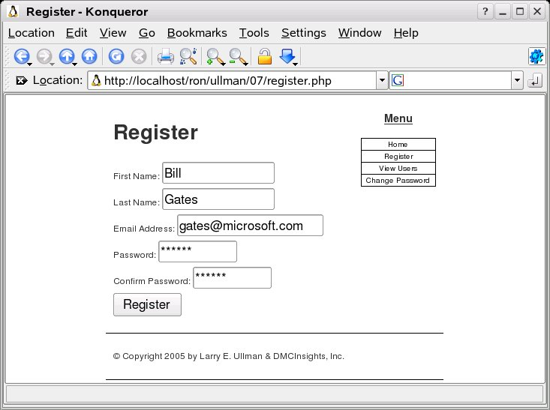

Clicking on the Register button gives:

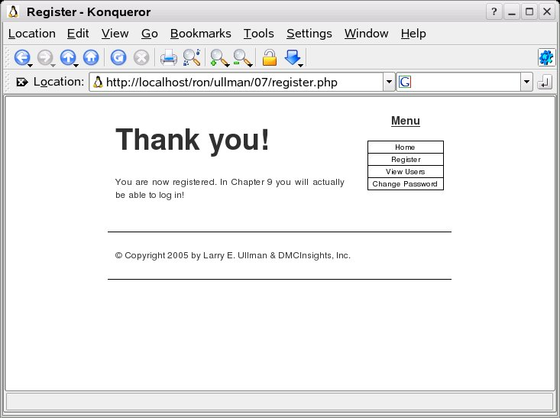

Retrieving Query Results

view_users.php

<?php # Script 7.4 - view_users.php
// This script retrieves all the records from the users table.

$page_title = 'View the Current Users';
include ('./includes/header.html');

// Page header.
echo '<h1 id="mainhead">Registered Users</h1>';

require_once ('../mysql_connect.php'); // Connect to the db.

// Make the query.
$query = "SELECT CONCAT(last_name, ', ', first_name) AS name, DATE_FORMAT(registration_date, '%M %d, %Y') AS dr FROM users ORDER BY registration_date ASC";
$result = @mysql_query ($query); // Run the query.

if ($result) { // If it ran OK, display the records.

// Table header.
echo '<table align="center" cellspacing="0" cellpadding="5">
<tr><td align="left"><b>Name</b></td><td align="left"><b>Date Registered</b></td></tr>
';

// Fetch and print all the records.
while ($row = mysql_fetch_array($result, MYSQL_ASSOC)) {
echo '<tr><td align="left">' . $row['name'] . '</td><td align="left">' . $row['dr'] . '</td></tr>
';
}

echo '</table>';

mysql_free_result ($result); // Free up the resources.

} else { // If it did not run OK.
echo '<p class="error">The current users could not be retrieved. We apologize for any inconvenience.</p>'; // Public message.
echo '<p>' . mysql_error() . '<br /><br />Query: ' . $query . '</p>'; // Debugging message.
}

mysql_close(); // Close the database connection.

include ('./includes/footer.html'); // Include the HTML footer.
?>

Pressing on the View Users button

http://localhost/ron/ullman/07/view_users.php

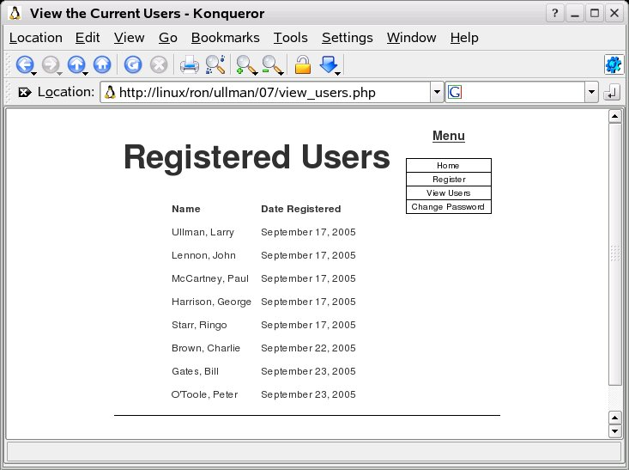

Ensuring Secure SQL

<?php # Script 7.5 - register.php (2nd version after Script 7.3)

$page_title = 'Register';
include ('./includes/header.html');

// Check if the form has been submitted.
if (isset($_POST['submitted'])) {

require_once ('../mysql_connect.php'); // Connect to the db.

// Create a function for escaping the data.
function escape_data ($data) {
global $dbc; // Need the connection.
if (ini_get('magic_quotes_gpc')) {
$data = stripslashes($data);
}
return mysql_real_escape_string(trim($data), $dbc);
} // End of function.

$errors = array(); // Initialize error array.

// Check for a first name.
if (empty($_POST['first_name'])) {
$errors[] = 'You forgot to enter your first name.';
} else {
$fn = escape_data($_POST['first_name']);
}

// Check for a last name.
if (empty($_POST['last_name'])) {
$errors[] = 'You forgot to enter your last name.';
} else {
$ln = escape_data($_POST['last_name']);
}

// Check for an email address.
if (empty($_POST['email'])) {
$errors[] = 'You forgot to enter your email address.';
} else {
$e = escape_data($_POST['email']);
}

// Check for a password and match against the confirmed password.
if (!empty($_POST['password1'])) {
if ($_POST['password1'] != $_POST['password2']) {
$errors[] = 'Your password did not match the confirmed password.';
} else {
$p = escape_data($_POST['password1']);
}
} else {
$errors[] = 'You forgot to enter your password.';
}

if (empty($errors)) { // If everything's okay.

// Register the user in the database.

// Make the query.
$query = "INSERT INTO users (first_name, last_name, email, password, registration_date) VALUES ('$fn', '$ln', '$e', SHA('$p'), NOW() )";
$result = @mysql_query ($query); // Run the query.
if ($result) { // If it ran OK.

// Send an email, if desired.

// Print a message.
echo '<h1 id="mainhead">Thank you!</h1>
<p>You are now registered. In Chapter 9 you will actually be able to log in!</p><p><br /></p>';

// Include the footer and quit the script (to not show the form).
include ('./includes/footer.html');
exit();

} else { // If it did not run OK.
echo '<h1 id="mainhead">System Error</h1>
<p class="error">You could not be registered due to a system error. We apologize for any inconvenience.</p>'; // Public message.
echo '<p>' . mysql_error() . '<br /><br />Query: ' . $query . '</p>'; // Debugging message.
include ('./includes/footer.html');
exit();
}

} else { // Report the errors.

echo '<h1 id="mainhead">Error!</h1>
<p class="error">The following error(s) occurred:<br />';
foreach ($errors as $msg) { // Print each error.
echo " - $msg<br />\n";
}
echo '</p><p>Please try again.</p><p><br /></p>';

} // End of if (empty($errors)) IF.

mysql_close(); // Close the database connection.

} // End of the main Submit conditional.
?>
<h2>Register</h2>
<form action="register.php" method="post">
<p>First Name: <input type="text" name="first_name" size="15" maxlength="15" value="<?php if (isset($_POST['first_name'])) echo $_POST['first_name']; ?>" /></p>
<p>Last Name: <input type="text" name="last_name" size="15" maxlength="30" value="<?php if (isset($_POST['last_name'])) echo $_POST['last_name']; ?>" /></p>
<p>Email Address: <input type="text" name="email" size="20" maxlength="40" value="<?php if (isset($_POST['email'])) echo $_POST['email']; ?>" /> </p>
<p>Password: <input type="password" name="password1" size="10" maxlength="20" /></p>
<p>Confirm Password: <input type="password" name="password2" size="10" maxlength="20" /></p>
<p><input type="submit" name="submit" value="Register" /></p>
<input type="hidden" name="submitted" value="TRUE" />
</form>
<?php
include ('./includes/footer.html');
?>

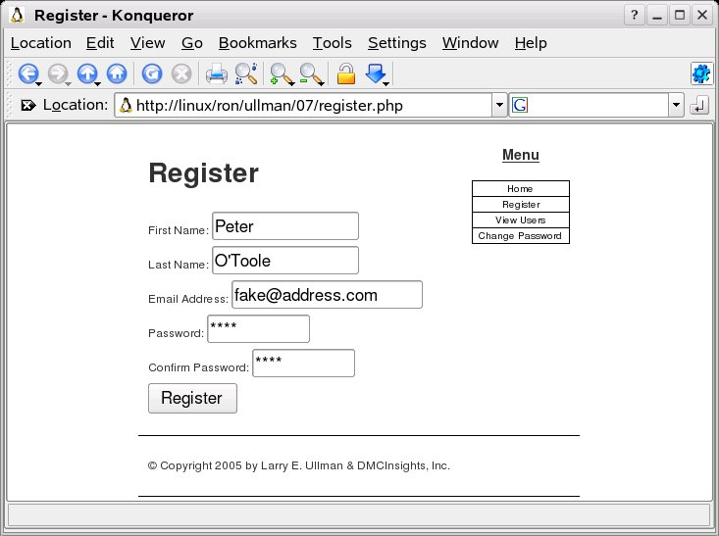

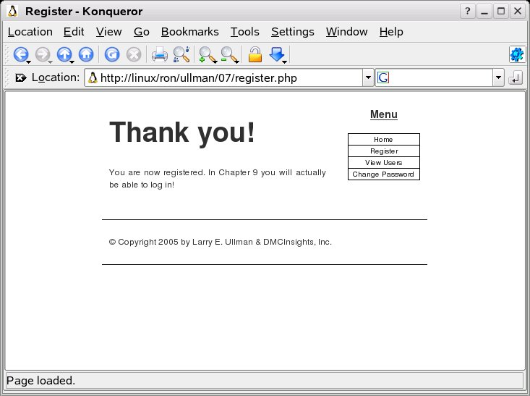

Counting Returned Records
<?php # Script 7.6 - view_users.php (2nd version after Script 7.4)
// This script retrieves all the records from the users table.

$page_title = 'View the Current Users';
include ('./includes/header.html');

// Page header.
echo '<h1 id="mainhead">Registered Users</h1>';

require_once ('../mysql_connect.php'); // Connect to the db.

// Make the query.
$query = "SELECT CONCAT(last_name, ', ', first_name) AS name, DATE_FORMAT(registration_date, '%M %d, %Y') AS dr FROM users ORDER BY registration_date ASC";
$result = @mysql_query ($query); // Run the query.
$num = mysql_num_rows($result);

if ($num > 0) { // If it ran OK, display the records.

echo "<p>There are currently $num registered users.</p>\n";

// Table header.
echo '<table align="center" cellspacing="0" cellpadding="5">
<tr><td align="left"><b>Name</b></td><td align="left"><b>Date Registered</b></td></tr>
';

// Fetch and print all the records.
while ($row = mysql_fetch_array($result, MYSQL_ASSOC)) {
echo '<tr><td align="left">' . $row['name'] . '</td><td align="left">' . $row['dr'] . '</td></tr>
';
}

echo '</table>';

mysql_free_result ($result); // Free up the resources.

} else { // If it did not run OK.
echo '<p class="error">There are currently no registered users.</p>';
}

mysql_close(); // Close the database connection.

include ('./includes/footer.html'); // Include the HTML footer.
?>
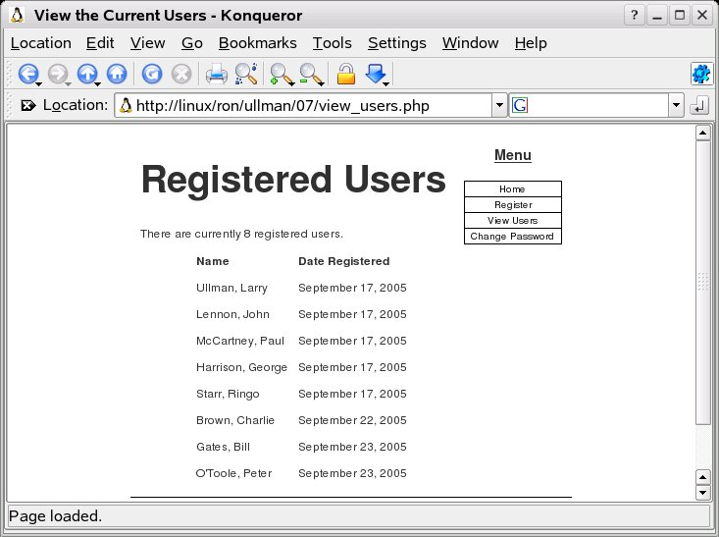

Registration Checks

<?php # Script 7.7 - register.php (3rd version after Scripts 7.3 & 7.5)

$page_title = 'Register';
include ('./includes/header.html');

// Check if the form has been submitted.
if (isset($_POST['submitted'])) {

require_once ('../mysql_connect.php'); // Connect to the db.

// Create a function for escaping the data.
function escape_data ($data) {
global $dbc; // Need the connection.
if (ini_get('magic_quotes_gpc')) {
$data = stripslashes($data);
}
return mysql_real_escape_string(trim($data), $dbc);
} // End of function.

$errors = array(); // Initialize error array.

// Check for a first name.
if (empty($_POST['first_name'])) {
$errors[] = 'You forgot to enter your first name.';
} else {
$fn = escape_data($_POST['first_name']);
}

// Check for a last name.
if (empty($_POST['last_name'])) {
$errors[] = 'You forgot to enter your last name.';
} else {
$ln = escape_data($_POST['last_name']);
}

// Check for an email address.
if (empty($_POST['email'])) {
$errors[] = 'You forgot to enter your email address.';
} else {
$e = escape_data($_POST['email']);
}

// Check for a password and match against the confirmed password.
if (!empty($_POST['password1'])) {
if ($_POST['password1'] != $_POST['password2']) {
$errors[] = 'Your password did not match the confirmed password.';
} else {
$p = escape_data($_POST['password1']);
}
} else {
$errors[] = 'You forgot to enter your password.';
}

if (empty($errors)) { // If everything's okay.

// Register the user in the database.

// Check for previous registration.
$query = "SELECT user_id FROM users WHERE email='$e'";
$result = mysql_query($query);
if (mysql_num_rows($result) == 0) {

// Make the query.
$query = "INSERT INTO users (first_name, last_name, email, password, registration_date) VALUES ('$fn', '$ln', '$e', SHA('$p'), NOW() )";
$result = @mysql_query ($query); // Run the query.
if ($result) { // If it ran OK.

// Send an email, if desired.

// Print a message.
echo '<h1 id="mainhead">Thank you!</h1>
<p>You are now registered. In Chapter 9 you will actually be able to log in!</p><p><br /></p>';

// Include the footer and quit the script (to not show the form).
include ('./includes/footer.html');
exit();

} else { // If it did not run OK.
echo '<h1 id="mainhead">System Error</h1>
<p class="error">You could not be registered due to a system error. We apologize for any inconvenience.</p>'; // Public message.
echo '<p>' . mysql_error() . '<br /><br />Query: ' . $query . '</p>'; // Debugging message.
include ('./includes/footer.html');
exit();
}

} else { // Already registered.
echo '<h1 id="mainhead">Error!</h1>
<p class="error">The email address has already been registered.</p>';
}

} else { // Report the errors.

echo '<h1 id="mainhead">Error!</h1>
<p class="error">The following error(s) occurred:<br />';
foreach ($errors as $msg) { // Print each error.
echo " - $msg<br />\n";
}
echo '</p><p>Please try again.</p><p><br /></p>';

} // End of if (empty($errors)) IF.

mysql_close(); // Close the database connection.

} // End of the main Submit conditional.
?>
<h2>Register</h2>
<form action="register.php" method="post">
<p>First Name: <input type="text" name="first_name" size="15" maxlength="15" value="<?php if (isset($_POST['first_name'])) echo $_POST['first_name']; ?>" /></p>
<p>Last Name: <input type="text" name="last_name" size="15" maxlength="30" value="<?php if (isset($_POST['last_name'])) echo $_POST['last_name']; ?>" /></p>
<p>Email Address: <input type="text" name="email" size="20" maxlength="40" value="<?php if (isset($_POST['email'])) echo $_POST['email']; ?>" /> </p>
<p>Password: <input type="password" name="password1" size="10" maxlength="20" /></p>
<p>Confirm Password: <input type="password" name="password2" size="10" maxlength="20" /></p>
<p><input type="submit" name="submit" value="Register" /></p>
<input type="hidden" name="submitted" value="TRUE" />
</form>
<?php
include ('./includes/footer.html');
?>
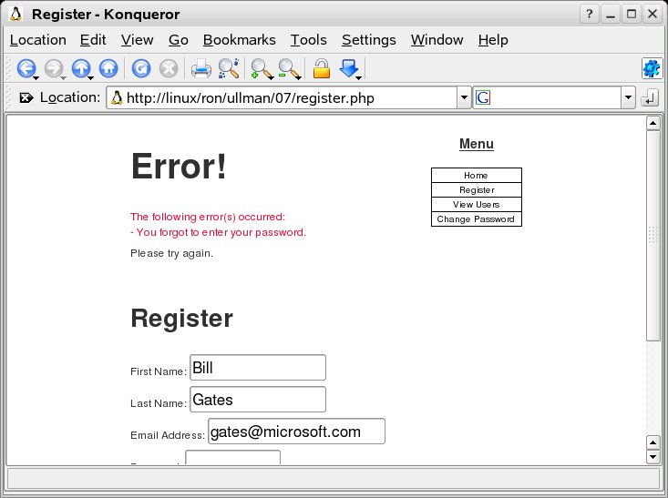

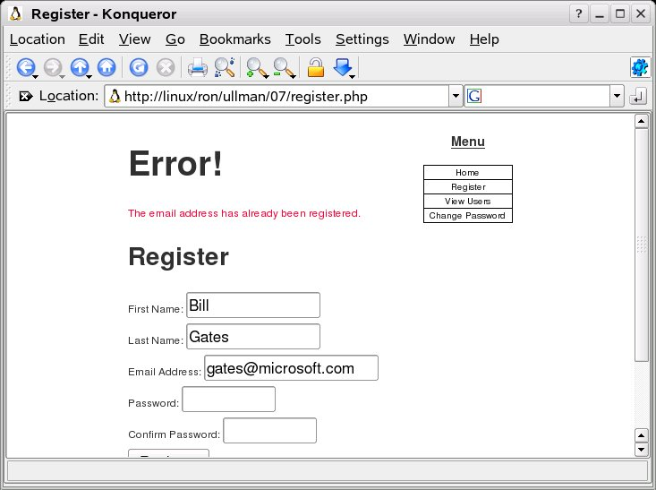

Updating Records with PHP

<?php # Script 7.8 - password.php
// This page lets a user change their password.

// Set the page title and include the HTML header.
$page_title = 'Change Your Password';
include ('./includes/header.html');

// Check if the form has been submitted.
if (isset($_POST['submitted'])) {

require_once ('../mysql_connect.php'); // Connect to the db.

// Create a function for escaping the data.
function escape_data ($data) {
global $dbc; // Need the connection.
if (ini_get('magic_quotes_gpc')) {
$data = stripslashes($data);
}
return mysql_real_escape_string(trim($data), $dbc);
} // End of function.

$errors = array(); // Initialize error array.

// Check for an email address.
if (empty($_POST['email'])) {
$errors[] = 'You forgot to enter your email address.';
} else {
$e = escape_data($_POST['email']);
}

// Check for an existing password.
if (empty($_POST['password'])) {
$errors[] = 'You forgot to enter your existing password.';
} else {
$p = escape_data($_POST['password']);
}

// Check for a password and match against the confirmed password.
if (!empty($_POST['password1'])) {
if ($_POST['password1'] != $_POST['password2']) {
$errors[] = 'Your new password did not match the confirmed new password.';
} else {
$np = escape_data($_POST['password1']);
}
} else {
$errors[] = 'You forgot to enter your new password.';
}

if (empty($errors)) { // If everything's OK.

// Check that they've entered the right email address/password combination.
$query = "SELECT user_id FROM users WHERE (email='$e' AND password=SHA('$p') )";
$result = mysql_query($query);
$num = mysql_num_rows($result);
if (mysql_num_rows($result) == 1) { // Match was made.

// Get the user_id.
$row = mysql_fetch_array($result, MYSQL_NUM);

// Make the UPDATE query.
$query = "UPDATE users SET password=SHA('$np') WHERE user_id=$row[0]";
$result = @mysql_query ($query);
if (mysql_affected_rows() == 1) { // If it ran OK.

// Send an email, if desired.

// Print a message.
echo '<h1 id="mainhead">Thank you!</h1>
<p>Your password has been updated. In Chapter 9 you will actually be able to log in!</p><p><br /></p>';

// Include the footer and quit the script (to not show the form).
include ('./includes/footer.html');
exit();

} else { // If it did not run OK.
echo '<h1 id="mainhead">System Error</h1>
<p class="error">Your password could not be changed due to a system error. We apologize for any inconvenience.</p>'; // Public message.
echo '<p>' . mysql_error() . '<br /><br />Query: ' . $query . '</p>'; // Debugging message.
include ('./includes/footer.html');
exit();
}

} else { // Invalid email address/password combination.
echo '<h1 id="mainhead">Error!</h1>
<p class="error">The email address and password do not match those on file.</p>';
}

} else { // Report the errors.

echo '<h1 id="mainhead">Error!</h1>
<p class="error">The following error(s) occurred:<br />';
foreach ($errors as $msg) { // Print each error.
echo " - $msg<br />\n";
}
echo '</p><p>Please try again.</p><p><br /></p>';

} // End of if (empty($errors)) IF.

mysql_close(); // Close the database connection.

} // End of the main Submit conditional.
?>
<h2>Change Your Password</h2>
<form action="password.php" method="post">
<p>Email Address: <input type="text" name="email" size="20" maxlength="40" value="<?php if (isset($_POST['email'])) echo $_POST['email']; ?>" /> </p>
<p>Current Password: <input type="password" name="password" size="10" maxlength="20" /></p>
<p>New Password: <input type="password" name="password1" size="10" maxlength="20" /></p>
<p>Confirm New Password: <input type="password" name="password2" size="10" maxlength="20" /></p>
<p><input type="submit" name="submit" value="Register" /></p>
<input type="hidden" name="submitted" value="TRUE" />
</form>
<?php
include ('./includes/footer.html');
?>
