Assignment –1
Name: Vishal Chawla
Couse : CSEG 220 Enterprise Software Development
Referring website : www.avis.com

- Screen Capture with Information filled ( No Errors )

a) First Half of form
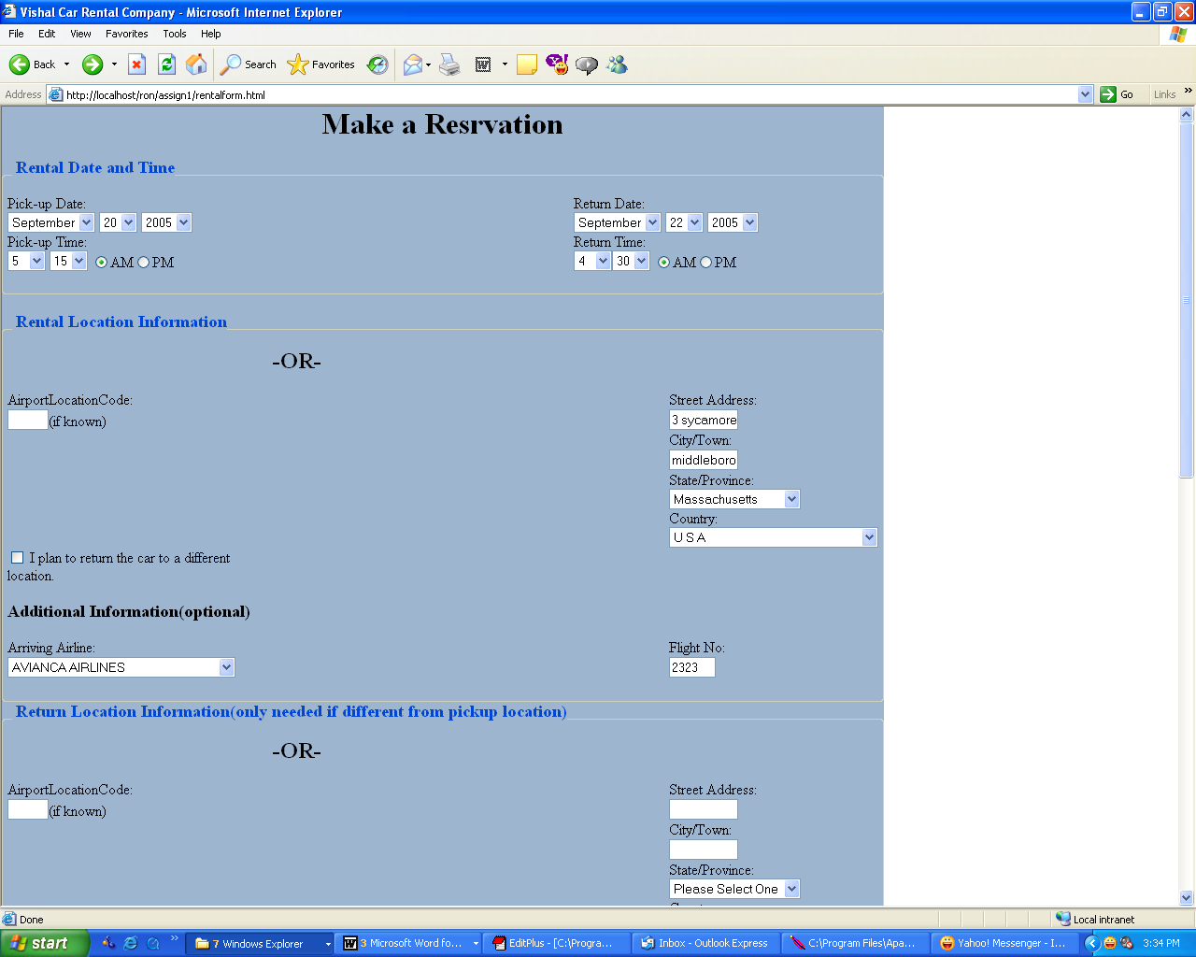

b) Second Half of Form
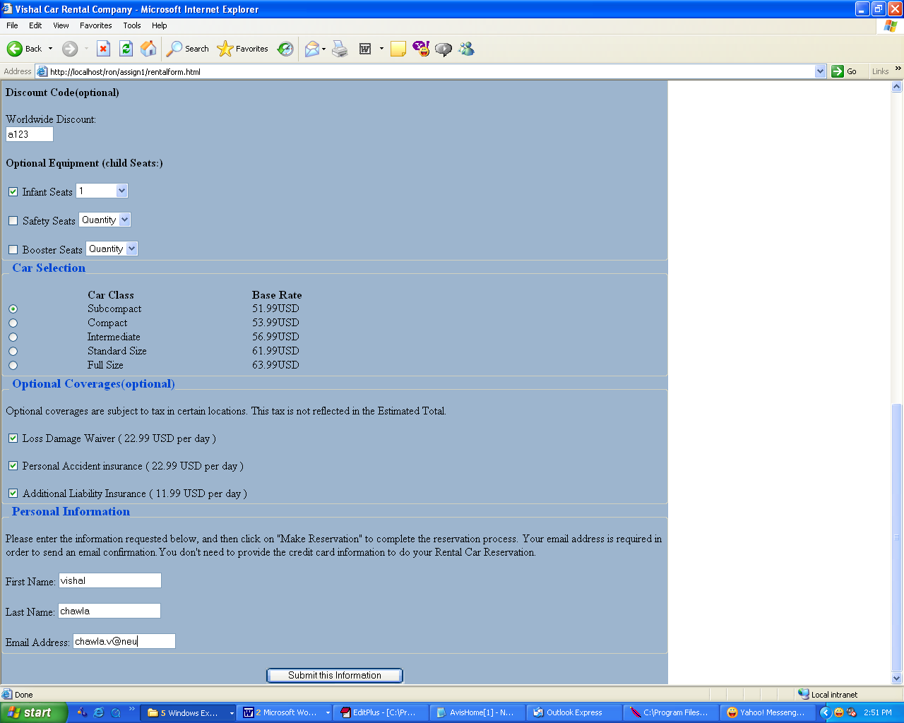

Output of Form ( No Errors)

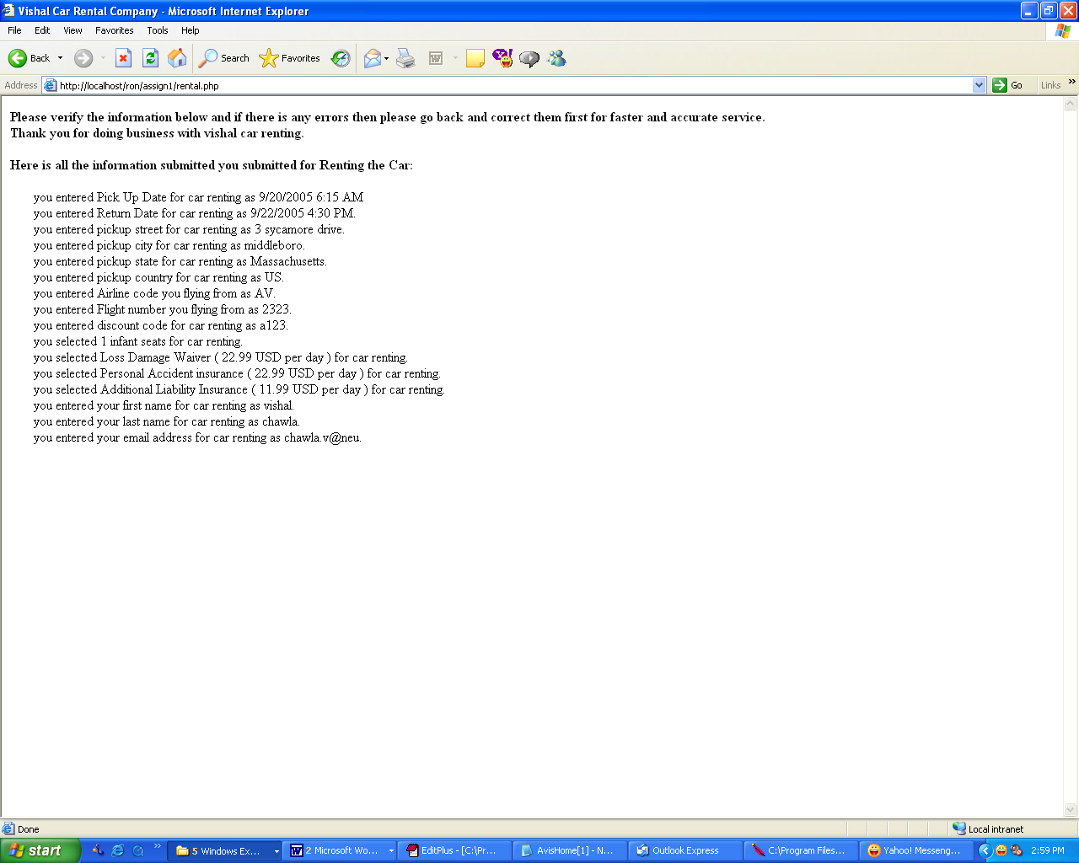

- Screen Capture with Information filled ( No Errors )

  - First Half of Form

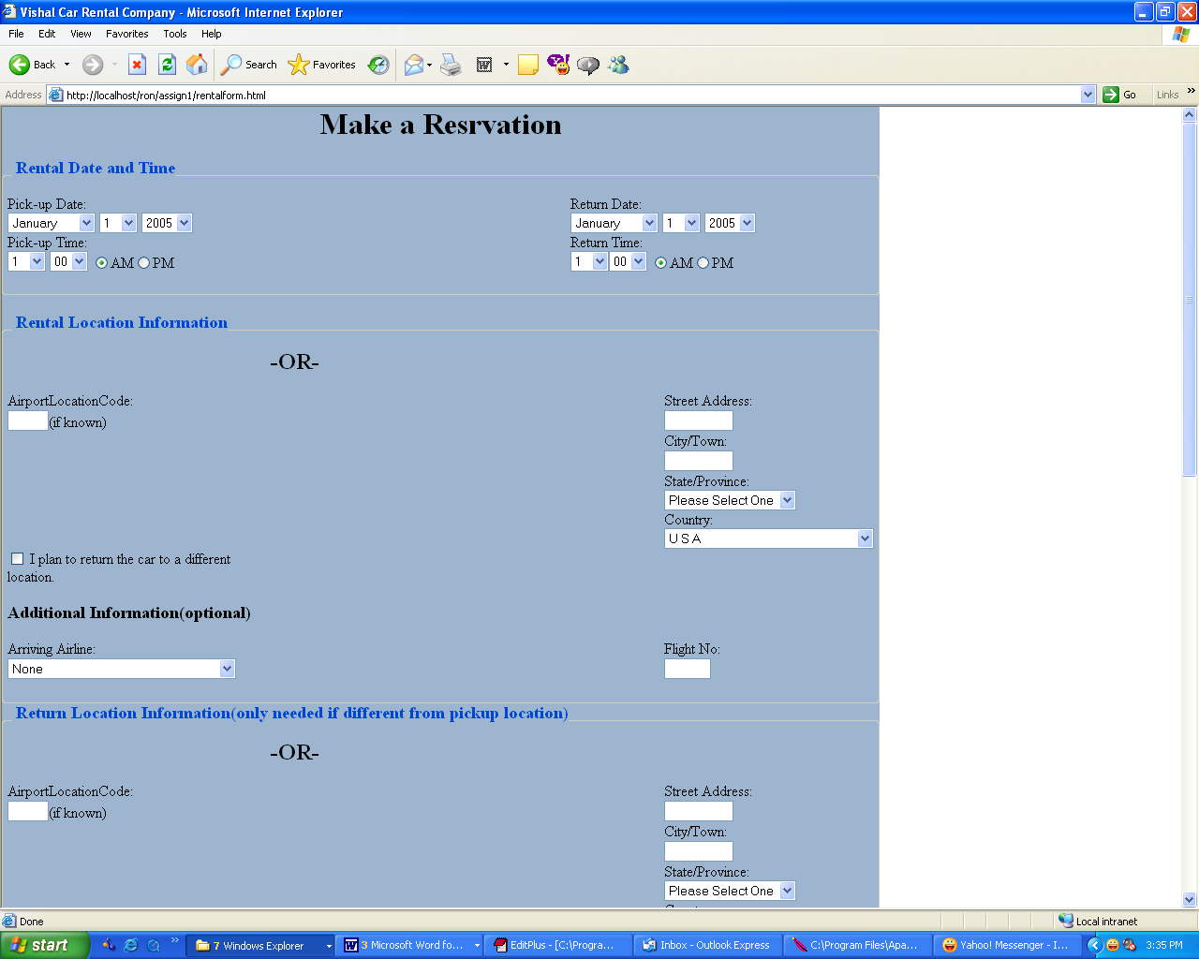

b) Second Half of the Form

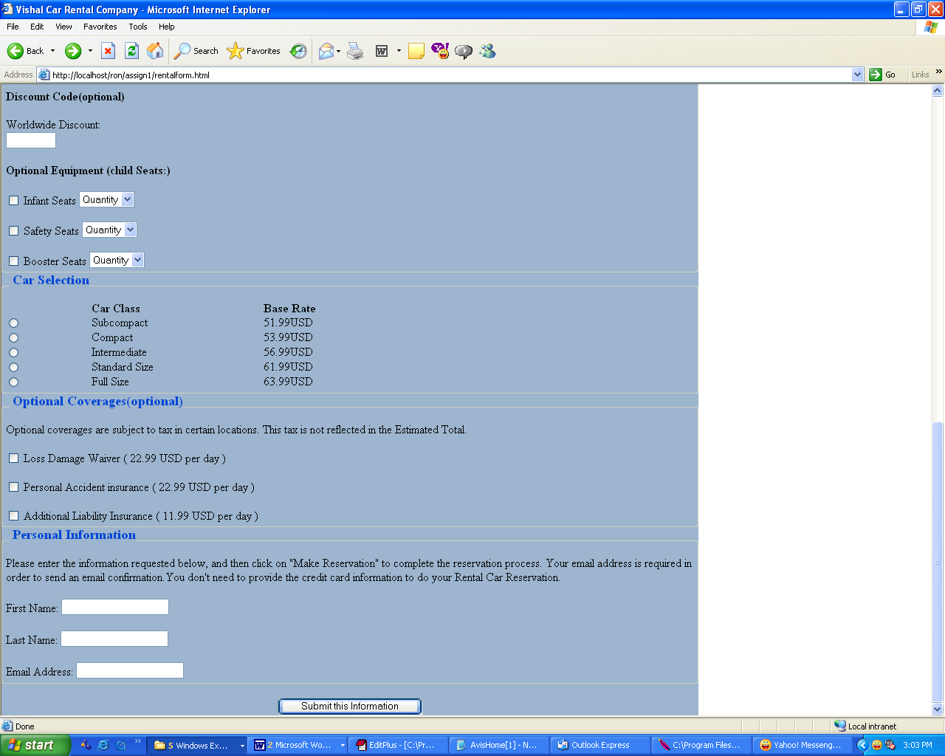

Output with Errors

