Lecture 2 – Programming with PHP

form.html

<!DOCTYPE html PUBLIC "-//W3C//DTD XHTML 1.0 Transitional//EN"
"http://www.w3.org/TR/xhtml1/DTD/xhtml1-transitional.dtd">
<html xmlns="http://www.w3.org/1999/xhtml" xml:lang="en" lang="en">
<head>
<meta http-equiv="content-type" content="text/html; charset=iso-8859-1" />
<title>Simple HTML Form</title>
</head>
<body>
<!-- Script 2.1 - form.html -->

<form action="handle_form.php" method="post">

<fieldset><legend>Enter your information in the form below:</legend>

<p><b>Name:</b> <input type="text" name="name" size="20" maxlength="40" /></p>

<p><b>Email Address:</b> <input type="text" name="email" size="40" maxlength="60" /></p>

<p><b>Gender:</b> <input type="radio" name="gender" value="M" /> Male <input type="radio" name="gender" value="F" /> Female</p>

<p><b>Age:</b>
<select name="age">
<option value="0-29">Under 30</option>
<option value="30-60">Between 30 and 60</option>
<option value="60+">Over 60</option>
</select></p>

<p><b>Comments:</b> <textarea name="comments" rows="3" cols="40"></textarea></p>

</fieldset>

<div align="center"><input type="submit" name="submit" value="Submit My Information" /></div>

</form>

</body>
</html>

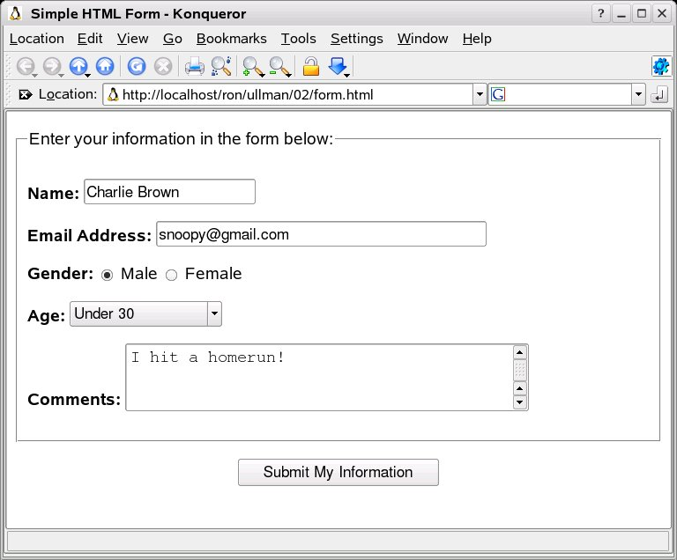

Hitting the “Submit My Information Button”

http://localhost/ulman/02/handle_form.php

Thank you, Charlie Brown, for the following comments: I hit a homerun!
We will reply to you at snoopy@gmail.com.

handle_form.php

<!DOCTYPE html PUBLIC "-//W3C//DTD XHTML 1.0 Transitional//EN"
"http://www.w3.org/TR/xhtml1/DTD/xhtml1-transitional.dtd">
<html xmlns="http://www.w3.org/1999/xhtml" xml:lang="en" lang="en">
<head>
<meta http-equiv="content-type" content="text/html; charset=iso-8859-1" />
<title>Form Feedback</title>
</head>
<body>
<?php # Script 2.2 - handle_form.php

// Create a shorthand for the form data.
$name = $_REQUEST['name'];
$email = $_REQUEST['email'];
$comments = $_REQUEST['comments'];
// Not used: $_REQUEST['age'], $_REQUEST['gender'], and $_REQUEST['submit'].

// Print the submitted information.
echo "<p>Thank you, <b>$name</b>, for the following comments:<br />
<tt>$comments</tt></p>
<p>We will reply to you at <i>$email</i>.</p>\n";

?>
</body>
</html>

Magic Quotes

stripslashes
(PHP 3, PHP 4, PHP 5)
stripslashes -- Un-quote string quoted with addslashes()

Description
string stripslashes ( string str )
Returns a string with backslashes stripped off. (\' becomes ' and so on.) Double backslashes (\\) are made into a single backslash (\).
Note: If magic_quotes_sybase is on, no backslashes are stripped off but two apostrophes are replaced by one instead.
An example use of stripslashes() is when the PHP directive magic_quotes_gpc is on (it's on by default), and you aren't inserting this data into a place (such as a database) that requires escaping. For example, if you're simply outputting data straight from an HTML form.
Example 1. A stripslashes() example
<?php
$str = "Is your name O\'reilly?";
// Outputs: Is your name O'reilly?
echo stripslashes($str);
?>
Note: stripslashes() is not recursive. If you want to apply this function to a mutli-dimensional array, you need to use a recursive function.
Changing handle_form.php

$name = stripslashes($_REQUEST['name']);
$email = $_REQUEST['email'];
$comments = stripslashes($_REQUEST['comments']);
http://localhost/ ulman/02/handle_form.php

Thank you, Charlie Brown, for the following comments: My dog's breath smells like garlic!
We will reply to you at snoopy@gmail.com.

isset
(PHP 3, PHP 4, PHP 5)
isset -- Determine whether a variable is set

Description
bool isset ( mixed var [, mixed var [, ...]] )
Returns TRUE if var exists; FALSE otherwise.
If a variable has been unset with unset(), it will no longer be set. isset() will return FALSE if testing a variable that has been set to NULL. Also note that a NULL byte ("\0") is not equivalent to the PHP NULL constant.
Warning: isset() only works with variables as passing anything else will result in a parse error. For checking if constants are set use the defined() function.

<?php
$var = '';
// This will evaluate to TRUE so the text will be printed.
if (isset($var)) {
echo "This var is set so I will print.";
}
// In the next examples we'll use var_dump to output
// the return value of isset().
$a = "test";
$b = "anothertest";
var_dump(isset($a)); // TRUE
var_dump(isset($a, $b)); // TRUE
unset ($a);
var_dump(isset($a)); // FALSE
var_dump(isset($a, $b)); // FALSE
$foo = NULL;
var_dump(isset($foo)); // FALSE
?>

Dealing with Gender

// Create the $gender variable.
if (isset($_REQUEST['gender'])) {
$gender = $_REQUEST['gender'];
} else {
$gender = NULL;
}

// Print the submitted information.
echo "<p>Thank you, <b>$name</b>, for the following comments:<br />
<tt>$comments</tt></p>
<p>We will reply to you at <i>$email</i>.</p>\n";

// Print a message based upon the gender value.
if ($gender == 'M') {
echo '<p><b>Good day, Sir!</b></p>';
} elseif ($gender == 'F') {
echo '<p><b>Good day, Madam!</b></p>';
} else { // No gender selected.
echo '<p><b>You forgot to enter your gender!</b></p>';
}

Thank you, Charlie Brown, for the following comments: I'm happy.
We will reply to you at snoopy@gmail.com.
Good day, Sir!

Validating Form Data

empty
(PHP 3, PHP 4, PHP 5)
empty -- Determine whether a variable is empty

Description
bool empty ( mixed var )
Determine whether a variable is considered to be empty.

Parameters
var
Variable to be checked
Note: empty() only checks variables as anything else will result in a parse error. In other words, the following will not work: empty(trim($name)).
empty() is the opposite of (boolean) var, except that no warning is generated when the variable is not set.

Return Values
Returns FALSE if var has a non-empty and non-zero value.
The following things are considered to be empty:
 | "" (an empty string)
 | 0 (0 as an integer)
 | "0" (0 as a string)
 | NULL
 | FALSE
 | array() (an empty array)
 | var $var; (a variable declared, but without a value in a class)

ChangeLog
 | Version | Description
 | PHP 5 | As of PHP 5, objects with no properties are no longer considered empty.
 | PHP 4 | As of PHP 4, The string value "0" is considered empty.

Examples
 | Example 1. A simple empty() / isset() comparison.
<?php
$var = 0;

// Evaluates to true because $var is empty
if (empty($var)) {
echo '$var is either 0, empty, or not set at all';
}

// Evaluates as true because $var is set
if (isset($var)) {
echo '$var is set even though it is empty';
}

?>

You forgot to enter your name!
You forgot to enter your email address!
You forgot to enter your comments!
You forgot to select your gender!
Please go back and fill out the form again.

<?php # Script 2.5 - handle_form.php (4th version after Scripts 2.2, 2.3, & 2.4)

// Validate the name and combat Magic Quotes, if necessary.
if (!empty($_REQUEST['name'])) {
$name = stripslashes($_REQUEST['name']);
} else {
$name = NULL;
echo '<p><font color="red">You forgot to enter your name!</font></p>';
}

// Validate the email and combat Magic Quotes, if necessary.
if (!empty($_REQUEST['email'])) {
$email = $_REQUEST['email'];
} else {
$email = NULL;
echo '<p><font color="red">You forgot to enter your email address!</font></p>';
}

// Validate the comments and combat Magic Quotes, if necessary.
if (!empty($_REQUEST['comments'])) {
$comments = stripslashes($_REQUEST['comments']);
} else {
$comments = NULL;
echo '<p><font color="red">You forgot to enter your comments!</font></p>';
}

// Validate gender.
if (isset($_REQUEST['gender'])) {

$gender = $_REQUEST['gender'];

if ($gender == 'M') {
$message = '<p><b>Good day, Sir!</b></p>';
} elseif ($gender == 'F') {
$message = '<p><b>Good day, Madam!</b></p>';
} else { // Unacceptable value.
$message = NULL;
echo '<p><font color="red">Gender should be either "M" or "F"!</font></p>';
}

} else { // $_REQUEST['gender'] is not set.
$gender = NULL;
echo '<p><font color="red">You forgot to select your gender!</font></p>';
}

// If everything is okay, print the message.
if ($name && $email && $gender && $comments) {

echo "<p>Thank you, <b>$name</b>, for the following comments:<br />
<tt>$comments</tt></p>
<p>We will reply to you at <i>$email</i>.</p>\n";
echo $message; // From the $gender conditional.

} else { // One form element was not filled out properly.
echo '<p><font color="red">Please go back and fill out the form again.</font></p>';
}

?>
</body>
</html>

http://us2.php.net/manual/en/language.types.array.php

Arrays
An array in PHP is actually an ordered map. A map is a type that maps values to keys. This type is optimized in several ways, so you can use it as a real array, or a list (vector), hashtable (which is an implementation of a map), dictionary, collection, stack, queue and probably more. Because you can have another PHP array as a value, you can also quite easily simulate trees.

Last updated: Wed, 07 Sep 2005

array
(PHP 3, PHP 4, PHP 5)
array -- Create an array

Description
array array ( [mixed ...] )
Returns an array of the parameters. The parameters can be given an index with the => operator. Read the section on the array type for more information on what an array is.
Note: array() is a language construct used to represent literal arrays, and not a regular function.
Syntax "index => values", separated by commas, define index and values. index may be of type string or numeric. When index is omitted, an integer index is automatically generated, starting at 0. If index is an integer, next generated index will be the biggest integer index + 1. Note that when two identical index are defined, the last overwrite the first.
Having a trailing comma after the last defined array entry, while unusual, is a valid syntax.

<!DOCTYPE html PUBLIC "-//W3C//DTD XHTML 1.0 Transitional//EN"
"http://www.w3.org/TR/xhtml1/DTD/xhtml1-transitional.dtd">
<html xmlns="http://www.w3.org/1999/xhtml" xml:lang="en" lang="en">
<head>
<meta http-equiv="content-type" content="text/html; charset=iso-8859-1" />
<title>Form Feedback</title>
</head>
<body>
<?php # Script 2.6 - handle_form.php (rewrite of Script 2.3)

// Create a shorthand for the form data.
// Use stripslashes() to combat Magic Quotes, if necessary.
$name = stripslashes($_POST['name']);
$comments = stripslashes($_POST['comments']);
// Not used: $_POST['age'], $_POST['gender'], and $_POST['submit'].

// Print the submitted information.
echo "<p>Thank you, <b>$name</b>, for the following comments:<br />
<tt>$comments</tt></p>
<p>We will reply to you at <i>{$_POST['email']}</i>.</p>\n";

?>
</body>
</html>

HTTP POST variables: $_POST
Note: Introduced in 4.1.0. In earlier versions, use $HTTP_POST_VARS.
An associative array of variables passed to the current script via the HTTP POST method.

calendar.php
<!DOCTYPE html PUBLIC "-//W3C//DTD XHTML 1.0 Transitional//EN"
"http://www.w3.org/TR/xhtml1/DTD/xhtml1-transitional.dtd">
<html xmlns="http://www.w3.org/1999/xhtml" xml:lang="en" lang="en">
<head>
<meta http-equiv="content-type" content="text/html; charset=iso-8859-1" />
<title>Calendar</title>
</head>
<body>
<form action="calendar.php" method="post">
<?php # Script 2.7 - calendar.php
// This script makes three pull-down menus for an HTML form: months, days, years.

// Make the months array.
$months = array (1 => 'January', 'February', 'March', 'April', 'May', 'June', 'July', 'August', 'September', 'October', 'November', 'December');

// Make the days and years arrays.
$days = range (1, 31);
$years = range (2005, 2016);

// Make the months pull-down menu.
echo '<select name="month">';
foreach ($months as $key => $value) {
echo "<option value=\"$key\">$value</option>\n";
}
echo '</select>';

// Make the days pull-down menu.
echo '<select name="day">';
foreach ($days as $value) {
echo "<option value=\"$value\">$value</option>\n";
}
echo '</select>';

// Make the years pull-down menu.
echo '<select name="year">';
foreach ($years as $value) {
echo "<option value=\"$value\">$value</option>\n";
}
echo '</select>';

?>
</form>
</body>
</html>

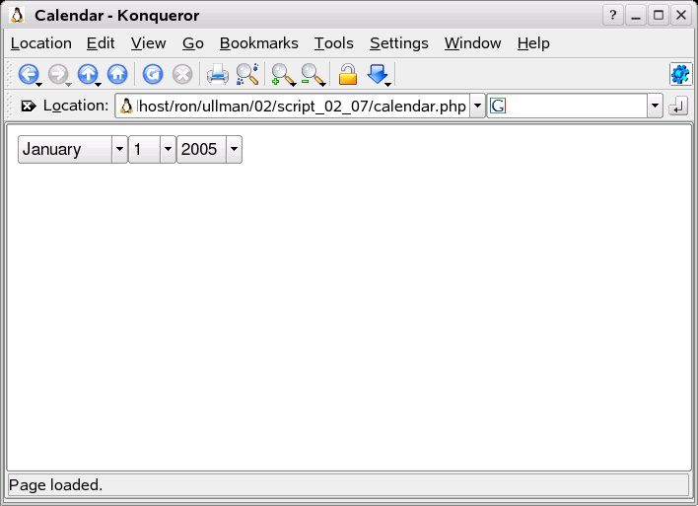

about.html

<!DOCTYPE html PUBLIC "-//W3C//DTD XHTML 1.0 Transitional//EN"
"http://www.w3.org/TR/xhtml1/DTD/xhtml1-transitional.dtd">
<html xmlns="http://www.w3.org/1999/xhtml" xml:lang="en" lang="en">
<head>
<meta http-equiv="content-type" content="text/html; charset=iso-8859-1" />
<title>Tell Us About Yourself</title>
</head>
<body>

<!-- Script 2.8 - about.html -->

<form action="handle_about.php" method="post">

<fieldset><legend>Enter your information in the form below:</legend>

<p><b>Name:</b> <input type="text" name="name" size="20" maxlength="40" /></p>

<p><b>Interests:</b>
<input type="checkbox" name="interests[]" value="Music" /> Music
<input type="checkbox" name="interests[]" value="Movies" /> Movies
<input type="checkbox" name="interests[]" value="Books" /> Books
<input type="checkbox" name="interests[]" value="Skiing" /> Skiing
<input type="checkbox" name="interests[]" value="Napping" /> Napping
</p>

</fieldset>

<div align="center"><input type="submit" name="submit" value="Submit My Information" /></div>

</form>
</body>
</html>

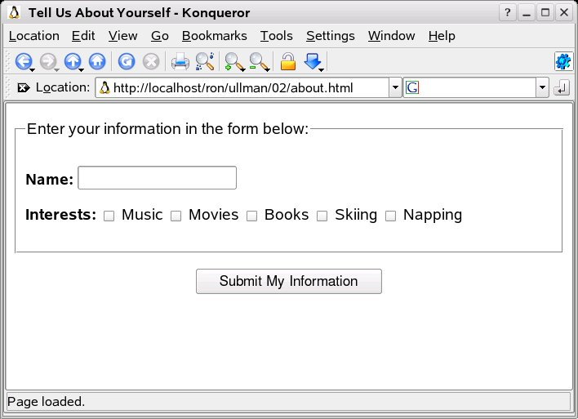

Script 2.9 - handle_about.php

<!DOCTYPE html PUBLIC "-//W3C//DTD XHTML 1.0 Transitional//EN"
"http://www.w3.org/TR/xhtml1/DTD/xhtml1-transitional.dtd">
<html xmlns="http://www.w3.org/1999/xhtml" xml:lang="en" lang="en">
<head>
<meta http-equiv="content-type" content="text/html; charset=iso-8859-1" />
<title>About You Form Feedback</title>
</head>
<body>
<?php # Script 2.9 - handle_about.php

// Check $_POST['name'] and strip any slashes.
if (!empty($_POST['name'])) {
$name = stripslashes($_POST['name']);
} else {
$name = NULL;
echo '<p><font color="red">You forgot to enter your name!</font></p>';
}

// Check the interests.
if (isset($_POST['interests'])) {
$interests = TRUE;
} else {
$interests = NULL;
echo '<p><font color="red">You forgot to enter your interests!</font></p>';
}

// If everything was filled out, print the message.
if ($name && $interests) {

echo "Thank you, <b>$name</b>. You entered your interests as:<ul>";

// Print each interest.
foreach ($_POST['interests'] as $value) { // Loop through each.
echo "<li>$value</li>\n";
}

echo '</ul>'; // Close the list.

} else { // One form element was not filled out properly.
echo '<p><font color="red">Please go back and fill out the form again.</font></p>';
}
?>
</body>
</html>

http://localhost/ulman/02/handle_about.php

Thank you, Charlie Brown. You entered your interests as:
- Music
- Books

Arrays and strings

explode
(PHP 3, PHP 4, PHP 5)
explode -- Split a string by string

Description
array explode ( string separator, string string [, int limit] )
Returns an array of strings, each of which is a substring of string formed by splitting it on boundaries formed by the string separator. If limit is set, the returned array will contain a maximum of limit elements with the last element containing the rest of string.
If separator is an empty string (""), explode() will return FALSE. If separator contains a value that is not contained in string, then explode() will return an array containing string.
If the limit parameter is negative, all components except the last limit are returned. This feature was added in PHP 5.1.0.
Although implode() can, for historical reasons, accept its parameters in either order, explode() cannot. You must ensure that the separator argument comes before the string argument.

implode
(PHP 3, PHP 4, PHP 5)
implode -- Join array elements with a string

Description
string implode ( string glue, array pieces )
Returns a string containing a string representation of all the array elements in the same order, with the glue string between each element.
Script 2.10 - handle_about.php

<!DOCTYPE html PUBLIC "-//W3C//DTD XHTML 1.0 Transitional//EN"
"http://www.w3.org/TR/xhtml1/DTD/xhtml1-transitional.dtd">
<html xmlns="http://www.w3.org/1999/xhtml" xml:lang="en" lang="en">
<head>
<meta http-equiv="content-type" content="text/html; charset=iso-8859-1" />
<title>About You Form Feedback</title>
</head>
<body>
<?php # Script 2.10 - handle_about.php (2nd version after Script 2.9)

// Check $_POST['name'] and strip any slashes.
if (!empty($_POST['name'])) {
$name = stripslashes($_POST['name']);
} else {
$name = NULL;
echo '<p><font color="red">You forgot to enter your name!</font></p>';
}

// Check the interests.
if (isset($_POST['interests'])) {
$interests = implode (', ', $_POST['interests']);
} else {
$interests = NULL;
echo '<p><font color="red">You forgot to enter your interests!</font></p>';
}

// If everything was filled out, print the message.
if ($name && $interests) {

echo "Thank you, <b>$name</b>. You entered your interests as:<br />$interests";

} else { // One form element was not filled out properly.
echo '<p><font color="red">Please go back and fill out the form again.</font></p>';
}
?>
</body>
</html>

http://localhost/ulman/02/handle_about.php

Thank you, Charlie Brown. You entered your interests as:Music, Books

Sorting Arrays

Last updated: Sat, 09 Aug 2003

sort
(PHP 3, PHP 4, PHP 5)
sort -- Sort an array

Description
bool sort ( array &array [, int sort_flags] )
This function sorts an array. Elements will be arranged from lowest to highest when this function has completed.
Note: This function assigns new keys for the elements in array. It will remove any existing keys you may have assigned, rather than just reordering the keys.
Returns TRUE on success or FALSE on failure.
Example 1. sort() example
<?php
$fruits = array("lemon", "orange", "banana", "apple"); sort($fruits);
foreach ($fruits as $key => $val) {
echo "fruits[" . $key . "] = " . $val . "\n";
}
?>
The above example will output:
fruits[0] = apple
fruits[1] = banana
fruits[2] = lemon
fruits[3] = orange
The fruits have been sorted in alphabetical order.
The optional second parameter sort_flags may be used to modify the sorting behavior using these values:
Sorting type flags:
- SORT_REGULAR - compare items normally (don't change types)
- SORT_NUMERIC - compare items numerically
- SORT_STRING - compare items as strings
- SORT_LOCALE_STRING - compare items as strings, based on the current locale. Added in PHP 4.4.0 an

asort
(PHP 3, PHP 4, PHP 5)
asort -- Sort an array and maintain index association

Description
bool asort ( array &array [, int sort_flags] )
This function sorts an array such that array indices maintain their correlation with the array elements they are associated with. This is used mainly when sorting associative arrays where the actual element order is significant.
Returns TRUE on success or FALSE on failure.
Example 1. asort() example
<?php
$fruits = array("d" => "lemon", "a" => "orange", "b" => "banana", "c" => "apple");
asort($fruits);
foreach ($fruits as $key => $val) { echo "$key = $val\n"; }
?>
The above example will output:
c = apple
b = banana
d = lemon
a = orange
The fruits have been sorted in alphabetical order, and the index associated with each element has been ma

ksort
(PHP 3, PHP 4, PHP 5)
ksort -- Sort an array by key

Description
bool ksort ( array &array [, int sort_flags] )
Sorts an array by key, maintaining key to data correlations. This is useful mainly for associative arrays.
Returns TRUE on success or FALSE on failure.
Example 1. ksort() example
<?php
$fruits = array("d"=>"lemon", "a"=>"orange", "b"=>"banana", "c"=>"apple");
ksort($fruits);
foreach ($fruits as $key => $val) { echo "$key = $val\n"; }
?>
The above example will output:
a = orange
b = banana
c = apple
d = lemon
You may modify the behavior of the sort using the optional parameter sort_flags, for details see sort().

Script 2.11 – sorting.php

<!DOCTYPE html PUBLIC "-//W3C//DTD XHTML 1.0 Transitional//EN"
"http://www.w3.org/TR/xhtml1/DTD/xhtml1-transitional.dtd">
<html xmlns="http://www.w3.org/1999/xhtml" xml:lang="en" lang="en">
<head>
<meta http-equiv="content-type" content="text/html; charset=iso-8859-1" />
<title>Sorting Arrays</title>
</head>
<body>
<?php # Script 2.11 - sorting.php

// Create the array.
$movies = array (
10 => 'Casablanca',
9 => 'To Kill a Mockingbird',
2 => 'The English Patient',
8 => 'Sideways',
7 => 'Donnie Darko'
);

// Display the movies in their original order.
echo '<p>In their original order:<br /><pre>Rating Title
';
foreach ($movies as $key => $value) {
echo "$key\t$value\n";
}
echo '</pre></p>';

// Display the movies sorted by title.
echo '<p>Sorted by title:<br /><pre>Rating Title
';
asort($movies);
foreach ($movies as $key => $value) {
echo "$key\t$value\n";
}
echo '</pre></p>';

// Display the movies sorted by rating.
echo '<p>Sorted by rating:<br /><pre>Rating Title
';
krsort($movies);
foreach ($movies as $key => $value) {
echo "$key\t$value\n";
}
echo '</pre></p>';
?>
</body>
</html>

http://localhost/ulman/02/sorting.php

In their original order:
Rating Title
10 Casablanca
9 To Kill a Mockingbird
2 The English Patient
8 Sideways
7 Donnie Darko
Sorted by title:
Rating Title
10 Casablanca
7 Donnie Darko
8 Sideways
2 The English Patient
9 To Kill a Mockingbird
Sorted by rating:
Rating Title
10 Casablanca
9 To Kill a Mockingbird
8 Sideways
7 Donnie Darko
2 The English Patient

For and While Loops
Script 2.12 - calendar.php

<!DOCTYPE html PUBLIC "-//W3C//DTD XHTML 1.0 Transitional//EN"
"http://www.w3.org/TR/xhtml1/DTD/xhtml1-transitional.dtd">
<html xmlns="http://www.w3.org/1999/xhtml" xml:lang="en" lang="en">
<head>
<meta http-equiv="content-type" content="text/html; charset=iso-8859-1" />
<title>Calendar</title>
</head>
<body>
<form action="calendar.php" method="post">
<?php # Script 2.12 - calendar.php (2nd version after Script 2.7)
// This script makes three pull-down menus for an HTML form: months, days, years.

// Make the months array.
$months = array (1 => 'January', 'February', 'March', 'April', 'May', 'June', 'July', 'August', 'September', 'October', 'November', 'December');

// Make the months pull-down menu.
echo '<select name="month">';
foreach ($months as $key => $value) {
echo "<option value=\"$key\">$value</option>\n";
}
echo '</select>';

// Make the days pull-down menu.
echo '<select name="day">';
for ($day = 1; $day <= 31; $day++) {
echo "<option value=\"$day\">$day</option>\n";
}
echo '</select>';

// Make the years pull-down menu.
echo '<select name="year">';
$year = 2005;
while ($year <= 2015) {
echo "<option value=\"$year\">$year</option>\n";
$year++;
}
echo '</select>';

?>
</form>
</body>
</html>

