Lecture 8 – Web Application Development
October 3, 2005

http://us3.php.net/function_exists

bool function_exists ( string function_name )
Checks the list of defined functions, both built-in (internal) and user-defined, for function_name. Returns TRUE on success or FALSE on failure.
<?php
if (function_exists('imap_open'))
{ echo "IMAP functions are available.<br />\n"; }
else
{ echo "IMAP functions are not available.<br />\n"; }
?>

string mysql_real_escape_string ( string unescaped_string [, resource link_identifier] )
Escapes special characters in the unescaped_string, taking into account the current character set of the connection so that it is safe to place it in a mysql_query(). If binary data is to be inserted, this function must be used.
mysql_real_escape_string() calls MySQL's library function mysql_real_escape_string, which prepends backslashes to the following characters: \x00, \n, \r, \, ', " and \x1a.
This function must always (with few exceptions) be used to make data safe before sending a query to MySQL.

string mysql_escape_string ( string unescaped_string )
This function will escape the unescaped_string, so that it is safe to place it in a mysql_query(). This function is deprecated.
This function is identical to mysql_real_escape_string() except that mysql_real_escape_string() takes a connection handler and escapes the string according to the current character set. mysql_escape_string() does not take a connection argument and does not respect the current charset setting.
Version Description
    - This function became deprecated, do not use this function. Instead, use mysql_real_escape_string().

Now mysql_connect.php contains our function: escape_data()

<?php # Script 8.1 - mysql_connect.php

// This file contains the database access information.
// This file also establishes a connection to MySQL and selects the database.
// This file also defines the escape_data() function.

// Set the database access information as constants.
DEFINE ('DB_USER', 'username');
DEFINE ('DB_PASSWORD', 'password');
DEFINE ('DB_HOST', 'localhost');
DEFINE ('DB_NAME', 'sitename');

// Make the connection.
$dbc = @mysql_connect (DB_HOST, DB_USER, DB_PASSWORD) OR die ('Could not connect to MySQL: ' . mysql_error() );

// Select the database.
@mysql_select_db (DB_NAME) OR die ('Could not select the database: ' . mysql_error() );

// Create a function for escaping the data.
function escape_data ($data) {

// Address Magic Quotes.
if (ini_get('magic_quotes_gpc')) {
$data = stripslashes($data);
}

// Check for mysql_real_escape_string() support.
if (function_exists('mysql_real_escape_string')) {
global $dbc; // Need the connection.
$data = mysql_real_escape_string (trim($data), $dbc);
} else {
$data = mysql_escape_string (trim($data));
}

// Return the escaped value.
return $data;

} // End of function.
?>

Generating a link from a query in terms of a GET

view_users.php

<?php # Script 8.2 - view_users.php
# (3rd version after Scripts 7.4 & 7.6)

// This script retrieves all the records from the users table.
// This new version links to edit and delete pages.

$page_title = 'View the Current Users';
include ('./includes/header.html');

// Page header.
echo '<h1 id="mainhead">Registered Users</h1>';

require_once ('../mysql_connect.php'); // Connect to the db.

// Make the query.
$query = "SELECT last_name, first_name, DATE_FORMAT(registration_date, '%M %d, %Y') AS dr, user_id FROM users ORDER BY registration_date ASC";
$result = mysql_query ($query); // Run the query.
$num = mysql_num_rows($result);

if ($num > 0) { // If it ran OK, display the records.

echo "<p>There are currently $num registered users.</p>\n";

// Table header.
echo '<table align="center" cellspacing="0" cellpadding="5">
<tr>
<td align="left"><b>Edit</b></td>
<td align="left"><b>Delete</b></td>
<td align="left"><b>Last Name</b></td>
<td align="left"><b>First Name</b></td>
<td align="left"><b>Date Registered</b></td>
</tr>
';

// Fetch and print all the records.
while ($row = mysql_fetch_array($result, MYSQL_ASSOC)) {
echo '<tr>
<td align="left"><a href="edit_user.php?id=' . $row['user_id'] . '">Edit</a></td>
<td align="left"><a href="delete_user.php?id=' . $row['user_id'] . '">Delete</a></td>
<td align="left">' . $row['last_name'] . '</td>
<td align="left">' . $row['first_name'] . '</td>
<td align="left">' . $row['dr'] . '</td>
</tr>
';
}

echo '</table>';

mysql_free_result ($result); // Free up the resources.

} else { // If it did not run OK.
echo '<p class="error">There are currently no registered users.</p>';
}

mysql_close(); // Close the database connection.

include ('./includes/footer.html'); // Include the HTML footer.
?>
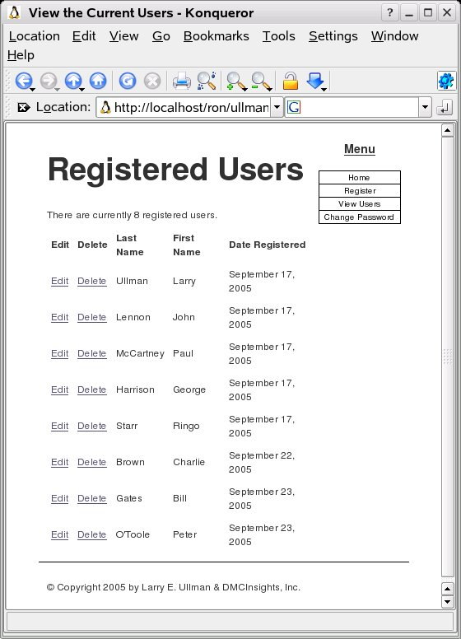

Looking at “View – Document Source” gives

<tr>
<td align="left"><a href="edit_user.php?id=2">Edit</a></td>
<td align="left"><a href="delete_user.php?id=2">Delete</a></td>
<td align="left">Lennon</td>
<td align="left">John</td>
<td align="left">September 17, 2005</td>
</tr>
<tr>
<td align="left"><a href="edit_user.php?id=3">Edit</a></td>
<td align="left"><a href="delete_user.php?id=3">Delete</a></td>
<td align="left">McCartney</td>
<td align="left">Paul</td>
<td align="left">September 17, 2005</td>
</tr>
Now we will pass the user ID and delete that user's record.
First, here is delete_user.php

<?php # Script 8.3 - delete_user.php
// This page deletes a user.
// This page is accessed through view_users.php.

$page_title = 'Delete a User';
include ('./includes/header.html');

// Check for a valid user ID, through GET or POST.
if ( (isset($_GET['id'])) && (is_numeric($_GET['id'])) ) { // Accessed through view_users.php
$id = $_GET['id'];
} elseif ( (isset($_POST['id'])) && (is_numeric($_POST['id'])) ) { // Form has been submitted.
$id = $_POST['id'];
} else { // No valid ID, kill the script.
echo '<h1 id="mainhead">Page Error</h1>
<p class="error">This page has been accessed in error.</p><p><br /><br /></p>';
include ('./includes/footer.html');
exit();
}

require_once ('../mysql_connect.php'); // Connect to the db.

// Check if the form has been submitted.
if (isset($_POST['submitted'])) {

if ($_POST['sure'] == 'Yes') { // Delete them.

// Make the query.
$query = "DELETE FROM users WHERE user_id=$id";
$result = @mysql_query ($query); // Run the query.
if (mysql_affected_rows() == 1) { // If it ran OK.

// Print a message.
echo '<h1 id="mainhead">Delete a User</h1>
<p>The user has been deleted.</p><p><br /><br /></p>';

} else { // If the query did not run OK.
echo '<h1 id="mainhead">System Error</h1>
<p class="error">The user could not be deleted due to a system error.</p>'; // Public message.
echo '<p>' . mysql_error() . '<br /><br />Query: ' . $query . '</p>'; // Debugging message.
}

} else { // Wasn't sure about deleting the user.
echo '<h1 id="mainhead">Delete a User</h1>
<p>The user has NOT been deleted.</p><p><br /><br /></p>';
}

} else { // Show the form.

// Retrieve the user's information.
$query = "SELECT CONCAT(last_name, ', ', first_name) FROM users WHERE user_id=$id";
$result = @mysql_query ($query); // Run the query.

if (mysql_num_rows($result) == 1) { // Valid user ID, show the form.

// Get the user's information.
$row = mysql_fetch_array ($result, MYSQL_NUM);

// Create the form.
echo '<h2>Delete a User</h2>
<form action="delete_user.php" method="post">
<h3>Name: ' . $row[0] . '</h3>
<p>Are you sure you want to delete this user?<br />
<input type="radio" name="sure" value="Yes" /> Yes
<input type="radio" name="sure" value="No" checked="checked" /> No</p>
<p><input type="submit" name="submit" value="Submit" /></p>
<input type="hidden" name="submitted" value="TRUE" />
<input type="hidden" name="id" value="' . $id . '" />
</form>';

} else { // Not a valid user ID.
echo '<h1 id="mainhead">Page Error</h1>
<p class="error">This page has been accessed in error.</p><p><br /><br /></p>';
}

} // End of the main Submit conditional.

mysql_close(); // Close the database connection.

include ('./includes/footer.html');
?>

Clicking on “Delete” for Bill Gates gives:

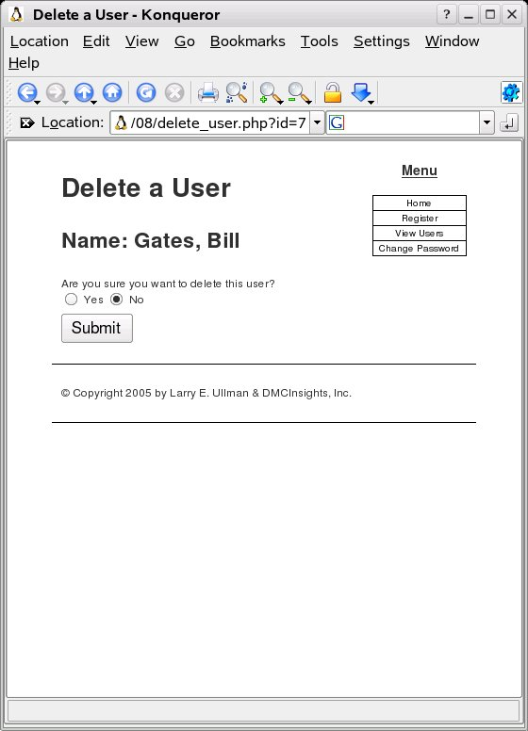

Checking Yes and clicking on Submit gives:

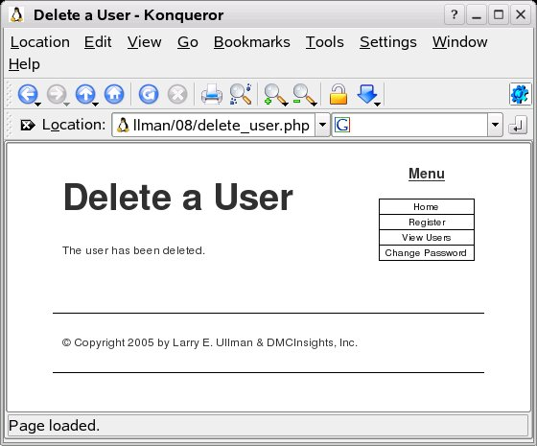

edit_user.php

<?php # Script 8.4 - edit_user.php

// This page edits a user.
// This page is accessed through view_users.php.

$page_title = 'Edit a User';
include ('./includes/header.html');

// Check for a valid user ID, through GET or POST.
if ( (isset($_GET['id'])) && (is_numeric($_GET['id'])) ) { // Accessed through view_users.php
$id = $_GET['id'];
} elseif ( (isset($_POST['id'])) && (is_numeric($_POST['id'])) ) { // Form has been submitted.
$id = $_POST['id'];
} else { // No valid ID, kill the script.
echo '<h1 id="mainhead">Page Error</h1>
<p class="error">This page has been accessed in error.</p><p><br /><br /></p>';
include ('./includes/footer.html');
exit();
}

require_once ('../mysql_connect.php'); // Connect to the db.

// Check if the form has been submitted.
if (isset($_POST['submitted'])) {

$errors = array(); // Initialize error array.

// Check for a first name.
if (empty($_POST['first_name'])) {
$errors[] = 'You forgot to enter your first name.';
} else {
$fn = escape_data($_POST['first_name']);
}

// Check for a last name.
if (empty($_POST['last_name'])) {
$errors[] = 'You forgot to enter your last name.';
} else {
$ln = escape_data($_POST['last_name']);
}

// Check for an email address.
if (empty($_POST['email'])) {
$errors[] = 'You forgot to enter your email address.';
} else {
$e = escape_data($_POST['email']);
}

if (empty($errors)) { // If everything's OK.

// Test for unique email address.
$query = "SELECT user_id FROM users WHERE email='$e' AND user_id != $id";
$result = mysql_query($query);
if (mysql_num_rows($result) == 0) {

// Make the query.
$query = "UPDATE users SET first_name='$fn', last_name='$ln', email='$e' WHERE user_id=$id";
$result = @mysql_query ($query); // Run the query.
if (mysql_affected_rows() == 1) { // If it ran OK.

// Print a message.
echo '<h1 id="mainhead">Edit a User</h1>
<p>The user has been edited.</p><p><br /><br /></p>';

} else { // If it did not run OK.
echo '<h1 id="mainhead">System Error</h1>
<p class="error">The user could not be edited due to a system error. We apologize for any inconvenience.</p>'; // Public message.
echo '<p>' . mysql_error() . '<br /><br />Query: ' . $query . '</p>'; // Debugging message.
include ('./includes/footer.html');
exit();
}

} else { // Already registered.
echo '<h1 id="mainhead">Error!</h1>
<p class="error">The email address has already been registered.</p>';
}

} else { // Report the errors.

echo '<h1 id="mainhead">Error!</h1>
<p class="error">The following error(s) occurred:<br />';
foreach ($errors as $msg) { // Print each error.
echo " - $msg<br />\n";
}
echo '</p><p>Please try again.</p><p><br /></p>';

} // End of if (empty($errors)) IF.

} // End of submit conditional.

// Always show the form.

// Retrieve the user's information.
$query = "SELECT first_name, last_name, email FROM users WHERE user_id=$id";
$result = @mysql_query ($query); // Run the query.

if (mysql_num_rows($result) == 1) { // Valid user ID, show the form.

// Get the user's information.
$row = mysql_fetch_array ($result, MYSQL_NUM);

// Create the form.
echo '<h2>Edit a User</h2>
<form action="edit_user.php" method="post">
<p>First Name: <input type="text" name="first_name" size="15" maxlength="15" value="' . $row[0] . '" /></p>
<p>Last Name: <input type="text" name="last_name" size="15" maxlength="30" value="' . $row[1] . '" /></p>
<p>Email Address: <input type="text" name="email" size="20" maxlength="40" value="' . $row[2] . '" /> </p>
<p><input type="submit" name="submit" value="Submit" /></p>
<input type="hidden" name="submitted" value="TRUE" />
<input type="hidden" name="id" value="' . $id . '" />
</form>';

} else { // Not a valid user ID.
echo '<h1 id="mainhead">Page Error</h1>
<p class="error">This page has been accessed in error.</p><p><br /><br /></p>';
}

mysql_close(); // Close the database connection.

include ('./includes/footer.html');
?>

Run the view_users.php script and click on the edit button for Ringo Starr.

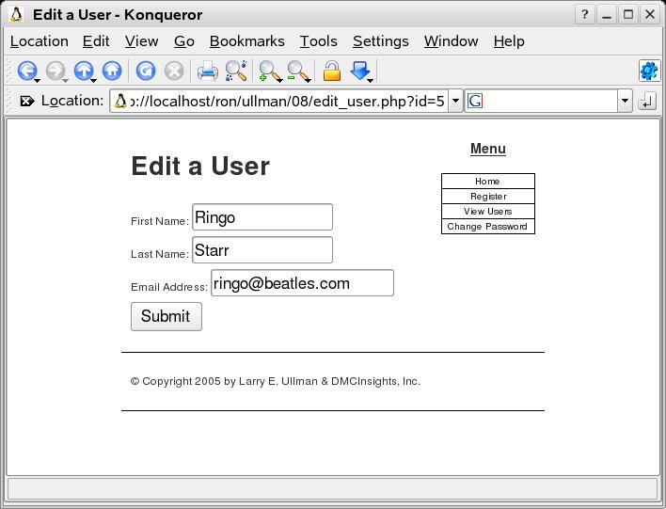

Changing Starr to Start gives:

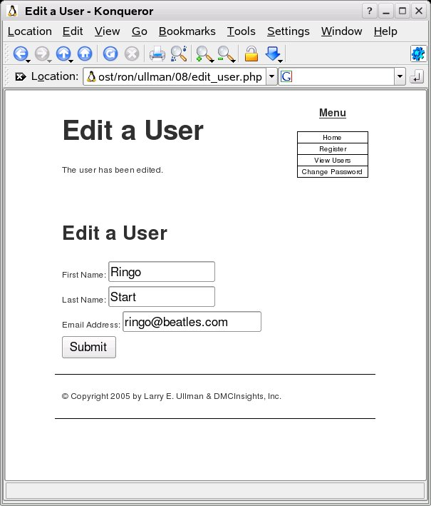

Paginating Query Results

<?php # Script 8.5 - view_users.php
# (4th version after Scripts 7.4, 7.6, & 8.2)

// This script retrieves all the records from the users table.
// This new version paginates the query results.

$page_title = 'View the Current Users';
include ('./includes/header.html');

// Page header.
echo '<h1 id="mainhead">Registered Users</h1>';

require_once ('../mysql_connect.php'); // Connect to the db.

// Number of records to show per page:
$display = 10;

// Determine how many pages there are.
if (isset($_GET['np'])) { // Already been determined.

$num_pages = $_GET['np'];

} else { // Need to determine.

// Count the number of records
$query = "SELECT COUNT(*) FROM users ORDER BY registration_date ASC";
$result = mysql_query ($query);
$row = mysql_fetch_array ($result, MYSQL_NUM);
$num_records = $row[0];

// Calculate the number of pages.
if ($num_records > $display) { // More than 1 page.
$num_pages = ceil ($num_records/$display);
} else {
$num_pages = 1;
}

} // End of np IF.

// Determine where in the database to start returning results.
if (isset($_GET['s'])) {
$start = $_GET['s'];
} else {
$start = 0;
}

// Make the query.
$query = "SELECT last_name, first_name, DATE_FORMAT(registration_date, '%M %d, %Y') AS dr, user_id FROM users ORDER BY registration_date ASC LIMIT $start, $display";
$result = mysql_query ($query); // Run the query.

// Table header.
echo '<table align="center" cellspacing="0" cellpadding="5">
<tr>
<td align="left"><b>Edit</b></td>
<td align="left"><b>Delete</b></td>
<td align="left"><b>Last Name</b></td>
<td align="left"><b>First Name</b></td>
<td align="left"><b>Date Registered</b></td>
</tr>
';

// Fetch and print all the records.
$bg = '#eeeeee'; // Set the background color.
while ($row = mysql_fetch_array($result, MYSQL_ASSOC)) {
$bg = ($bg=='#eeeeee' ? '#ffffff' : '#eeeeee'); // Switch the background color.
echo '<tr bgcolor="' . $bg . '">
<td align="left"><a href="edit_user.php?id=' . $row['user_id'] . '">Edit</a></td>
<td align="left"><a href="delete_user.php?id=' . $row['user_id'] . '">Delete</a></td>
<td align="left">' . $row['last_name'] . '</td>
<td align="left">' . $row['first_name'] . '</td>
<td align="left">' . $row['dr'] . '</td>
</tr>
';
}

echo '</table>';

mysql_free_result ($result); // Free up the resources.

mysql_close(); // Close the database connection.

// Make the links to other pages, if necessary.
if ($num_pages > 1) {

echo '<br /><p>';
// Determine what page the script is on.
$current_page = ($start/$display) + 1;

// If it's not the first page, make a Previous button.
if ($current_page != 1) {
echo '<a href="view_users.php?s=' . ($start - $display) . '&np=' . $num_pages . '">Previous</a> ';
}

// Make all the numbered pages.
for ($i = 1; $i <= $num_pages; $i++) {
if ($i != $current_page) {
echo '<a href="view_users.php?s=' . (($display * ($i - 1))) . '&np=' . $num_pages . '">' . $i . '</a> ';
} else {
echo $i . ' ';
}
}

// If it's not the last page, make a Next button.
if ($current_page != $num_pages) {
echo '<a href="view_users.php?s=' . ($start + $display) . '&np=' . $num_pages . '">Next</a>';
}

echo '</p>';

} // End of links section.

include ('./includes/footer.html'); // Include the HTML footer.
?>
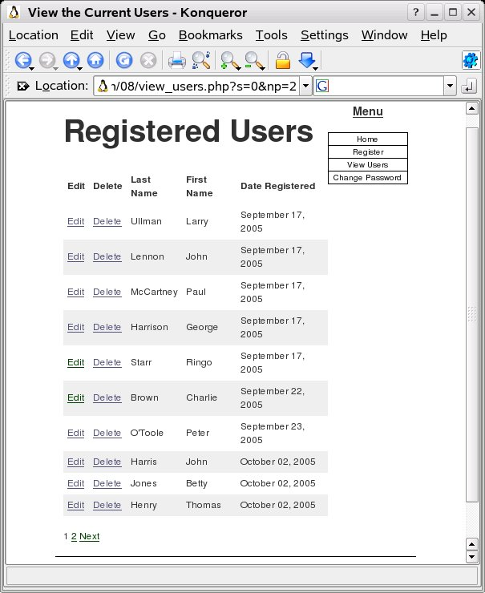

Making Sortable Displays

<?php # Script 8.6 - view_users.php
# (5th version after Scripts 7.4, 7.6, 8.2 & 8.5)

// This script retrieves all the records from the users table.
// This new version allows the results to be sorted in different ways.

$page_title = 'View the Current Users';
include ('./includes/header.html');

// Page header.
echo '<h1 id="mainhead">Registered Users</h1>';

require_once ('../mysql_connect.php'); // Connect to the db.

// Number of records to show per page:
$display = 10;

// Determine how many pages there are.
if (isset($_GET['np'])) { // Already been determined.
$num_pages = $_GET['np'];
} else { // Need to determine.

// Count the number of records
$query = "SELECT COUNT(*) FROM users ORDER BY registration_date ASC";
$result = @mysql_query ($query);
$row = mysql_fetch_array ($result, MYSQL_NUM);
$num_records = $row[0];

// Calculate the number of pages.
if ($num_records > $display) { // More than 1 page.
$num_pages = ceil ($num_records/$display);
} else {
$num_pages = 1;
}

} // End of np IF.

// Determine where in the database to start returning results.
if (isset($_GET['s'])) {
$start = $_GET['s'];
} else {
$start = 0;
}

// Default column links.
$link1 = "{$_SERVER['PHP_SELF']}?sort=lna";
$link2 = "{$_SERVER['PHP_SELF']}?sort=fna";
$link3 = "{$_SERVER['PHP_SELF']}?sort=dra";

// Determine the sorting order.
if (isset($_GET['sort'])) {

// Use existing sorting order.
switch ($_GET['sort']) {
case 'lna':
$order_by = 'last_name ASC';
$link1 = "{$_SERVER['PHP_SELF']}?sort=lnd";
break;
case 'lnd':
$order_by = 'last_name DESC';
$link1 = "{$_SERVER['PHP_SELF']}?sort=lna";
break;
case 'fna':
$order_by = 'first_name ASC';
$link2 = "{$_SERVER['PHP_SELF']}?sort=fnd";
break;
case 'fnd':
$order_by = 'first_name DESC';
$link2 = "{$_SERVER['PHP_SELF']}?sort=fna";
break;
case 'dra':
$order_by = 'registration_date ASC';
$link3 = "{$_SERVER['PHP_SELF']}?sort=drd";
break;
case 'drd':
$order_by = 'registration_date DESC';
$link3 = "{$_SERVER['PHP_SELF']}?sort=dra";
break;
default:
$order_by = 'registration_date DESC';
break;
}

// $sort will be appended to the pagination links.
$sort = $_GET['sort'];

} else { // Use the default sorting order.
$order_by = 'registration_date ASC';
$sort = 'drd';
}

// Make the query.
$query = "SELECT last_name, first_name, DATE_FORMAT(registration_date, '%M %d, %Y') AS dr, user_id FROM users ORDER BY $order_by LIMIT $start, $display";
$result = @mysql_query ($query); // Run the query.

// Table header.
echo '<table align="center" cellspacing="0" cellpadding="5">
<tr>
<td align="left"><b>Edit</b></td>
<td align="left"><b>Delete</b></td>
<td align="left"><b><a href="' . $link1 . '">Last Name</a></b></td>
<td align="left"><b><a href="' . $link2 . '">First Name</a></b></td>
<td align="left"><b><a href="' . $link3 . '">Date Registered</a></b></td>
</tr>
';

// Fetch and print all the records.
$bg = '#eeeeee'; // Set the background color.
while ($row = mysql_fetch_array($result, MYSQL_ASSOC)) {
$bg = ($bg=='#eeeeee' ? '#ffffff' : '#eeeeee'); // Switch the background color.
echo '<tr bgcolor="' . $bg . '">
<td align="left"><a href="edit_user.php?id=' . $row['user_id'] . '">Edit</a></td>
<td align="left"><a href="delete_user.php?id=' . $row['user_id'] . '">Delete</a></td>
<td align="left">' . $row['last_name'] . '</td>
<td align="left">' . $row['first_name'] . '</td>
<td align="left">' . $row['dr'] . '</td>
</tr>
';
}

echo '</table>';

mysql_free_result ($result); // Free up the resources.

mysql_close(); // Close the database connection.

// Make the links to other pages, if necessary.
if ($num_pages > 1) {

echo '<br /><p>';
// Determine what page the script is on.
$current_page = ($start/$display) + 1;

// If it's not the first page, make a Previous button.
if ($current_page != 1) {
echo '<a href="view_users.php?s=' . ($start - $display) . '&np=' . $num_pages . '&sort=' . $sort .'">Previous</a> ';
}

// Make all the numbered pages.
for ($i = 1; $i <= $num_pages; $i++) {
if ($i != $current_page) {
echo '<a href="view_users.php?s=' . (($display * ($i - 1))) . '&np=' . $num_pages . '&sort=' . $sort .'">' . $i . '</a> ';
} else {
echo $i . ' ';
}
}

// If it's not the last page, make a Next button.
if ($current_page != $num_pages) {
echo '<a href="view_users.php?s=' . ($start + $display) . '&np=' . $num_pages . '&sort=' . $sort .'">Next</a>';
}

echo '</p>';

} // End of links section.

include ('./includes/footer.html'); // Include the HTML footer.
?>

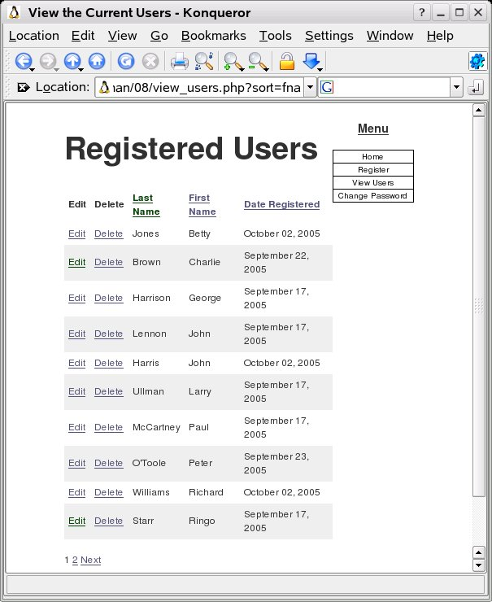

Understanding HTTP Headers

void header ( string string [, bool replace [, int http_response_code]] )
header() is used to send raw HTTP headers. See the HTTP/1.1 specification for more information on HTTP headers.

The second special case is the "Location:" header. Not only does it send this header back to the browser, but it also returns a REDIRECT (302) status code to the browser unless some 3xx status code has already been set.
<?php
header("Location: http://www.example.com/"); /* Redirect browser */
/* Make sure that code below does not get executed when we redirect. */
exit;
?>

<?php # Script 8.7 - register.php
// Send NOTHING to the Web browser prior to the header() line!

// Check if the form has been submitted.
if (isset($_POST['submitted'])) {

require_once ('../mysql_connect.php'); // Connect to the db.

$errors = array(); // Initialize error array.

// Check for a first name.
if (empty($_POST['first_name'])) {
$errors[] = 'You forgot to enter your first name.';
} else {
$fn = escape_data($_POST['first_name']);
}

// Check for a last name.
if (empty($_POST['last_name'])) {
$errors[] = 'You forgot to enter your last name.';
} else {
$ln = escape_data($_POST['last_name']);
}

// Check for an email address.
if (empty($_POST['email'])) {
$errors[] = 'You forgot to enter your email address.';
} else {
$e = escape_data($_POST['email']);
}

// Check for a password and match against the confirmed password.
if (!empty($_POST['password1'])) {
if ($_POST['password1'] != $_POST['password2']) {
$errors[] = 'Your password did not match the confirmed password.';
} else {
$p = escape_data($_POST['password1']);
}
} else {
$errors[] = 'You forgot to enter your password.';
}

if (empty($errors)) { // If everything's OK.

// Register the user in the database.

// Check for previous registration.
$query = "SELECT user_id FROM users WHERE email='$e'";
$result = mysql_query($query);
if (mysql_num_rows($result) == 0) {

// Make the query.
$query = "INSERT INTO users (first_name, last_name, email, password, registration_date) VALUES ('$fn', '$ln', '$e', SHA('$p'), NOW() )";
$result = @mysql_query ($query); // Run the query.
if ($result) { // If it ran OK.

// Send an email, if desired.

// Redirect the user to the thanks.php page.
// Start defining the URL.
$url = 'http://' . $_SERVER['HTTP_HOST'] . dirname($_SERVER['PHP_SELF']);

// Check for a trailing slash.
if ((substr($url, -1) == '/') OR (substr($url, -1) == '\\') ) {
$url = substr ($url, 0, -1); // Chop off the slash.
}

// Add the page.
$url .= '/thanks.php';

header("Location: $url");
exit();

} else { // If it did not run OK.
$errors[] = 'You could not be registered due to a system error. We apologize for any inconvenience.'; // Public message.
$errors[] = mysql_error() . '<br /><br />Query: ' . $query; // Debugging message.
}

} else { // Email address is already taken.
$errors[] = 'The email address has already been registered.';
}

} // End of if (empty($errors)) IF.

mysql_close(); // Close the database connection.

} else { // Form has not been submitted.

$errors = NULL;

} // End of the main Submit conditional.

// Begin the page now.
$page_title = 'Register';
include ('./includes/header.html');

if (!empty($errors)) { // Print any error messages.
echo '<h1 id="mainhead">Error!</h1>
<p class="error">The following error(s) occurred:<br />';
foreach ($errors as $msg) { // Print each error.
echo " - $msg<br />\n";
}
echo '</p><p>Please try again.</p>';
}

// Create the form.
?>
<h2>Register</h2>
<form action="register.php" method="post">
<p>First Name: <input type="text" name="first_name" size="15" maxlength="15" value="<?php if (isset($_POST['first_name'])) echo $_POST['first_name']; ?>" /></p>
<p>Last Name: <input type="text" name="last_name" size="15" maxlength="30" value="<?php if (isset($_POST['last_name'])) echo $_POST['last_name']; ?>" /></p>
<p>Email Address: <input type="text" name="email" size="20" maxlength="40" value="<?php if (isset($_POST['email'])) echo $_POST['email']; ?>" /> </p>
<p>Password: <input type="password" name="password1" size="10" maxlength="20" /></p>
<p>Confirm Password: <input type="password" name="password2" size="10" maxlength="20" /></p>
<p><input type="submit" name="submit" value="Register" /></p>
<input type="hidden" name="submitted" value="TRUE" />
</form>
<?php
include ('./includes/footer.html');
?>
<?php # Script 8.8 - thanks.php
$page_title = 'Thank You!';
include ('./includes/header.html');
?>
<h1 id="mainhead">Thank you!</h1>
<p>You are now registered. In Chapter 9--just around the corner--you will actually be able to log in!</p><p><br /></p>
<?php
include ('./includes/footer.html');
?>

