REPORT

Problem Statement:

The objective of this assignment is to instil in you the techniques for turning an object model into a machine for information gathering and data aggregation.

We want to use software engineering techniques to improve the quality of education anywhere and hold people accountable for improving the quality of life through education, learning to learn, and feedback.

Your task to study ways to create a performance measurement solution to enable universities to measure the quality of the education they deliver to their students. The approach will be to look into how an educational system in terms of faculty and courses contribute to growth of their graduates over a 5-year period. You must figure out ways to track the jobs and promotions graduates get over time and assign rankings accordingly. In addition, track the connection of courses and their relevance to graduates growth.

One of your deliverables will be to design a dashboard that enables college and university administrators to compare the performance of their academic units. One additional question is to consider ways to define your own ranking system for students to decide where they want to go for their studies. The current system is biased toward research.

Proposed Solution to evaluate the performance of academic units such as Faculty and Courses:

University

College

Department

Alumni directory

Alumni

Navigation

Transcript

For proposed solution

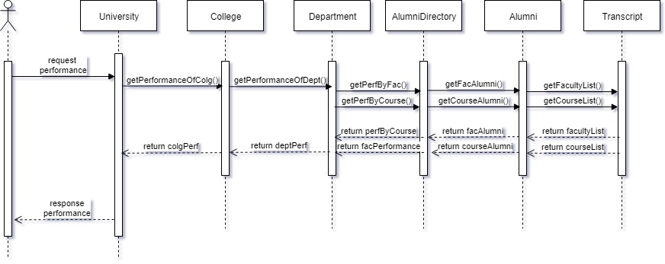

Understanding the flow:

To calculate the performance of the educational system based on course and faculty, one possible solution could be:

The performance is calculated by first extracting the list of courses the student (Alumni now) has taken which comes from the transcript class. This goes into the alumni class. Then, the alumni class has attributes such as Job position, placement status, Salary, Promotion Interval. Then, in the alumni directory, there will be a list of students in a course taught by a faculty their performance. The total number of students who are placed who took a particular course under a faculty can be found out. Then, performance for a department can be found. This helps in evaluating performance of college. Then, a more specified result is extracted by calculating the best performance of a particular course and faculty for the whole university. This is how navigation could be performed to know the performances of the various academic units.

Proposed solution for knowing the current academic proclivity:

To find whether what the college or department is currently biased towards the research, the current research work going on currently will again be dependent on the faculty who has a faculty profile of PhD. Then, the number PhD. Faculty with an ongoing research and the ones not in research can be calculated. And, if the number of research faculty is more than the non research based faculty then, it could be construed that the college or the university is research biased depending on the search.

The navigation will be as follows:

University

College

Department

Job Position

Role

Faculty Role

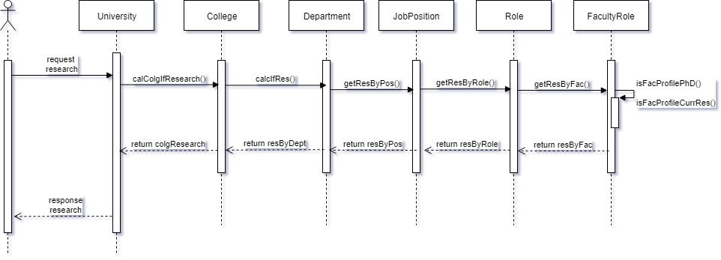

1. Department Question

1) What are the courses we teach？

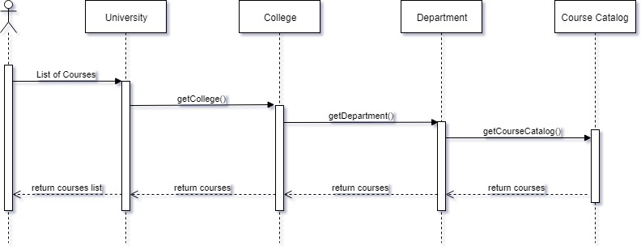

2) What are the courses we offer at any given semester?

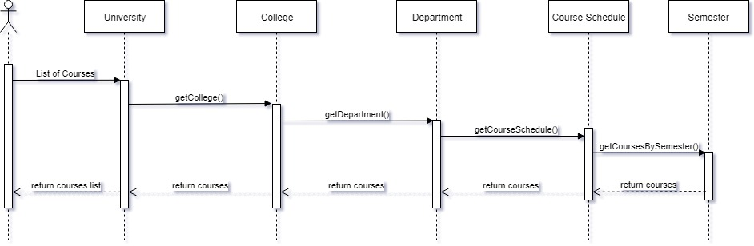

3) Which courses are core and which one are elective? What are the course requirement?

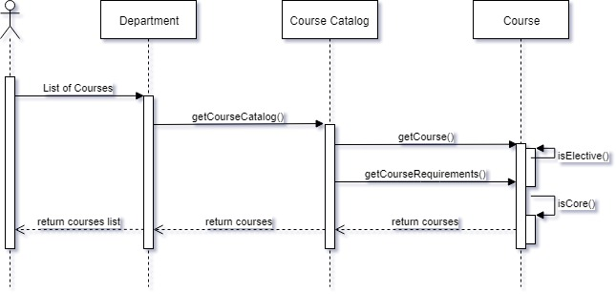

4) What are the degree requirement？

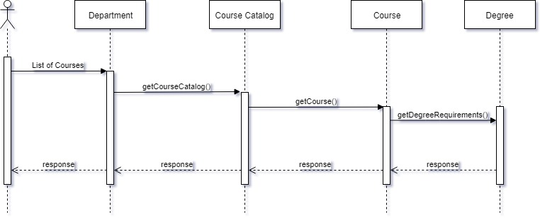

5) What is our current capacity? How many seat are empty?

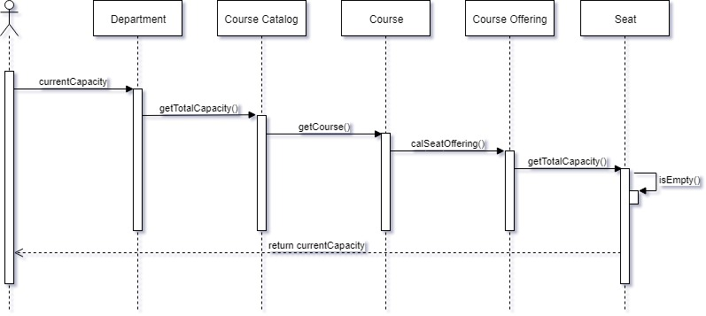

6) What is our Faculty/Student ratio per class? How do we compare with other department in the college?

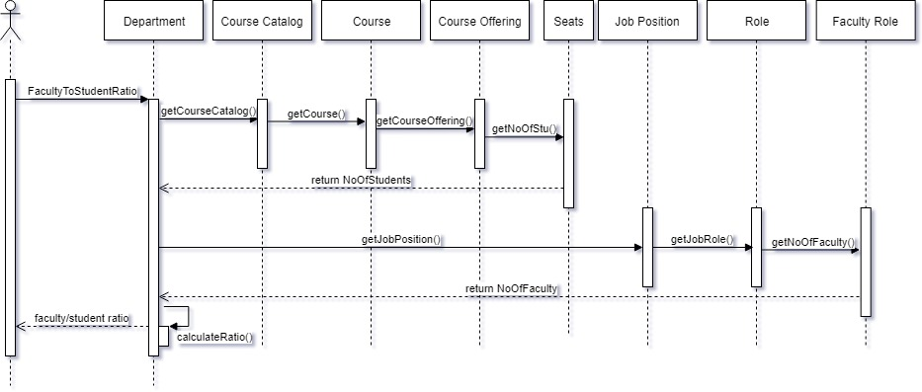

7) What is the average number of students per class? longest class? smallest class?

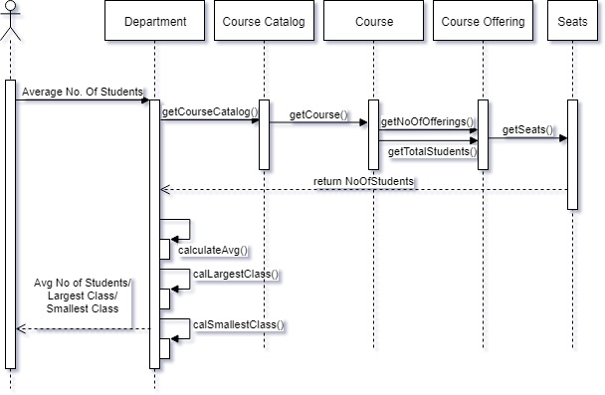

8) What is the current student enrollment in the college?

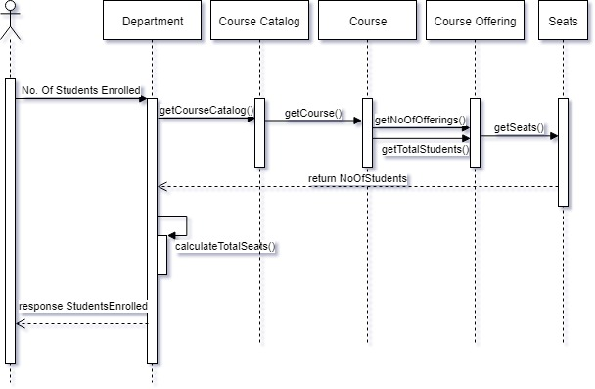

9) What is the admin staff / faculty ratio?

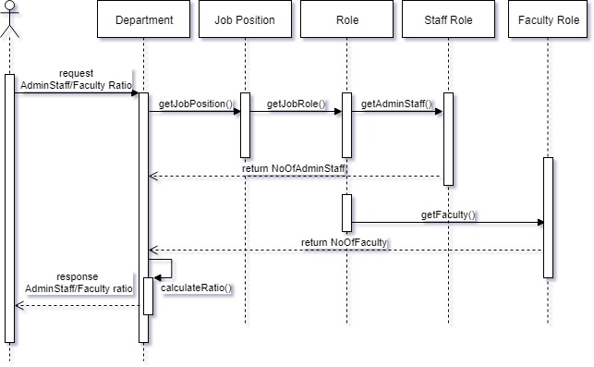

10) What is the ratio of full time faculty vs part time?

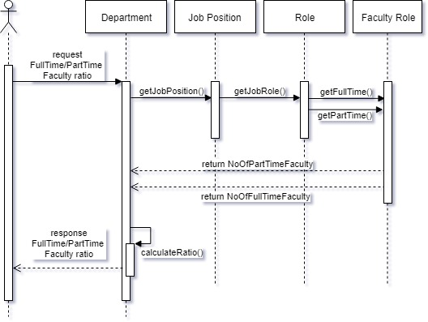

11) What is the percentage of faculty with PHD?

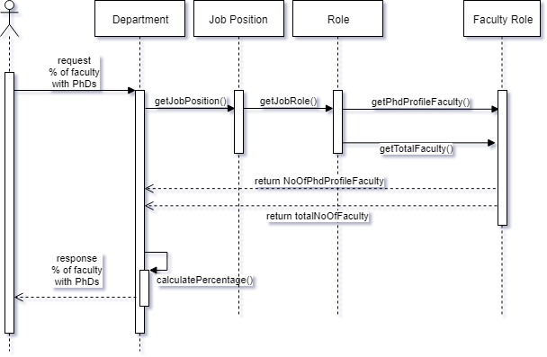

2. Course Schedule

1) Which course are taught in the given semester

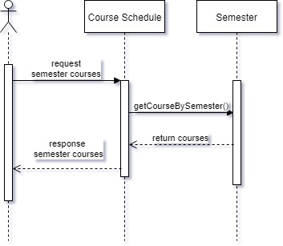

2) Add a course to course schedule

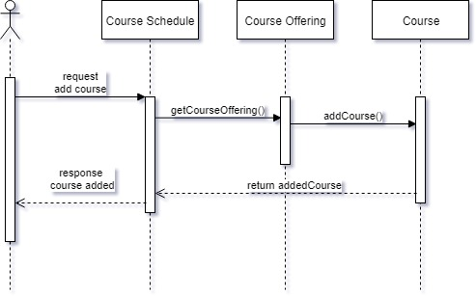

3) Assign a teacher to teach a scheduled course

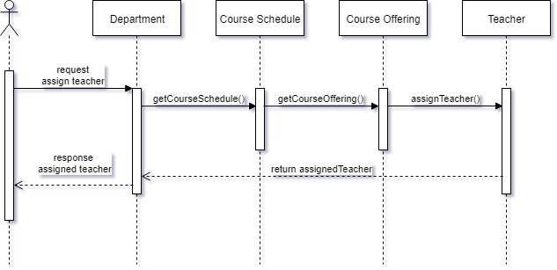

3. Course Offering

1) What is the course being offered?

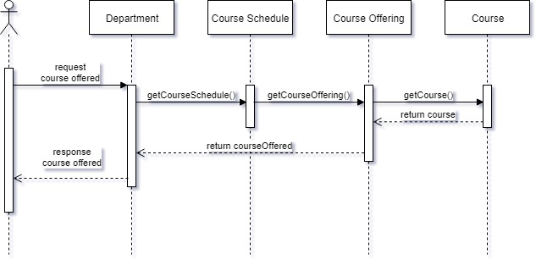

2) Who is teaching the course?

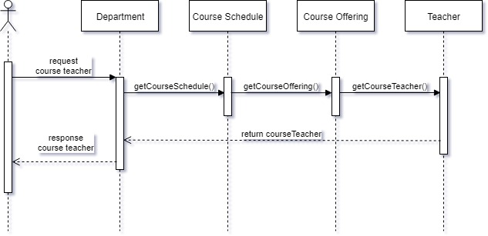

3) When is it offered?

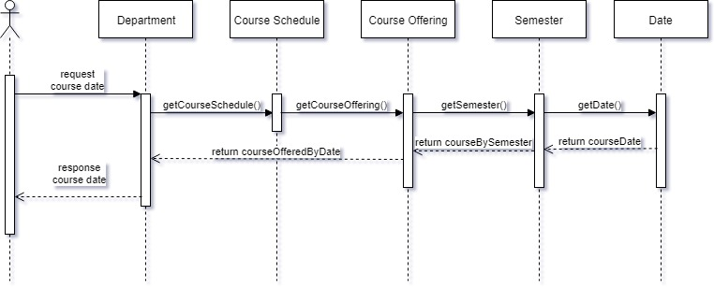

4) Where is it offered?

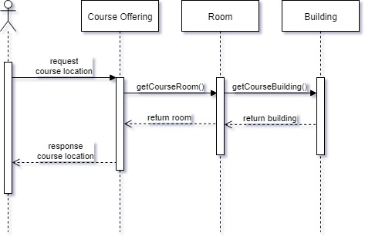

5) Who are the students signed up for the class?

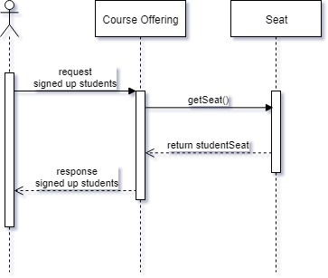

4. Course Catalog

1) Find course given the course name?

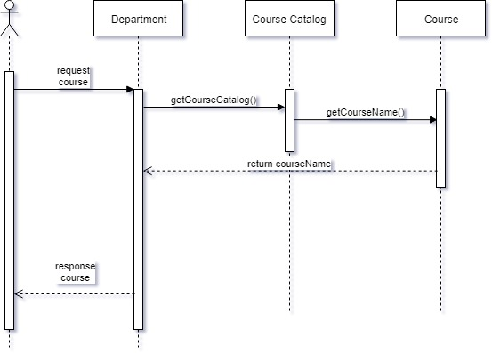

2) Find course given course number?

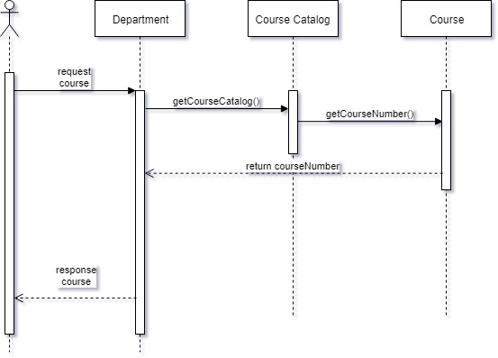

3) List all courses

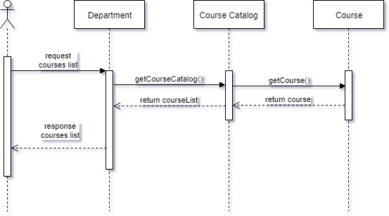

4) Update courses

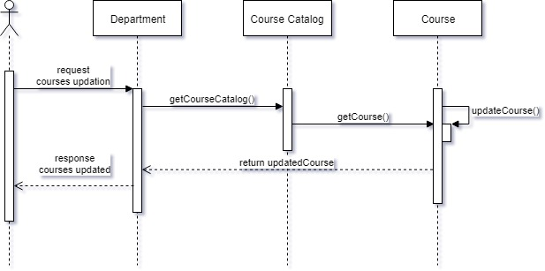

6. University

1) Are we profitable?

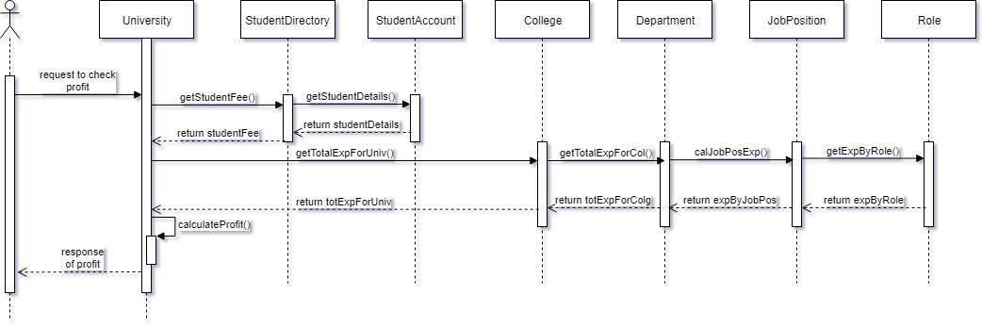

2) What is the faculty/student ratio per class broken down by college? What is the current enrollment in our university broken down by college?

