Student Name: CHOI Man Hin

Student ID: 1155125212

Course: IERG3080B

Project Topic: Topic 4(Typing Game)

How to play:

1. Open “ierg3080project_1155125212.exe”

Or run solution after opening “ierg3080project_1155125212.sln”

1. Choose game difficulty at title screen.   
   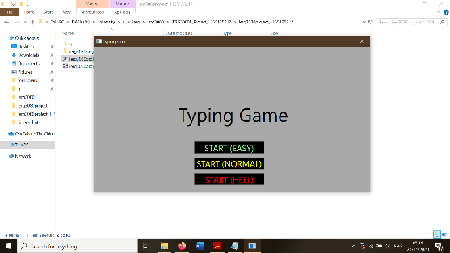

Game difficulty affects the rate of generating falling “words” and the number of lives.

1. Within 60 seconds, “destroy” as many falling “words” as possible by typing exactly same word(typed letters are presented as yellow texts) as the falling “word” that is closest to the pink line but has not passed it yet. The player gets 10 scores for each “words” “destroyed”. Score is shown at bottom right corner of the game. Remaining time is shown at right side of the game.

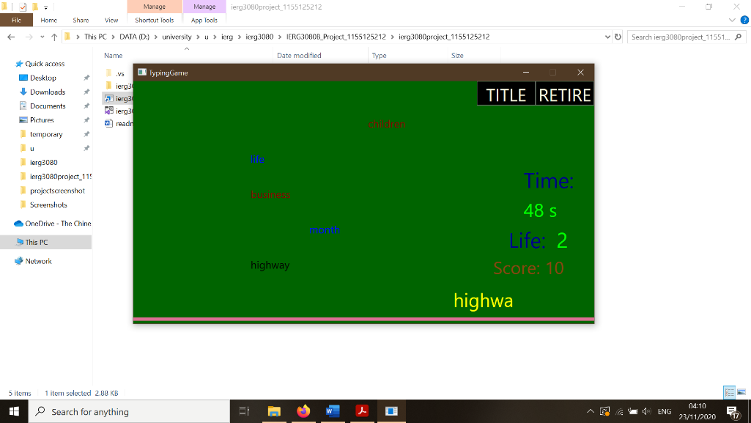

When a falling “word” passes the pink line, the number of lives of the player decreases by 1. Background color of the game turns to pink for 1 second to indicate that the player missed “destroying” one falling “word”.

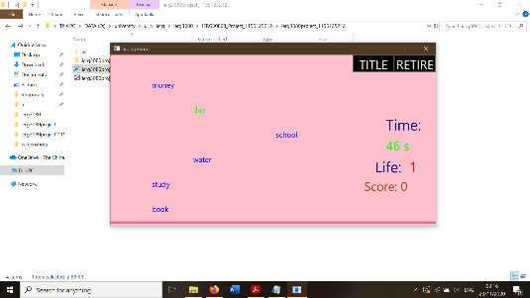

The color of game background depends on the player’s remaining health.

(more than half: dark green;

less than half and more than one: orange;

equal or less than one: purple)

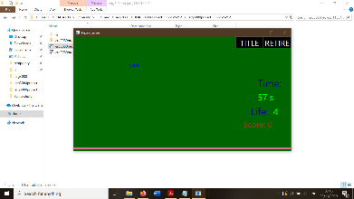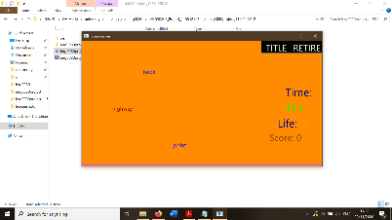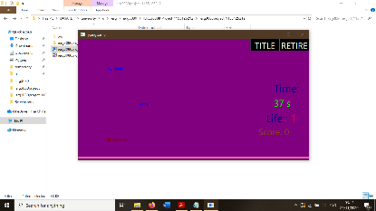

1. Game Over: time runs out or zero lives left

* Game ends 60 seconds after starting(time = 0 s).

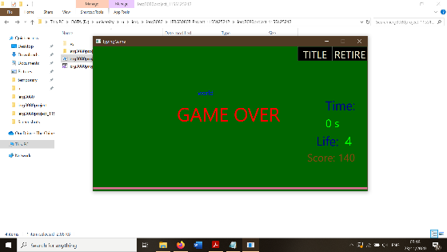

* Game ends after the player loses all lives(life = 0).

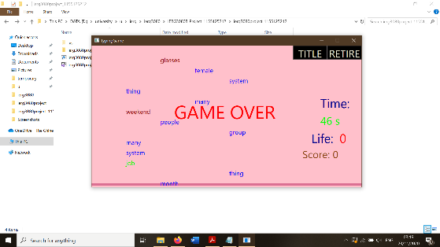

* The player cannot continue playing the game until a new game is started.

1. Control Button: “TITLE” button and “RETIRE” button

* “TITLE” button: current game is cleared, and the player will be returned to title screen. The player can start a new game as mentioned at step 1.
* “RETIRE” button: The player forfeits and cannot continue playing the current game. The player can then either click “TITLE” button to return to title screen to start a new game or exit the game by closing the game window.

Game codes:

A canvas is used instead of a grid in the .xaml file for better coding of movements of falling textblocks.

Three glasses “newGame”, ”whentimepass” and ”textchange” are created.

Class “newGame”: mainly used to store information of current game like time passed, number of lives left and game difficulty. There is also a “reset” method to reset current game.

Class “whentimepass”: contains methods which are called every tick of timer, which are methods of falling textblocks generating, remaining lives calculation and gameover judging.

Class “textchange”: contains methods which are called whenever the player types letters and text of the typing textbox changes , which are methods of “destroying” falling textblocks and game score calculation.

List<string> vocablist: most words in the list of 50 words generated are found from <https://www.ef.com/wwen/english-resources/english-vocabulary/top-50-nouns/> .