Computational

Microelectronics [HW-5]

Professor: Sung-Min Hong

Data: 18/10/08

Student ID: 20172106

# Student name: Hyo Seok, Kim

1. Simulation explanation

In the previous lecture, we have learned the Newton method. So we are going to calculate the electrostatic potential by using the Newton method and compare the numerical results with the analytic results in order to know the utility of the Newton method. The governing equation is as follows.

$N^{+}+ n_{int}e^{-\frac{ϕ}{V_{T}}}-n_{int}e^{\frac{ϕ}{V_{T}}}=0$– (1)

We assume the room temperature. The intrinsic carrier density, $n_{int}$, of silicon at 300 K is ${10}^{10}{cm}^{-3}$. Our purpose is to know the changes of the electrostatic potential under the varying positive and negative impurity densities, $N^{+}\&{ N}^{-}$, whose absolute value varies from ${10}^{10}{cm}^{-3}$ to ${10}^{18}{cm}^{-3}$.

When we simulated the results, the parameters under the consideration are shown in the table below.

|  |  |
| --- | --- |
| Elementary charge, [C] | 1.602192e-19 |
| Vacuum permittivity, [F/m] | 8.854187817e-12 |
| Boltzmann constant, [eV/K] | 8.6173303e-5 |
| Temperature, [K] | 300.0 |
| Intrinsic electron density [/cm3] | 1.0e10 |
| Initial electrostatic potential [V] | 10.0 V |

**Table.1: Simulation parameters**

1. Result and discussion

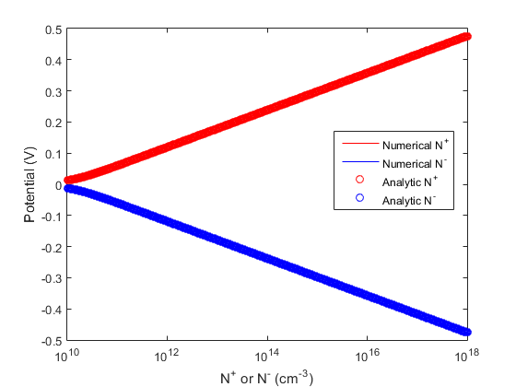

Figure . The variation of the potential for the changing impurity densities for the cases of both of the numerical and the analytic solutions

As a result of Figure 1, we can know that the newton method is the good numerical method to get the estimated values to the analytic values.

In order to know the accurate error between the numerical values through the Newton method and the analytic values, we can plot the graph for the relation of the error for the potentials with the corresponding impurity densities. You can see these in the Figure 2.

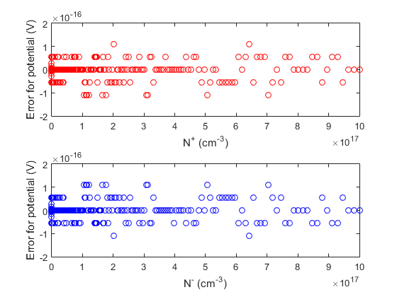

Figure . The error for potential between the numerical and analytic solutions via the changing impurity densities. the above graph is for N+ and the below graph is for N-.

The range of the error for potentials is in $1^{-13} \%$. So we can trust the result by using Newton method.