Computational Microelectronics, 2018 Fall

Homework #2

20171058 Hwiin Ju

**Assumption**:

a = 5nm

m = 0.19 m0

**Analytical solution**:

Smallest k2 is 3.94784176043574e+17

Ground state energy is 0.0791704700008312

**Numerical solution**:

1. N=5: k2 = 3.74903320081219e+17

Ground state energy = 7.518354e-02 eV

1. N=50: k2 = 3.94648960515371e+17

Ground state energy = 7.914335e-02 eV

1. N=500: k2 = 3.94782872043323e+17

Ground state energy = 7.917021e-02 eV

**Error\***:

1. N=5: k2: 5.04 %

E: 5.04 %

1. N=5: k2: 0.0343 %

E: 0.0343 %

1. N=5: k2: 0.000330 %

E: 0.000328 %

*: $\frac{analytical solution – numerical solution}{analytical solution}×100 \%$

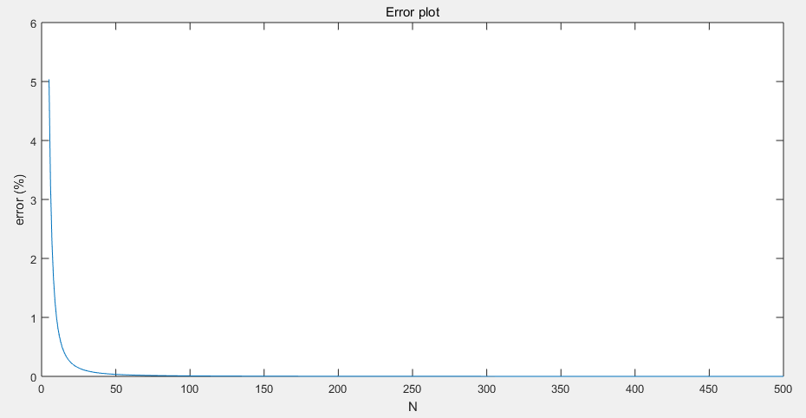

**Code**

clear all;

hbar = 1.054571800e-34; % Planck constant (J*s)

m_elec = 9.10938356e-31; % Mass of electron (kg)

x = 5.0e-9;

N = 5;

m = 0.19*m_elec;

dx = x/(N-1);

for i = 1:N-2

if i==1

A(i,i) = -2;

A(i,i+1)= 1;

elseif i==N-2

A(i,i) = -2;

A(i,i-1)= 1;

else

A(i,i-1)=1;

A(i,i) = -2;

A(i,i+1)= 1;

end

end

[eigvec,eigval] = eig(A);

k_sq = -eigval/(dx^2);

E = (hbar^2)*k_sq/(2*m);

E_ground = E(N-2,N-2);

E_ground_eV = E_ground*6.242e+18;

%% wave function

eig_vec = eigvec(N-2,:); %wave function of n-th excited state =N-2-n (ground state = 0th state)

for i = 1:N-2

x_val(i) = i*dx;

end

figure(1)

plot(x_val,eig_vec)

%%

fprintf('Ground state energy is %d eV\n',E_ground_eV)