Computational

Microelectronics [HW-11]

Professor: Sung-Min Hong

Data: 18/11/19

Student ID: 20172106

# Student name: Hyo Seok, Kim

1. Simulation explanation

In this report, we consider BTE simulator in a 30 nm long structure. It’s potential is 0 from 0 nm to 10 nm, V increases linearly from 10 nm to 20 nm, $V= V_{D}>0$ from 20 nm to 30 nm. We are only treating $f_{0}$& $f_{1}$, whose relation is shown below.

$$ν\frac{∂}{∂x}\frac{1}{c_{1}}f_{0}\left(x,H\right)γ_{0,1,1}= -\frac{f_{1}(x,H)}{τ} \\ \frac{1}{c_{1}}= \sqrt{\frac{1}{π}}$$

|  |  |
| --- | --- |
| Elementary charge, [C] | 1.602192e-19 |
| Vacuum permittivity, [F/m] | 8.854187817e-12 |
| Boltzmann constant, [J/K] | 1.380662e-23 |
| Temperature, [K] | 300.0 |
| Relaxation time [s] | 1e-12 |
| Electron mass [Kg] | 9.109534e-31 |
| Drain voltage [V] | 0.01 |

**Table.1: Simulation parameters**

1. Result and discussion

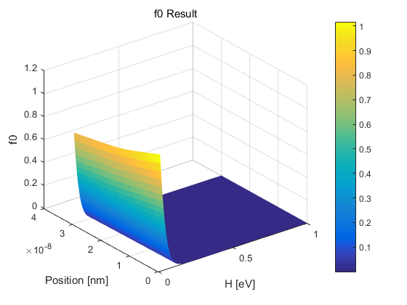

Figure f0 variation in terms of H(Energy) and x-position

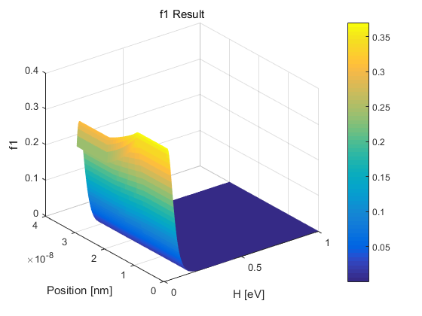

Figure f1 variation in terms of H(Energy) and x-position