Homework3

Jae Hoon Cho

October 2, 2018

## R Markdown

This is an R Markdown document. Markdown is a simple formatting syntax for authoring HTML, PDF, and MS Word documents. For more details on using R Markdown see <http://rmarkdown.rstudio.com>.

When you click the **Knit** button a document will be generated that includes both content as well as the output of any embedded R code chunks within the document. You can embed an R code chunk like this:

library(tidyverse)

## -- Attaching packages ----------------------------------------------- tidyverse 1.2.1 --

## v ggplot2 3.0.0 v purrr 0.2.5  
## v tibble 1.4.2 v dplyr 0.7.6  
## v tidyr 0.8.1 v stringr 1.3.1  
## v readr 1.1.1 v forcats 0.3.0

## -- Conflicts -------------------------------------------------- tidyverse_conflicts() --  
## x dplyr::filter() masks stats::filter()  
## x dplyr::lag() masks stats::lag()

library(gapminder)  
gap2007 <- gapminder %>% filter(year==2007)  
  
labelling <- gap2007 %>%   
 summarize (gdpPercap=max(gdpPercap),lifeExp=max(lifeExp))   
  
ggplot(data=gap2007, aes(x=gdpPercap, y=lifeExp)) +   
 geom_rect(aes(xmin=39000, xmax=50000, ymin=75, ymax=85, alpha=1, fill=T))+  
 geom_point(shape=1,size=2) +  
 labs(x="GDP per capita", y="Life expectancy") +  
 geom_text(label="Countries with \n high GDP", data=labelling, vjust="high", hjust="right", size=3)

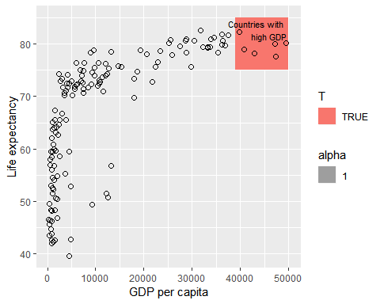

## Including Plots

You can also embed plots, for example:

Note that the echo = FALSE parameter was added to the code chunk to prevent printing of the R code that generated the plot.