Homework4

Jae Hoon Cho

October 10, 2018

## R Markdown

This is an R Markdown document. Markdown is a simple formatting syntax for authoring HTML, PDF, and MS Word documents. For more details on using R Markdown see <http://rmarkdown.rstudio.com>.

When you click the **Knit** button a document will be generated that includes both content as well as the output of any embedded R code chunks within the document. You can embed an R code chunk like this:

# Q1. Write the R code using ggplot function to recreate the graph from the Lecture 8 notes

library(tidyverse)

## -- Attaching packages ------------------------------- tidyverse 1.2.1 --

## v ggplot2 3.0.0 v purrr 0.2.5  
## v tibble 1.4.2 v dplyr 0.7.6  
## v tidyr 0.8.1 v stringr 1.3.1  
## v readr 1.1.1 v forcats 0.3.0

## -- Conflicts ---------------------------------- tidyverse_conflicts() --  
## x dplyr::filter() masks stats::filter()  
## x dplyr::lag() masks stats::lag()

norm1 <- data.frame(x1<- seq(-3,3, by=0.01), y1<-dnorm(x1))  
norm2 <- data.frame(x2<- seq(0.2,6.2, by=0.01), y2<-dnorm(mean=3.2,x2))  
norm1.1 <- data.frame(x3<- seq(qnorm(0.95),3,by=0.01), y3<-dnorm(x3))  
norm2.1 <- data.frame(x4<- seq(0.2,qnorm(0.95), by=0.01), y4<-dnorm(mean=3.2,x4))  
  
ggplot(data=norm1, aes(x=x1,y=y1)) + geom_line(color="blue",lwd=1.5) +  
 geom_line(data=norm2, aes(x=x2,y=y2), color="red", lwd=1.5) +  
 geom_vline(xintercept = qnorm(0.95), linetype = 'longdash', lwd = 0.7) +  
 annotate("text", x = 2, y = 0.02, label = expression(alpha),  
 color = 'black', size = 5) +  
 annotate("text", x = 1.2, y = 0.02, label = expression(beta),  
 color = 'black', size = 5) +  
 annotate("text", x = -2, y = 0.4, label = "Type I error", color="blue", size=5)+  
 annotate("text", x = -2, y = 0.37, label = "Type II error", color="red", size=5)+  
 geom_area(data=norm1.1, aes(x=x3, y=y3), fill="blue", alpha=0.5) +  
 geom_area(data=norm2.1, aes(x=x4, y=y4), fill="red", alpha=0.5)

## Warning in is.na(x): is.na() applied to non-(list or vector) of type  
## 'expression'  
  
## Warning in is.na(x): is.na() applied to non-(list or vector) of type  
## 'expression'

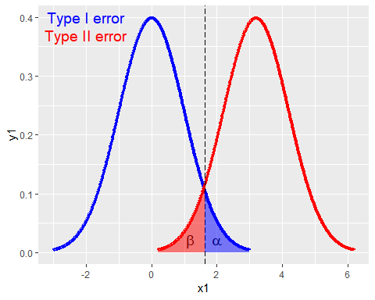

# Q2.Implement a function that will check if a given positive integer is a prime number.

prime_number <- function (x) {n <- 0  
 for (i in 2:x-1) {  
 if (x%%i==0){n <- n+1}  
 else{n <- n}}  
 ifelse(n>1,"not prime","prime")}  
  
prime_number(8)

## [1] "not prime"

prime_number(19)

## [1] "prime"

Note that the echo = FALSE parameter was added to the code chunk to prevent printing of the R code that generated the plot.