**Mood Board**

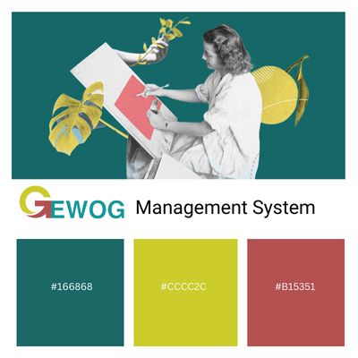

**Design Concept**

What will the product do?

The Gewog Management System will provide a useful platform for the Jurmey Gewog people and the administration's staff. Where people can request a pass, register a new born child, and record personal information. Moreover, Staff from Concern Gewog will keep track of the private data supplied by each individual, authorize a census of the newborn, and issue a pass if necessary.

Who is the product for?

The Gewog Management system primarily benefits the Jurmey population and the Gewog administration. People won't have to struggle to contact concerned gewog staff members in order to appeal the pass, submit their information, and register their new-born child, as they did in the past. This website will significantly reduce human work. The gewog staff will also find it simpler to track each person's data throughout the course of a year as a result.