Exp. No.: 21

Date:

**MYSQL STRING FUNCTIONS- SPACE, SUBSTR, UPPER, LOWER, TRIM, LENGTH**

AIM:

To implement Space, Substr, Upper, Lower, Trim, Length String Functions using MySQL.

SPACE():

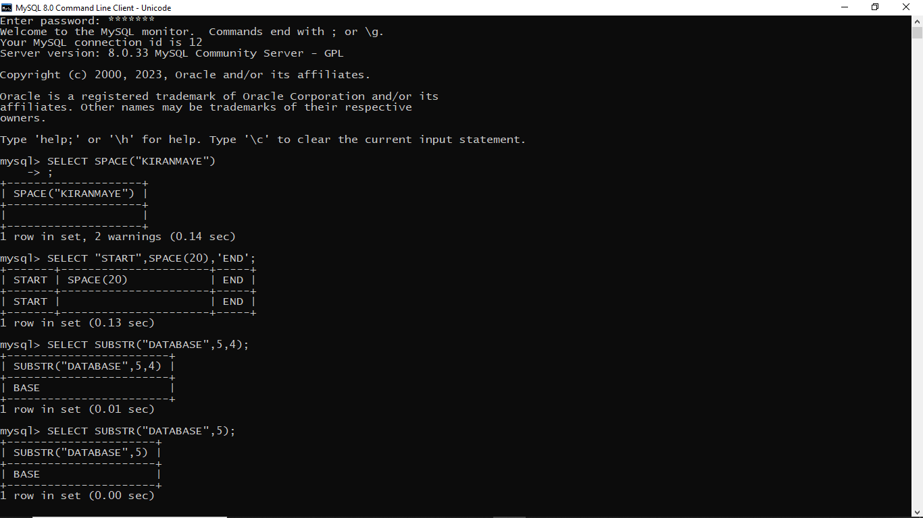

MySQL SUBSTRING():



UPPER()

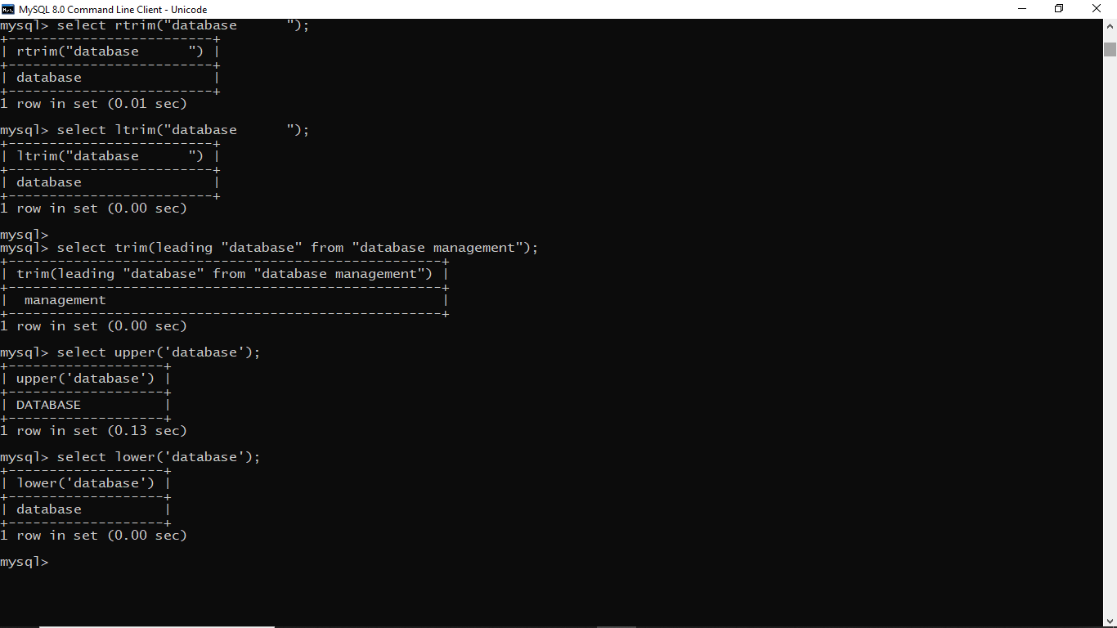

LOWER()



TRIM()

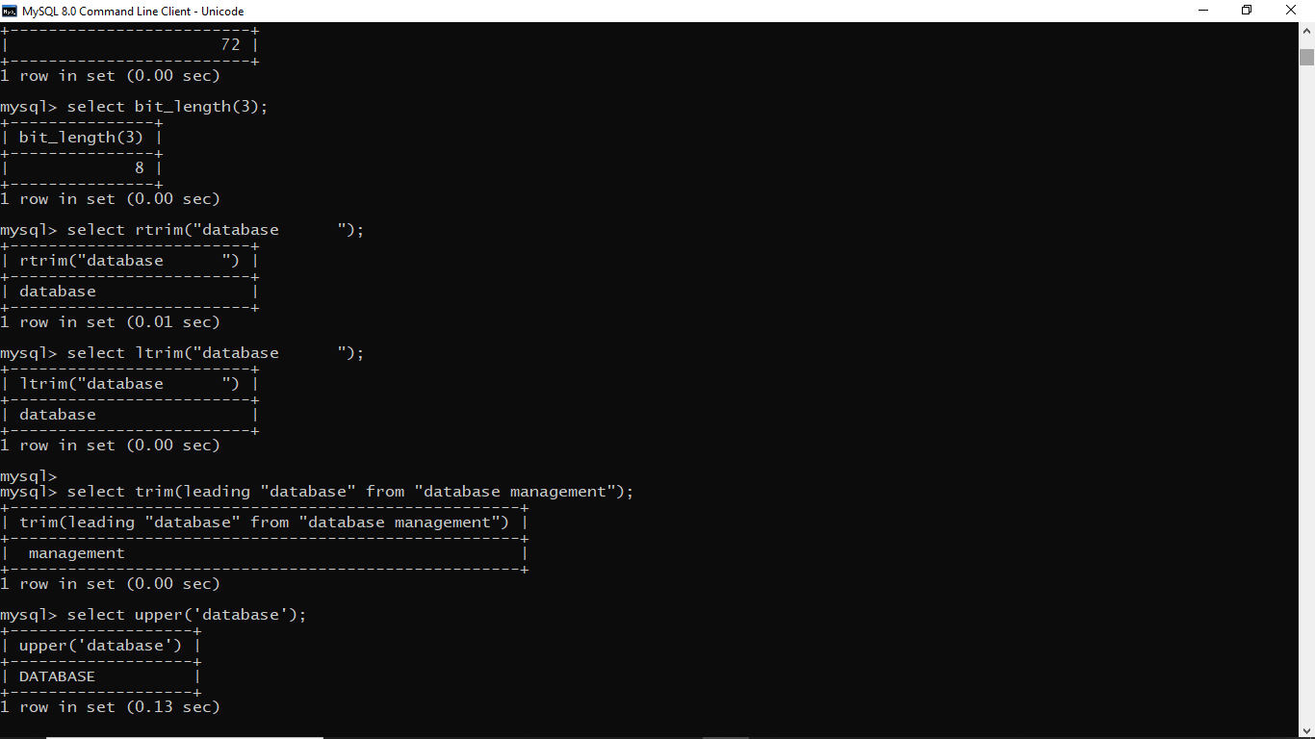

LENGTH()

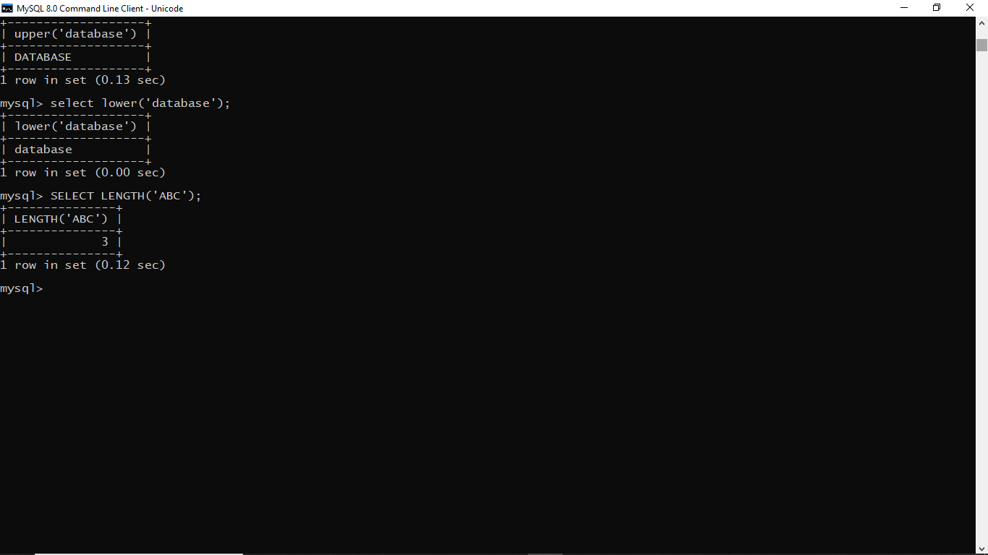

BIT_LENGTH()

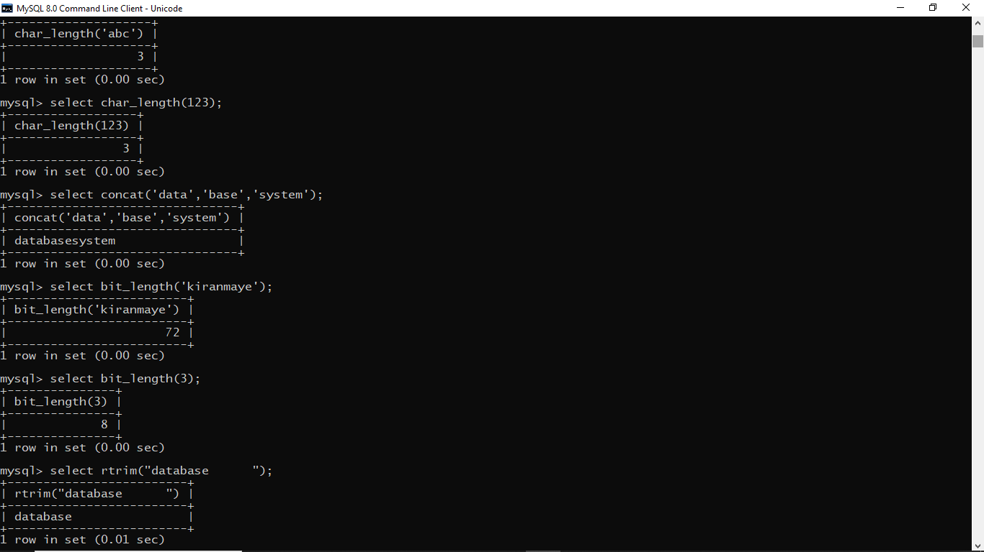

CHAR_LENGTH()

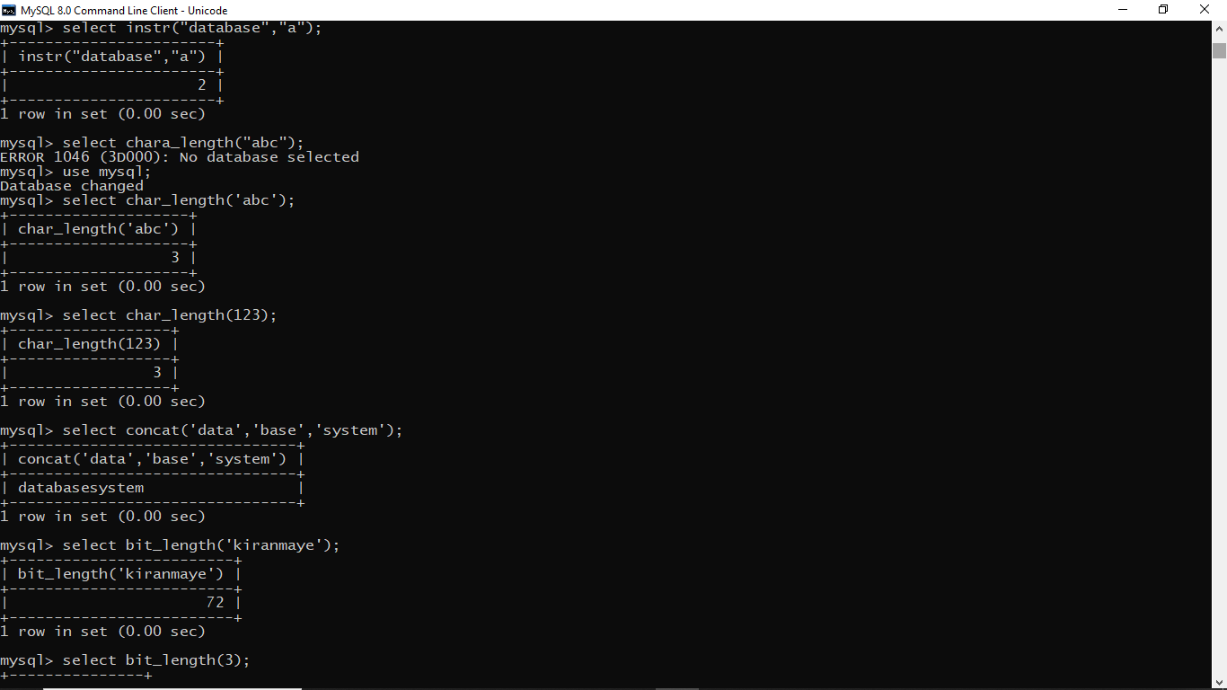

CONCAT()

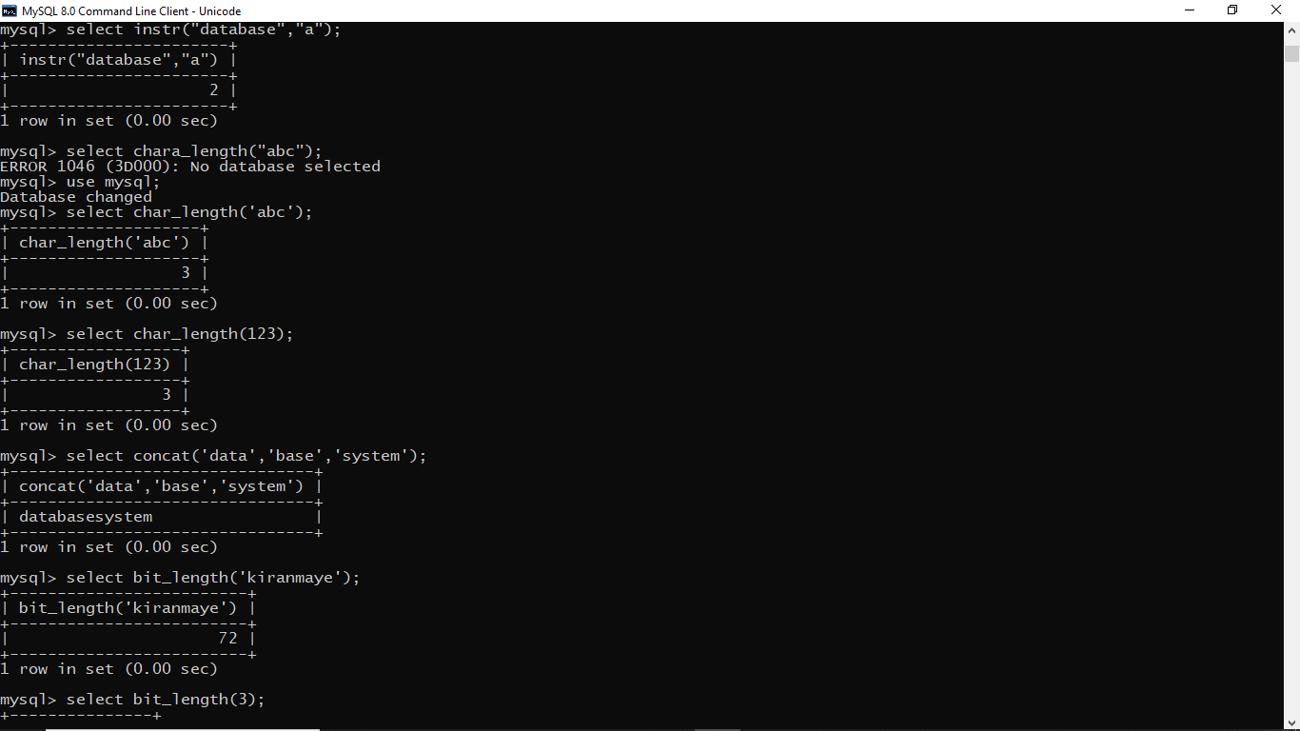

INSTR()

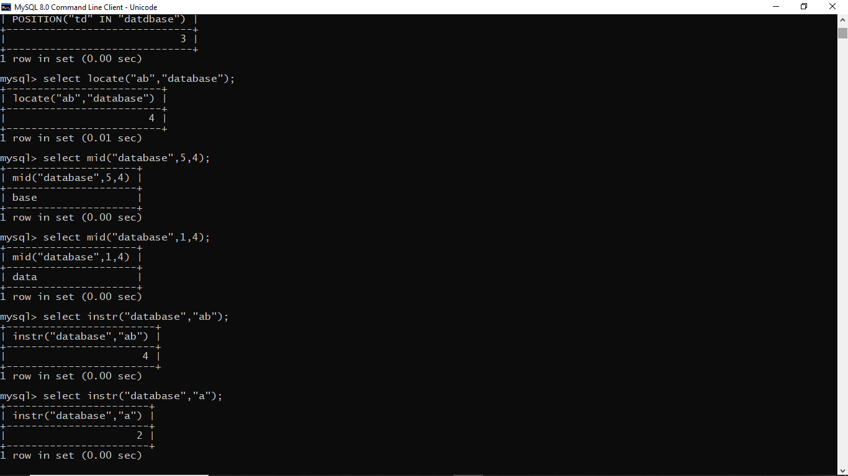

LOCATE()



MID()



POSITION()

