Simply Online: A Video Calling App for Online Classes with Automated Attendance using Face Recognition Technology

Mr. Amarendra Reddy, *Graduate Student, Department of Computer Science Pace University*, Mr. Ajay Kumar Cholker, *Graduate Student, Department of Computer Science Pace University*, Mr. Mounik, *Graduate Student, Department of Computer Science Pace University,*

Mr. Ravi Teja Reddy*, Graduate Student, Department of Computer Science Pace University,* Mr. Pruthvi Raj Reddy*, Graduate Student, Department of Computer Science Pace University,* Ms. Sreeja Reddy*, Graduate Student, Department of Computer Science Pace University*

***Abstract*-- More and more people are using the internet to learn. Online classes have a big problem - it's hard for teachers and students to talk to each other and get interested in the lessons. To solve this problem, we created Simply Online which is an app that makes online learning better by allowing video meetings. It lets students and teachers have video conversations easily and learn together right away. The app has a tool that recognizes faces and records who is present during online classes without needing someone to take attendance by hand. This paper explains how the app was made, including its structure, style, and creation steps. This writing talks about problems faced while creating something and how those problems were solved.**

**Keywords: face recognition, video conference, automated attendance, online classes, online learning.**

1. INTRODUCTION

O

nline learning has become increasingly popular in recent years, especially in the wake of the COVID-19 pandemic. Online classes are easy to take from anywhere, but they may not have as much communication and participation as classes where you go in person. We made a new app called Simply Online that helps make video calls for online learning easier and

more fun.

Simply Online uses Agora SDK to allow people to talk and see each other in real-time through the Internet. WebRTC is a free tool that helps people make real-time video and voice calls on the internet.

It enables high-quality audio and video communication without the need for plugins or external software, making it ideal for online learning applications.

Face recognition technology using the Deep face library in Python is used to implement automated attendance marking system. Deep face is a deep learning-based face recognition library that enables accurate and efficient face recognition and facial analysis. Deep face utilizes deep learning algorithms to achieve high accuracy in face recognition tasks making it an ideal choice for applications like automated attendance taking.

Taking attendance is now easier and faster. The Deep face library can take attendance by recognizing the faces of students and recording if they are present. The app shows the names of all the students who are present and absent in one place, so the teacher can easily see who is there and who is not. This tool helps to save time and gets rid of the need for people to manually take attendance. It makes sure the attendance is accurate and that everyone is responsible.

Users can register in the application and add their face data to their profiles. A face recognition model will be built using the registered faces and later used to mark attendance using face recognition.

Simply Online is an app that helps make learning on the internet better by making it more enjoyable and interactive for students and teachers.

# LITERATURE REVIEW

Some new studies looked at using computer programs to take attendance in online classes by recognizing your face. Singh and Choudhary made a machine that can see and remember people's faces to track when they come in or leave. Bhardwaj, Choudhary, and Chhabra (2021) suggested a system that recognizes faces using deep learning technology. Both studies demonstrate the efficiency and accuracy of automated attendance-taking using facial recognition technology. In addition, several studies have highlighted the benefits of WebRTC technology for online education (Wu and Wu, 2018). Finally, Neupane, Aryal, and Adhikari (2021) discuss the ethical considerations of using facial recognition technology in education and suggest ways to address these concerns.

Overall, these studies provide valuable insights into the potential applications of facial recognition and WebRTC technologies in online education.

# PROJECT REQUIREMENTS

The objective of the project Simply Online is to develop a video calling application for online classes that includes a face recognition feature for automated attendance taking.

* 1. Functional Requirements

The following are the functional requirements for the Simply Online app:

1. User Registration: The application should allow users to signup into the application with their email address and password. Users can also add face data to their profile on the user registration page.
2. User Authentication: The application should allow users to create an account with a unique username and password. Users should be able to log in to the application using their credentials. Credentials should be stored in the database by encryption.
3. Creating and Joining Rooms: The application should allow users to create a room for their class. Users should be able to join existing rooms for their classes by entering a room name or link.
4. Video Calling: The application should enable video calling between users in the same room. Users should be able to mute and unmute their audio and video during the call.
5. Screen Sharing: The application should allow users to share their screens with other users in the same room. Users should be able to control which screen is being shared and who can see it.
6. Face Recognition and Attendance: The application should capture images of users' faces during the video call. The application should analyze these images using the Deep Face library to recognize users and mark their attendance. The application should provide the lecturer with a summary of attendance for each class.
   1. Non-functional Requirements

The following are the non-functional requirements for the Simply Online app:

1. User Interface: The app should be easy to use and understand. People need to be able to move around the app and use everything easily.
2. Compatibility: The program needs to work with different kinds of internet browsers. The program needs to work well on both computers and phones.
3. Performance: The program needs to give good video and sound that works well when people are talking to each other. The program needs to work well even if lots of people are using it in one room.
   1. Constraints

The following are the constraints for the Simply Online app:

1. Scalability: Applications must be able to handle many concurrent users and meetings, ranging from small team meetings to large-scale webinars or virtual events.
2. Security: Making sure user information and meetings are safe and private is very important for any program. We need to make strong plans to stop people from getting into our information without permission, leaking our data, or causing harm to our security.
3. Reliability: Simple online applications must provide reliable and stable video and audio communication, with minimal disruptions, and lags.
4. Recording and playback: The ability to record meetings and playback recordings is often a crucial feature for simply online-like applications to allow users to review and share meetings or events.
   1. Functional Requirements
5. Platform: Applications can be developed as standalone web applications, desktop applications for Windows, macOS, or Linux, mobile applications for iOS and Android platforms, or a combination of these platforms.
6. Programming language: The app should be written in Python programming language.
7. User authentication and authorization: Robust user authentication and authorization mechanisms to ensure secure access to meetings and prevent unauthorized users from joining the meetings.
8. Video and audio conferencing: Ability to establish real-time video and audio communication between multiple participants in a meeting, with features such as screen sharing.
9. Participant management: Controls for meeting hosts to manage participants, such as muting/unmuting, and removing participants.
10. Camera access: The app should have access to the device's camera to allow users to take pictures.
11. Image input: The system should be able to accept images as input from a live video feed for face recognition.
12. Face detection: The system should be able to detect and extract faces from input images using pre-trained deep learning models, TensorFlow Object Detection API, to localize faces in the images.
13. Face encoding: The system should be able to encode the detected faces into feature vectors using pre- trained deep learning models, such as Deep Face, which can represent the unique characteristics of each face in a numerical format.
14. Face database: The system should maintain a face database, which stores the encoded feature vectors of known faces, and allows for fast retrieval and comparison of face embeddings for identification and recognition purposes.
15. Face matching: The system should be able to match the encoded feature vectors of detected faces with those stored in the face database.
16. Face recognition: The system should be able to recognize known faces and provide their corresponding identities based on the matching results from the face database, allowing for real-time or batch processing of face recognition tasks.
17. SEQUENCE DIAGRAM

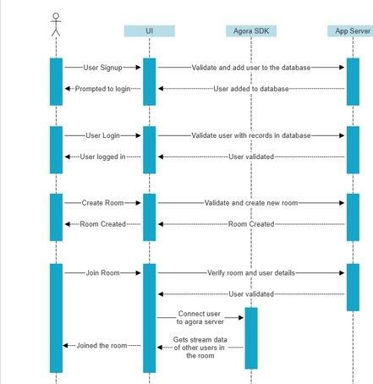

*Figure 4.2 Sequence Diagram*

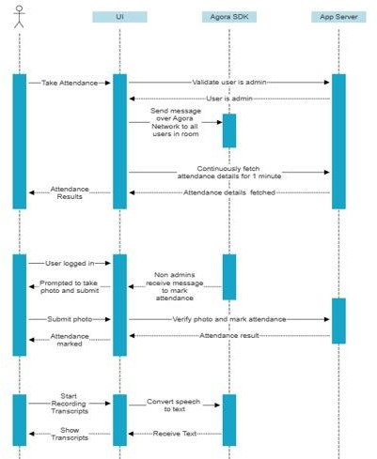

*Figure 4.2 Sequence Diagram*

The sequence diagram above illustrates the process for creating and joining rooms, as well as the steps involved in marking attendance within a room. When a user creates a room, the backend validates whether the room already exists and responds with an error or success message accordingly. Similarly, when a user attempts to join a room, the backend validates whether the user has access to the room and responds with an error or success message. Once a user has joined a room, only the room owner has access to mark attendance.

When the owner clicks on the "mark attendance" button, a popup opens for all students in the room, and attendance marking begins. The result of the attendance marking is then displayed to the owner.

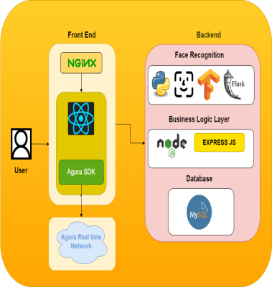

*Figure 4.3 Conceptual Architecture Diagram*

The architecture diagram demonstrates the high-level structure of the Simply Online application. This system has a front-end using Agora SDK, React, and Nginx. In the back- end, there's a layer for recognizing faces that's written in Python using Deepface and Flask, and there's another layer for handling business logic written in Node.js. The front-end and back-end can talk to each other using Express.js REST APIs. This design allows the app to work for lots of people and do video chatting with face recognition to mark attendance. It works well and is fast.

WebRTC

WebRTC is a free tool that allows people to talk or message each other in real-time using their web browsers or mobile apps. You can easily use it by following simple codes called APIs. Google made a new thing in 2011 that lots of people use for talking and working together on the internet. WebRTC lets people talk to each other online without needing extra programs or tools. It's an easy way to learn remotely.

WebRTC lets people talk to each other quickly using some rules and tools like RTP, SIP, and ICE. These rules make sure that communication is safe, works well, and is fast, even when the network is not easy to use. WebRTC has tools that can make the sound and video better in communication. They can help to stop noise, echoes, and make sure the volume is good.

WebRTC makes online learning easier because it allows people to talk in real-time without needing fancy technology or expensive equipment. WebRTC lets students and teachers talk and work together online without needing special software. They can use a website or an app. You can learn online from anywhere, anytime, and using any device. It's simple and helpful for teachers and students. WebRTC is always improving and adding new things because it's open-source. This means people can work together to make it better and add new abilities and features.

Deepface

DeepFace is a software that recognizes faces and was made by Facebook's technology team in 2014. It uses a clever computer program to see and know whose face is in pictures and movies very well. DeepFace is a technology that can identify people even if their face is not fully visible or seen from a different direction. It does this by creating a 3D model of their face and matching it to their facial features. DeepFace is a really good system for recognizing faces. It is almost as good as a human at recognizing faces.

DeepFace is useful for online learning because it can automatically keep track of who is present, and it can verify someone's identity based on their face. DeepFace helps online classes take attendance without people having to do it manually. It saves time and makes sure it's accurate. DeepFace can confirm if students and teachers are who they say they are, so only the right people can use the online learning platform. This can keep people from getting into the online learning platform without permission and make it safer.

We need to know that facial recognition technology may cause worries about privacy and safety. DeepFace technology looks at pictures of people's faces, which may be private and personal, to learn about them. We must ensure that people's privacy is protected, and their pictures are not seen or used by anyone who shouldn't have access to them. Some people think that facial recognition systems might not treat all races and genders equally. This is when people unfairly treat others differently because of who they are. It's important to check for problems before using DeepFace for online learning.

1. CONCLUSION

Many people nowadays are using the internet more often than before to learn. Simply Online makes taking classes on the internet easier by fixing normal issues and giving you everything you need in one place. Simply Online is a helpful tool for teachers and students. It is easy to use, lets you have video chats without problems, and keeps a good record of attendance. Simply Online helps people learn online, even when it's hard to do so.

1. BIBLIOGRAPHY

Han, J., Choi, Y., Lee, J., & Lee, S. (2017). A real-time face recognition system for automated attendance control in university classrooms. Journal of Educational Technology & Society, 20(4), 31-43.

Jadhav, V. B., & More, S. P. (2021). Face Recognition System for Automated Attendance Management System. International Journal of Advanced Science and Technology, 30(5), 1849- 1857.

Al-Mehrizi, M. H., & Adesta, E. Y. T. (2019). Utilizing WebRTC for interactive e-learning system. International Journal of Advanced Computer Science and Applications, 10(2), 64-72.

Taigman, Y., Yang, M., Ranzato, M., & Wolf, L. (2014). DeepFace: Closing the Gap to Human-Level Performance in Face Verification. In Proceedings of the IEEE Conference on Computer Vision and Pattern Recognition (pp. 1701-1708).