**CHAPTER I – PROJECT DEFINITION**

1. **Introduction**

The project, Spa Payment and Sales Monitoring System, is a business system that deals with the Payment System which will be necessary for the spa company to manage the collection and transferring of payments between the clients properly. Along with it is the Sales System which is necessary for keeping tracks of its daily transactions, as well as the monthly overall total sales. A report will be provided together with the logs and other expenditures.

1. **Objective**

* To create an efficient and functional system that will provide a faster transaction of payments.
* To establish a reliable system that could help in organizing the transactions.
* To develop a system that will accurately compute the expenses and revenue of the company and to guarantee the safety of it by applying higher security measures.

1. **Scope and Limitation**

* Appointments/Reservations are not allowed.
* All payment can only be paid after the service; a receipt will be provided.
* The mode of payment could either be cash or voucher.
* The system will show the sales report depending on the date (range) selected by the admin.
* The system will have 2 types of users: the admin and the employee.
* Other expenses that are not relative to the service offered are not included in the computation.

1. **Project Organizational Structure**

|  |  |  |
| --- | --- | --- |
| *PROJECT ORGANIZATIONAL STRUCTURE* | | |
| Function | **Name** | **Role** |
| The leader of the team; Allocates tasks to team members according to their specialty. Also the programmer, the one who writes and designs programs logically fit to the system requirements. | Cholo Miguel B. Antonio | Project Leader, Programmer |
| Collaborates with the programmer to analyze system design and the process model best suitable to it; examines the system requirements; implements and configures test feasible solutions. | Albert T. Coner | Systems Analyst |
| Collaborates with the programmer to analyze system design and the process model best suitable to it; examines the system requirements; implements and configures test feasible solutions. | Juan Paolo V. Famodulan | Systems Analyst |
| * In charge of writing, editing and revising documents according to guidelines; proofread, merge and format documents when required; identifies and resolves problems with the programmer and analysts. | Nica Andrea B. Lleno | Documentation Specialist |
| * In charge of writing, editing and revising documents according to guidelines; proofread, merge and format documents when required; identifies and resolves problems with the programmer and analysts;. | Reina Rina R. Rilles | Documentation Specialist |

1. **Engineering Paradigm**

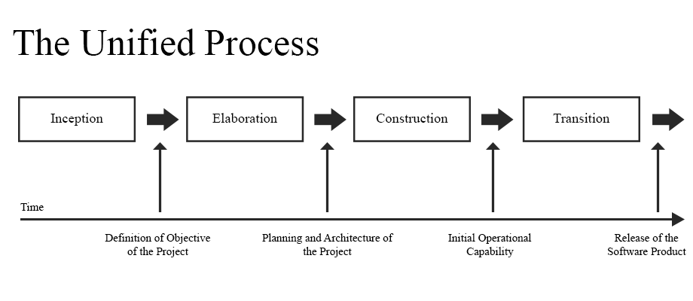

*Inception*

* In this phase, we formulate the objectives of the system.

*Elaboration*

* Java and MySQL are the two languages to be used for the development of the system. A mainframe with an Operating System of Window XP and higher to guarantee a properly working software.
* Included in this phase are the business rules that are essential of how the software should work.

*Architecture*

* In this phase, we determine the user interface of the system.

*Construction*

* After finalizing the architecture, coding will be conducted by the programmer.
* After the coding process, the current system will be tested for the verification of a working, bug-free system and to ensure that the current system meets the objectives and business rules.

*Transition*

* The software will be deployed accordingly with the timeline.

1. **Gantt Chart**
2. PERT-CPM Network

|  |  |  |  |  |
| --- | --- | --- | --- | --- |
| **Activity** | **Pre-requisite** | **EST** | **LST** | **Float/Stack** |
| A |  |  |  |  |
| B |  |  |  |  |
| C |  |  |  |  |
| D |  |  |  |  |
| E |  |  |  |  |
| F |  |  |  |  |

1. Timetable of Activities

|  |  |  |  |
| --- | --- | --- | --- |
| **Activity** | **Time Started** | **Time Finished** | **No. of Days/Weeks** |
| Requirements Gathering | January 04, 2016 | January 11, 2016 |  |
| Planning and Estimation | January 12, 2016 | January 18, 2016 |  |
| Development of the System | January 19, 2016 | February 20, 2016 |  |
| Testing/Checking of Errors | February 21, 2015 | February 29, 2016 |  |
| Collaboration including the technological information | March 01, 2016 | March 18, 2016 |  |
| Final Defense | March 21, 2016 | March 21, 2016 |  |

1. **Problems Encountered**

|  |  |  |
| --- | --- | --- |
| *PROBLEMS ENCOUNTERED* | | |
| Function | **Name** | **Problem** |
|  |  |  |
|  |  |  |
|  |  |  |
|  |  |  |
|  |  |  |

1. **Conclusions and Recommendations**

To conclude, although we encountered different problems while developing the system required we have finally finished it within the scheduled time. We also recommend a system that is useful and efficient for a manual process and could be beneficial for the business.

**CHAPTER II – PROJECT DESIGN**

**System Screenshots**