My First Markdown Document

Clemens

August 2, 2018

This is my first Markdown Document

Let’s load some data.

library(datasets)  
data(airquality)  
summary(airquality)

## Ozone Solar.R Wind Temp   
## Min. : 1.00 Min. : 7.0 Min. : 1.700 Min. :56.00   
## 1st Qu.: 18.00 1st Qu.:115.8 1st Qu.: 7.400 1st Qu.:72.00   
## Median : 31.50 Median :205.0 Median : 9.700 Median :79.00   
## Mean : 42.13 Mean :185.9 Mean : 9.958 Mean :77.88   
## 3rd Qu.: 63.25 3rd Qu.:258.8 3rd Qu.:11.500 3rd Qu.:85.00   
## Max. :168.00 Max. :334.0 Max. :20.700 Max. :97.00   
## NA's :37 NA's :7   
## Month Day   
## Min. :5.000 Min. : 1.0   
## 1st Qu.:6.000 1st Qu.: 8.0   
## Median :7.000 Median :16.0   
## Mean :6.993 Mean :15.8   
## 3rd Qu.:8.000 3rd Qu.:23.0   
## Max. :9.000 Max. :31.0   
##

Here’s a pairs plot of the data.

pairs(airquality)

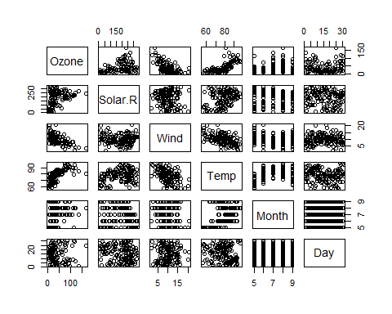

Here’s a regression model of ozone on some predictors.

fit <- lm(Ozone ~ Solar.R + Wind + Temp, data = airquality)  
summary(fit)

##   
## Call:  
## lm(formula = Ozone ~ Solar.R + Wind + Temp, data = airquality)  
##   
## Residuals:  
## Min 1Q Median 3Q Max   
## -40.485 -14.219 -3.551 10.097 95.619   
##   
## Coefficients:  
## Estimate Std. Error t value Pr(>|t|)   
## (Intercept) -64.34208 23.05472 -2.791 0.00623 **   
## Solar.R 0.05982 0.02319 2.580 0.01124 *   
## Wind -3.33359 0.65441 -5.094 1.52e-06 ***  
## Temp 1.65209 0.25353 6.516 2.42e-09 ***  
## ---  
## Signif. codes: 0 '***' 0.001 '**' 0.01 '*' 0.05 '.' 0.1 ' ' 1  
##   
## Residual standard error: 21.18 on 107 degrees of freedom  
## (42 observations deleted due to missingness)  
## Multiple R-squared: 0.6059, Adjusted R-squared: 0.5948   
## F-statistic: 54.83 on 3 and 107 DF, p-value: < 2.2e-16

Here’s an unordered list

. Here’s item one . Here’s item two

Here’s an ordered list

1. Don’t pick up the phone
2. Don’t be his friend