# **Pre-Lab (Lab1)**

## **Task 1**

Execute a simple python program to check the python installation and environment setup.

import numpy as np

import matplotlib.pyplot as plt

values = np.random.randn(100)

plt.plot(values)

plt.title('random noise using test program')

plt.xlabel('x- axis')

plt.ylabel('y-axis')

plt.show()

After executing the program, you should see an output similar to the following image.

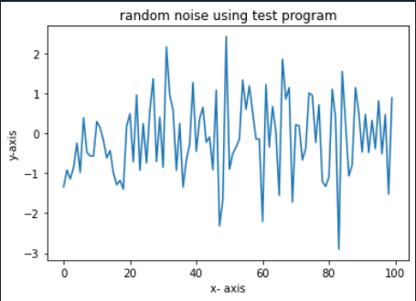

# **In-Lab**

## **Task 1**

Execute a simple python program to check the python installation and environment setup.

## **Task 2**

Execute a simple python program to check the python installation and environment setup.

print('Hello World!')

After executing the program, you should see an output similar to the following image.



## **Task 3**

Execute a simple python program to check the python installation and environment setup.

x=1

if x==1:

print('x is',x)

To test whether a variable has a specific value, use the Boolean operators:

* ♣  equal: ==
* ♣  not equal: !=
* ♣  greater than: >
* ♣  less than: <

After executing the program, you should see an output similar to the following image.



## **Task 4**

Execute a simple python program to check the python installation and environment setup.

print('Print Value of Integer ... ')

integer_us = 7

print (integer_us)

# 2. Float

print('Print Value of Float ...')

float_us = 7.0

print(float_us)

myfloat = float(integer_us)

# 3. Convert float to integer

myint= int(7.3)

print(myint)

mystring = "Hello, World!"

print (mystring)

print (mystring)

one = 1

two = 2

three = one + two

print(three)

hello= "Hello,"

world = "World!"

helloworld = hello + " " + world

a, b = 3, 4

print (a, b)

mylist = []

mylist.append(1)

mylist.append(2)

mylist.append(3)

print(mylist[-1])

names = ["John", 3234, 2342, 3323, "Eric", 234, "Jessica", 734978234, "Lois", 2384]

print("Number of names in list: {}".format(len(names)))

2. Float

print('Print Value of Float ...')

float_us = 7.0

print(float_us)

myfloat = float(integer_us)

# 3. Convert float to integer

myint= int(7.3)

print(myint)

mystring = "Hello, World!"

print (mystring)

print (mystring)

one = 1

two = 2

three = one + two

print(three)

hello= "Hello,"

world = "World!"

helloworld = hello + " " + world

a, b = 3, 4

print (a, b)

mylist = []

mylist.append(1)

mylist.append(2)

mylist.append(3)

print(mylist[-1])

names = ["John", 3234, 2342, 3323, "Eric", 234, "Jessica", 734978234, "Lois", 2384]

print("Number of names in list: {}".format(len(names)))

mylist.append(2)

mylist.append(3)

print(mylist[-1])

names = ["John", 3234, 2342, 3323, "Eric", 234, "Jessica", 734978234, "Lois", 2384]

print("Number of names in list: {}".format(len(names)))

After executing the program, you should see an output similar to the following image.

