REPUBLIC OF KENYA

MINISTRY OF LANDS, PUBLIC WORKS, HOUSING AND URBAN DEVELOPMENT
State Department for Housing and Urban Development

Affordable Housing with Associated Amenities and Infrastructure

PROPOSED CONSTRUCTION OF MAKINDU AFFORDABLE HOUSING PROJECT IN MAKINDU, KIBWEZI WEST CONSTITUENCY, MAKUENI COUNTY WITH ASSOCIATED INFRASTRUCTURE.

MONTHLY REPORT (24th March –
19th April 2026)

- CONTRACT DETAILS
Table 1: Summarized contract information
1. | Project Title | Proposed Construction of Makindu Affordable Housing  Project in Makindu, Kibwezi West Constituency, Makueni County with associated infrastructure.
2. | Contract No. | MLPWHUD/SDHUD/AHP/160/2023-2024.
3. | County | MAKUENI
4. | Sub-County | MAKINDU
5. | Constituency | KIBWEZI WEST
6. | Client | State Department of Housing and Urban Development
7. | Employer | Principal Secretary,  State Department of Housing and Urban Development  P. O. Box 30119 – 00200  Nairobi, KENYA
8. | Contractor | NETGAS ENERGY AND CONSTRUCTION LTD
9. | Contract Sum | KES. 2,127,050,827.72
10. | Advance Payment | KES 425,410,165.54
11. | Commencement Date | 24th November 2025
12. | Project Duration | 24 Months
13. | Date of Completion | 24th November 2027
14. | Time Lapsed in Weeks | 21 Weeks
15. | % contract period elapsed | 20.25%
16. | % work done | 7.29%
17. | Reporting Period | 25TH MARCH– 20th APRIL 2026

- SOCIO-ECONOMIC IMPACT
The Makindu affordable housing project has significant socio-economic impacts, as it generates employment opportunities during construction and in related supply chains, stimulates local businesses through increased demand for goods and services, and provides secure, decent housing that improves health and safety outcomes for low-income families. By offering rent-to-own and tenant purchase options, it enhances financial stability and asset ownership among residents, while also fostering community development through better infrastructure and social amenities. Overall, the project acts as a catalyst for inclusive economic growth, poverty reduction, and long-term resilience in the region.

- SCOPE OF WORKS
The Works to Be Carried Out Comprises Construction of: -
  - 4 No. Blocks (G+9) Block Type B-Affordable +Market units
  - 5 No. Blocks (G+9) Block type C-Social + Shops + Affordable units
  - Club House (G+1)
  - Kindergarten-(G)
  - Garbage Receptacle
  - Gate House
  - Associated amenities and Infrastructure
The following is a tabulation of items typologies as outlined in the Drawings
S/N | UNITS | NO. OF UNITS
1 | SOCIAL UNITS- 19%
a). | 1 Room social Housing 20 sqm | 50
b). | 2 Room Social Housing 30 sqm | 100
c). | 3 Room Social Housing 40 sqm | 50
2 | AHP UNITS- 45%
a). | Studio Affordable Housing 20 sqm | 100
b). | 2 Bed Affordable Housing 40 sqm | 225
c). | 3 Bed Affordable Housing 60 sqm | 90
3 | MARKET UNITS- 36%
a). | 2 Bed Market Housing 60 sqm | 120
b). | 3 Bed Market Housing 80 sqm | 120
4 | AMENITIES
a). | Kindergarten
b). | Shops
c). | Power House
d). | Garbage Receptacles
e). | Gate House
f). | Playground
g). | Club House
h). | Outdoor kids play area
i). | Secured boundary wall
j). | Borehole
k). | back-up Generator
l). | Cabro paved driveways

- DETAILED SCOPE OF WORKS AND IMPLEMENTATION STATUS
Table 2: Physical work progress executed as at from 24TH Feb 2025 to 23rd March 2026.
GENERAL WORKS
- Construction of 2No. staff Sanitation facilities – done
- Site hoarding branding - ongoing
- 3-phase power connection to site - completed
- Construction of realtor’s office - ongoing
- Installation of CCTV cameras - completed
BUILDER’S WORK
- UNDERGROUND WATER TANK
- Excavation - ongoing
- KINDERGATEN UNIT
- Mass excavation and disposal of excavated material within the site – complete
- Setting out of the site
- Blinding
- Rebar installation of the isolated and strip footing
- Casting of the footing
- Installation of the foundation walling
- Hardcore and murram filling and compaction
- Casting of ground slab, reinforcement to superstructure columns
- BLOCK TYPE B
B4
- Mass excavation and disposal of excavated material within the site – complete
- Blinding works - complete
- Rebar to raft foundation and starter columns - complete

B3
- Blinding works - complete
- Rebar to raft foundation and starter columns – complete
- Casting of raft foundation – complete
- Lapping of reinforcement to foundation columns – complete
- Setting and casting of columns kickers for the foundation columns – complete
- Formwork to lift core – complete

B2
- Blinding works - complete
- Rebar to raft foundation and starter columns - complete
- Casting of raft foundation – complete
- Lapping of reinforcement to foundation columns – complete
- Setting and casting of columns kickers for the foundation columns – complete
- Formwork to lift core – complete

B1
- Blinding works - complete
- Rebar to raft foundation and starter columns - complete
- Casting of raft foundation – complete
- Lapping of reinforcement to foundation columns – complete
- Setting and casting of columns kickers for the foundation columns – complete
- Formwork to lift core – done
- Formwork to foundation columns – done
- Casting of foundation columns and lift core C30 concrete- complete
- BLOCK TYPE C
C5
  - Mass Excavation and disposal of excavated material – complete
  - Blinding works- complete

- INSURANCES
INSURANCE POLICY | EXPIRY DATE
Performance security | 15/03/2027
Advance payment guarantee | 02/12/2026
Contractor’s All Risk | 11/03/2027
Public Liability | 02/02/2027
Work Injury Benefit | 02/02/2027
- PROGRESS COMPARISON WITH PREVIOUS MEETING
 | PREVIOUS MEETING | CURRENT MEETING
Time Elapsed | 16.29% | 20.25%
Work Progress | 5.83% | 7.29%

- CUBES LAB TEST RESULTS DONE TO DATE
BLOCK B1 BLINDING | Compressive strength at 7 days (N/mm2)
Sample 1 | 12.3
Sample 2 | 12
Sample 3 | 10.6
BLOCK B1 BLINDING | Compressive strength at 7 days (N/mm2)
Sample 1 | 11.1
Sample 2 | 11.9

- MACHINES AND EQUIPMENT MOBILIZATION
The following are contractors’ plant and equipment returns reported from 24th Feb to 23rd March 2026.
Category | No. | Condition | Status
21T Chain Excavator | 1 | Good | Working
Backhoe excavator | 1 | Good | Working
Rotating drum concrete mixers | 2 | Good | Working
Batching Plant – 30M3/Hr. | 1 | Good | Working
18-Ton Tipper | 2 | Good | Working
Generator | 1 | Good | Working

Wheelbarrows | 5 | Good | Working
Assorted tools and equipment |  | Good | Working

- LABOUR TURN OVER
In the period under review, the following were number of personnel on site

23rd March –29th March 2026
CATEGORY | MON | TUE | WED | THU | FRI  (Night) | FRI (Day) | SAT | SUN
Site Agent / PM | 1 | 2 | 1 | 1 | 1 | 1 | 1 | 1
Ass. Site Agent | 1 | 2 | 1 | 1 | 1 | 1 | 1 | 1
Office Attendant /  Assistant | 0 | 0 | 3 | 3 | 1 | 0 | 1 | 1
Foreman | 4 | 3 | 4 | 3 | 3 | 3 | 3 | 1
Operator | 8 | 8 | 8 | 4 | 5 | 5 | 5 | 0
Mason | 5 | 5 | 5 | 4 | 2 | 0 | 3 | 0
Electrician | 0 | 0 | 0 | 0 | 0 | 0 | 0 | 0
Carpenters | 9 | 12 | 16 | 10 | 2 | 12 | 7 | 4
Steel Fixers | 9 | 5 | 2 | 2 | 1 | 1 | 8 | 0
Surveyors | 2 | 2 | 2 | 2 | 2 | 0 | 2 | 2
Unskilled (Day) | 31 | 39 | 35 | 37 | 40 | 52 | 42 | 4
Safety Officer | 1 | 1 | 1 | 1 | 1 | 1 | 1 | 0
Store Keeper | 1 | 1 | 1 | 1 | 1 | 1 | 1 | 1
Security (Day &  Night) | 8 | 8 | 2 | 2 | 6 | 2 | 2 | 2
TOTAL | 80 | 88 | 81 | 71 | 64 | 96 | 85 | 19

30th March - 5th April 2026
CATEGORY | Mon | Tue | Wed | Thur | Fri | Sat | Sun
Site Agent/PM | 1 | 1 | 1 | 1 | 1 | 1 | 1
Ass. Site Agent | 2 | 2 | 2 | 1 | 1 | 1 | 1
Office Attendant | 0 | 0 | 0 | 1(f) | 2(m) | 2(m) | 2(m)
Office Assistant | 0 | 0 | 0 | 2(m) | 1(f) | 1(f) | 1(f)
Foreman | 3 | 3 | 3 | 3 | 3(m) | 3(m) | 0
Operator | 5 | 5 | 5 | 4(m) | 4(m) | 6(m) | 0
Mason | 3 | 3 | 3 | 2(m) | 2(m) | 2(m) | 0
Electrician | 0 | 0 | 0 | 0 | 0 | 0 | 0
Plumbers | 0 | 0 | 0 | 0 | 0 | 0 | 0
Carpenters | 0 | 4 | 4 | 1(m) | 4(m) | 1(m) | 0
Steel fixers | 0 | 16 | 16 | 8(1f,  7m) | 1(m) | 1(m) | 0
Steel Unskilled | 0 | 0 | 0 | 7(m) | 1(m) | 0 | 0
Drivers | 0 | 0 | 0 | 0 | 0 | 1(m) | 0
Surveyors | 2 | 2 | 2 | 2(1m,  1f) | 2(1m,  1f) | 2(1m,  1f) | 2(1m,  1f)
Unskilled | 15 | 27 | 16 | 6(1f,  5m) | 6(1f,  5m) | 13(3f,  10m) | 1(m)
Safety officer | 1 | 1 | 1 | 1(m) | 1(m) | 1(m) | 0
Store keeper | 1 | 1 | 1 | 1(m) | 1(m) | 1(m) | 1(m)
Security | 8 | 8 | 8 | 2(1m,1f) | 2(1m, 1f) | 2(1m,1f) | 2(1m, 1f)
TOTAL | 41 | 41 | 62 | 42 | 32 | 38 | 11

6th April - 12th April 2026
CATEGORY | Mon | Tue | Wed | Thu | Fri | Sat | Sun
Site Agent/PM | 1 | 1 | 1 | 1 | 1 | 1 | 1
Ass. Site Agent | 1 | 2 | 2 | 2 | 1 | 1 | 1
Office Attendant | 1 | 0 | 0 | 0 | 3 | 1 | 1
Office Assistant | 3 | 0 | 0 | 0 | 0 | 3 | 3
Foreman | 1 | 1 | 1 | 1 | 3 | 2 | 1
Operator | 5 | 5 | 6 | 6 | 6 | 6 | 1
Mason | 0 | 4 | 5 | 5 | 3 | 1 | 0
Electrician | 0 | 0 | 0 | 0 | 0 | 0 | 0
Plumbers | 0 | 0 | 0 | 0 | 0 | 0 | 0
Carpenters | 0 | 0 | 0 | 0 | 0 | 0 | 0
Steel Fixers | 0 | 0 | 0 | 7 | 8 | 9 | 0
Steel Unskilled | 0 | 0 | 0 | 0 | 4 | 5 | 0
Drivers | 1 | 0 | 0 | 1 | 0 | 0 | 0
Surveyors | 2 | 2 | 2 | 2 | 2 | 2 | 2
Unskilled | 5 | 9 | 9 | 10 | 14 | 11 | 9
Safety Officer | 1 | 1 | 1 | 1 | 1 | 1 | 0
Store Keeper | 1 | 1 | 1 | 1 | 1 | 1 | 1
Security | 2 | 8 | 8 | 8 | 2 | 2 | 2
TOTAL | 24 | 34 | 36 | 45 | 49 | 46 | 22

13th April – 19th April 2026
CATEGORY | Mon | Tue | Wed | Thur | Fri | Sat | Sun
Site Agent/PM | 1 | 1 | 1 | 1 | 1 | 1(m) | 1(m)
Ass. Site Agent | 1 | 1 | 1 | 1 | 1 | 1(m) | 1(m)
Office Attendant | 1(f) | 1(f) | 1(f) | 1(f) | 1(f) | 1(f) | 1(f)
Office Assistant | 3(m) | 3(m) | 3(m) | 3(m) | 1(m) | 2(m) | 2(m)
Foreman | 1(m) | 1(m) | 3(m) | 3(m) | 4(m) | 4(m) | 4(m)
Operator | 6(m) | 3(m) | 3(m) | 7(m) | 7(m) | 7(m) | 6(m)
Mason | 1(m) | 1(m) | 1(m) | 1(m) | 2(m) | 1(m) | 13(m)
Electrician | 0 | 0 | 0 | 0 | 0 | 0 | 1
Plumbers | 0 | 0 | 0 | 0 | 0 | 2 (m) | 2 (m)
Carpenters | 0 | 0 | 5(m) | 7(m) | 12(m) | 2(m) | 0
Steel fixers | 0 | 0 | 13(m) 1(f) | 15(14m, 1f) | 13(12m, 1f) | 13(12m, 1f) | 7(m)
Drivers | 0 | 0 | 0 | 0 | 0 | 0 | 0
Surveyors | 2(1f, 1m) | 2(1f, 1m) | 2(1f, 1m) | 2(1f, 1m) | 2(1f, 1m) | 2(1f, 1m) | 2(1f, 1m)
Unskilled | 9(1f, 8m) | 10(2f, 8m) | 35(2f, 33m) | 47(9f, 36m) | 45(11f, 34m) | 41(7f, 34m) | 31(6f, 25m)
Safety officer | 1(m) | 1(m) | 1(m) | 1(m) | 1(m) | 1(m) | 1(m)
Store keeper | 1(m) | 1(m) | 1(m) | 1(m) | 1(m) | 1(m) | 1(m)
Security | 2(1m, 1f) | 2(1m, 1f) | 8(7m, 1f) | 8(7m, 1f) | 8(7m, 1f) | 8(7m, 1f) | 8(7m, 1f)
TOTAL | 29 | 27 | 81 | 98 | 99 | 88 | 81

- MATERIALS DELIVERED TO SITE
S/N | Description | Total Quantity | Unit
01 | D16 Reinforcement Bars | 2,288 | pcs
02 | D20 Reinforcement Bars | 575 | pcs
03 | Cement 32.5N | 580 | bags
04 | Cement 42.5N | 580 | bags
05 | Cement (Unspecified Grade) | 2,030 | bags
06 | Ballast | 453.4 | tons
07 | Aggregates | 338.32 | tons
08 | Foundation Stones | 4674 | ft
09 | Hardcore | 11 | tippers
10 | Clean Fresh Water | 5,000 | Ltrs
- WEATHER REPORT
23rd March – 30th March 2026
DAY | MORNING | AFTERNOON | EVENING | CONDITION
Monday | Cloudy | Cloudy with light showers | Cloudy | Conducive for working
Tuesday | Cloudy | Cloudy with light showers | Cloudy | Conducive for working
Wednesday | Sunny | Sunny | Cloudy | Conducive for working
Thursday | Sunny | Sunny | Cloudy | Conducive for working
Friday | Sunny | Sunny | Cloudy | Conducive for working
Saturday | Sunny | Sunny | Cloudy | Conducive for working
Sunday | Sunny | Sunny | Cloudy | Conducive for working
 |  |  |  | Conducive for working
31st March - 5th April 2026
DAY | MORNING | AFTERNOON | EVENING | CONDITION
Sunday | Sunny | Sunny | Cloudy | Conducive for working
Monday | Sunny | Sunny | Cloudy | Conducive for working
Tuesday | Sunny | Sunny | Cloudy | Conducive for working
Wednesday | Sunny | Sunny | Cloudy | Conducive for working
Thursday | Sunny | Sunny | Cloudy | Conducive for working
Friday | Sunny | Sunny | Cloudy | Conducive for working
Saturday | Sunny | Sunny | Cloudy | Conducive for working
Sunday | Sunny | Sunny | Cloudy | Conducive for working
6TH – 12TH March 2026
DAY | MORNING | AFTERNOON | EVENING | CONDITION
Monday | Sunny | Sunny | Cloudy | Conducive for working
Tuesday | Sunny | Sunny | Cloudy | Conducive for working
Wednesday | Sunny | Sunny | Cloudy | Conducive for working
Thursday | Sunny | Sunny | Cloudy | Conducive for working
Friday | Sunny | Sunny | Cloudy | Conducive for working
Saturday | Sunny | Sunny | Cloudy | Conducive for working
Sunday | Sunny | Sunny | Cloudy | Conducive for working

13th -19th March 2026
Day | Morning | Afternoon | Evening | Condition
Monday | Sunny | Sunny | Sunny | Conducive for working
Tuesday | Sunny | Sunny | Sunny | Conducive for working
Wednesday | Sunny | Sunny | Sunny | Conducive for working
Thursday | Sunny | Sunny | Sunny | Conducive for working
Friday | Sunny | Sunny | Sunny | Conducive for working
Saturday | Sunny | Sunny | Sunny | Conducive for working
Sunday | Sunny | Sunny | Sunny | Conducive for working

- HEALTH AND SAFETY
- 3 Minor incidences reported over the reporting period

- SECURITY
- 1 theft case reported

- VISITORS/ CONSULTANTS ON SITE
S/NO. | NAME | ORGANIZATION | DATE ON SITE | PURPOSE FOR  SITE VISIT
1. | Teresia Wangui | Medivoly consultants | 24/02/2026 | Site Meeting
2. | Edwin Kariuki | Amazon Consultants | 24/02/2026 | Site Meeting
3. | Mwangi Mwangi | Epoch Consultants (Structural Engineer) | 24/02/2026 | Site Meeting
4. | Paul Bhoyo | Tej Architects (Project Architect) | 24/02/2026 | Site Meeting
5. | Legeck Duncan | Tej Consultants | 24/02/2026 | Site Meeting
6. | Boniface Mule | CDH | 24/02/2026 | Site Meeting
7. | Hellen Chege | DCC | 24/02/2026 | Site Meeting

- SITE INSTRUCTIONS ISSUED
REF NO | DETAILS | DATE | INSTRUCTOR
019 | MEP Sample Approval – The provided MEP sample board on site has met the requirements. PPR pipes are PN 20, drainage pipes are heavy gauge as per required standards. Electric conduits (metro) & fittings approved. | 24/03/2026 | Tej/Medivolt Consultants
020 | CASTING OF BLINDING (B4)  Contractor is given approval to proceed and cast blind for B4 foundation with class 15 of concrete | 02/04/2026 | George Ajwang (Resident Engineer)
022 | CASTING OF BLINDING (C5)  Casting of Blind (C5) Contractor is given approval to proceed and cast blind for (C5) foundation with class (15) of concrete. | 15/04/2026 | George Ajwang (Resident Engineer)

- CHALLENGES
- Mud and water ponding from rain delayed excavation works of foundation pits on certain days
- Untimely mobilization of materials slowing down work progress
- Insufficient tools/equipment used to perform certain activities, causing slow work progress

- PROGRESS PHOTOS

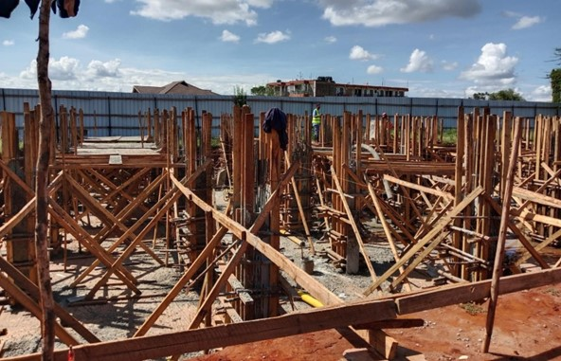
Figure 1: Casting of foundation columns at B1

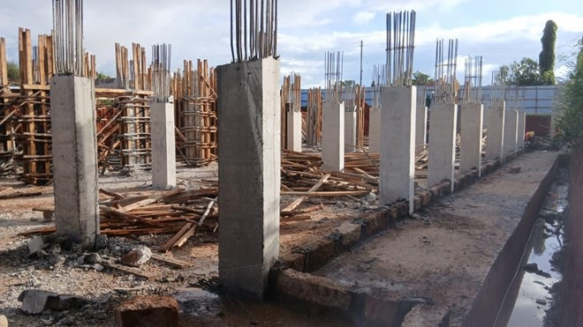
Figure2: Block B1 with the casted foundation columns
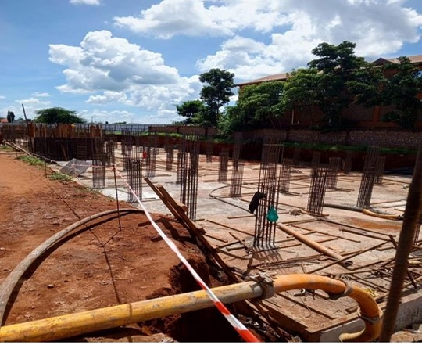
Figure 3: Block B3 raft foundation

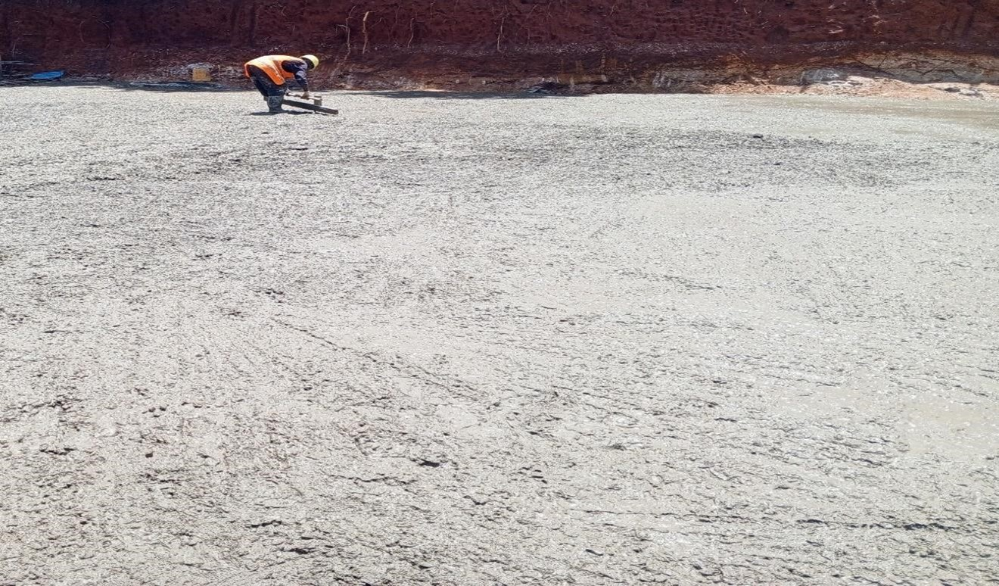
Figure 4: Blinding at Block B4
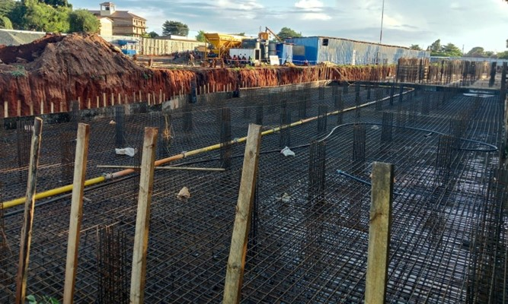
Figure 5: Formwork to raft foundation, Steel fixing and setting of starter columns in Block B4

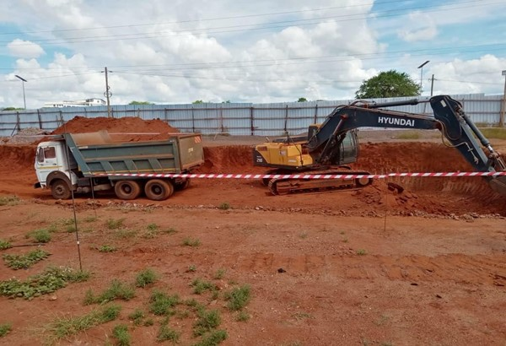
Figure 6: Excavation of Block C5 foundation pit

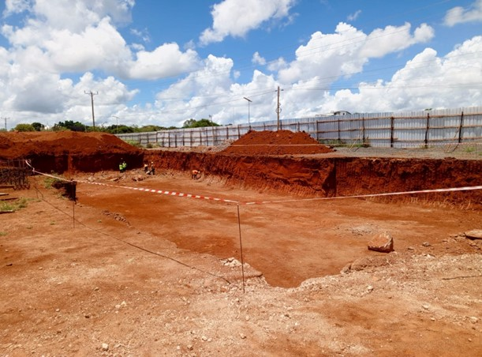
Figure 7: Block C5 Foundation pit
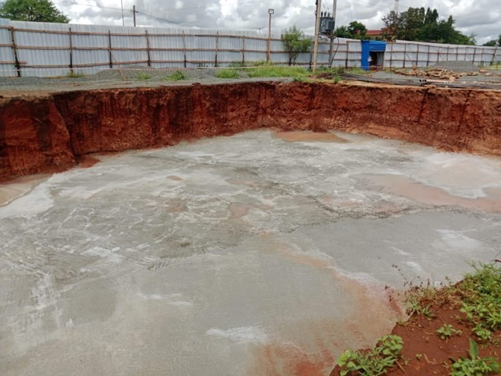
Figure 8: Blinding at Block C5
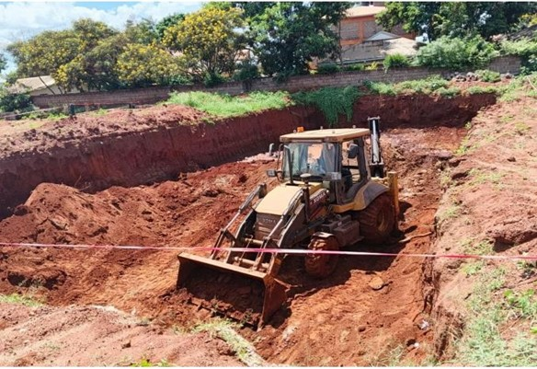
Figure 9: Excavation of pit for the underground tank

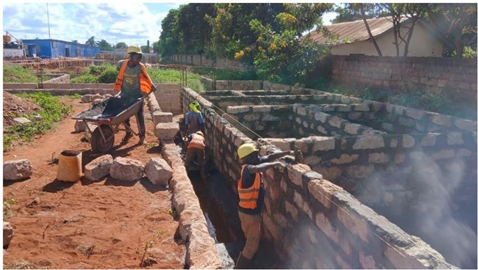
Figure 10: Foundation walling construction in the kindergarten building

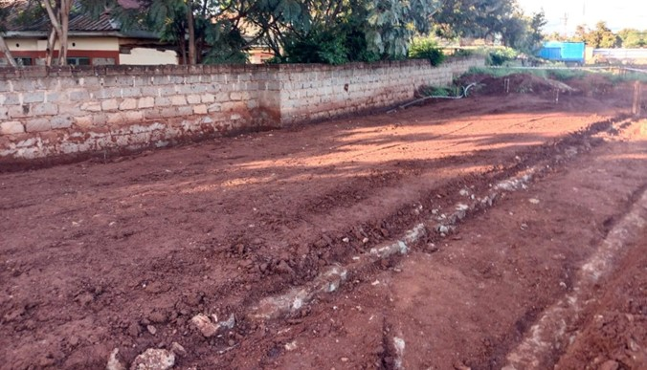
Figure 11: Kindergarten – hardcore and murram filling and compaction

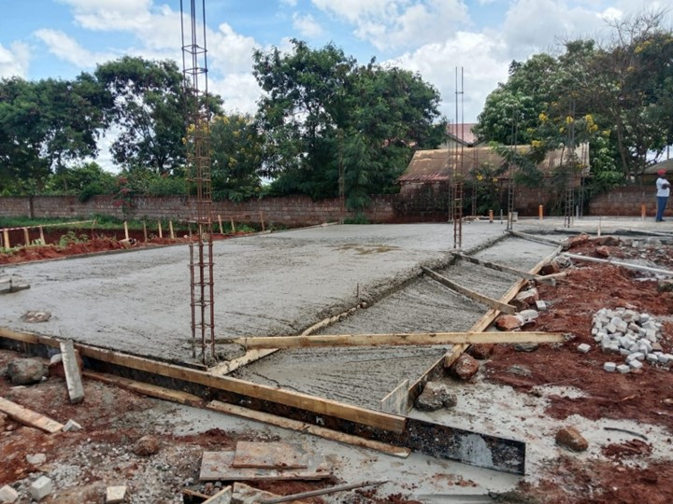
Figure 12: Kindergarten – casting of ground slab, reinforcement to superstructure columns
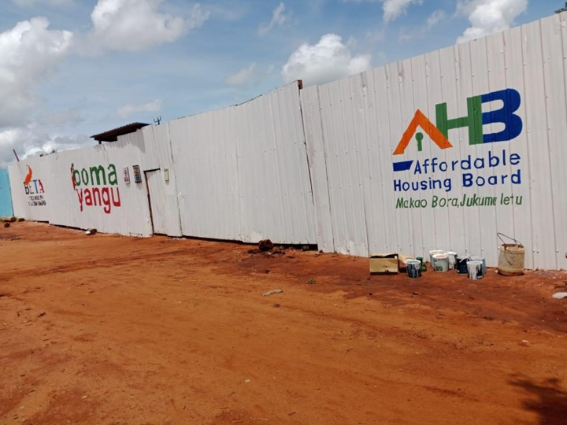
Figure 13: Branding of the Site’s Perimeter wall

Prepared by: Grace Musangi
Designation: Clerk of Works

Signature: …………………… Date: ……………………

Signed: ………………………...... Date: ………………….
Lead Consultant (Tej Consortium)

