REPUBLIC OF KENYA

MINISTRY OF LANDS, PUBLIC WORKS, HOUSING AND URBAN DEVELOPMENT
State Department for Housing and Urban Development

Affordable Housing with Associated Amenities and Infrastructure

PROPOSED CONSTRUCTION OF MAKINDU AFFORDABLE HOUSING PROJECT IN KIBWEZI WEST CONSTITUENCY, MAKUENI COUNTY.

WEEK _ PROGRESS REPORT

DATE:

CONTRACT DETAILS
Table 1: Summarized contract information
1. | Project Title | Proposed Construction of Makindu Affordable Housing Project in Kibwezi West Constituency, Makueni County.
2. | Contract No. | MLPWHUD/SDHUD/AHP/160/2024-2025.
3. | County | MAKUENI
4. | Sub-County | MAKINDU
5. | Constituency | KIBWEZI WEST
6. | Client | State Department of Housing and Urban Development
7. | Employer | Principal Secretary,  State Department of Housing and Urban Development  P. O. Box 30119 – 00200  Nairobi, KENYA
8. | Contractor | NETGAS ENERGY AND CONSTRUCTION LTD
9. | Contract Sum | KES. 2,127,050,827.72
10. | Advance Payment | KES 425,410,165.54
11. | Commencement Date | 24th November 2025
12. | Project Duration | 24 Months
13. | Date of Completion | 24th November 2027
14. | Time Lapsed in Weeks
15. | % contract period elapsed
16. | % work done
17. | Date of this Report

INSURANCES
INSURANCE POLICY | EXPIRY DATE
Performance security | 15/03/2027
Advance payment guarantee | 02/12/2026
Contractors all risk | 11/03/2027
Public Liability | 02/02/2027
Work injury benefit | 02/02/2027

SOCIO-ECONOMIC IMPACT
The Makindu affordable housing project has significant socio-economic impacts, as it generates employment opportunities during construction and in related supply chains, stimulates local businesses through increased demand for goods and services, and provides secure, decent housing that improves health and safety outcomes for low-income families. By offering rent-to-own and tenant purchase options, it enhances financial stability and asset ownership among residents, while also fostering community development through better infrastructure and social amenities. Overall, the project acts as a catalyst for inclusive economic growth, poverty reduction, and long-term resilience in the region.

SCOPE OF WORKS
The Works to Be Carried Out Comprises Construction of: -
  - 4 No. Blocks (G+9) Block Type B-Affordable +Market units
  - 5 No. Blocks (G+9) Block type C-Social + Shops + Affordable units
  - Club House (G+1)
  - Kindergarten-(G)
  - Garbage Receptacle
  - Gate House
  - Associated amenities and Infrastructure
The following is a tabulation of items typologies as outlined in the Drawings
c | UNITS | NO. OF UNITS
1 | SOCIAL UNITS- 19%
a). | 1 Room social Housing 20 sqm | 50
b). | 2 Room Social Housing 30 sqm | 100
c). | 3 Room Social Housing 40 sqm | 50
2 | AHP UNITS- 45%
a). | Studio Affordable Housing 20 sqm | 100
b). | 2 Bed Affordable Housing 40 sqm | 225
c). | 3 Bed Affordable Housing 60 sqm | 90
3 | MARKET UNITS- 36%
a). | 2 Bed Market Housing 60 sqm | 120
b). | 3 Bed Market Housing 80 sqm | 120
4 | AMENITIES
a). | Kindergarten
b). | Shops
c). | Power House
d). | Garbage Receptacles
e). | Gate House
f). | Playground
g). | Club House
h). | Outdoor kids play area
i). | Secured boundary wall
j). | Borehole
k). | back-up Generator
l). | Cabro paved driveways

SITE REPORT
PROJECT: PROPOSED CONSTRUCTION OF MAKINDU AFFORDABLE HOUSING PROJECT IN KIBWEZI WEST CONSTITUENCY, MAKUENI COUNTY.
DATE:
WORKING DURATION: | Starting time | 7:30 AM
WORKING DURATION: | Closing time | 6:00 PM

WORKS CARRIED OUT ON SITE
Table 2: Breakdown of Scope and Work Progress
DAY | WORK DONE
MONDAY- DATE:
TUESDAY- DATE:
WEDNESDAY- DATE:

THURSDAY- DATE:
FRIDAY- DATE:
SATURDAY- DATE:
SUNDAY- DATE:
- MATERIALS DELIVERED TO SITE
S/NO | Description | Quantity

- MACHINES AND EQUIPMENT MOBILIZATION
S/N | Description | QTY | Status
 | Back-hoe excavator
 | 21T Chain Excavator
 | Concrete Mixer
 | Concrete Pump
 | Batching Plant
- LABOUR TURN OVER
CATEGORY | Mon | Tue | Wed | Thur | Fri | Sat | Sun
Site Agent/PM
Ass. Site Agent
Office Attendant
Office Assistant
Foreman
Operator
Mason
Electrician
Plumbers
Carpenters
Steel fixers
Steel Unskilled
Drivers
Surveyors
Unskilled
Safety officer
Store keeper
Security
TOTAL

SITE INSTRUCTIONS ISSUED
REF. NO | INSTRUCTION ISSUED | DATE | INSTRUCTIONS GIVEN BY:

- INTERNS
Mon | Tue | Wed | Thur | Fri | Sat | Sun

- SECURITY

WEATHER

DAY | MORNING | AFTERNOON | EVENING | CONDITION

Monday

Tuesday

Wednesday

Thursday

Friday

Saturday

Sunday

HEALTH AND SAFETY.

- VISITORS

CHALLENGES / PENDING ISSUES

- SUMMARY OF WORKS DONE TO DATE

SUMMARY OF WORK DONE TO DATE:
GENERAL WORKS | - Hoarding  - Construction of site office  - Construction of Cement store  - Construction of general store  - Construction of Operation room for the batching plant  - Construction of 7No. Ablution blocks  - Construction of changing rooms (male and female)  - Electrical power connection  - Borehole drilling  - 3-phase power connection – Ongoing  - Construction of realtor’s office - ongoing
BLOCK B1 | - Site clearance  - Setting out  - Mass excavation ongoing  - Compaction of excavated section  - FDD Test  - Blinding works  - Reinforcement to the raft foundation  - Casting of raft foundation- done  - Reinforcement and formwork of foundation columns and lift shear wall
BLOCK B2 | - Site clearance  - Setting out  - Excavation for raft foundation to a depth of 3m.  - Levelling and compaction.  - FDD Test  - Blinding works  - Reinforcement to the raft foundation  - Casting of raft foundation- done  - Reinforcement of foundation columns and lift shear wall  - Formwork of the lift shear wall
BLOCK B3 | - Site clearance  - Setting out  - Excavation for raft foundation to a depth of 3m.  - Levelling and compaction.  - FDD Test  - Blinding works  - Reinforcement to the raft foundation  - Casting of raft foundation- done  - Reinforcement of foundation columns and lift shear wall  - Formwork of the lift shear wall
BLOCK B4 | - Site clearance  - Setting out  - Excavation for raft foundation to a depth of 3m.  - Levelling and compaction in progress.
BLOCK C5 | - Site clearance  - Setting out  - Excavation for raft foundation to a depth of 3m- ongoing
UNDERGROUND TANK | - Site clearance  - Setting out  - Excavations for the foundation pit.  - Other works on hold
KINDERGATEN | - Site clearance  - Excavation for pad footings and trenches for strip footing.  - Levelling and compaction.  - Concrete blinding.  - Casting of strip and pad footings.  - Casting of substructure columns.  - Foundation walling -ongoing
SWIMMING POOL | - Site clearance  - Setting out.  - Other works on hold
CLUB HOUSE | - None
SEPTIC TANK | - None
WASTE CUBICLE | - None
WTP | - None

- MATERIALS ON SITE
S/NO | DESCRPTION
 | Reinforcement steel (D8, D10, D12)
 | Ballast
 | River sand
 | Cement
 | Building blocks
 | Cypress Timber
 | BRC
 | Timber poles

PROGRESS PHOTOS

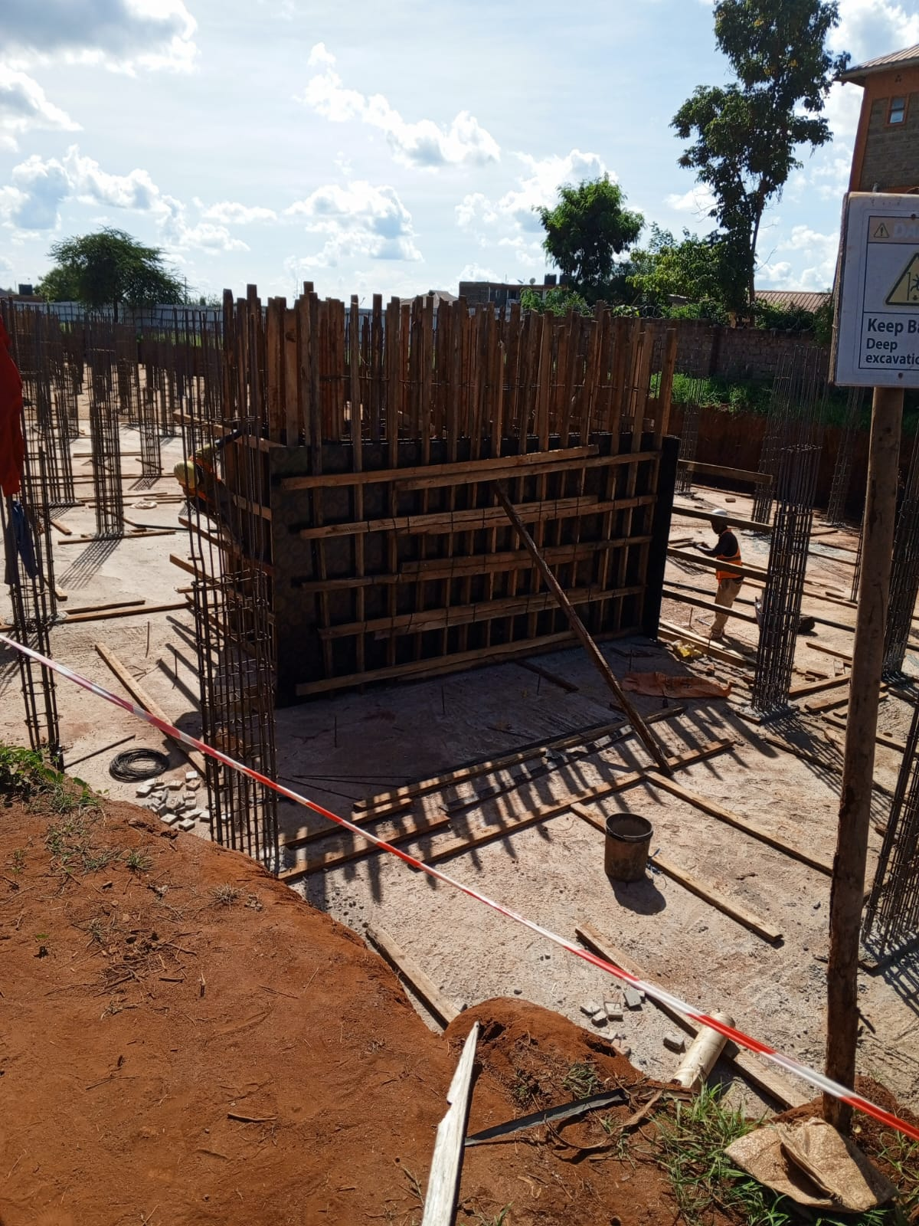
Figure 1: Installing and Bracing of Lift’s formwork at Block B3

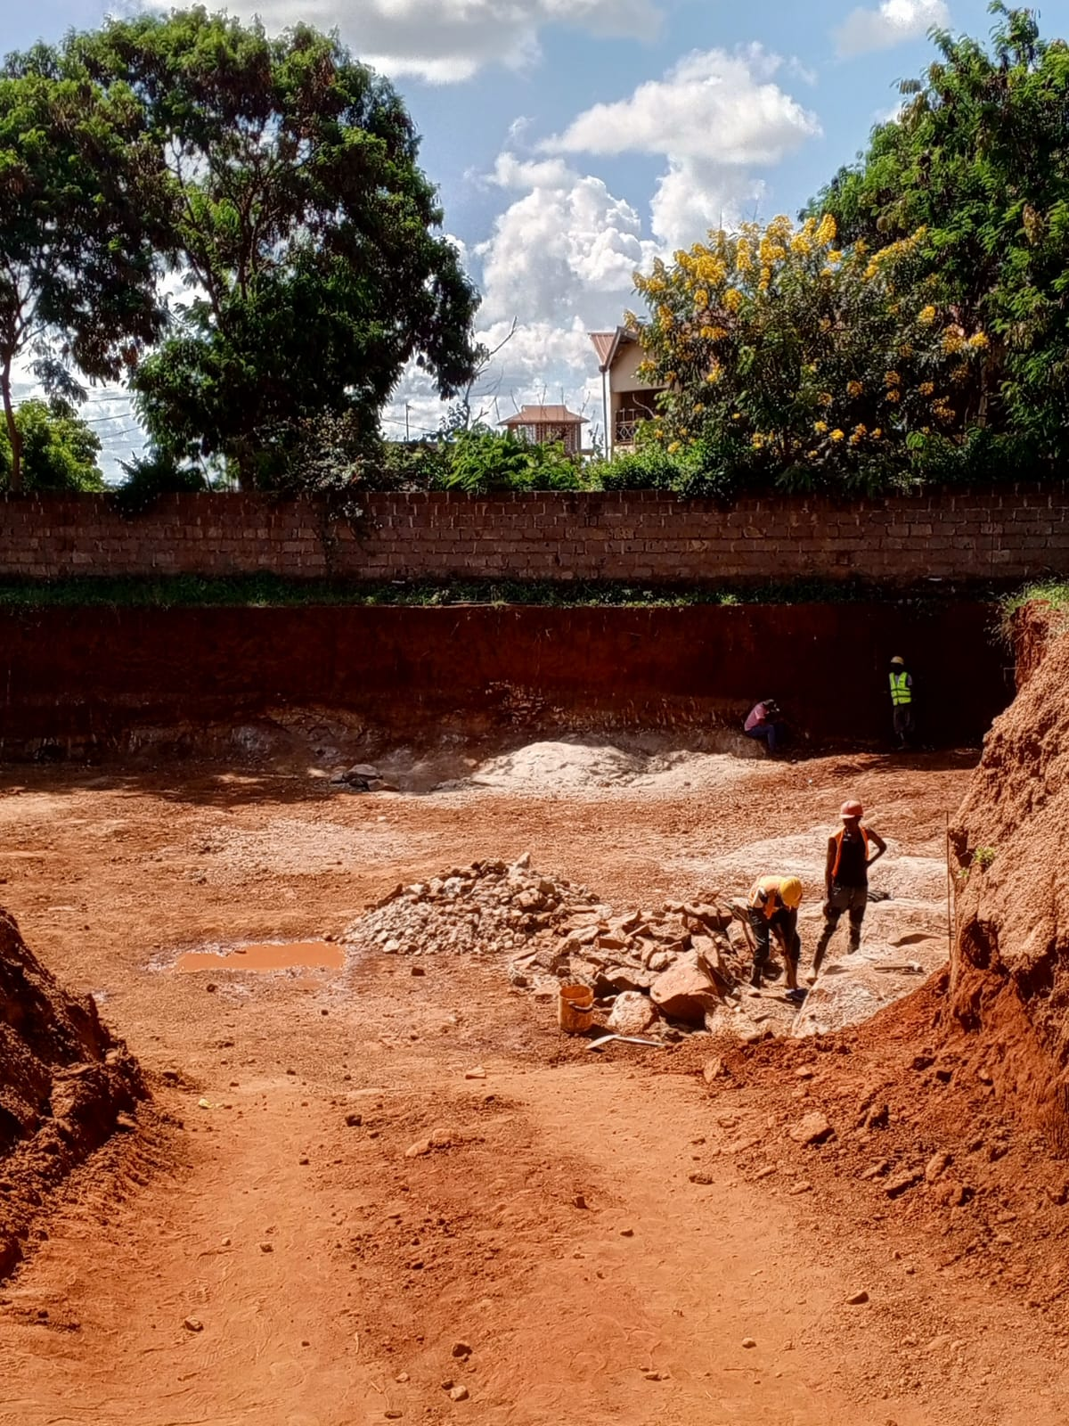
Figure 2: Rock excavation and removal of hard strata to achieve design founding levels at B4
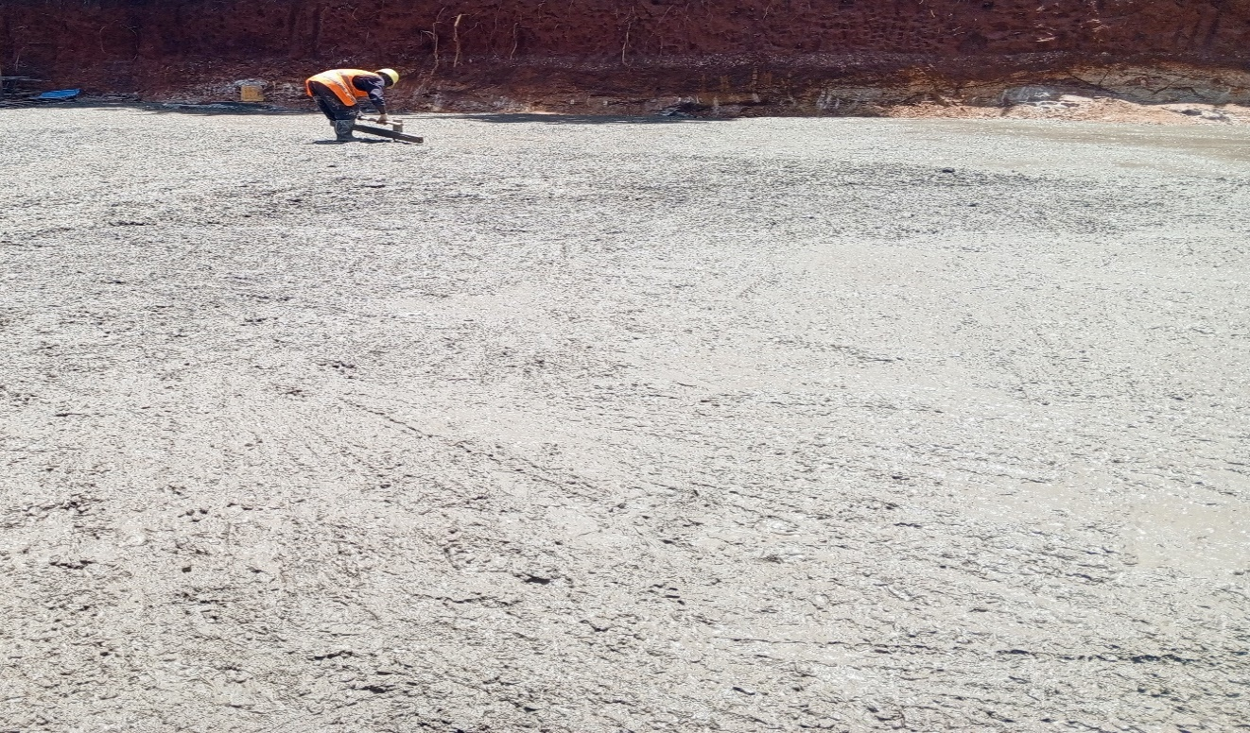
Figure 3: Blinding of Block B4
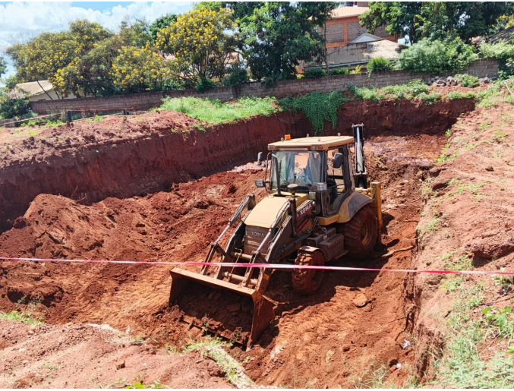
Figure 4: Excavation of pit for the Underground Water Tank
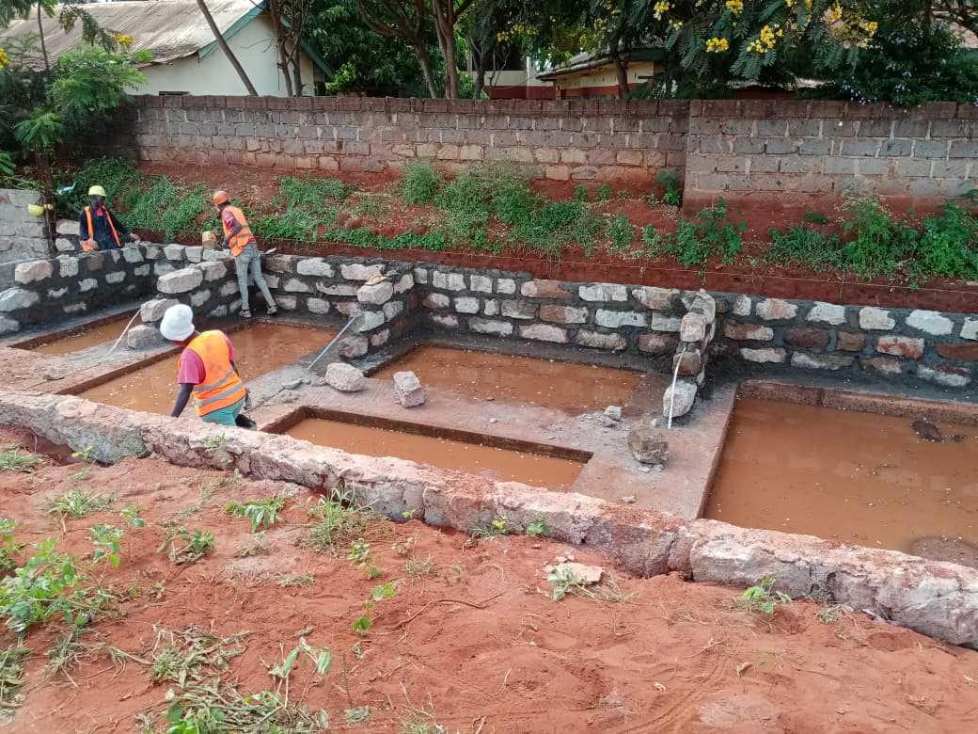
Figure 5: Construction of foundation masonry for the kindergarten unit
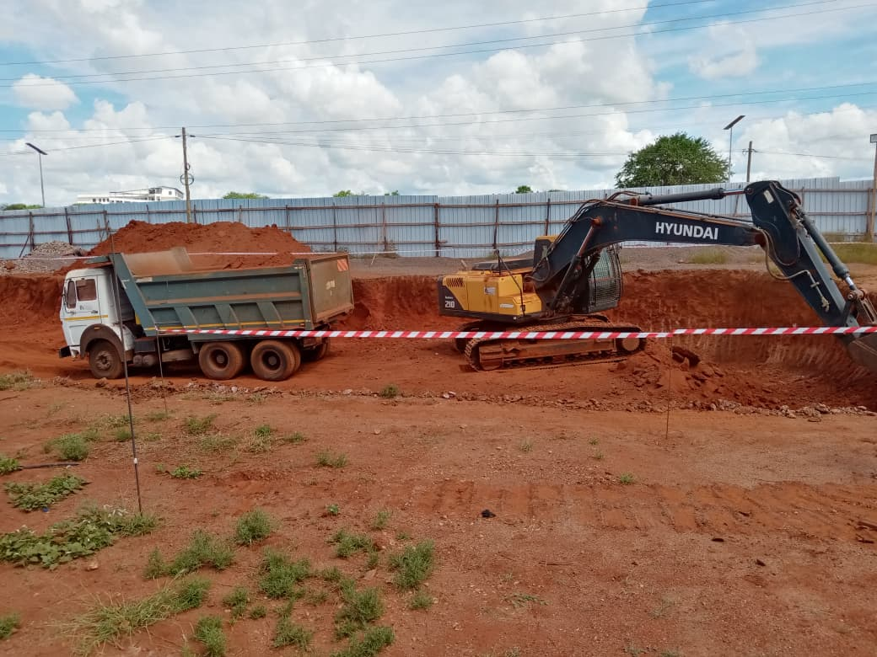
Figure 6: Excavation of Block C5 foundation pit
- MATERIALS ON SITE
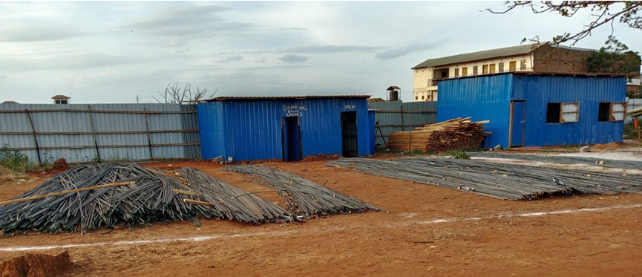
Steel reinforcement
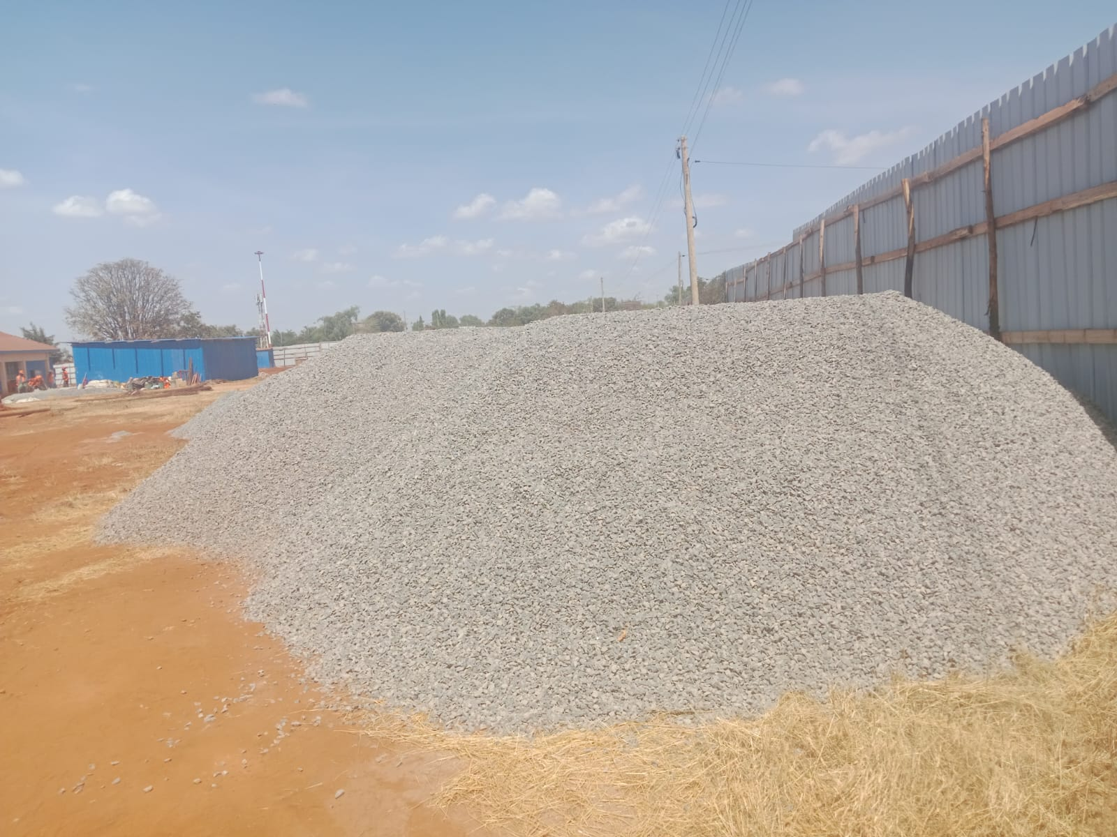
Ballast

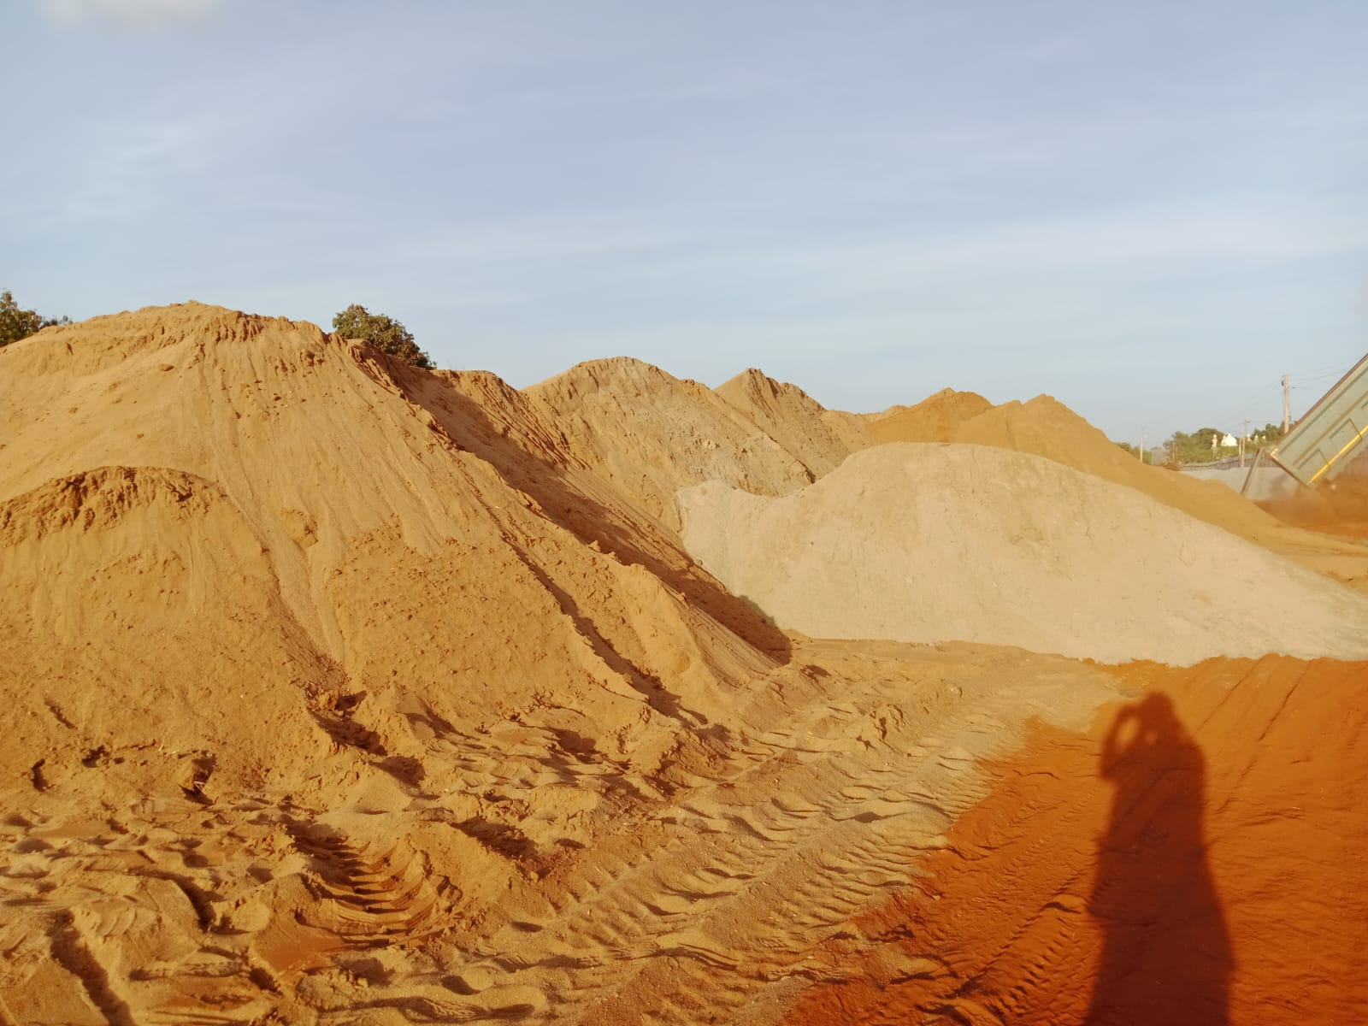
River Sand
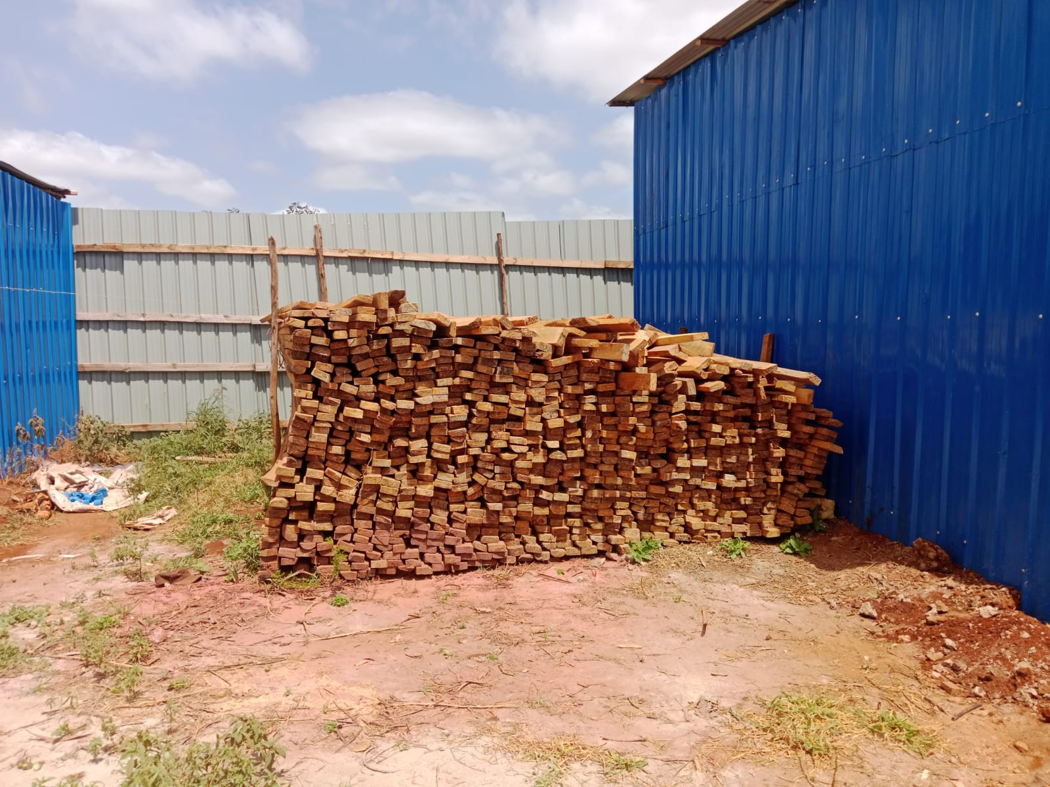
Cypress Timber
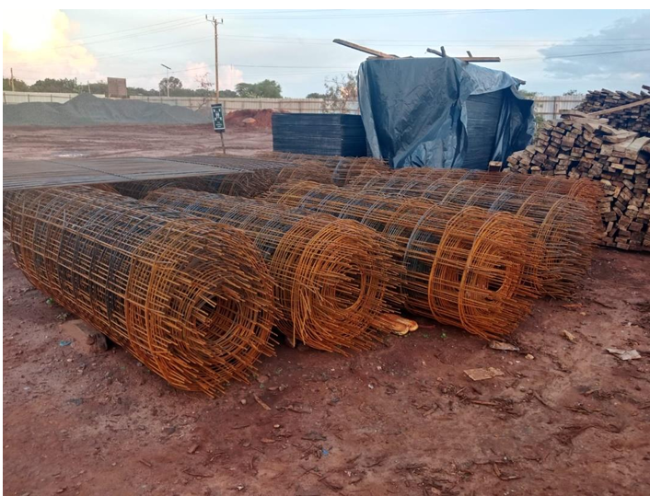
BRC
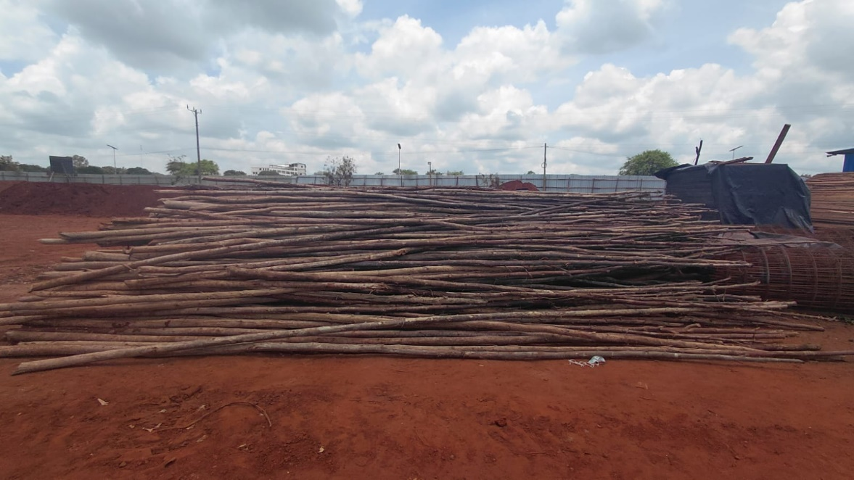
Timber Poles

- MACHINES AND EQUIPMENTS ON SITE

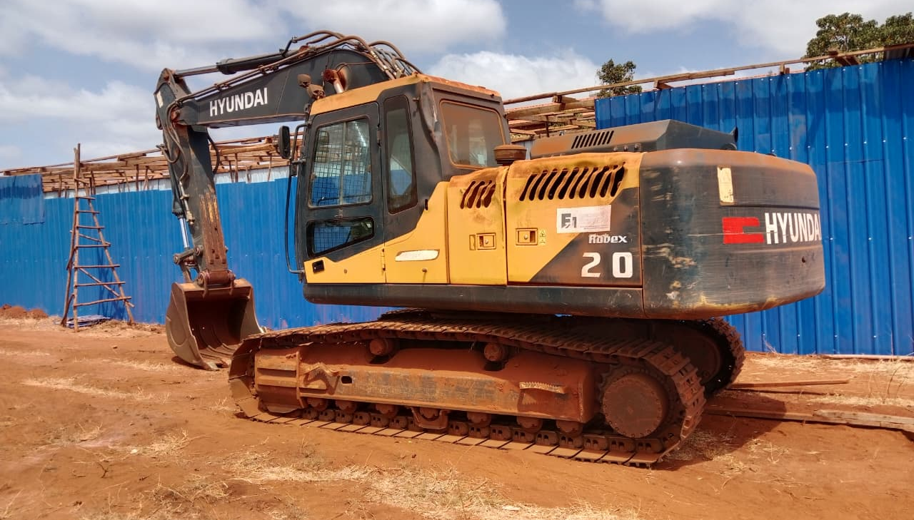
Excavator

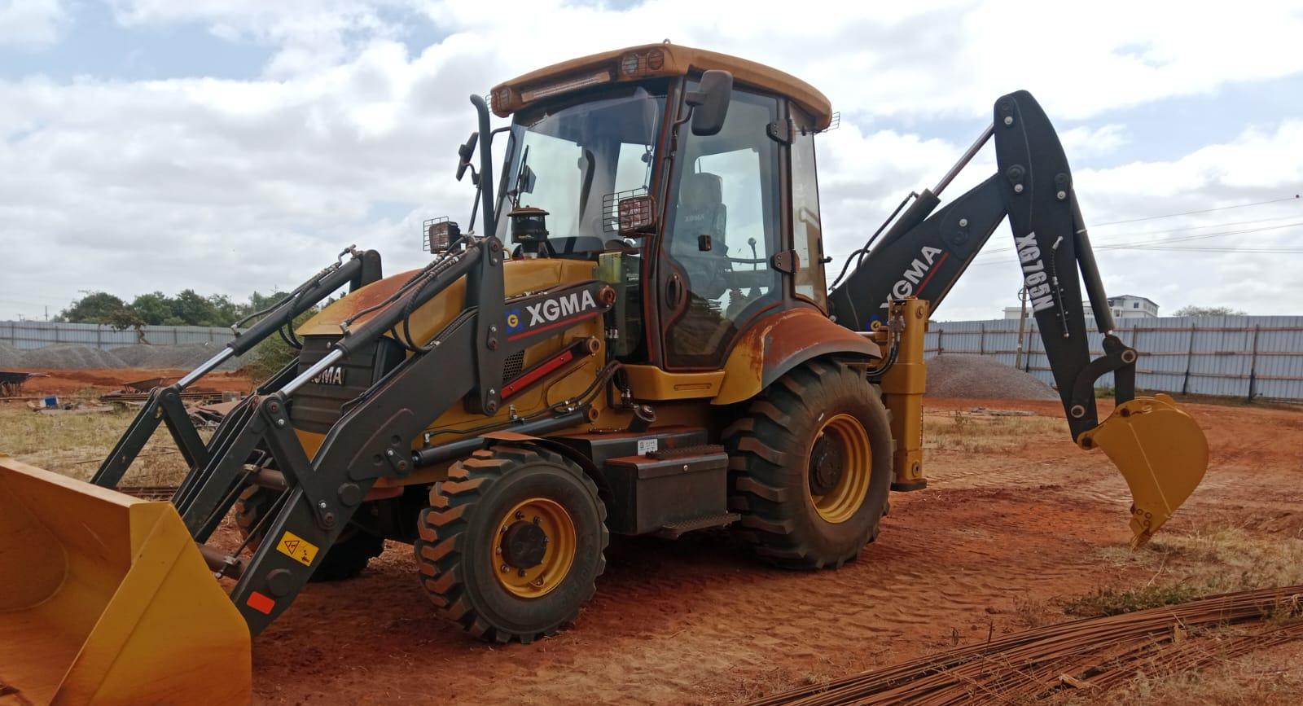
Backhoe excavator

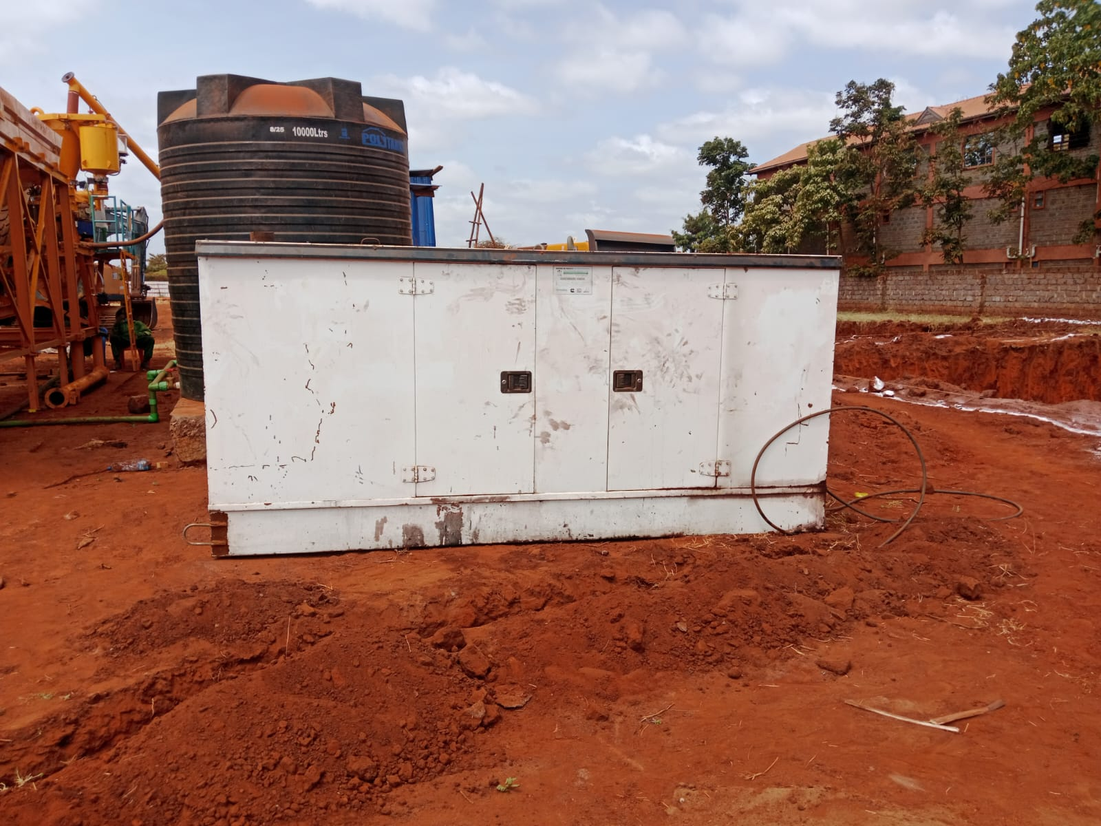
Stand-by Generator

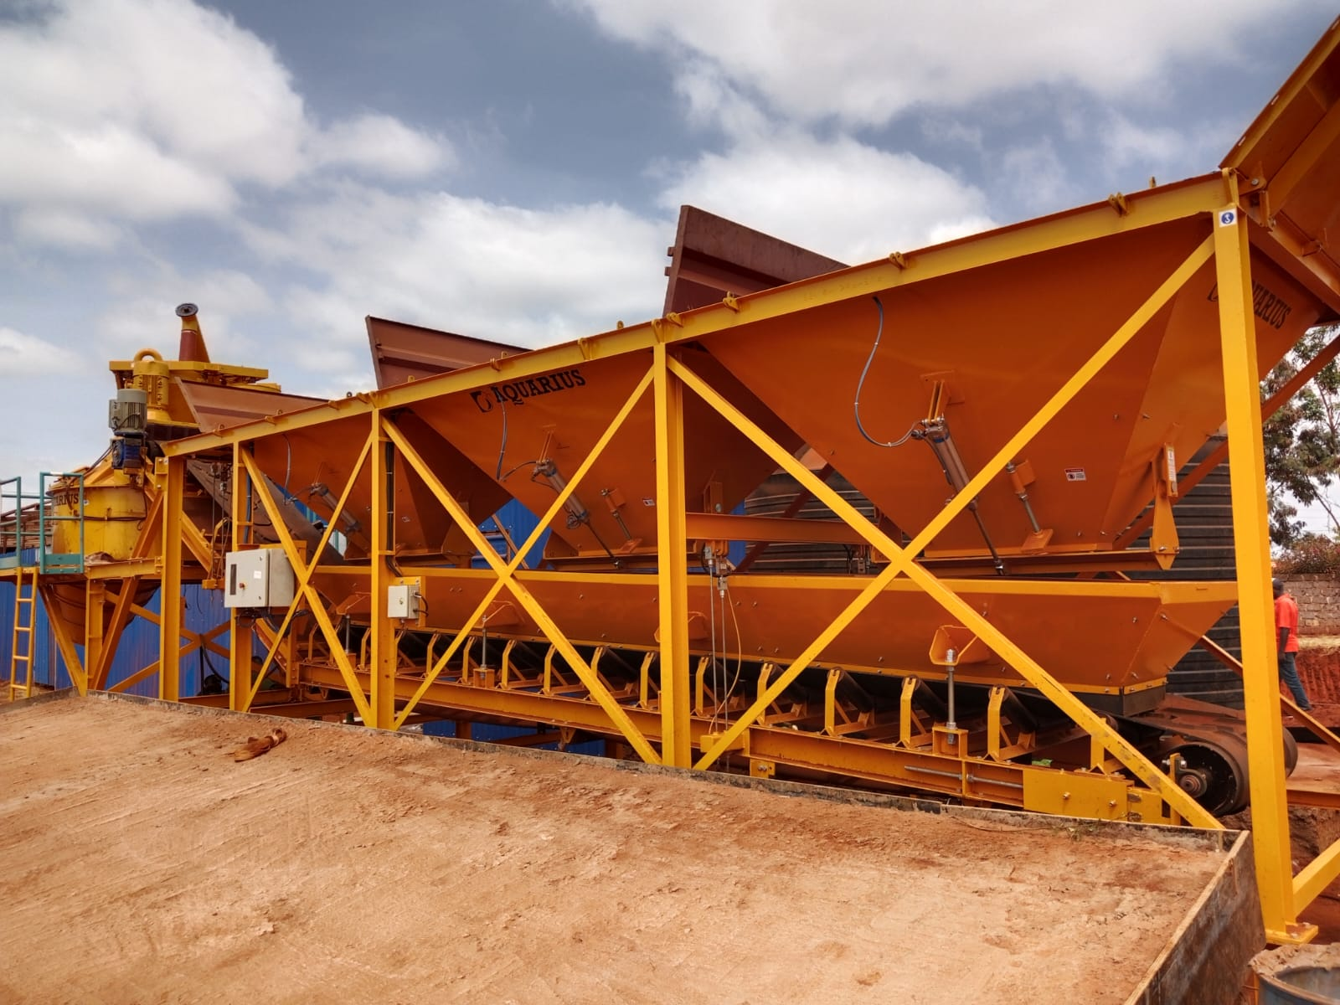
Batching plant

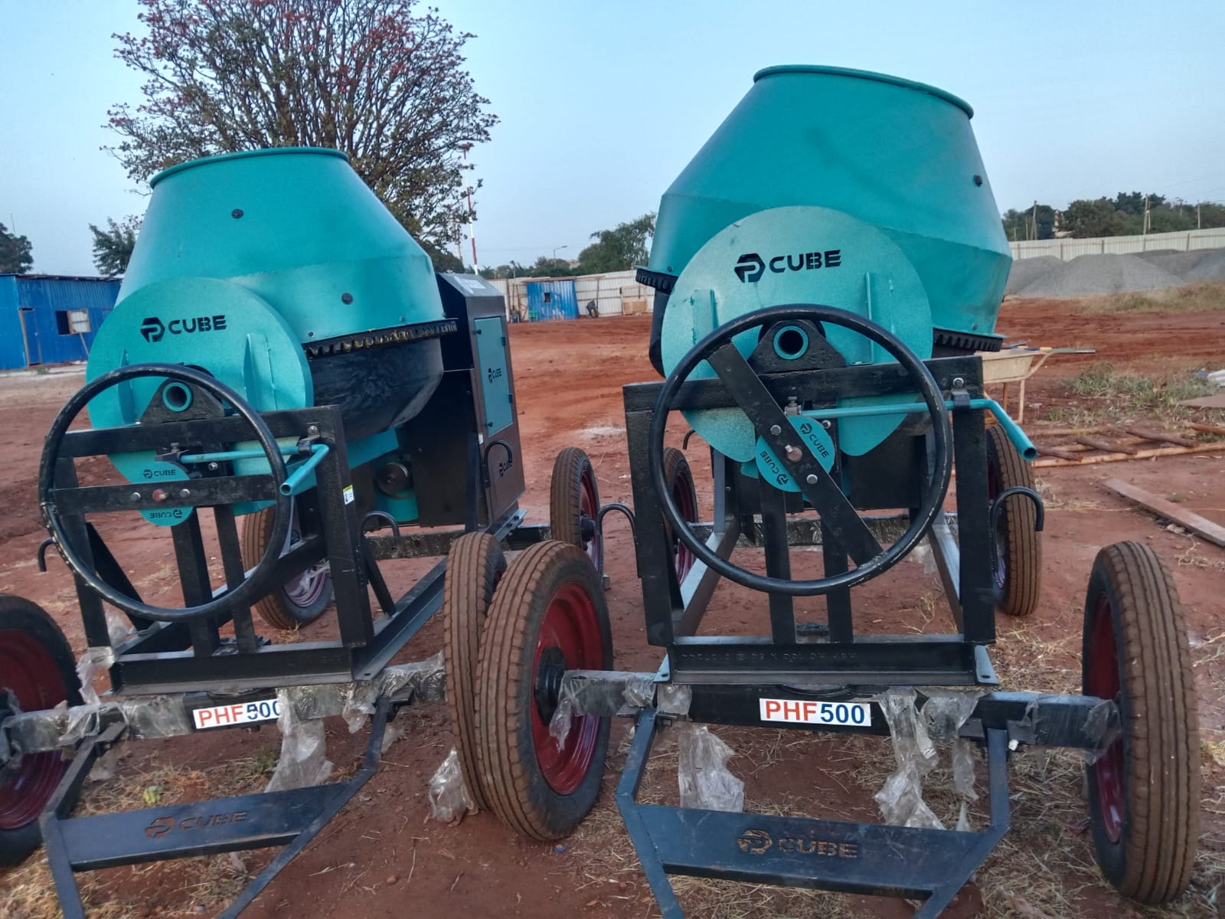
Concrete mixers

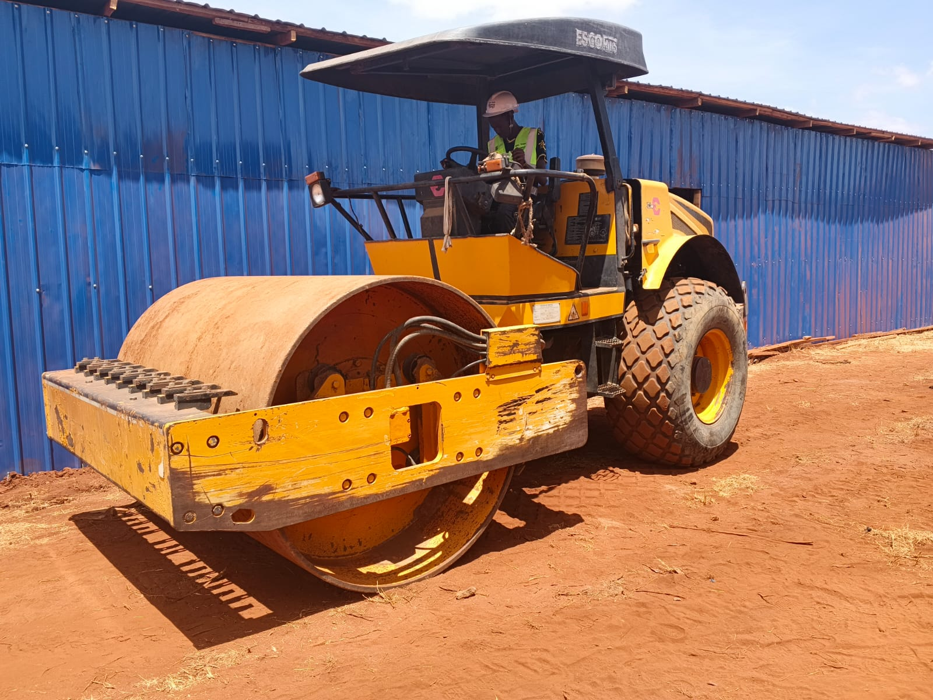
18- ton roller

Prepared by: Dennis Chomba
(Clerk of Works)

