REPUBLIC OF KENYA


MINISTRY OF LANDS, PUBLIC WORKS,
HOUSING AND URBAN DEVELOPMENT
State Department for Housing and Urban
Development

Affordable Housing with Associated Amenities and

Infrastructure

PROPOSED CONSTRUCTION OF MAKINDU AFFORDABLE HOUSING PROJECT IN MAKINDU, KIBWEZI WEST CONSTITUENCY, MAKUENI COUNTY WITH ASSOCIATED INFRASTRUCTURE.

TITLE:

- CONTRACT DETAILS
Table 1: Summarized contract information
1. | Project Title | Proposed Construction of Makindu Affordable Housing Project in Makindu, Kibwezi West Constituency, Makueni County with associated infrastructure.
2. | Contract No. | MLPWHUD/SDHUD/AHP/160/2023-2024.
3. | County | MAKUENI
4. | Sub-County | MAKINDU
5. | Constituency | KIBWEZI WEST
6. | Client | State Department of Housing and Urban Development
7. | Employer | Principal Secretary,  State Department of Housing and Urban Development  P. O. Box 30119 – 00200  Nairobi, KENYA
8. | Contractor | NETGAS ENERGY AND CONSTRUCTION LTD
9. | Contract Sum | KES. 2,127,050,827.72
10. | Advance Payment | KES 425,410,165.54
11. | Commencement Date | 24th November 2025
12. | Project Duration | 24 Months
13. | Date of Completion | 24th November 2027
14. | Time Lapsed in Weeks
15. | % contract period elapsed
16. | % work done
17. | Reporting Period

- SOCIO-ECONOMIC IMPACT
The Makindu affordable housing project has significant socio-economic impacts, as it generates employment opportunities during construction and in related supply chains, stimulates local businesses through increased demand for goods and services, and provides secure, decent housing that improves health and safety outcomes for low-income families. By offering rent-to-own and tenant purchase options, it enhances financial stability and asset ownership among residents, while also fostering community development through better infrastructure and social amenities. Overall, the project acts as a catalyst for inclusive economic growth, poverty reduction, and long-term resilience in the region.

- SCOPE OF WORKS
The Works to Be Carried Out Comprises Construction of: -
- 4 No. Blocks (G+9) Block Type B-Affordable +Market units
- 5 No. Blocks (G+9) Block type C-Social + Shops + Affordable units
- Club House (G+1)
- Kindergarten-(G)
- Garbage Receptacle
- Gate House
- Associated amenities and Infrastructure
The following is a tabulation of items typologies as outlined in the Drawings
S/N | UNITS | NO. OF UNITS
1 | SOCIAL UNITS- 19%
a). | 1 Room social Housing 20 sqm | 50
b). | 2 Room Social Housing 30 sqm | 100
c). | 3 Room Social Housing 40 sqm | 50
2 | AHP UNITS- 45%
a). | Studio Affordable Housing 20 sqm | 100
b). | 2 Bed Affordable Housing 40 sqm | 225
c). | 3 Bed Affordable Housing 60 sqm | 90
3 | MARKET UNITS- 36%
a). | 2 Bed Market Housing 60 sqm | 120
b). | 3 Bed Market Housing 80 sqm | 120
4 | AMENITIES
a). | Kindergarten
b). | Shops
c). | Power House
d). | Garbage Receptacles
e). | Gate House
f). | Playground
g). | Club House
h). | Outdoor kids play area
i). | Secured boundary wall
j). | Borehole
k). | back-up Generator
l). | Cabro paved driveways

- WORK DONE UPTO DATE
SUMMARY OF WORK DONE TO DATE:
GENERAL WORKS | - Hoarding  - Construction of site office  - Construction of Cement store  - Construction of general store  - Construction of Operation room for the batching plant  - Construction of Ablution blocks  - Construction of changing rooms (male and female)  - Electrical power connection  - CCTV installation  - WIFI installation  - Borehole drilling  - 3-phase power connection  - Construction of realtor’s office
BLOCK B1 | - Site clearance  - Setting out  - Mass excavation ongoing  - Compaction of excavated section  - FDD Test  - Blinding works  - Reinforcement to the raft foundation  - Casting of raft foundation- done  - Reinforcement and formwork of foundation columns and lift shear wall  - Formwork to starter columns and lift shear wall.
BLOCK B2 | - Site clearance  - Setting out  - Excavation for raft foundation to a depth of 3m.  - Levelling and compaction.  - FDD Test  - Blinding works  - Reinforcement to the raft foundation  - Casting of raft foundation- done  - Reinforcement of foundation columns and lift shear wall  - Formwork of the lift shear wall - ongoing
BLOCK B3 | - Site clearance  - Setting out  - Excavation for raft foundation to a depth of 3m.  - Levelling and compaction.  - FDD Test  - Blinding works  - Reinforcement to the raft foundation ⁴  - Casting of raft foundation- done  - Reinforcement of foundation columns and lift shear wall
BLOCK B4 | - Site clearance  - Setting out  - Excavation for raft foundation to a depth of 3m - ongoing.
UNDERGROUND TANK | - Site clearance  - Setting out  - Excavations for the foundation pit.  - Other works on hold
KINDERGATEN | - Site clearance  - Excavation for pad footings and trenches for strip footing.  - Levelling and compaction.  - Concrete blinding.  - Casting of strip and pad footings.  - Casting of substructure columns.  - Foundation walling -ongoing
SWIMMING POOL | - Site clearance  - Setting out.  - Other works on hold
CLUB HOUSE | • None
SEPTIC TANK | • None
WASTE CUBICLE | • None
WTP | • None

- INSURANCES
INSURANCE POLICY | EXPIRY DATE
Performance security | 15/03/2027
Advance payment guarantee | 02/12/2026
Contractor’s All Risk | 11/03/2027
Public Liability | 02/02/2027
Work Injury Benefit | 02/02/2027

- CUBES LAB TEST RESULTS DONE TO DATE
BLOCK B1  BLINDING | Compressive strength at 7 days  (N/mm2)

MACHINES AND EQUIPMENT MOBILIZATION
Category | No. | Condition | Status
Excavator | 1 | Good | Working
Backhoe excavator | 1 | Good | Working
Rotating drum concrete mixers | 2 | Good | Working
Batching Plant – 30M3/Hr. | 1 | Good | Working
18-Ton Tipper | 2 | Good | Working
Generator | 1 | Good | Working
Wheelbarrows | 5 | Good | Working
Assorted tools and equipment |  | Good | Working

- LABOUR TURNOVER
In the period under review, the following were number of personnel on site

- MATERIALS DELIVERED TO SITE

- WEATHER REPORT

K. HEALTH AND SAFETY

L. SECURITY

  - VISITORS/ CONSULTANTS ON SITE
S/N | NAME | ORGANISATION | DATE ON SITE
1.
2.
3.

  - SITE INSTRUCTIONS ISSUED

O. CHALLENGES

PROGRESS PHOTOS

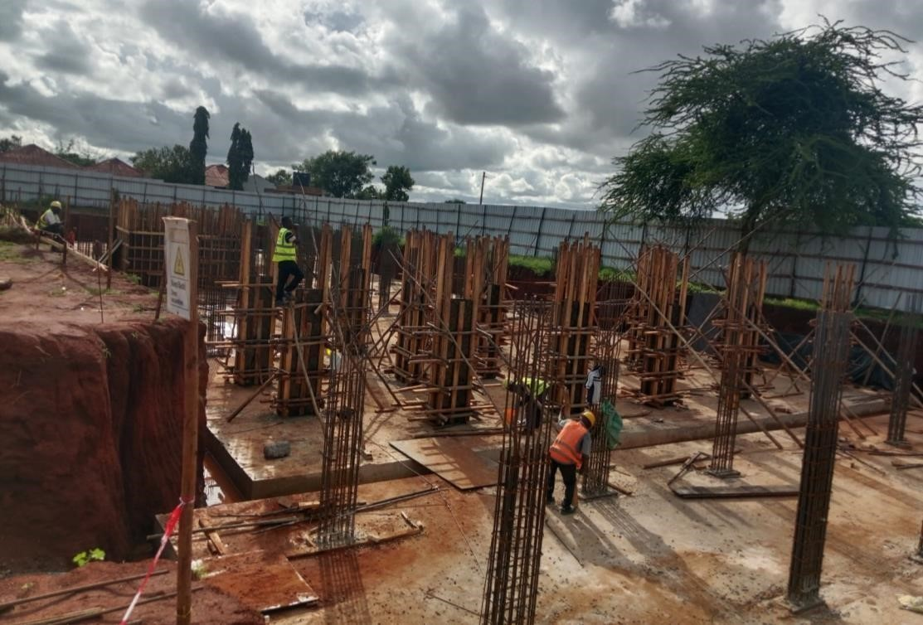

Block B1

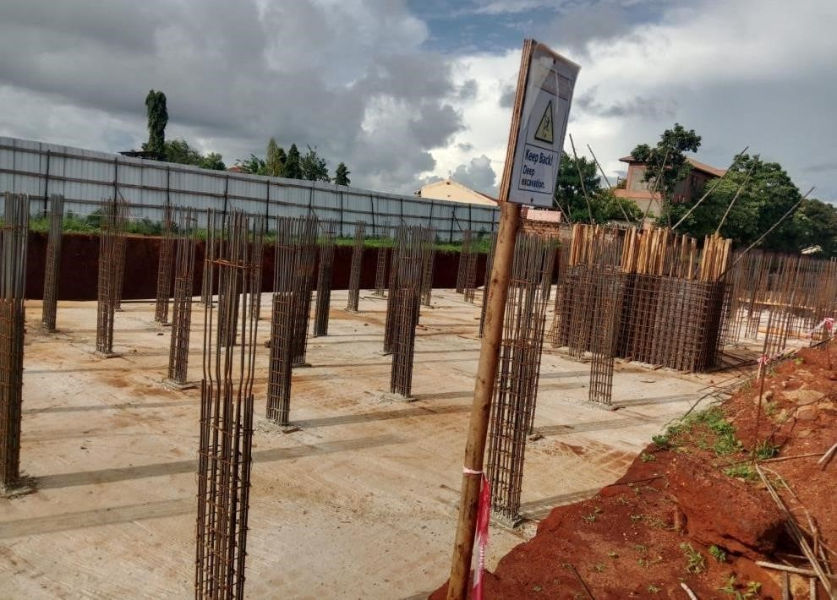
Block B2

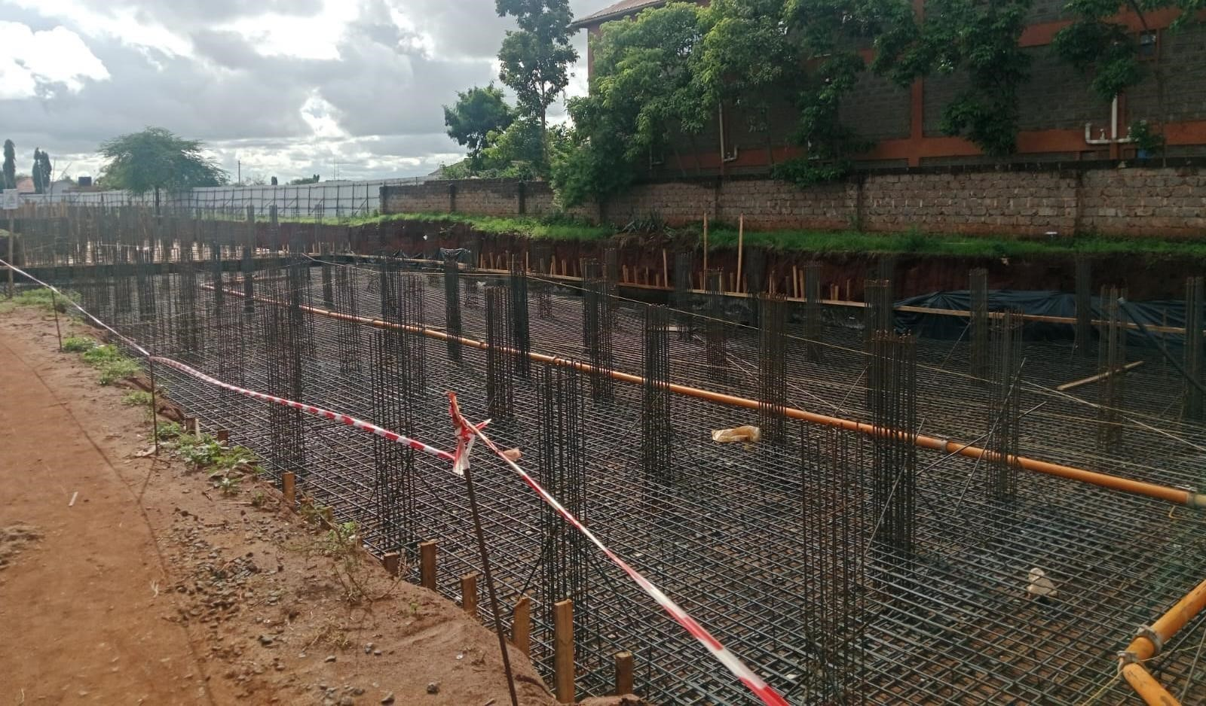

A view of Block B3

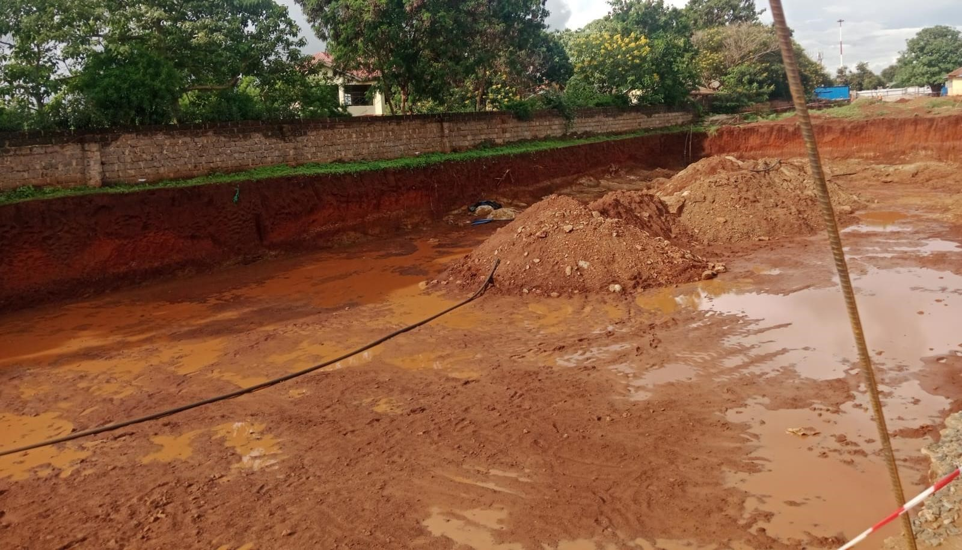

A view of Block B4

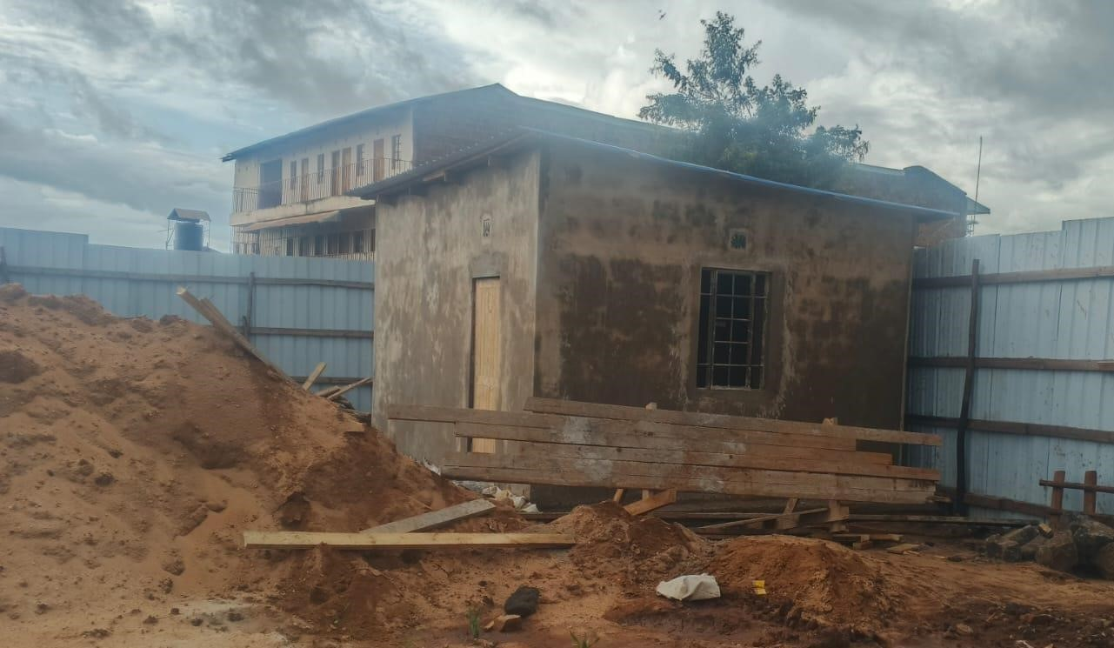
Realtor’s office

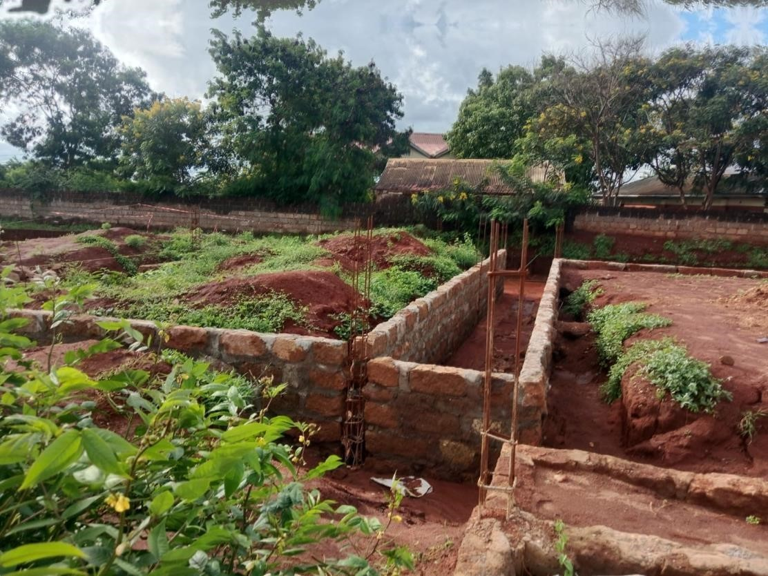

Foundation walling – Kindergarten

Prepared by: Grace Musangi
Designation: Clerk of Works

