### 基础教程



可加V代搭建

1、解压压缩包

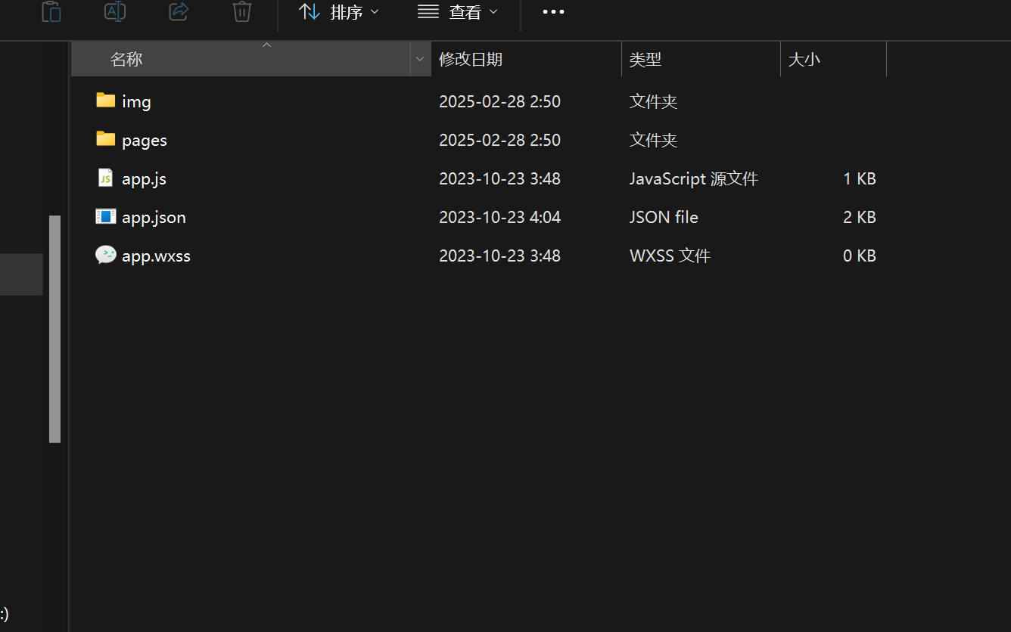

1. 微信开发者工具，导入此文件夹，输入自己的appid

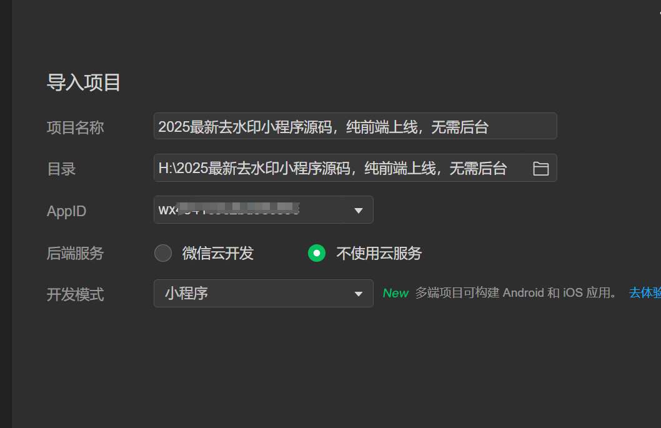

1. 打开文件pages/index/index.js，去接口网站<https://api.wxshares.com>注册账号，获取自己的KEY替换上

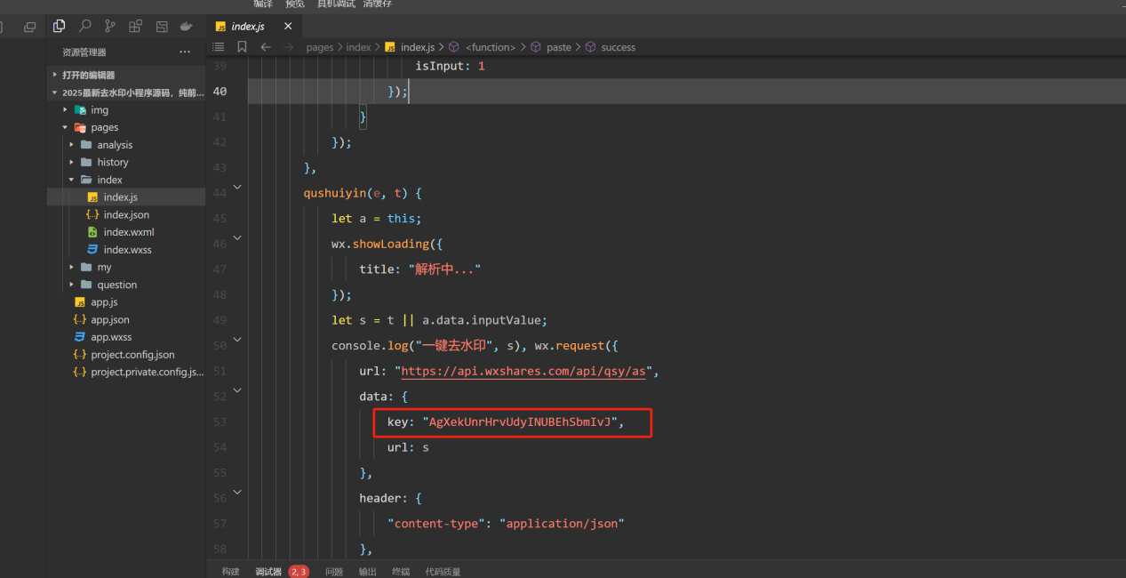

4、打开文件pages/index/index.wxml，修改图中位置为你自己的客服微信号

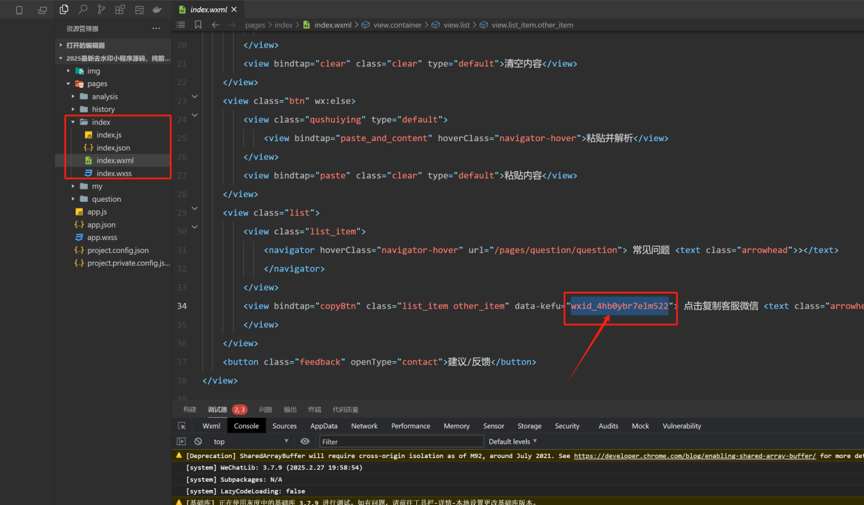

5、自行测试解析，可以上传代码了

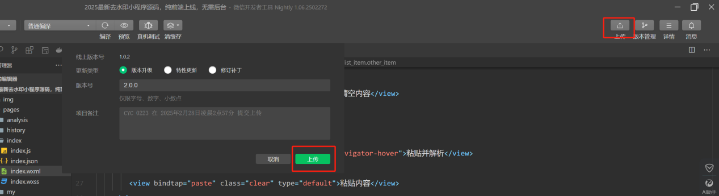

最后上传完成，自己去小程序后台提审版本即可，审核通过后就能上线了

（测试功能有问题的，先按下面的配置，添加安全域名等，所有都配置好了再测试）

### 流量主教程

全局搜索以下流量主ID，替换成你自己的（未开通流量主可不改）

原生广告ID：adunit-77fd267bf23e7bb3

插屏广告ID：adunit-1f5844642a93579d

激励广告ID：adunit-bf6c85886ae3a7ee

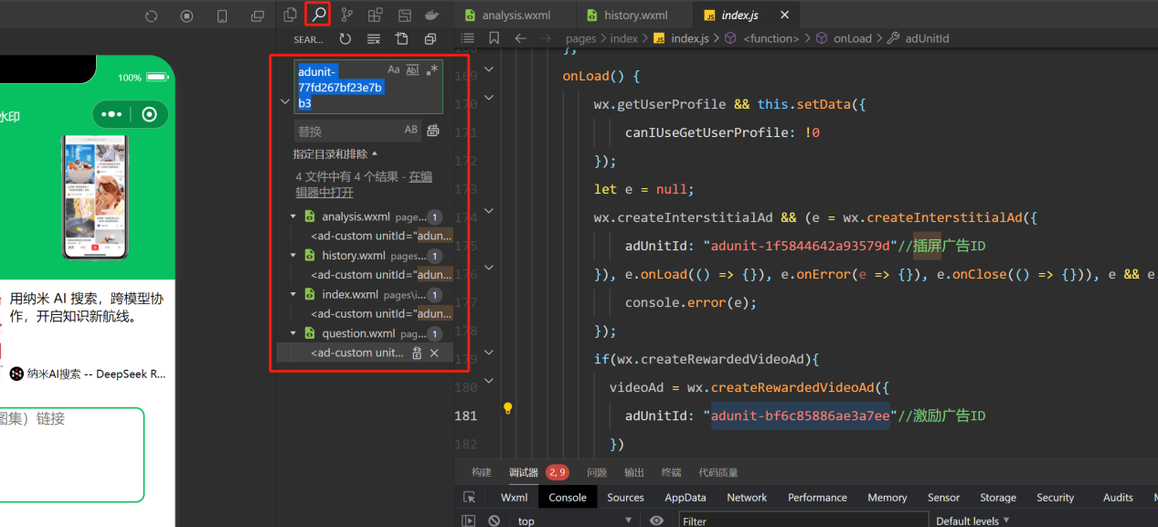

全局搜索以上ID，全都换成你自己的广告ID，流量主ID自行在小程序后台创建获取

### 小程序后台设置

1、将<https://api.wxshares.com>添加request合法域名

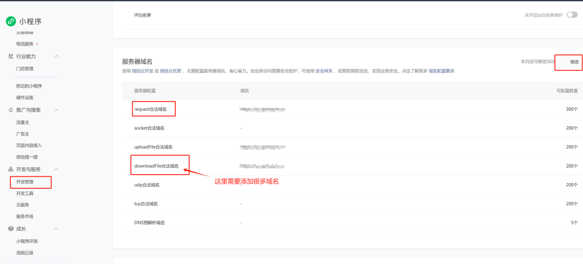

1. downloadFile合法域名需要添加以下所有链接，如果有不全的或平台域名变更，请自行修整：

https://ali-ky.video.yximgs.com;https://aweme.snssdk.com;https://bd2.a.kwimgs.com;https://bdmov2.a.kwimgs.com;https://cdn.poizon.com;https://channels.weixin.qq.com;https://china-img.soulapp.cn;https://ci.xiaohongshu.com;https://circlephotokd.photo.qq.com;https://circlevideo3.photo.qq.com;https://cloud.video.taobao.com;https://cn-gddg-dx-bcache-16.bilivideo.com;https://f.us.sinaimg.cn;https://f.video.weibocdn.com;https://fb.video.weibocdn.com;https://finder.video.qq.com;https://fvdcdn.cp63.ott.cibntv.net;https://gd3.alicdn.com;https://guangguang.cloudvideocdn.taobao.com;https://hw2.a.kwimgs.com;https://hwmov.a.kwimgs.com;https://image-cdn.poizon.com;https://img.alicdn.com;https://img2.soyoung.com;https://jsmov2.a.yximgs.com;https://jsmov3.a.yximgs.com;https://jvod.300hu.com;https://live-segment.cloudvideocdn.taobao.com;https://lz.sinaimg.cn;https://m.360buyimg.com;https://media.soyoung.com;https://mmbiz.qpic.cn;https://mp.weixin.qq.com;https://mpvideo.qpic.cn;https://o1.a.88cdn.com;https://oasis.video.weibocdn.com;https://p1-dy.byteimg.com;https://p1.a.yximgs.com;https://p1.douyinpic.com;https://p11.douyinpic.com;https://p2.a.yximgs.com;https://p26-sign.douyinpic.com;https://p26.douyinpic.com;https://p3-pc-sign.douyinpic.com;https://p3-ppx-sign.byteimg.com;https://p3-sign.douyinpic.com;https://p3-sign.toutiaoimg.com;https://p3.a.yximgs.com;https://p3.douyinpic.com;https://p4.a.yximgs.com;https://p5.a.yximgs.com;https://p5.douyinpic.com;https://p6-pc-sign.douyinpic.com;https://p6-ppx-sign.byteimg.com;https://p6-sign.douyinpic.com;https://p6.douyinpic.com;https://p9-pc-sign.douyinpic.com;https://p9-ppx.byteimg.com;https://p9-sign.douyinpic.com;https://p9.douyinpic.com;https://p95-sign.douyinpic.com;https://q.weishi.qq.com;https://shortv.cdp.qq.com;https://sns-img-hw.xhscdn.com;https://sns-img-qc.xhscdn.com;https://sns-video-al.xhscdn.com;https://sns-video-bd.xhscdn.com;https://sns-video-hw.xhscdn.com;https://sns-video-qc.xhscdn.com;https://svideo.qpic.cn;https://tb-video.bdstatic.com;https://tbm-auth.alicdn.com;https://tbvideo.ixiaochuan.cn;https://tx.stream.kg.qq.com;https://tx2.a.kwimgs.com;https://txmov2.a.kwimgs.com;https://txmov2.a.yximgs.com;https://upmov.a.kwimgs.com;https://us.sinaimg.cn;https://v.kdsvp.qq.com;https://v.weishi.qq.com;https://v.xiaohongshu.com;https://v1-cold1.douyinvod.com;https://v1.douyinvod.com;https://v11-cold.douyinvod.com;https://v11-x.douyinvod.com;https://v11.douyinvod.com;https://v13-a.douyinvod.com;https://v13-a.toutiaovod.com;https://v18.toutiaovod.com;https://v2.kwaicdn.com;https://v26-cold.douyinvod.com;https://v26-default.365yg.com;https://v26-default.ixigua.com;https://v26-dy.ixigua.com;https://v26-web.douyinvod.com;https://v26-x.toutiaovod.com;https://v26.douyinvod.com;https://v26.huoshanvod.com;https://v26.toutiaovod.com;https://v27.douyinvod.com;https://v3-a.huoshanvod.com;https://v3-cdn-tos.ppxvod.com;https://v3-cold.douyinvod.com;https://v3-cold1.douyinvod.com;https://v3-cold2.douyinvod.com;https://v3-cold3.douyinvod.com;https://v3-cold4.douyinvod.com;https://v3-default.365yg.com;https://v3-default.ixigua.com;https://v3-dy-o.zjcdn.com;https://v3-dy.ixigua.com;https://v3-jianying.vlabvod.com;https://v3-web.douyinvod.com;https://v3-x.douyinvod.com;https://v3-x.toutiaovod.com;https://v3-xg-web-pc.ixigua.com;https://v3-y.douyinvod.com;https://v3-z.douyinvod.com;https://v3.douyinvod.com;https://v3.huoshanvod.com;https://v3.toutiaovod.com;https://v5-cold.douyinvod.com;https://v5-colda.douyinvod.com;https://v5-coldb.douyinvod.com;https://v5-coldc.douyinvod.com;https://v5-colde.douyinvod.com;https://v5-coldv.douyinvod.com;https://v5-coldy.douyinvod.com;https://v5-f.douyinvod.com;https://v5-g.douyinvod.com;https://v5-h.douyinvod.com;https://v5-i.douyinvod.com;https://v5-j.douyinvod.com;https://v5-x.toutiaovod.com;https://v5.douyinvod.com;https://v6-cdn-tos.ppxvod.com;https://v6-cold.douyinvod.com;https://v6-cold1.douyinvod.com;https://v6-cold2.douyinvod.com;https://v6-default.365yg.com;https://v6-default.ixigua.com;https://v6-dy.ixigua.com;https://v6-jianying.vlabvod.com;https://v6-x.douyinvod.com;https://v6.douyinvod.com;https://v6.huoshanvod.com;https://v6.toutiaovod.com;https://v83-016.douyinvod.com;https://v83-017.douyinvod.com;https://v86-b.douyinvod.com;https://v9-cold.douyinvod.com;https://v9-cold1.douyinvod.com;https://v9-cold2.douyinvod.com;https://v9-default.365yg.com;https://v9-default.ixigua.com;https://v9-dy.ixigua.com;https://v9-x.toutiaovod.com;https://v9-xg-web-pc.ixigua.com;https://v9.douyinvod.com;https://v9.huoshanvod.com;https://v95-hb.douyinvod.com;https://v95-hn-cold.douyinvod.com;https://v95-p-cold.douyinvod.com;https://v95-p.douyinvod.com;https://v95-sh-cold.douyinvod.com;https://v95-sz-cold.douyinvod.com;https://v95-zj-cold.douyinvod.com;https://v95-zj.douyinvod.com;https://v95.douyinvod.com;https://v95.toutiaovod.com;https://v99-coldx.douyinvod.com;https://vd2.bdstatic.com;https://vd3.bdstatic.com;https://vd4.bdstatic.com;https://video.izuiyou.com;https://video.momocdn.com;https://vodkgeyttp8.vod.126.net;https://water.quanminyouxi.cn;https://ww3.sinaimg.cn;https://wx1.sinaimg.cn;https://wx2.sinaimg.cn;https://wx3.sinaimg.cn;https://wx4.sinaimg.cn;https://wxapp.tc.qq.com;https://xximg1.meitudata.com;https://zzx.sinaimg.cn;

1. 后台隐私协议添加相册写入与剪切板权限

