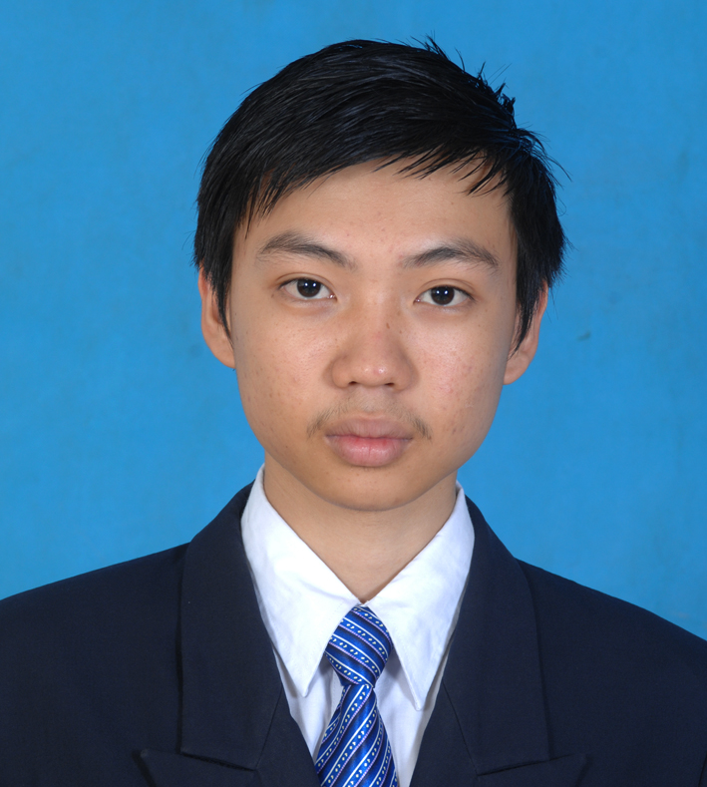
LAM TIPVICHIKA
House#54, Sangkat Dongkor,
Khan Dangkor, Phnom Penh, Cambodia
Tel: (098) 266869
E-mail: lamtipvichika@yahoo.com

PERSONAL DETAIL

Name : LAM TIPVICHIKA
Sex : Male
Nationality : Cambodia
Race : Khmer
Date of birth : 02 November 1993
Place of birth : Tek La Ork III District, Phnom Penh City
Marital : Single
Height : 1.70cm

EDUCATION BACKGROUND

2011 – 2016 : Finished Bachelor Degree of Architecture and Design at Pannasastra University of Cambodia.

2008-2011 : Graduation with High School Certificate, Beltei International Institute

OTHER SKILLS

2014 : 3D Max + Sketch Up

March 2013 : Certificate of Graphic design & printing

September 2012 : Certificate of Auto CAD 2D & 3D

WORK EXPERIENCE

March-2017 – Present : ADM Art and Design Media
Program Using:
- Auto CAD 2D & 3D
- Sketch Up
- Photoshop
- MS Word & Excel
- Power Point
Operation:
- Interior Design
- Exterior Design
- Draft Plan
- Handle problem about Plan

March-2015 - April-2016 : SBK RESEARCH AND DELELOPMENT
Program Using:
- Auto CAD 2D & 3D
- 3D Max
- Sketch Up
- Photoshop
- MS Word & Excel
- Power Point
Operation:
- Interior Design
- Exterior Design
- Draft Plan
- Handle problem about Plan

June 2014 to March 2015 : 7P Architecture work as a team
Program Using
- Auto cad 2D/3D,
- Autodesk 3Ds max
- Photoshop
Operation:
- Interior Design
- Exterior Design
- Draft Plan

July 2013 to March 2014 : Completed Internship Program at Creative Green Design Co., Ltd
Program Using
- Auto cad 2D/3D,
- Autodesk 3Ds max
Operation:
- Interior Design
- Exterior Design
- Draft Plan

LANGUAGES

Khmer : Mother Tongue

English : Good

REFERNCES

Mr. Gnoung Kunna : SBK RESEARCH AND DELELOPMENT
Tel : 016 633 960

Mr.Tous Saphoeun : Dean of School of Architecture and Design in PUC and Managing Director of Creative Green Design Co., Ltd (CGD).
Tel : 092-676-789/097-204-6789

Mr. Ke Samnang : 7P Architecture work as a team
Tel : 098 595 880

