


MSc Embedded Systems and IC Design
Lab 4: Loopback Design with PicoBlaze Using Verilog HDL

Name: Taha Khan
ID: 1177875
Module Name: IC System Design
Module Code: 7431MESI
Level: 7
Lecturer: Prof. Weidong Zhang

Introduction:
The aim of this lab was to learn how assembly language works and eventually build a loopback design with a picoblaze microprocessor embedded in a Xilinx FPGA. We were also introduced to communication protocols like UART which many systems use to communicate clearly with other systems. We integrated the Microprocessor with the FPGA and made sure the loopback system works.
Design description:
In terms of the design and hardware, most of the hardware was provided to us including the testbench file, the top module, communication protocols and the kcpsm compiler for the picoblaze microprocessor. As students, we had to make sure we have the correct cycle count as the baud rate and the oversampling values were already given to us.
In addition to the cycle count, we had to fill in parts of the top module including the port ids to their correct component or communication protocol. I found this particularly helpful as most of the things that we did in this lab were covered by the previous labs as well, in terms of the code, however the assembly side of things were new to me and learning that gave was interesting for me.
We were also given a assembly code and we had to change the assembly code to make sure the the correct assembly code goes into the HDL code. I changed the some parts of the assembly code to display hello world on the system.

Simulation Result:
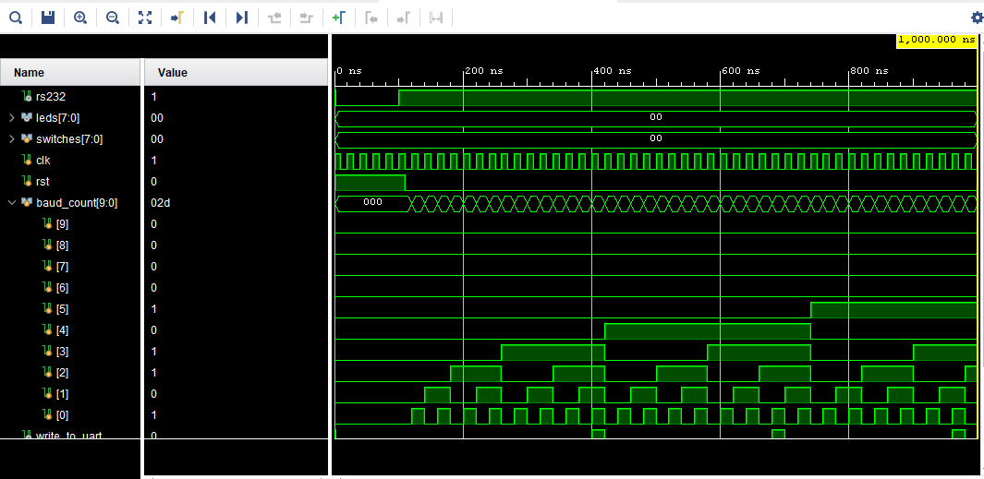

Synthesis Report:
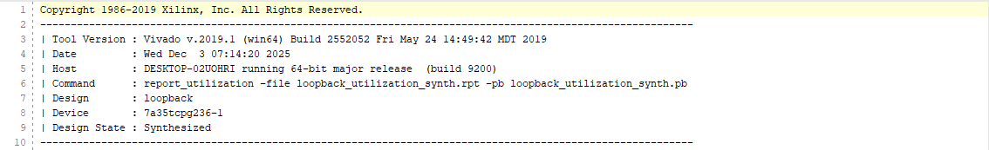

Implementation Report:
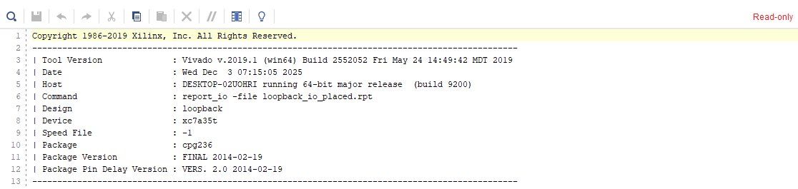

Loopback (Top Module):
// This is the top level design. It needed the
//Cycle count. I used the baud rate and the
//Oversampling rate to calculate the cycle
//Count which turned out to be 650.

// The `timescale directive specifies what
// the simulation time units are (1 ns here)
// and what the simulator timestep should be
// (1 ps here).

`timescale 1 ns / 1 ps

module loopback(clk, rst, leds, switches, rs232_tx, rs232_rx);

input clk, rst; //Here we define the clock, reset, leds, and the communicaton
output reg [7:0] leds; // protocol
input [7:0] switches;
input rs232_rx;
output rs232_tx;

//This part of the code instantiates the
//picoblaze microprocessor and defines
//the wire going in and out of the system

wire [11:0] address;
wire [17:0] instruction;
wire bram_enable;
wire [7:0] port_id;
wire [7:0] out_port;
reg [7:0] in_port;
wire write_strobe;
wire k_write_strobe;
wire read_strobe;
wire interrupt_ack;

//This part of the code connects
//the picoblaze assembly code
//to the top module. Kcpsm is
//the name of the compiler
//used to instantiate the assembly
//code

kcpsm6 kcpsm6_inst (
.address(address),
.instruction(instruction),
.bram_enable(bram_enable),
.port_id(port_id),
.write_strobe(write_strobe),
.k_write_strobe(k_write_strobe),
.out_port(out_port),
.read_strobe(read_strobe),
.in_port(in_port),
.interrupt(1'b0),
.interrupt_ack(interrupt_ack),
.reset(1'b0),
.sleep(1'b0),
.clk(clk)
);

//This part of the code connects the module
//my_program to the top module. My_prgram
//was already given to us.
program my_program (
.address(address),
.instruction(instruction),
.bram_enable(bram_enable),
.clk(clk)
);

//I implemented the 16x
//Oversampling with 9600
//Baud rate and calculated
//The baud tick count to be
//650. I have filled in the
//Correct baud tick whereever
//Required In this code.

reg [9:0] baud_count;
reg en_16_x_baud;

always @(posedge clk or posedge rst)
begin
if (rst)
begin
baud_count <= 0;
en_16_x_baud <= 0;
end
else
begin
if (baud_count == 10'd650)
begin
baud_count <= 0;
en_16_x_baud <= 1;
end
else
begin
baud_count <= baud_count + 1;
en_16_x_baud <= 0;
end
end
end

//I implemented the output
//Logic and assigned the correct
//Port ids with correct components.

wire write_to_uart;
wire write_to_leds;
wire buffer_full;

assign write_to_uart = write_strobe & (port_id == 8'h03);
assign write_to_leds = write_strobe & (port_id == 8'h01);

always @(posedge clk or posedge rst)
begin
if (rst) leds <= 0;
else if (write_to_leds) leds <= out_port;
end

uart_tx transmit (
.data_in(out_port),
.write_buffer(write_to_uart),
.reset_buffer(rst),
.en_16_x_baud(en_16_x_baud),
.serial_out(rs232_tx),
.buffer_full(buffer_full),
.buffer_half_full(),
.clk(clk)
);

reg read_from_uart;
wire [7:0] rx_data;
wire data_present;

always @(posedge clk or posedge rst)
begin
if (rst)
begin
in_port <= 0;
read_from_uart <= 0;
end
else
begin
case (port_id)
8'h00: in_port <= switches;
8'h02: in_port <= rx_data;
8'h04: in_port <= {7'b0000000, data_present};
8'h05: in_port <= {7'b0000000, buffer_full};
default: in_port <= 8'h00;
endcase
read_from_uart <= read_strobe & (port_id == 8'h02);
end
end

uart_rx receive (
.serial_in(rs232_rx),
.data_out(rx_data),
.read_buffer(read_from_uart),
.reset_buffer(rst),
.en_16_x_baud(en_16_x_baud),
.buffer_data_present(data_present),
.buffer_full(),
.buffer_half_full(),
.clk(clk)
);

Endmodule
Conclusion:
In this lab, I successfully implemented the loopback design using the picoblaze microprocessor. I calculated the baud tick using the baud rate, oversampling rate and the clock. I used that baud tick to make sure the FPGA is running at the correct speed and it conditions work after the desired baud tick rate is reached. I also changed the assembly code to make sure the right message is being displayed in the tera ram. The simulation graph, synthesis report and the implementation report in addition to the top module is attached in the lab report.

