Due to web interface providing requests based on heater functionality support I have no possibility to include all possible requests. So please follow the guide below.

- Install Google Chrome as a browser and Fiddler as analyzer.
- Log in to “https://www.ariston-net.remotethermo.com/” from Google Chrome
- Select “WinConfig”, allow all changes to the registry:
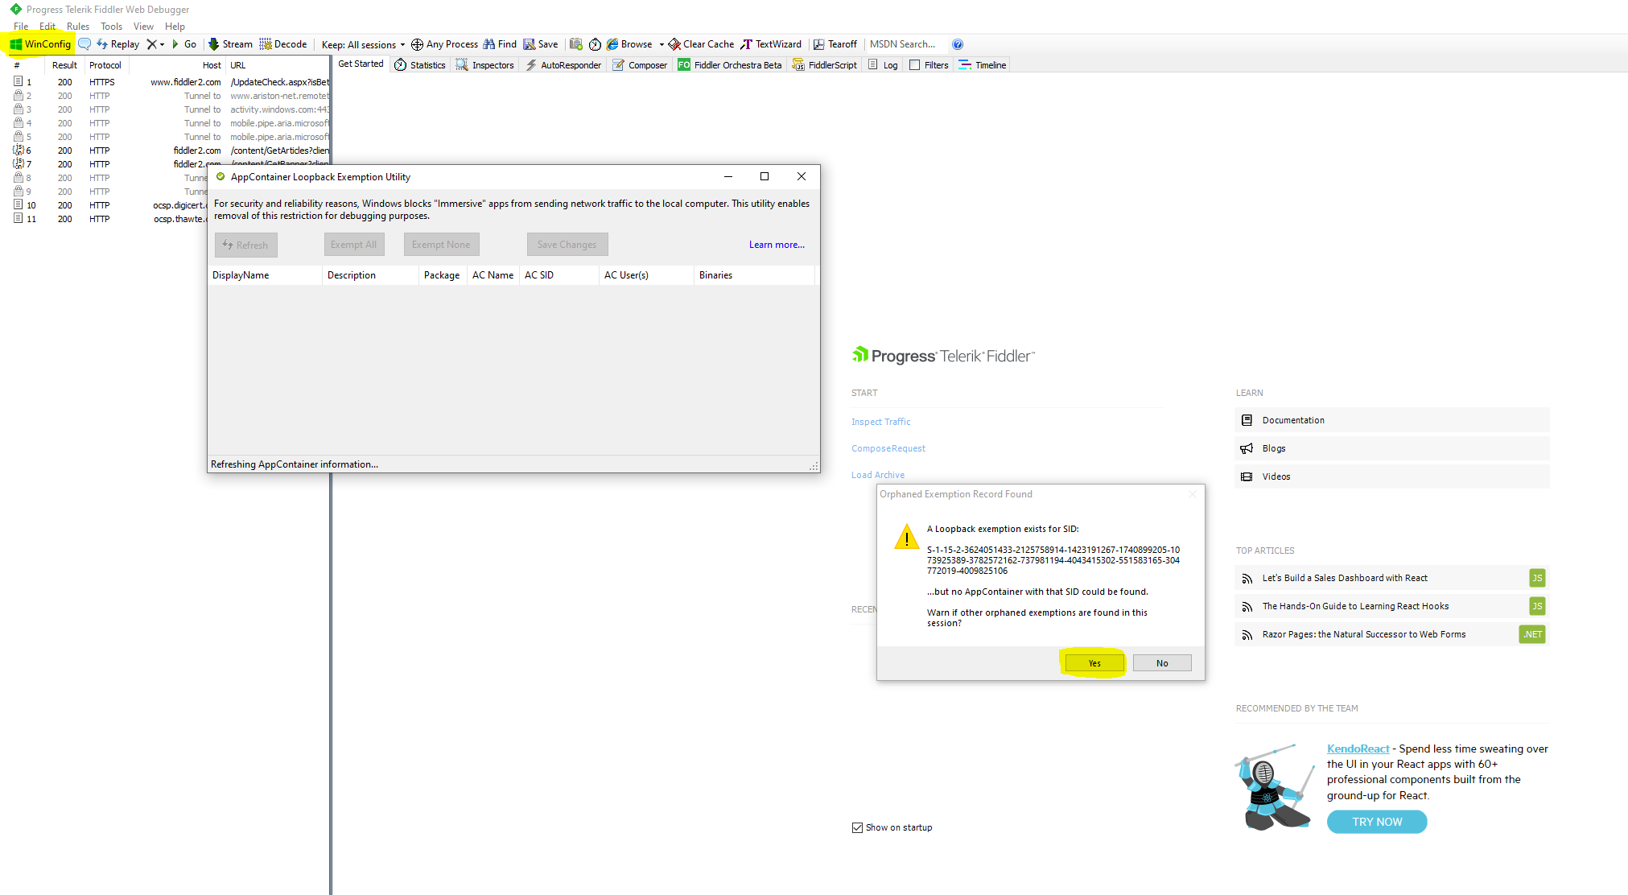
- Enable “Chrome Sandbox” (to see packets going to and from it) and save the changes:
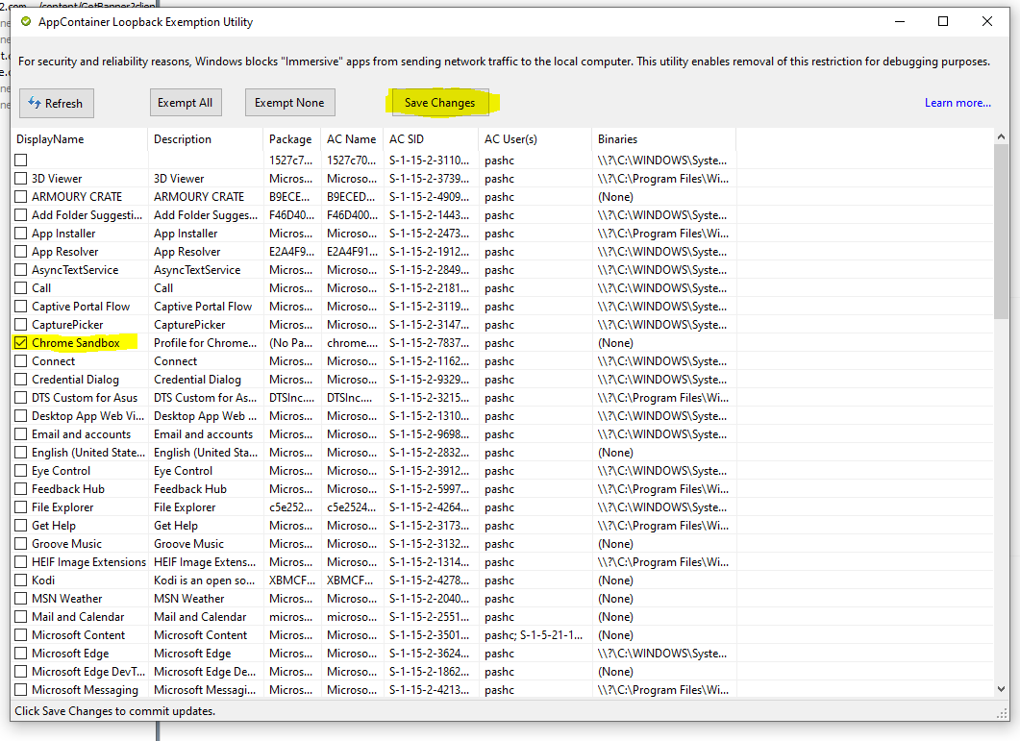
- Enable HTTPS decryption if it is disabled when trying to open packets from “https://www.ariston-net.remotethermo.com/”:
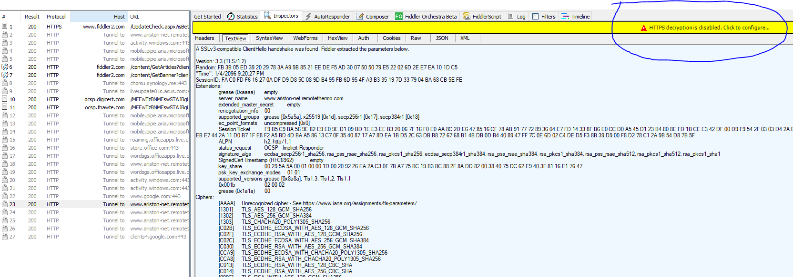
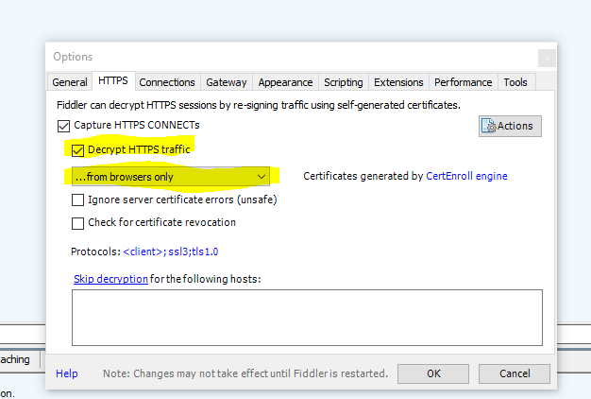

- New Get request (for new sensor)

  - After saving the settings go to Google Chrome, select page you are interested in. Example shown below. Refresh corresponding part.
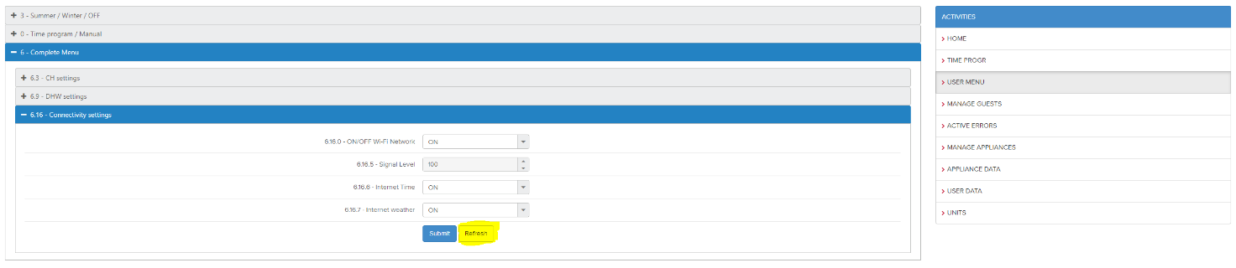
  - Quickly switch to fiddler and look for extraordinary request, which carries JSON reply. Example below.
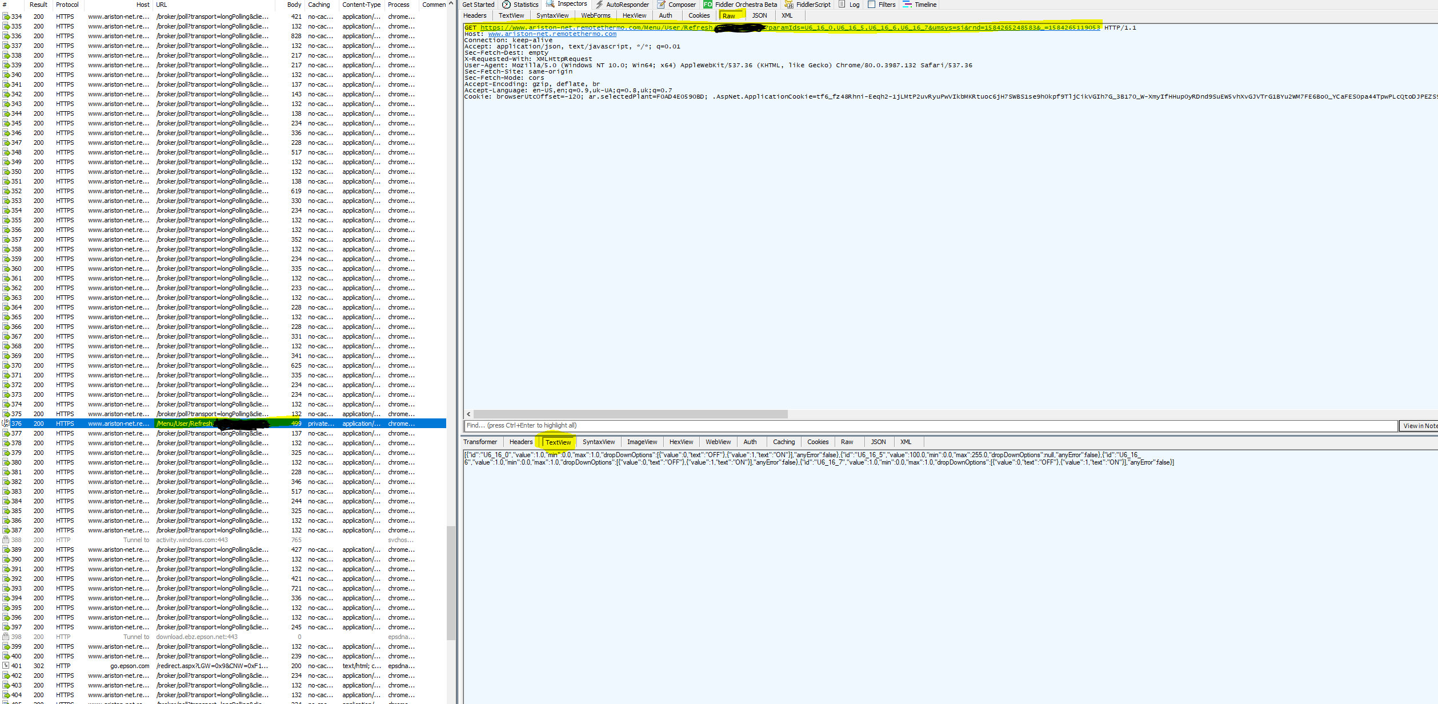
  - Save request address and see there is a valid JSON response. Part of header is individual PlantID, which is unique identification of your heater.
  - In this specific case we had 4 sensors refreshed on page and need to map which is which. Signal strength has unique value, so easy to identify “U6_16_5” is a signal strength. For the rest the simplest is to change one parameter and catch it in the fiddler. See “New set request”
  - If sensors have multiple values 0, 1, 2, 3 etc. please change values to each of them and see corresponding JSON to map value with represented one. Not needed for ON and OFF, but is needed for others.
- New Set request (for new service call attribute to change the data)
  - Change one parameter and select “Submit”
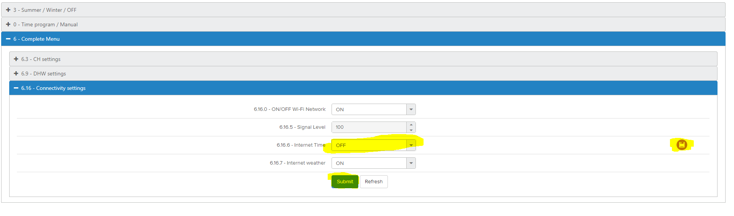
  - Quickly switch to fiddler and look for corresponding POST request (most likely with JSON):
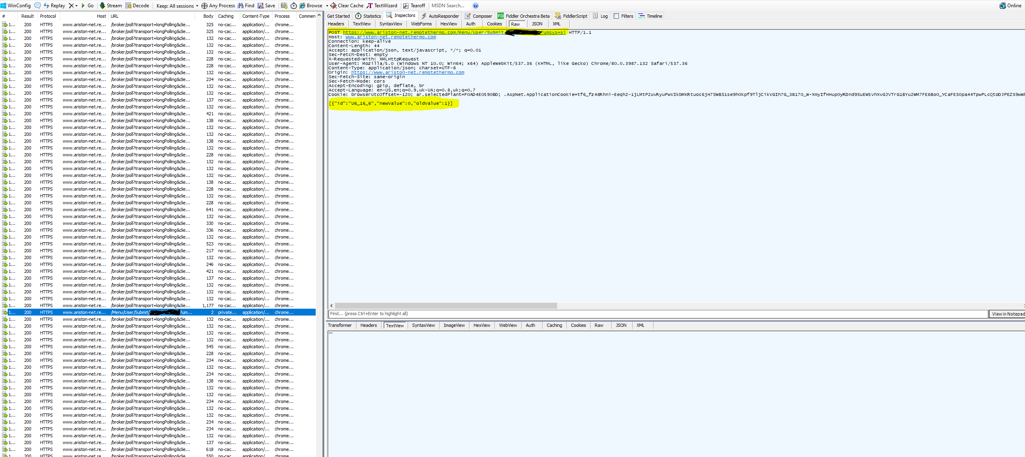
  - Save request address and JSON data. We can see that changed internet time was represented by "U6_16_6" and we see how JSON was formatted (old and new value besides the identifier).

To request new sensor, please provide:
- Request address. For example:
“https://www.ariston-net.remotethermo.com/TimeProg/GetWeeklyPlan/xxxxxxxxxxxx?progId=ChZn1&umsys=si”
- Full JSON reply example.
- Information on what is the sensor you are interested in within that JSON.
- Value mapping if it is not simple ON and OFF.
For example “mode” in main request can have values 0 (summer), 1(winter), 2 (heating only), 5 (off).

To request new service call attribute, please provide:
- Request address. For example:
“https://www.ariston-net.remotethermo.com/Menu/User/Submit/xxxxxxxxxxxx?umsys=si”
- JSON request (upper part)

