Saini Ye

U20722043

Nearby Restaurant Search Website

Product Mission:

Providing people a simple tool to quickly find and display the nearest restaurants around the school by entering the name of the school helps them find places to eat more easily.

User Stories:

1. As a college student, I want to quickly find restaurants around campus so that I can choose the nearest place to eat during recess.
2. As an educator, I would like to know the dining options near the school so that I can eat or discuss work with colleagues or students at a nearby restaurant.
3. As a school visitor or parent, I would like to know the dining options around the school so that I can conveniently choose a place to eat after visiting the school.
4. As a tourist, I want to know which restaurants offer local specialties so that I can enjoy the local cuisine when I visit the school.
5. As an administrator of the school, I would like to know the dining options around the school so that when organizing an event or meeting, I can recommend nearby dining places for participants.
6. As a deliveryman, I want to know the distribution of restaurants near the school so that I can plan my delivery route more efficiently.
7. As a customer, I want to know the specific location and opening hours of the restaurant in advance, so that I can plan my time and route in advance.
8. As a customer, I want to know the menu of the restaurant and the recommendations and reviews of other customers in advance, so that I can decide what I want to eat in advance.
9. As a customer, I want to be able to understand the price range of the restaurant so that I can choose the place that fits my budget.
10. As a customer, I wish I could get the specific address and contact information of the restaurant so that I can navigate or make a reservation directly.
11. As a restaurant owner near a school, I would like to confirm that my restaurant is listed in this tool to ensure that potential students and faculty can find my restaurant.
12. As a restaurant owner, I want to be able to update my restaurant information, including menu, prices, features and offers.
13. As a restaurant owner, I want to be able to receive and respond to customer reviews in order to improve service quality and customer satisfaction.

MVP (Minimum Viable Product):

1. As a college student, I want to quickly find restaurants around campus so that I can choose the nearest place to eat during recess
2. As a customer, I want to know the specific location and opening hours of the restaurant in advance, so that I can plan my time and route in advance.
3. As a customer, I want to know the menu of the restaurant and the recommendations and reviews of other customers in advance, so that I can decide what I want to eat in advance.
4. As a customer, I want to be able to understand the price range of the restaurant so that I can choose the place that fits my budget.

Product function:

1. Enter the name of the university.

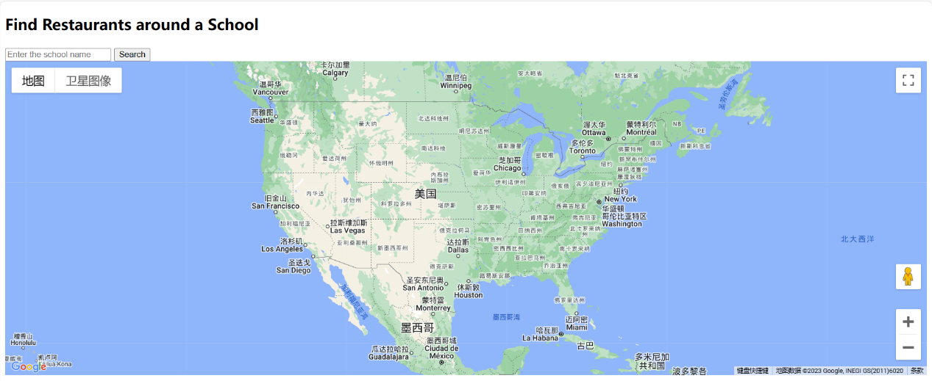

1. Show the 20 restaurants closest to the school.

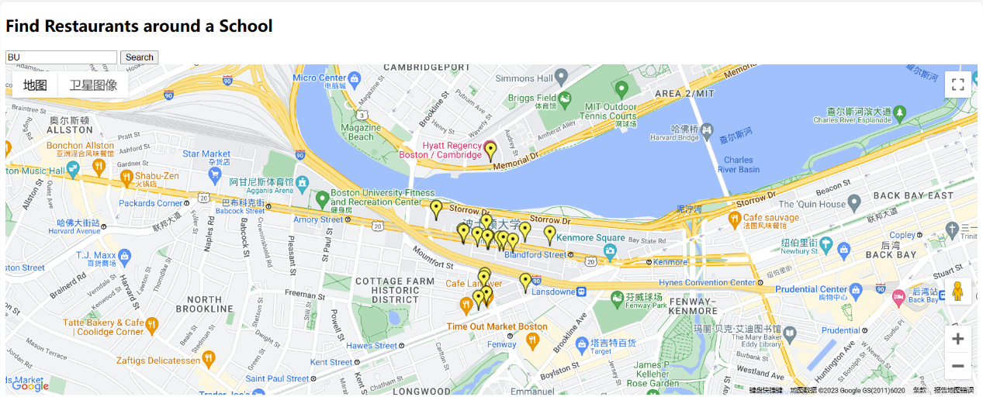

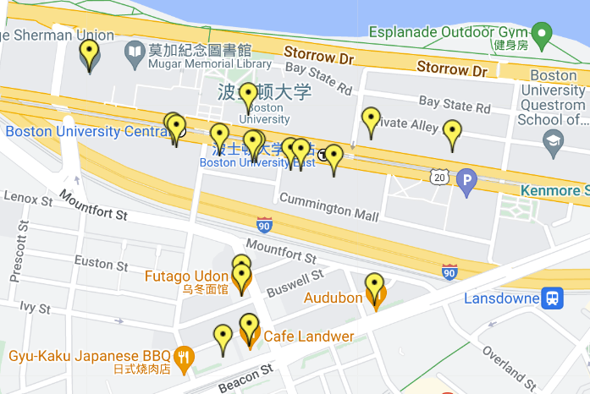

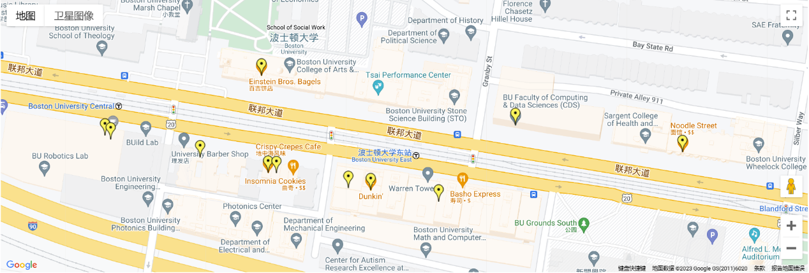

1. View restaurant information, address, opening hours, menu, customer reviews.

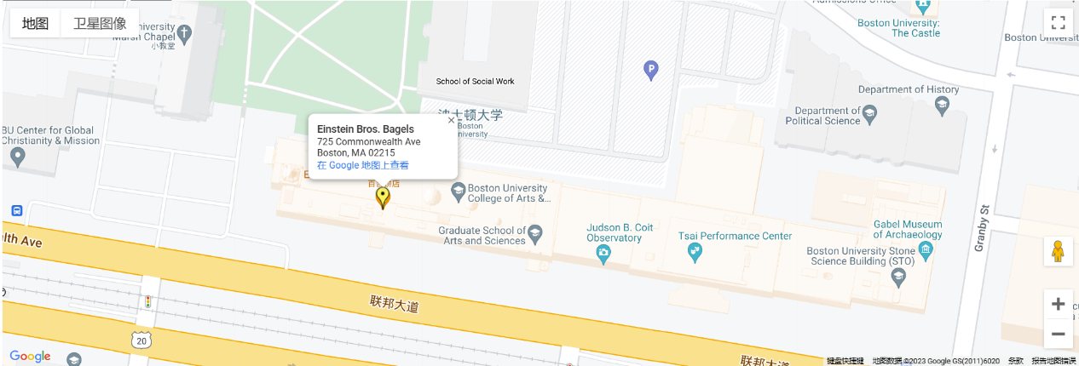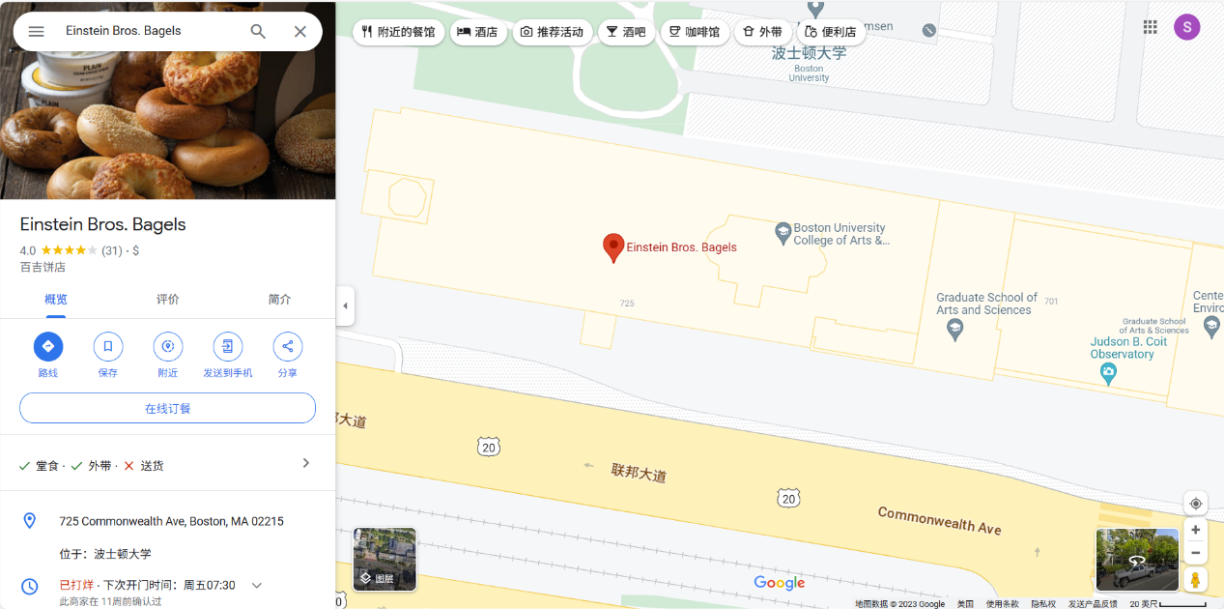

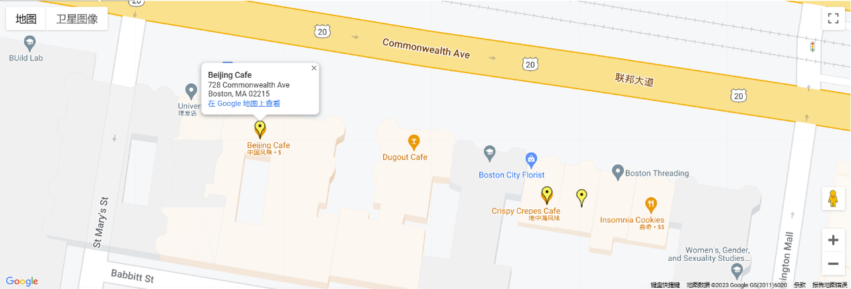

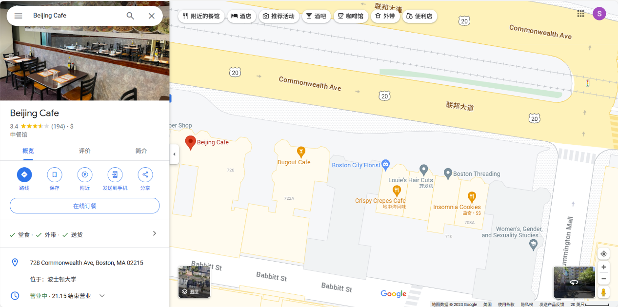

1. Search for restaurants near other schools.

