3.1.5 Benchmark dataset and preprocessing (UNSW-NB15)
To validate the methodology on real network traffic in addition to the live simulation, the supervised learning pipeline proposed in Assignment 1 was implemented in Python (ml/run_pipeline.py) using the UNSW-NB15 benchmark dataset [9]. The official partition CSV contains 175,341 labeled flow records with 39 numeric features, 3 categorical features (proto, service, state), a binary label (benign/attack) and a multiclass attack_cat covering nine attack families (Generic, Exploits, Fuzzers, DoS, Reconnaissance, Analysis, Backdoor, Shellcode, Worms). The attack_cat column is never shown to the models; it is retained solely to break results down per attack family.
Preprocessing followed the exact steps planned in Assignment 1 (Section 5.4):
1. Cleaning - the id column was dropped, 67,601 duplicate records were removed to prevent train/test leakage (175,341 -> 107,740 records), and non-finite values were median-imputed (0 found).
2. Encoding and normalization - proto, service and state were one-hot encoded with rare categories (< 0.1% of training rows) folded into an infrequent bucket, and all numeric features were standardized with a StandardScaler fitted on the training split only, expanding the feature space to 60 encoded features.
3. Splitting - a stratified 70/30 train/test split (75,418 / 32,322 records) stratified on attack_cat, so rare families such as Worms appear in both splits in proportion.
4. Balancing - the binary classes are moderately imbalanced (~68% attack / 32% benign after cleaning), so cost-sensitive learning was used: class_weight='balanced' for Random Forest and SVM, and scale_pos_weight for XGBoost. Synthetic oversampling (e.g. SMOTE) was deliberately avoided to keep the evaluation on genuine traffic records only.
5. Feature selection - mutual information between each encoded feature and the label was estimated on the training split, and the top 20 of 60 features were retained. This dimensionality reduction directly serves the IoT/edge feasibility objective (fewer features means smaller models and faster inference). The strongest features were sbytes, dbytes, sttl, dttl, ct_state_ttl.
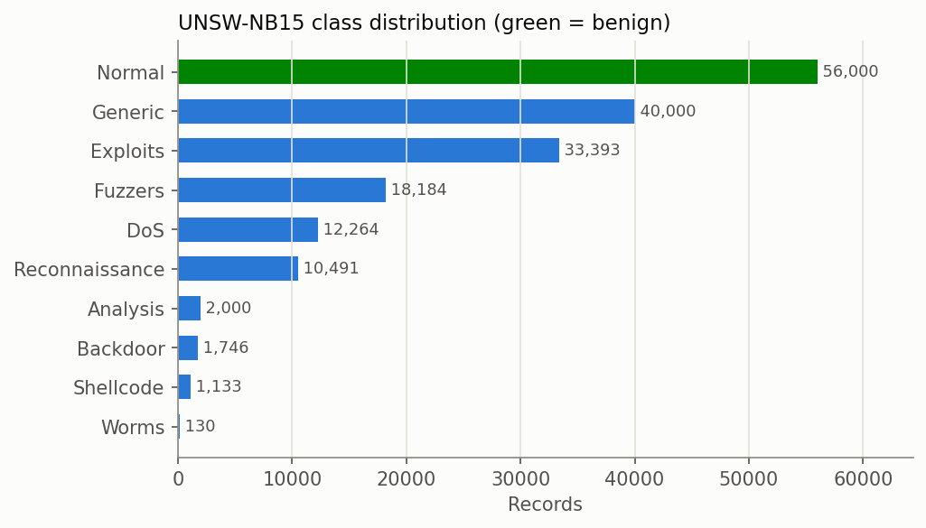
Figure B1. UNSW-NB15 class distribution (before cleaning).
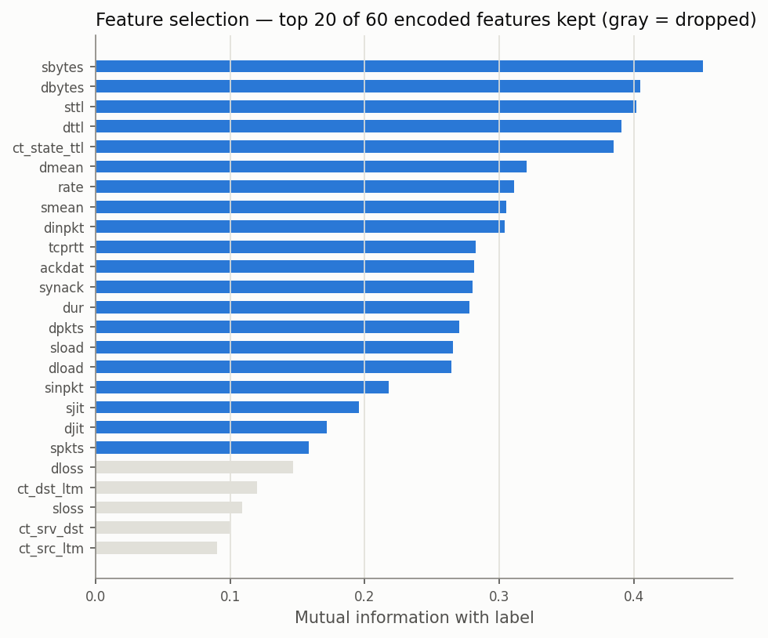
Figure B2. Mutual-information feature selection (top 20 of 60 encoded features kept).

3.2.1 Benchmark results: Random Forest vs SVM vs XGBoost
All three models were trained on the same 75,418-record training split and evaluated on the held-out 32,322-record test set. The RBF-kernel SVM was trained on a stratified 20,000-record subsample because kernel SVM training scales quadratically with the number of records - itself a relevant deployment finding. Results:
Metric | Random Forest | SVM (RBF) | XGBoost
Accuracy | 91.76% | 90.19% | 92.02%
Precision | 90.14% | 84.23% | 90.18%
Recall (detection rate) | 94.43% | 99.74% | 94.94%
F1-score | 92.23% | 91.33% | 92.50%
False Positive Rate | 11.11% | 20.09% | 11.13%
ROC-AUC | 0.9774 | 0.9450 | 0.9805
PR-AUC | 0.9756 | 0.9348 | 0.9804
True/False Positives | 15,821 / 1,730 | 16,711 / 3,128 | 15,907 / 1,732
5-fold CV accuracy | 91.40% ± 0.19% | n/a (cost) | 91.63% ± 0.18%

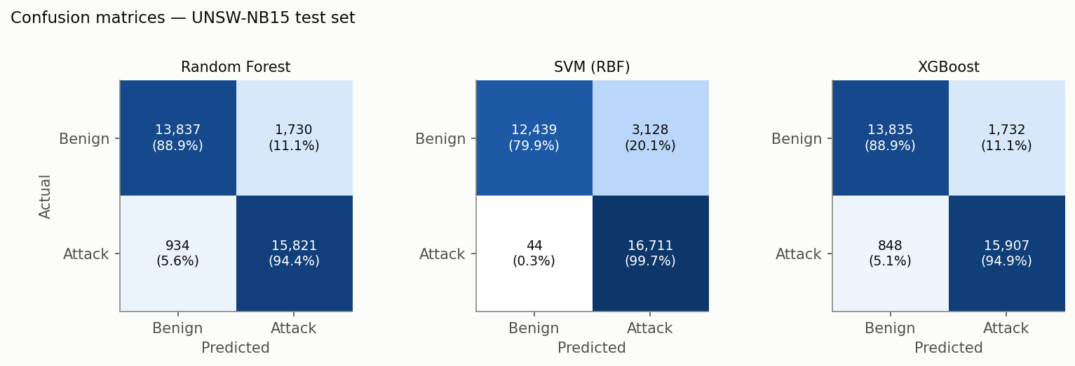
Figure B3. Confusion matrices on the UNSW-NB15 test set.
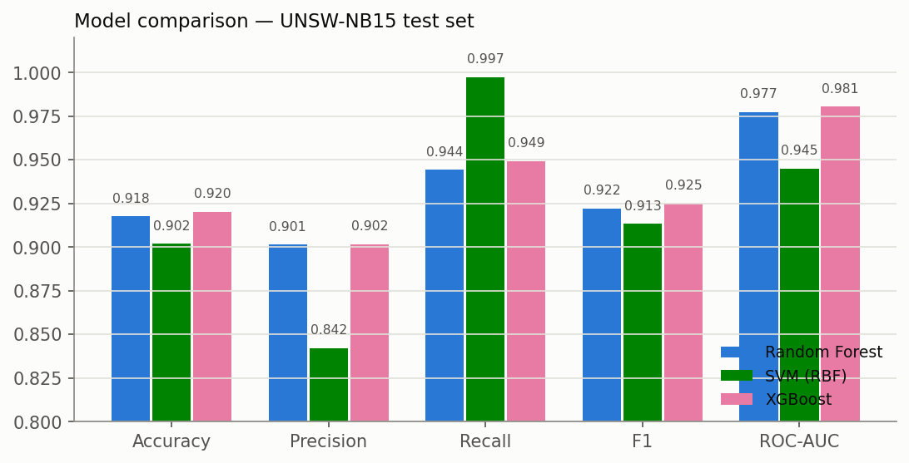
Figure B4. Metric comparison across the three models.
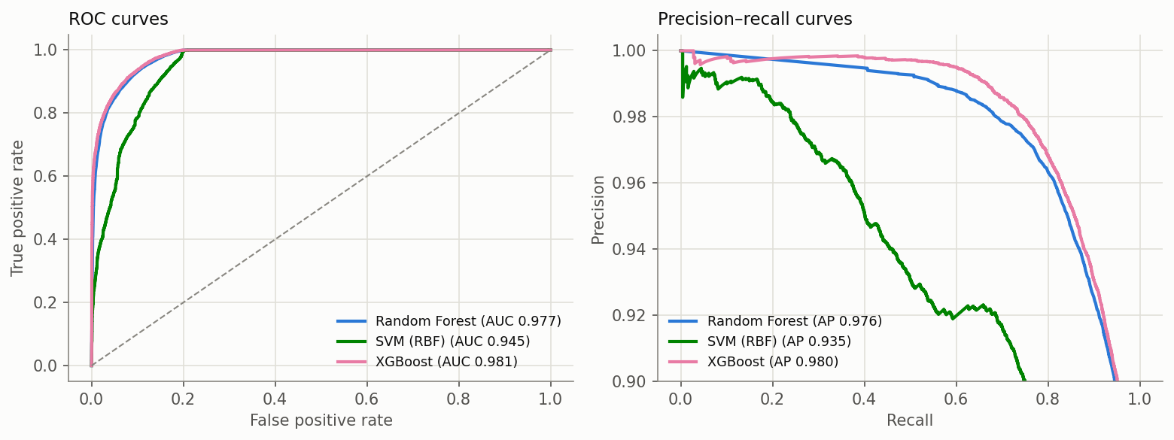
Figure B5. ROC and precision-recall curves.
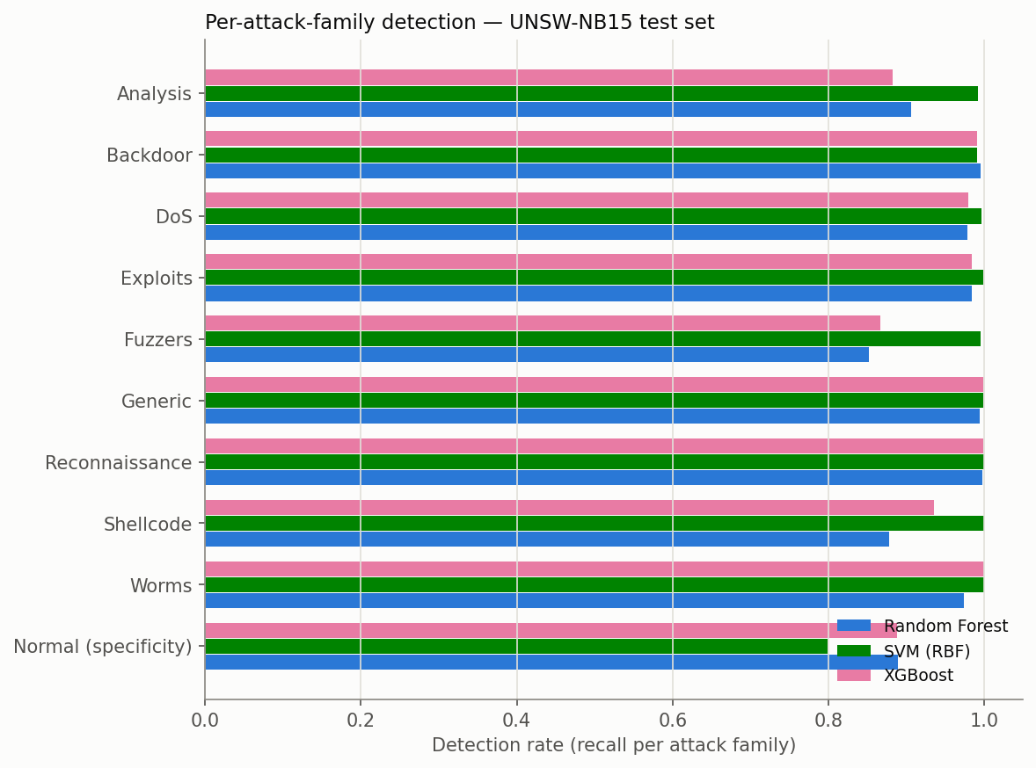
Figure B6. Detection rate per attack family (Normal row shows specificity).

3.2.2 Edge/IoT deployment feasibility
Assignment 1 required assessing deployment feasibility on constrained devices via feature count, model size and inference time. With the feature space reduced to 20 features:
Model | Training time | Serialized size | Inference latency / sample | Throughput
Random Forest | 13.5 s (75,418 rows) | 22.8 MB | 11.31 µs | 88,456 flows/s
SVM (RBF) | 12.81 s (20,000 rows) | 407.3 KB | 634 µs | 1,577 flows/s
XGBoost | 6.48 s (75,418 rows) | 808.1 KB | 4.89 µs | 204,649 flows/s

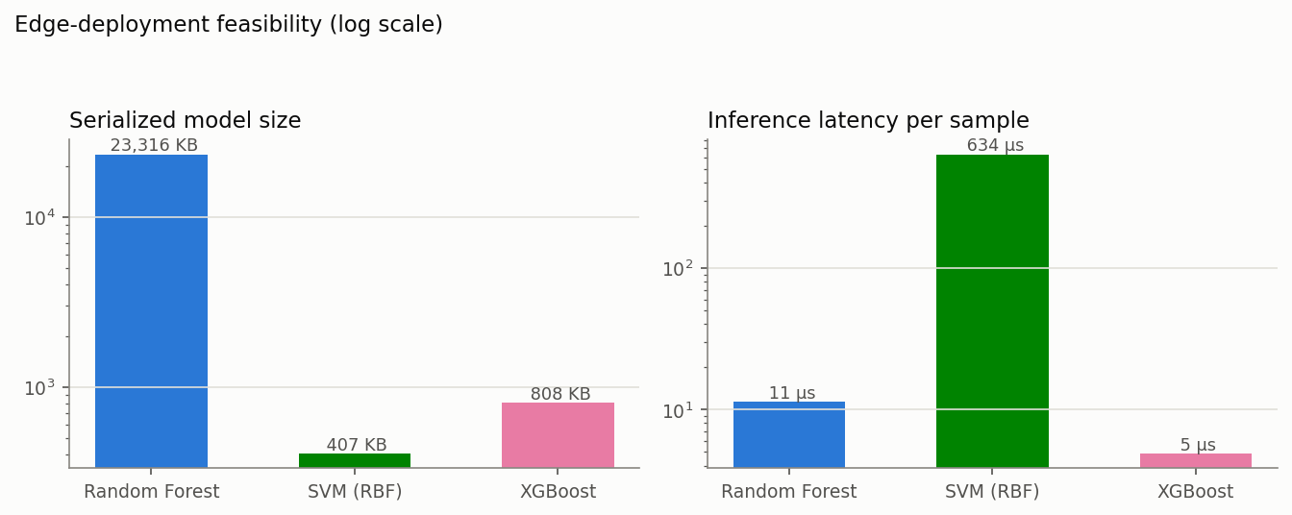
Figure B7. Model size and per-sample inference latency (log scale).

3.2.3 Explainability: feature importance and SHAP
Impurity-based feature importances were extracted from both tree ensembles, and SHAP (TreeExplainer) was applied to the XGBoost model on a 2,000-record test subsample. The most influential features were sttl, dbytes, ct_state_ttl, smean, sbytes, giving analysts a concrete, per-feature account of why traffic is classified as malicious [11].
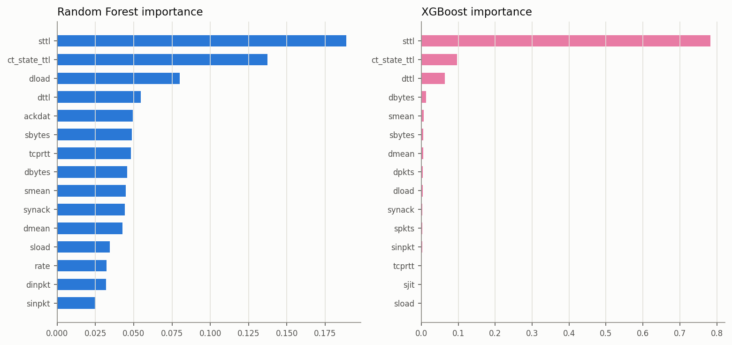
Figure B8. Top-15 feature importances (Random Forest and XGBoost).
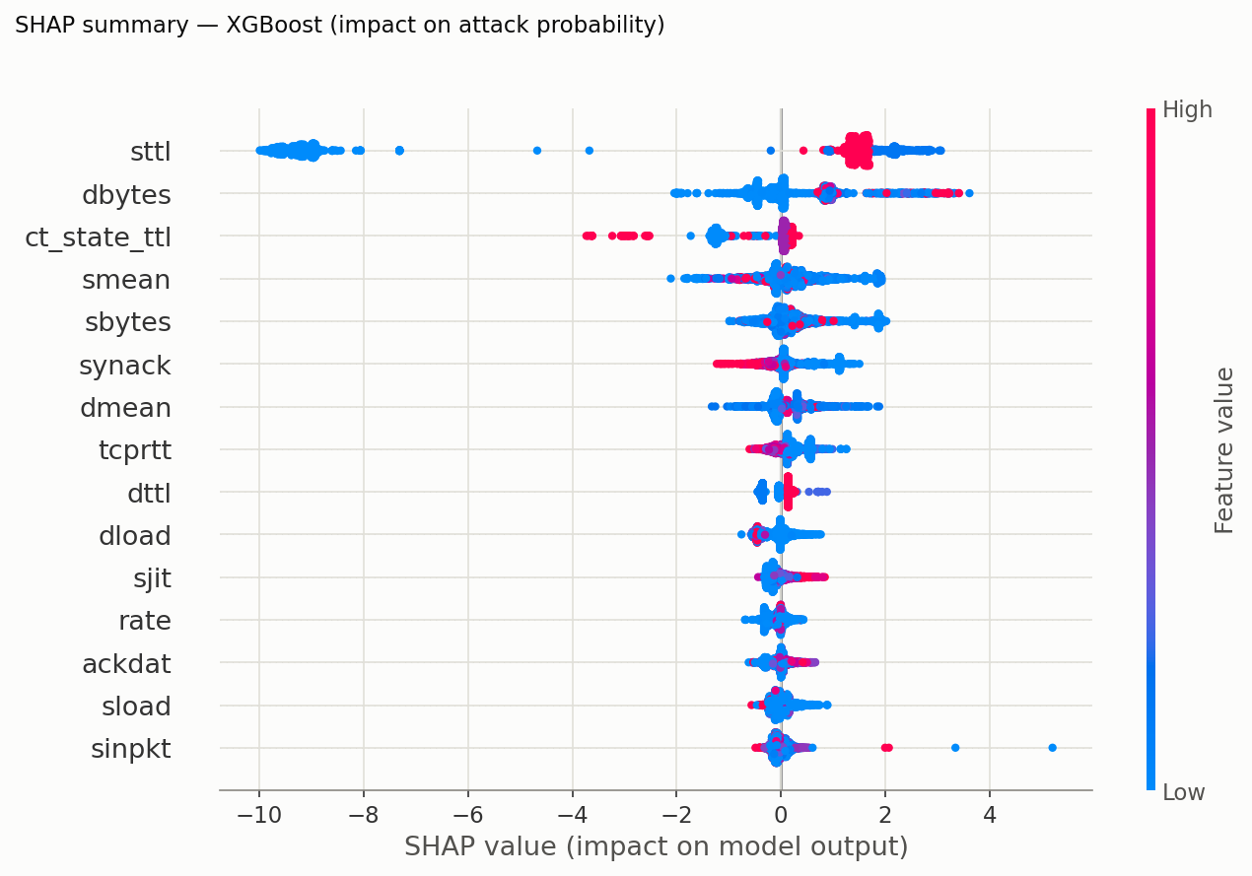
Figure B9. SHAP summary for XGBoost - impact of each feature on the attack probability.
A critical observation: TTL-derived features (sttl, ct_state_ttl, dttl) carry most of the signal. Published feature-analysis work on UNSW-NB15 [12] notes this is partly an artifact of how the dataset was generated (attack and benign traffic originate from hosts with different TTL defaults), so a model leaning on TTL may not transfer unchanged to other networks. This is a concrete instance of the data-representativeness limitation anticipated in Assignment 1, and an argument for the hybrid architecture in which learned models are fused with signature rules rather than trusted alone.

3.2.4 Benchmark analysis summary
XGBoost [10] is the best overall model and by far the most deployable: it leads on accuracy (92.02%), F1 (92.50%) and ROC-AUC (0.9805) while being ~28x smaller than Random Forest and 2.3x faster per flow. The RBF-SVM reaches near-perfect recall (99.74%, only 44 missed attacks) but misflags 20.09% of benign traffic and needs 634 microseconds per flow - precisely the alert-fatigue failure mode identified in the Assignment 1 literature review, and unsuitable for edge deployment. Five-fold cross-validation (RF 91.40% +/- 0.19%, XGBoost 91.63% +/- 0.18%) is within half a point of the held-out test accuracy, indicating no overfitting. Published binary classifiers on UNSW-NB15 report 89-99% accuracy; the top of that range typically evaluates without removing the 67,601 duplicate records, which inflates accuracy through memorization. After deduplication our results sit in the range reported by careful studies, and the ~11% false-positive rate of the tree models is the quantitative justification for the ensemble + human-in-the-loop layer: the live hybrid engine reduces FPR to 0.28% by fusing the ML verdict with signature rules and a suspicious tier.

Additional references (append to the reference list)
[9] N. Moustafa and J. Slay, “UNSW-NB15: A comprehensive data set for network intrusion detection systems,” in Proc. Military Communications and Information Systems Conference (MilCIS), Canberra, Australia, 2015, pp. 1–6, doi: 10.1109/MilCIS.2015.7348942.
[10] T. Chen and C. Guestrin, “XGBoost: A scalable tree boosting system,” in Proc. 22nd ACM SIGKDD Int. Conf. Knowledge Discovery and Data Mining, San Francisco, CA, USA, 2016, pp. 785–794, doi: 10.1145/2939672.2939785.
[11] S. M. Lundberg and S.-I. Lee, “A unified approach to interpreting model predictions,” in Proc. Advances in Neural Information Processing Systems (NeurIPS), Long Beach, CA, USA, 2017, pp. 4765–4774.
[12] M. Sarhan, S. Layeghy, and M. Portmann, “Feature analysis for machine learning-based IoT intrusion detection,” arXiv preprint arXiv:2108.12732, 2021.
[13] F. Pedregosa et al., “Scikit-learn: Machine learning in Python,” Journal of Machine Learning Research, vol. 12, pp. 2825–2830, 2011.

