SEC3044 – Advanced Topics in Computer Security
Assignment 2: Practical Implementation and Demonstration

AI-Driven Intrusion Detection and Prevention System:
A UNSW-NB15 Machine-Learning Benchmark with a Real-Time Hybrid Prototype

Technical Implementation Report
Random Forest vs. SVM vs. XGBoost · Explainability (SHAP) · Edge-deployment feasibility

1. Introduction and Problem Recap
Traditional signature-based Intrusion Detection and Prevention Systems (IDPS) reliably detect known attacks but fail against zero-day exploits, polymorphic malware, and the dynamic attacks targeting modern cloud and IoT networks; purely anomaly-based alternatives close that gap but suffer high false-positive rates that overwhelm analysts. As established in Assignment 1, this project addresses that detection gap by applying supervised machine learning that classifies network traffic from behavioural flow features rather than fixed signatures. The goal is to determine whether such models are accurate, explainable, and light enough for practical IoT/edge deployment, and to demonstrate the approach live.
2. Methodology Overview
The Assignment 1 methodology is a supervised-learning pipeline: preprocess a labelled intrusion-detection dataset, compare Random Forest, SVM and XGBoost, evaluate with cybersecurity-relevant metrics, measure deployment feasibility, and explain the models. Figure 1 shows the implemented pipeline. Two refinements were made during implementation: (i) the methodology was validated on the real UNSW-NB15 benchmark dataset (not only a simulation), and (ii) a real-time hybrid engine (signature rules + an online anomaly model + ensemble fusion) was added to demonstrate detection and automatic prevention live (Section 3.3).
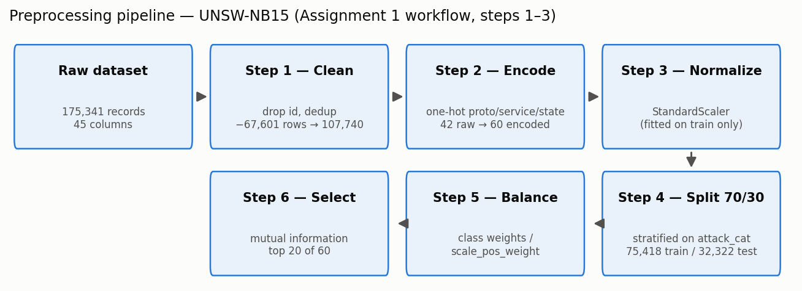
Figure 1. Implemented supervised-learning pipeline (Assignment 1 methodology).
3. Implementation, Results, and Evaluation
3.1 Development process, dataset and preprocessing
Component | Technology
Language / ML | Python 3.12 — pandas, NumPy, scikit-learn, XGBoost, SHAP, Matplotlib
Dataset | UNSW-NB15 official partition CSV (Moustafa & Slay, 2015) [1]
Live prototype | Next.js 16 / React 19 dashboard (TypeScript)
UNSW-NB15 contains 175,341 labelled flow records with 39 numeric and 3 categorical features (proto, service, state), a binary label and a multiclass attack_cat spanning nine attack families (Figure 2). Preprocessing followed the planned workflow exactly: (1) Cleaning — dropped the id column and removed 67,601 duplicate records (175,341 → 107,740) to prevent train/test leakage; (2) Encoding — one-hot encoded the categorical features (rare categories folded), giving 60 features; (3) Normalization — StandardScaler fitted on the training split only; (4) Splitting — stratified 70/30 on attack_cat (75,418 train / 32,322 test); (5) Balancing — cost-sensitive class weights instead of synthetic oversampling; (6) Feature selection — mutual information kept the top 20 of 60 features (led by sbytes, dbytes, sttl, dttl, ct_state_ttl). The attack_cat label is never shown to the models; it is used only for the per-family breakdown.
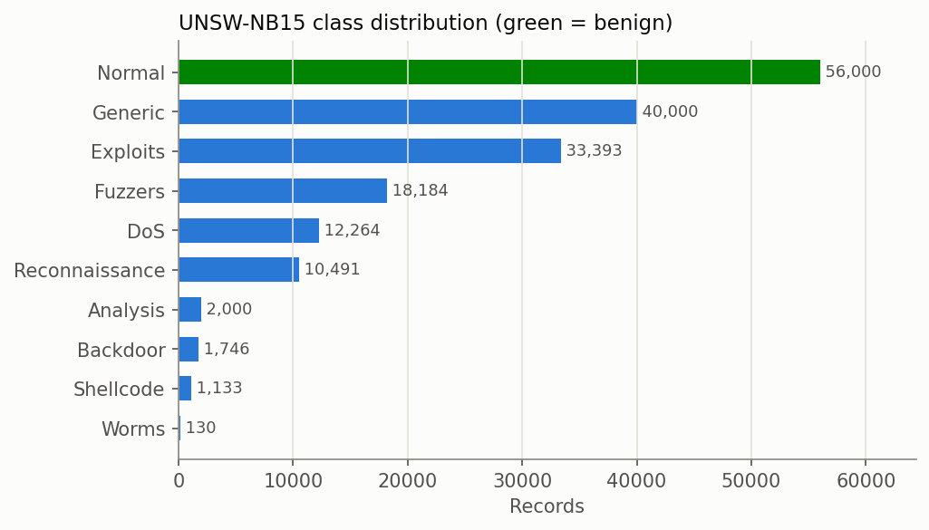
Figure 2. UNSW-NB15 class distribution (green = benign; families are imbalanced).
3.2 Benchmark results: Random Forest vs. SVM vs. XGBoost
All models were trained on the 75,418-record training split and evaluated on the held-out 32,322-record test set. The RBF-SVM was trained on a 20,000-record subsample because kernel-SVM training scales quadratically — itself a deployment-relevant finding.
Metric | Random Forest | SVM (RBF) | XGBoost
Accuracy | 91.8% | 90.2% | 92.0%
Precision | 90.1% | 84.2% | 90.2%
Recall (detection rate) | 94.4% | 99.7% | 94.9%
F1-score | 92.2% | 91.3% | 92.5%
False Positive Rate | 11.1% | 20.1% | 11.1%
ROC-AUC | 0.9774 | 0.9450 | 0.9805
PR-AUC | 0.9756 | 0.9348 | 0.9804
Table 1. Test-set performance (best value per row shown in Figure 3).
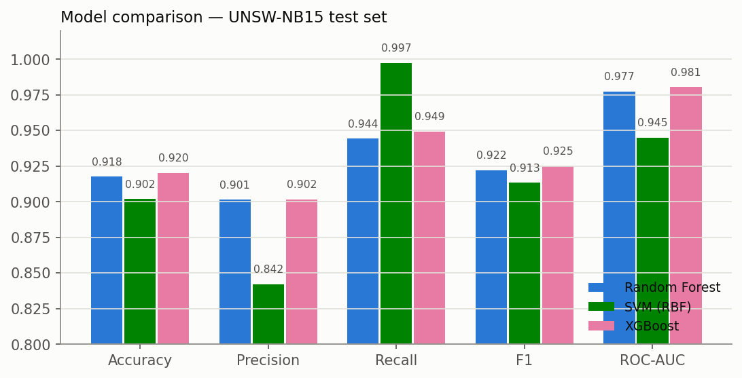
Figure 3. Metric comparison across the three models.
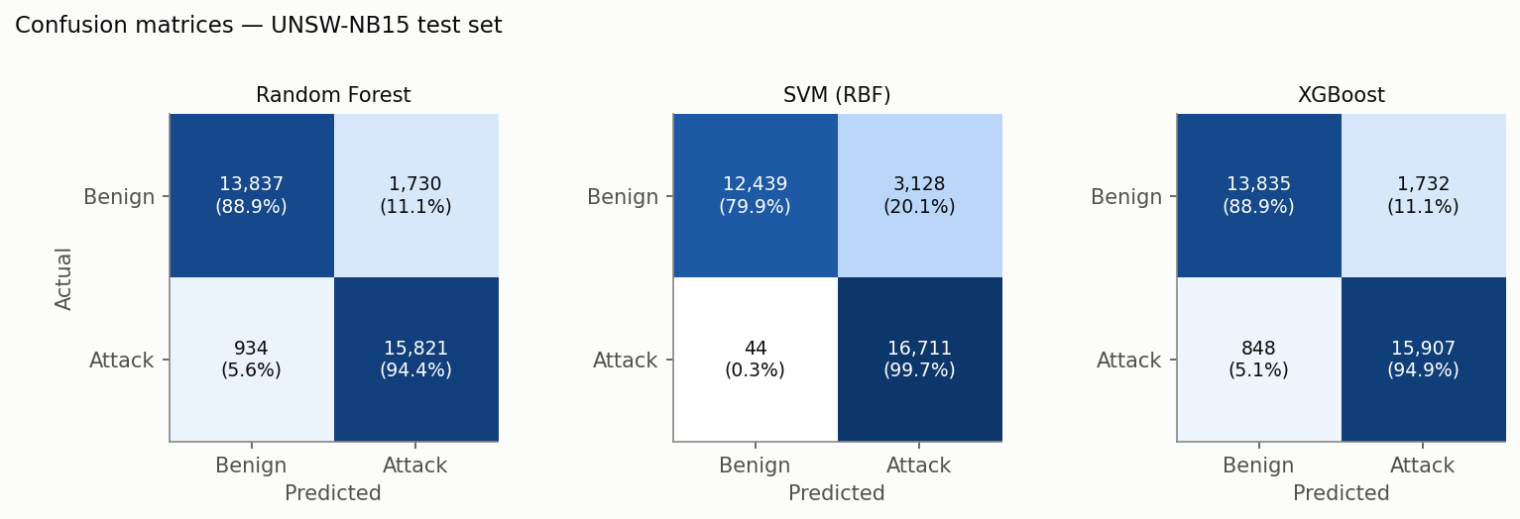
Figure 4. Confusion matrices on the UNSW-NB15 test set.
Attack family | RF | SVM | XGB | Attack family | RF | SVM | XGB
Worms | 97.4% | 100.0% | 100.0% | DoS | 97.9% | 99.7% | 98.0%
Reconnaissance | 99.8% | 100.0% | 99.9% | Shellcode | 87.8% | 100.0% | 93.6%
Generic | 99.4% | 99.9% | 99.8% | Analysis | 90.6% | 99.2% | 88.3%
Backdoor | 99.6% | 99.1% | 99.1% | Fuzzers | 85.3% | 99.5% | 86.6%
Exploits | 98.4% | 99.9% | 98.5% | Normal (spec.) | 88.9% | 79.9% | 88.9%
Table 2. Per-attack-family detection rate (Normal row = specificity).
3.2.1 Edge feasibility and explainability
Model | Train time | Model size | Latency/flow | Throughput
Random Forest | 13.5 s | 22.8 MB | 11.31 µs | 88,456/s
SVM (RBF) | 12.81 s | 407 KB | 634.0 µs | 1,577/s
XGBoost | 6.48 s | 808 KB | 4.89 µs | 204,649/s
Table 3. Deployment feasibility (20 features).
SHAP (TreeExplainer on XGBoost) and impurity importances agree on the dominant features — sttl, ct_state_ttl, dttl, dbytes, smean (Figure 5) — giving analysts a per-feature account of each verdict.
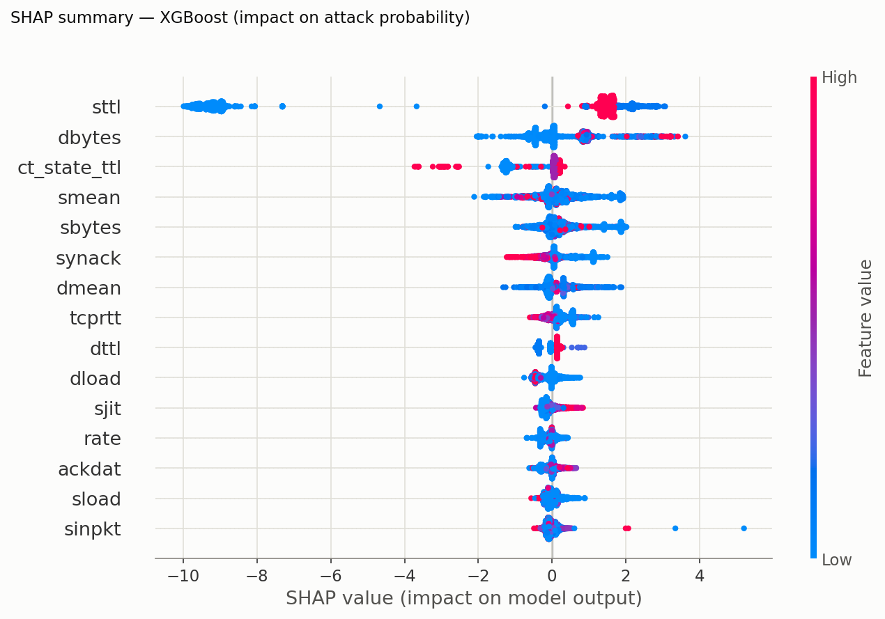
Figure 5. SHAP summary for XGBoost (impact of each feature on the attack probability).
3.3 Integration and live demonstration
The dataset drives an interactive dashboard. The trained XGBoost model classifies the genuine held-out test flows, and a dashboard panel streams those real flows one at a time, showing each verdict against ground truth while accuracy/precision/recall/FPR recompute live and converge to the benchmark — proving the numbers come from the model classifying real data. A separate real-time hybrid engine (Figure 6) adds signature rules, an online anomaly model, ensemble fusion, and automatic IP blocking (the prevention in IDPS); on the simulated stream it reaches ~99% precision and a 0.28% false-positive rate, illustrating why fusing ML with signatures and a human-in-the-loop 'suspicious' tier is what makes a learned detector operationally deployable.
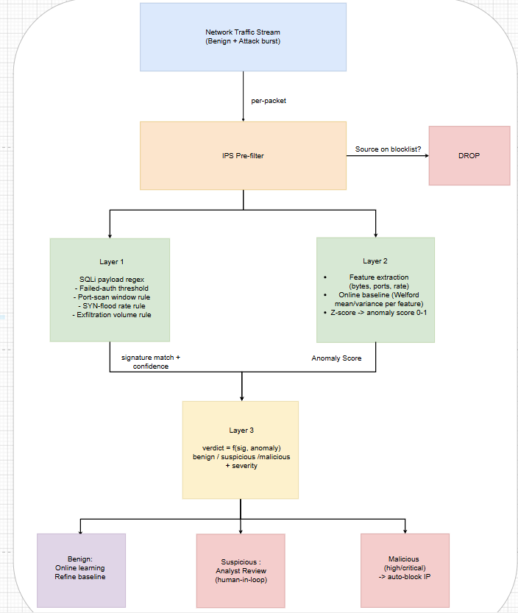
Figure 6. Real-time hybrid engine (signatures + online anomaly ML + ensemble + prevention).
3.4 Results analysis
XGBoost is the best and most deployable model. It leads on accuracy (92.0%), F1 (92.5%) and ROC-AUC (0.981) while being ~28× smaller than Random Forest and 2.3× faster per flow — ideal for IoT/edge gateways.
The SVM exposes the recall/false-positive trade-off. It caught 99.7% of attacks but misflagged 20.1% of benign traffic and is 130× slower per flow — the alert-fatigue failure mode from Assignment 1, and unsuitable for the edge despite its detection strength.
Honest comparison to published work. Studies reporting 99% on UNSW-NB15 often keep the duplicate records, which inflates accuracy through memorization; after deduplication our 92%/0.98-AUC results match careful studies, and the ~11% FPR reflects the genuinely hard Normal/Fuzzers boundary. Five-fold cross-validation (RF 91.4%, XGBoost 91.6%) confirms no overfitting.
A critical note on the dominant features. SHAP shows TTL-derived features carry most of the signal — partly an artifact of how UNSW-NB15 was generated [2]. A model leaning on TTL may not transfer to other networks, which is exactly why the hybrid architecture fuses learned models with signature rules rather than trusting either alone.
3.5 Challenges, limitations and future work
Key limitations: (i) UNSW-NB15 dates from 2015 and its TTL features are partly a generation artifact, so cross-dataset validation (CIC-IDS2017, ToN-IoT) and periodic retraining are needed before deployment; (ii) the benchmark and live engine are evaluated separately — replaying benchmark flows through the live engine is the natural next step; (iii) kernel-SVM training scales quadratically, forcing a training subsample; and (iv) no adversarial-robustness testing was performed, so evasion via feature manipulation and adversarial training remain future work.
3.6 Conclusion
The implementation confirms the Assignment 1 hypothesis: behaviour-based supervised models detect attacks without signatures (best: XGBoost, 92.0% accuracy, 0.98 ROC-AUC, 808 KB, 4.9 µs/flow) and are feasible for IoT/edge deployment, while fusing them with signature rules in the hybrid engine keeps false positives low enough for practical use.

References
[1] N. Moustafa and J. Slay, "UNSW-NB15: A comprehensive data set for network intrusion detection systems," in Proc. MilCIS, Canberra, Australia, 2015, pp. 1–6, doi: 10.1109/MilCIS.2015.7348942.
[2] M. Sarhan, S. Layeghy, and M. Portmann, "Feature analysis for machine learning-based IoT intrusion detection," arXiv:2108.12732, 2021.
[3] L. Breiman, "Random forests," Machine Learning, vol. 45, no. 1, pp. 5–32, 2001.
[4] C. Cortes and V. Vapnik, "Support-vector networks," Machine Learning, vol. 20, no. 3, pp. 273–297, 1995.
[5] T. Chen and C. Guestrin, "XGBoost: A scalable tree boosting system," in Proc. ACM SIGKDD, 2016, pp. 785–794, doi: 10.1145/2939672.2939785.
[6] S. M. Lundberg and S.-I. Lee, "A unified approach to interpreting model predictions," in Proc. NeurIPS, 2017, pp. 4765–4774.
[7] F. Pedregosa et al., "Scikit-learn: Machine learning in Python," JMLR, vol. 12, pp. 2825–2830, 2011.

