1.0 Introduction and Problem Recap
Traditional Intrusion Detection and Prevention Systems (IDPS) rely predominantly on static signatures and predefined rules. While effective against known threats, these approaches fail against zero-day exploits, polymorphic malware, and the dynamic attack strategies targeting modern cloud and IoT infrastructures. As identified in Assignment 1, the core problem this project addresses is the inability of signature-only IDPS to detect novel attacks in real time, and the high false-positive rates that plague purely anomaly-based alternatives.
Combining signature-based and anomaly-based detection is well established in the literature as a way to improve overall accuracy and reduce false positives relative to either approach alone [1], [2]. This project implements a hybrid AI-driven IDPS that combines a rule-based signature engine with an online machine-learning anomaly detector, fused through an ensemble decision layer. The system monitors a live network traffic stream, classifies each packet as benign, suspicious, or malicious, explains every verdict, and automatically prevents high-severity intrusions by blocking offending source IPs. The goal is to demonstrate that a hybrid architecture achieves broad detection coverage, including zero-day-style attacks with no known signature, while keeping false positives low enough for practical deployment.

2.0 Methodology Overview
The methodology follows the hybrid/ensemble framework proposed in Assignment, which combines interpretable classical detection with ML-based anomaly scoring to reduce false positives and enable human-in-the-loop validation.

2.1 Methodology Diagram
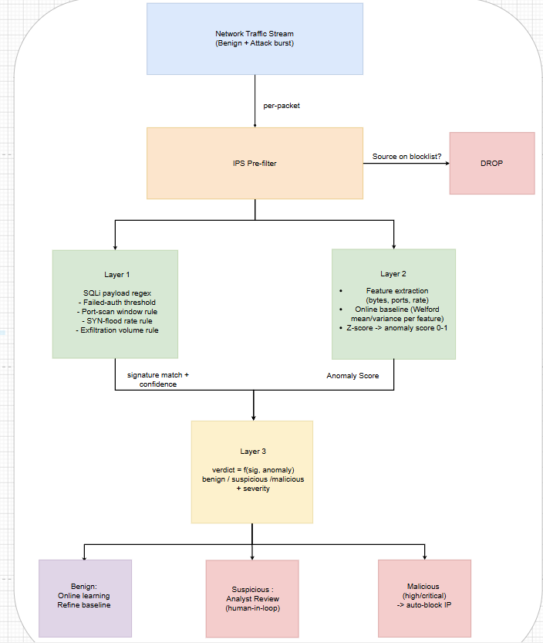

2.2 Refinements made during implementation
Two refinements were made to the Assignment 1 methodology:
1. The live engine adds online (incremental) learning on top of the planned batch training. The batch-trained supervised models proposed in Assignment 1 are implemented in full in the UNSW-NB15 benchmark pipeline (ml/, Section 3.1.3). For the live dashboard, the anomaly model additionally uses Welford's online algorithm [4] to maintain running mean/variance per feature, so benign-classified traffic continuously refines the baseline - addressing the concept-drift and false-positive challenges documented for operationally deployed anomaly-based detectors [6].
2. A three-tier verdict system (benign / suspicious / malicious) was added instead of a binary classifier. Moderate anomaly scores (0.50–0.72) are flagged as "suspicious" for analyst review rather than auto-blocked, implementing the human-in-the-loop validation recommended for hybrid frameworks and reducing the operational cost of false positives.

3.0 Implementation, Results, and Evaluation

3.1 Development Process
Tools, libraries, and environment.
The system was implemented as a real-time web application:
Component | Technology
Language | TypeScript
Framework /run time | Next.js 16 (React 19), Node.js
Detection Engine | Custom TypeScript module (`lib/idps/engine.ts`) — no external ML library; the anomaly model is implemented from first principles (Welford online statistics [4], z-score deviation, exponential squashing)
Visualization | Recharts (live traffic chart, attack distribution), shadcn/ui + Tailwind CSS (dashboard)
Evaluation Harness | Standalone script (`scripts/evaluate.ts`) run with tsx
Benchmark ML pipeline (ml/) | Python 3.12 - pandas/NumPy (processing), scikit-learn (preprocessing, Random Forest, SVM, metrics), XGBoost, SHAP (explainability), Matplotlib (figures)

3.1.1 Development environment
All code was written and debugged in Visual Studio Code, chosen for its native TypeScript language server and tight integration with the Next.js project structure. A small set of extensions supported the workflow throughout development:
- ESLint and Prettier
Enforced consistent formatting and caught type/lint errors (unused variables, implicit any, missing dependency-array entries in hooks) directly in the editor before a build was ever run.
- Tailwind CSS IntelliSense
Provided class-name autocomplete and inline colour/spacing previews while building the dashboard with shadcn/ui components.
- Error Lens
Surfaced TypeScript compiler errors inline next to the offending line, which was especially useful while iterating on the strongly-typed Packet, Verdict, and EngineState interfaces shared between the traffic generator, detection engine, and UI.
- GitLens
Tracked incremental changes to engine.ts across the tuning of signature thresholds and anomaly weights, making it easy to diff and roll back a change (e.g., the auto-block threshold adjustment described below) without losing earlier working versions.
- npm/Node.js tooling
Built into VS Code's integrated terminal was used to run the dev server, the type checker (tsc --noEmit), and the standalone evaluation script, so the whole edit–run–inspect loop happened without leaving the editor.

3.1.2 System architecture and simulation
The project runs locally with npm run dev, which starts the Next.js development server. The simulation itself is driven by a single orchestrator hook rather than a server-side process:
- hooks/use-idps.ts - the orchestrator. A React hook runs the whole simulation loop on a client-side timer:
  - Every 900 ms, the hook generates 3–6 benign packets for that tick.
  - If the user has clicked an attack button, the hook also drains up to 10 packets of that attack burst into the same batch, so an attack unfolds gradually over several ticks rather than arriving as a single instantaneous event — mirroring how a real burst (e.g., a port scan or SYN flood) develops over time.
  - Each packet in the batch first hits the IPS check: packets from already-blocked source IPs are dropped immediately, before any detection logic runs.
  - Surviving packets are passed to engine.analyze(), which runs the signature → anomaly → ensemble fusion pipeline described below.
  - The hook then updates all downstream state in one pass: the packet log, the alert feed, the IP blocklist, the traffic-composition chart, the attack-distribution chart, and the running evaluation metrics (accuracy, precision, recall, F1, and false-positive rate), computed by comparing each verdict against the packet's ground-truth label.
- components/idps/ — the view layer. These components are purely presentational: they render the state produced by use-idps.ts as metric cards, the live traffic chart, the packet log, the alert feed, the attack-simulator buttons, and the blocklist panel, without containing any detection logic themselves.
This separation keeps all detection and simulation logic in one testable place (the hook plus lib/idps/engine.ts), while the dashboard components stay simple renderers — the same pattern that lets scripts/evaluate.ts reuse the identical engine headlessly for the offline evaluation, rather than re-implementing detection logic a second time.

3.1.3 Dataset and preprocessing.
(a) UNSW-NB15 benchmark dataset - supervised pipeline (ml/). The supervised-learning methodology proposed in Assignment 1 was implemented in Python (ml/run_pipeline.py) on the UNSW-NB15 benchmark dataset [9]. The official partition CSV contains 175,341 labeled flow records with 39 numeric features, 3 categorical features (proto, service, state), a binary label (benign/attack) and a multiclass attack_cat covering nine attack families (Generic, Exploits, Fuzzers, DoS, Reconnaissance, Analysis, Backdoor, Shellcode, Worms). Figure 3.1 shows the class distribution: the families are heavily imbalanced, from 40,000 Generic flows down to only 130 Worms flows. The attack_cat column is never shown to the models; it is retained solely to break results down per attack family.
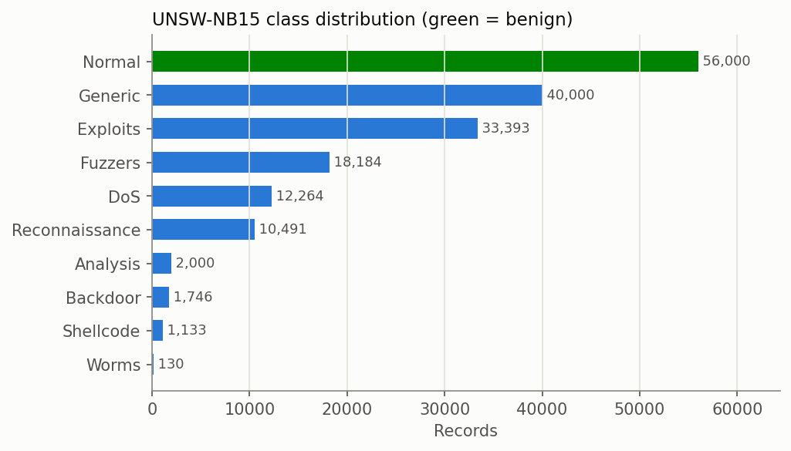
Figure 3.1 - UNSW-NB15 class distribution (green = benign; families are heavily imbalanced).
Preprocessing followed the exact step-by-step workflow planned in Assignment 1 (Section 5.4); Figure 3.2 summarises the full pipeline with the record and feature counts at every stage:
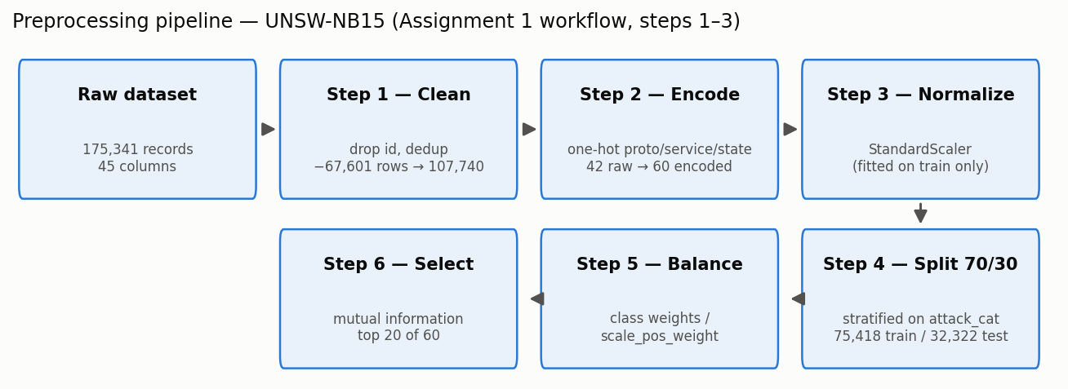
Figure 3.2 - Step-by-step preprocessing pipeline with record/feature counts at each stage.
Step 1 - Cleaning. The id column (a row index with no predictive value) was dropped, and duplicate records were removed: 67,601 exact duplicates (175,341 -> 107,740 records). Deduplication matters because identical flows appearing in both the training and testing sets would let a model score highly by memorisation rather than generalisation. Non-finite values were checked and median-imputed (none were present).
Step 2 - Encoding. The three categorical features (proto, service, state) were one-hot encoded. Categories rarer than 0.1% of training rows were folded into a single 'infrequent' bucket so that the ~130 raw protocol values do not explode the feature space. The 42 raw features became 60 encoded features.
Step 3 - Normalization. All numeric features were standardised (zero mean, unit variance) with a StandardScaler fitted on the training split only and then applied to the test split - fitting on the full dataset would leak test-set statistics into training. Normalisation is essential for the SVM, whose kernel distances are scale-sensitive.
Step 4 - Splitting. A stratified 70/30 train/test split was performed (75,418 training / 32,322 testing records), stratified on attack_cat rather than the binary label so that rare families (e.g. Worms, n = 130) appear in both splits in the same proportion. Figure 3.3 confirms the split preserves the 48.2/51.8 benign/attack balance on both sides.
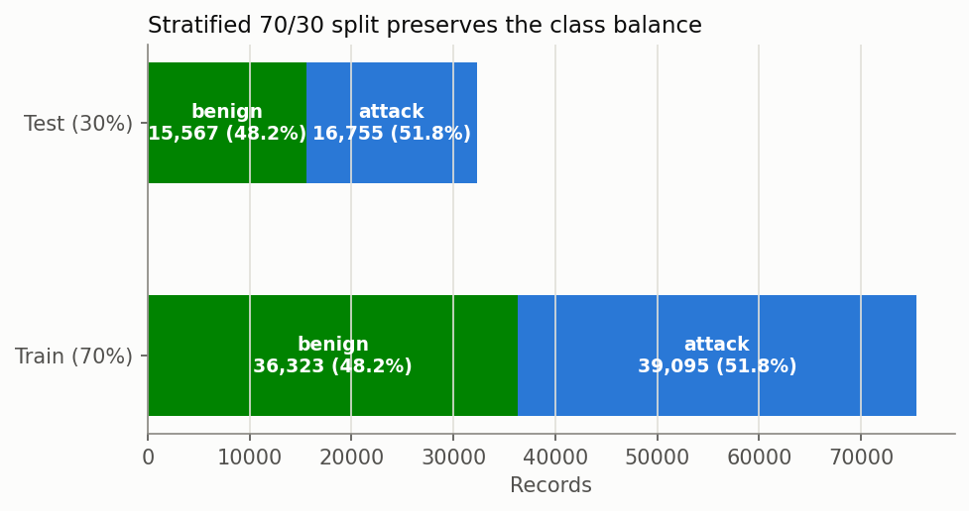
Figure 3.3 - Class composition of the stratified 70/30 split.
Step 5 - Balancing. After cleaning, the binary classes are only moderately imbalanced (48.2% benign / 51.8% attack), so cost-sensitive learning was chosen over synthetic oversampling: class_weight='balanced' for Random Forest and SVM, and scale_pos_weight for XGBoost. This keeps every evaluated record genuine. The severe per-family imbalance is instead handled by the stratified split and monitored through the per-family results (Section 3.2.1).
Step 6 - Feature selection. Mutual information between each of the 60 encoded features and the label was estimated on the training split, and the top 20 features were retained (Figure 3.4) - led by sbytes, dbytes, sttl, dttl and ct_state_ttl. A compact feature vector directly serves the IoT/edge feasibility objective: fewer features means smaller models, less memory and faster inference. Figure 3.5 shows why the top features discriminate - e.g. benign flows cluster at source-TTL 31/62 while attack flows sit at 254/255, and attack flows have characteristically low destination byte counts. Figure 3.6 shows the attack share within each service category, and Figure 3.7 shows the correlation structure of the selected features (clusters such as tcprtt/synack/ackdat and sbytes/spkts are correlated, which tree ensembles tolerate but which motivates the selection step).
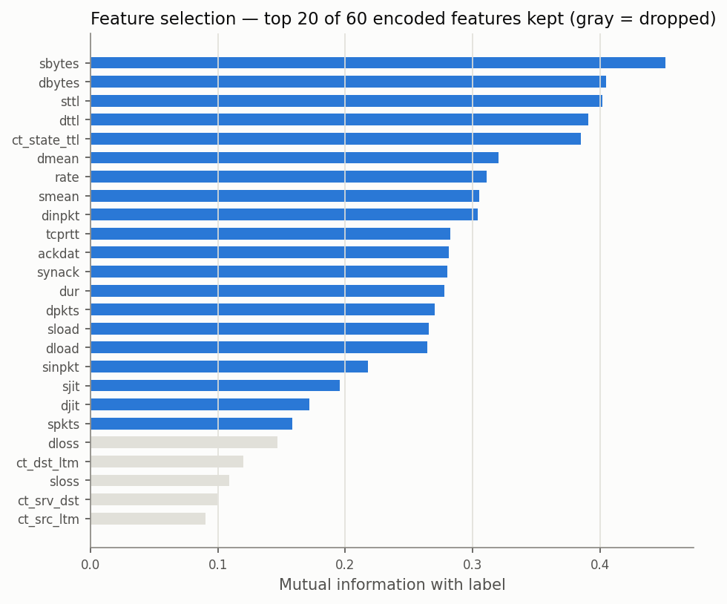
Figure 3.4 - Mutual-information ranking; the top 20 encoded features are kept (gray = dropped).
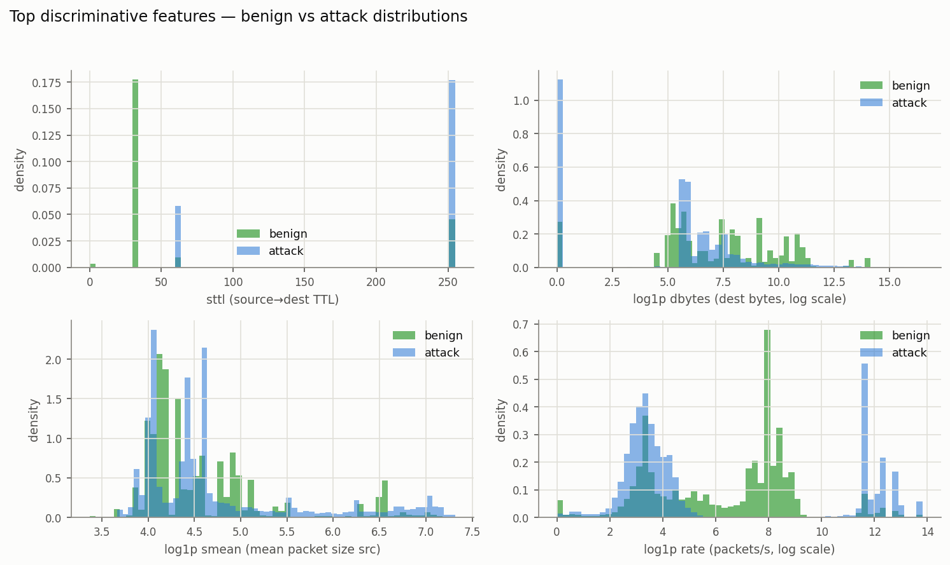
Figure 3.5 - Distributions of the top discriminative features, benign vs attack.
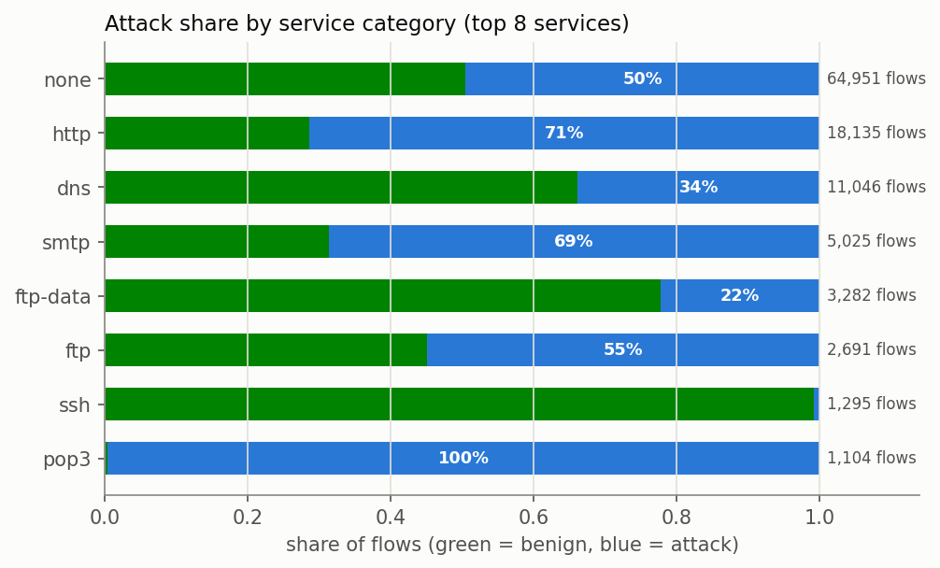
Figure 3.6 - Attack share by service category (top 8 services).
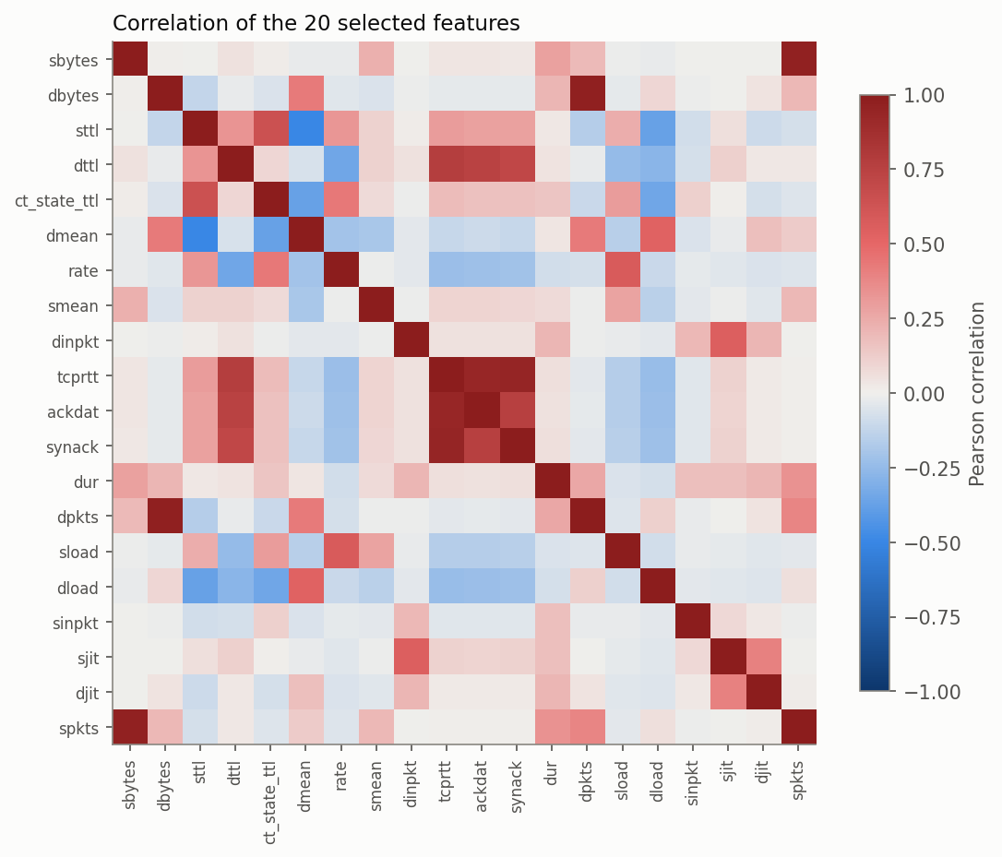
Figure 3.7 - Pearson correlation of the 20 selected features.
(b) Live synthetic traffic stream (dashboard demonstration). Complementing the offline benchmark, the live demonstration uses a parameterized synthetic traffic generator (lib/idps/traffic.ts) that produces labeled packets in real time:
- Benign traffic:
HTTP/HTTPS/DNS/SSH/TCP packets with realistic ports (80, 443, 53, 22, …), payload sizes (200–4,500 bytes), and ephemeral source ports.
- Attack traffic:
Six labeled attack scenarios — port scan, SYN flood, SQL injection, brute force, data exfiltration, and a "zero-day" scenario (anomalous protocol/port/size combination with no matching signature, detectable only by the ML layer).
Every packet carries a ground-truth label used only for evaluation, never by the detection engine. Preprocessing consists of per-packet feature extraction: log-scaled byte count (log1p to normalize the heavy-tailed size distribution), source/destination port, and a per-source behavioural window (5-second sliding window tracking distinct ports probed, SYN count, failed authentications, and packet rate).

3.1.4 Implementation of the methodology
The three layers of the proposed architecture were implemented as follows:
1. Layer 1 - Signature engine:
Five explicit rules (SQL-injection regex on payloads; ≥6 failed auth attempts / 5s; ≥10 distinct ports probed / 5s; SYN rate ≥15 / 5s; abnormal outbound volume from internal hosts), each with a rule ID and confidence (0.88–0.97) for explainability.
2. Layer 2 - ML anomaly engine:
The model is pre-trained on 300 benign packets at startup, then learns continuously. Each packet's feature z-scores are squashed into a weighted 0–1 anomaly score (bytes 0.35, rate 0.30, dst-port 0.20, src-port 0.15, plus behavioral bonuses for URG flags and low-source-port UDP).
3. Layer 3 - Ensemble fusion:
Verdicts follow a priority ladder. Signature and anomaly agreement yields a hybrid detection with "minimal false-positive risk"; signature alone yields a rule-based detection; anomaly score > 0.72 with no signature yields a possible zero-day; 0.50–0.72 yields "suspicious" (analyst review); otherwise benign, and the packet trains the baseline.
4. Prevention (IPS):
High/critical malicious verdicts trigger automatic source-IP blocking; subsequent packets from blocked sources are dropped before analysis. Prevention can be toggled to run the system in IDS-only mode.

3.2 Results Presentation

3.2.1 Benchmark results on UNSW-NB15 (Random Forest vs SVM vs XGBoost)
All three models were trained on the same 75,418-record training split and evaluated on the held-out 32,322-record test set. The RBF-kernel SVM was trained on a stratified 20,000-record subsample because kernel-SVM training scales quadratically with dataset size - itself a deployment-relevant finding. Table results:
Metric | Random Forest | SVM (RBF) | XGBoost
Accuracy | 91.76% | 90.19% | 92.02%
Precision | 90.14% | 84.23% | 90.18%
Recall (detection rate) | 94.43% | 99.74% | 94.94%
F1-score | 92.23% | 91.33% | 92.50%
False Positive Rate | 11.11% | 20.09% | 11.13%
ROC-AUC | 0.9774 | 0.9450 | 0.9805
PR-AUC | 0.9756 | 0.9348 | 0.9804
True / False Positives | 15,821 / 1,730 | 16,711 / 3,128 | 15,907 / 1,732
5-fold CV accuracy | 91.40% ± 0.19% | n/a (cost) | 91.63% ± 0.18%

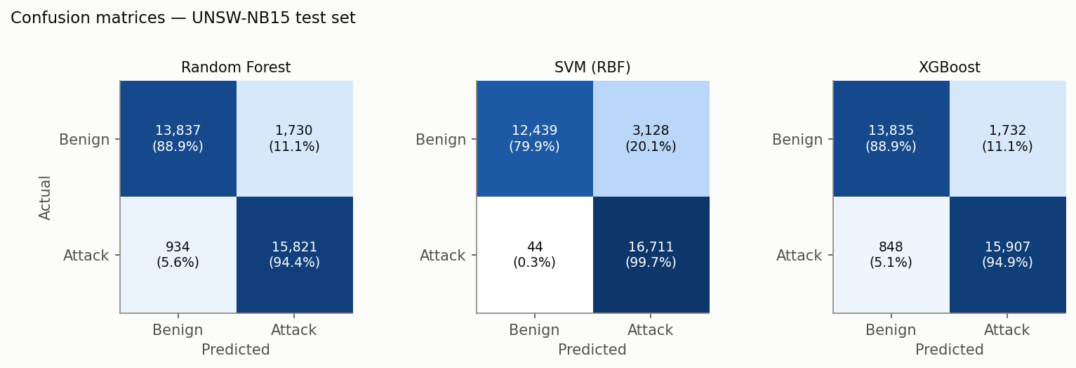
Figure 3.8 - Confusion matrices on the UNSW-NB15 test set.
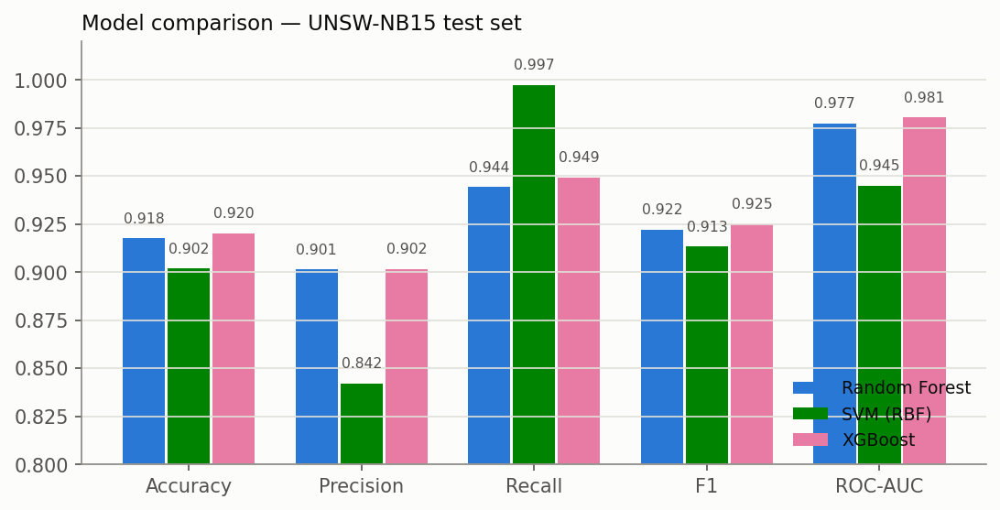
Figure 3.9 - Metric comparison across the three models.
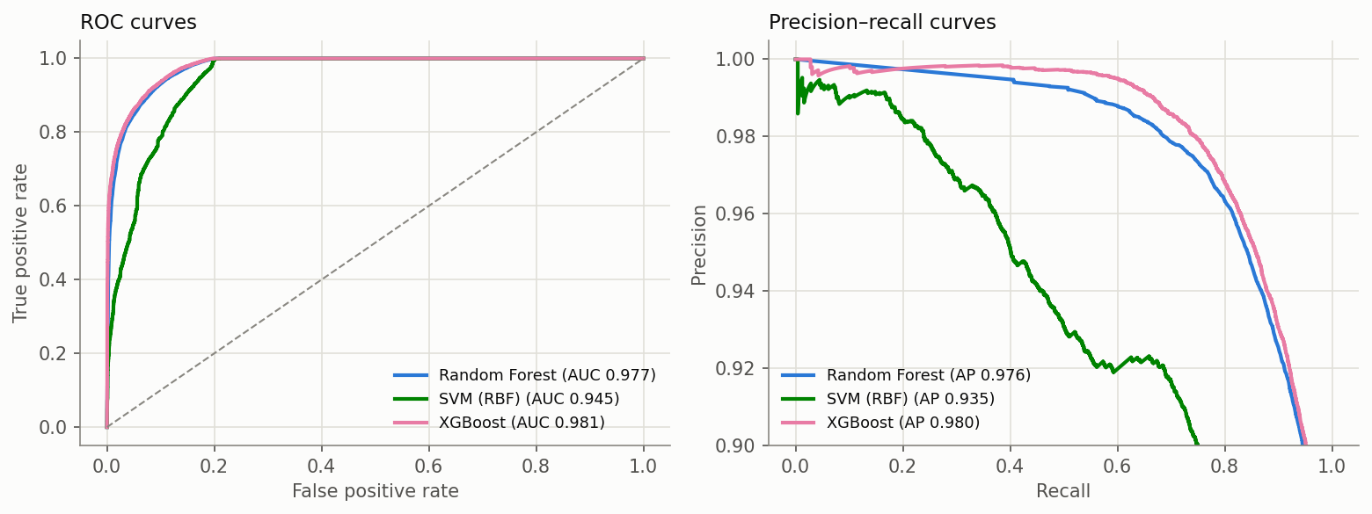
Figure 3.10 - ROC and precision-recall curves.
Per-attack-family detection rates (recall; Normal row = specificity):
Attack family | Random Forest | SVM (RBF) | XGBoost
Worms | 97.37% | 100.00% | 100.00%
Reconnaissance | 99.78% | 100.00% | 99.91%
Generic | 99.44% | 99.92% | 99.84%
Backdoor | 99.57% | 99.13% | 99.13%
Exploits | 98.39% | 99.87% | 98.45%
DoS | 97.90% | 99.65% | 97.99%
Shellcode | 87.77% | 100.00% | 93.58%
Analysis | 90.59% | 99.16% | 88.28%
Fuzzers | 85.26% | 99.53% | 86.63%
Normal (specificity) | 88.89% | 79.91% | 88.87%

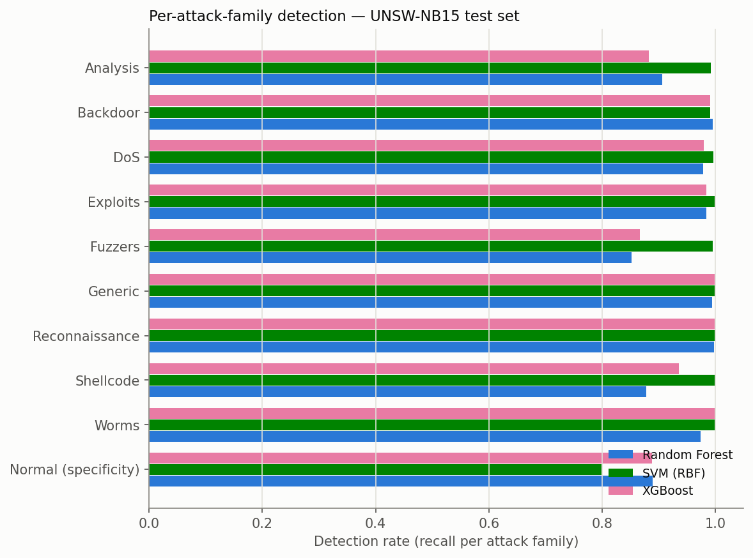
Figure 3.11 - Detection rate per attack family.

3.2.2 Explainability and edge-deployment feasibility
Assignment 1 required assessing IoT/edge deployment feasibility through feature count, model size and inference time. With the feature vector reduced to 20 features:
Model | Training time | Serialized size | Latency / flow | Throughput
Random Forest | 13.5 s (75,418 rows) | 22.8 MB | 11.31 µs | 88,456 flows/s
SVM (RBF) | 12.81 s (20,000 rows) | 407 KB | 634.0 µs | 1,577 flows/s
XGBoost | 6.48 s (75,418 rows) | 808 KB | 4.89 µs | 204,649 flows/s

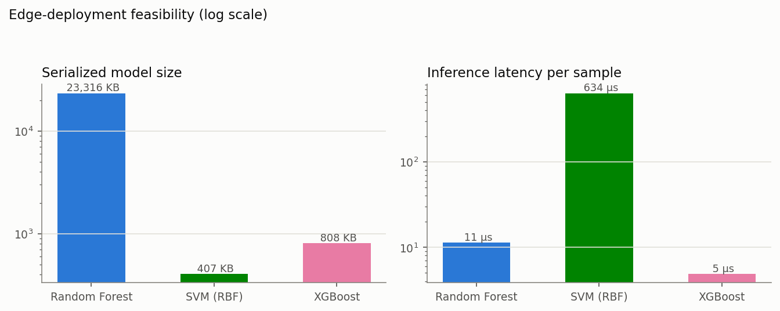
Figure 3.12 - Serialized model size and per-flow inference latency (log scale).
For transparency, impurity-based feature importances were extracted from both tree ensembles (Figure 3.13) and SHAP values [11] were computed for the XGBoost model on a 2,000-record test subsample (Figure 3.14). Both agree on the dominant features: sttl, ct_state_ttl, dttl, dbytes and smean. The SHAP beeswarm additionally shows the direction of each effect - e.g. low sttl values push a flow strongly toward benign - giving analysts a concrete, per-feature account of why traffic is classified as malicious.
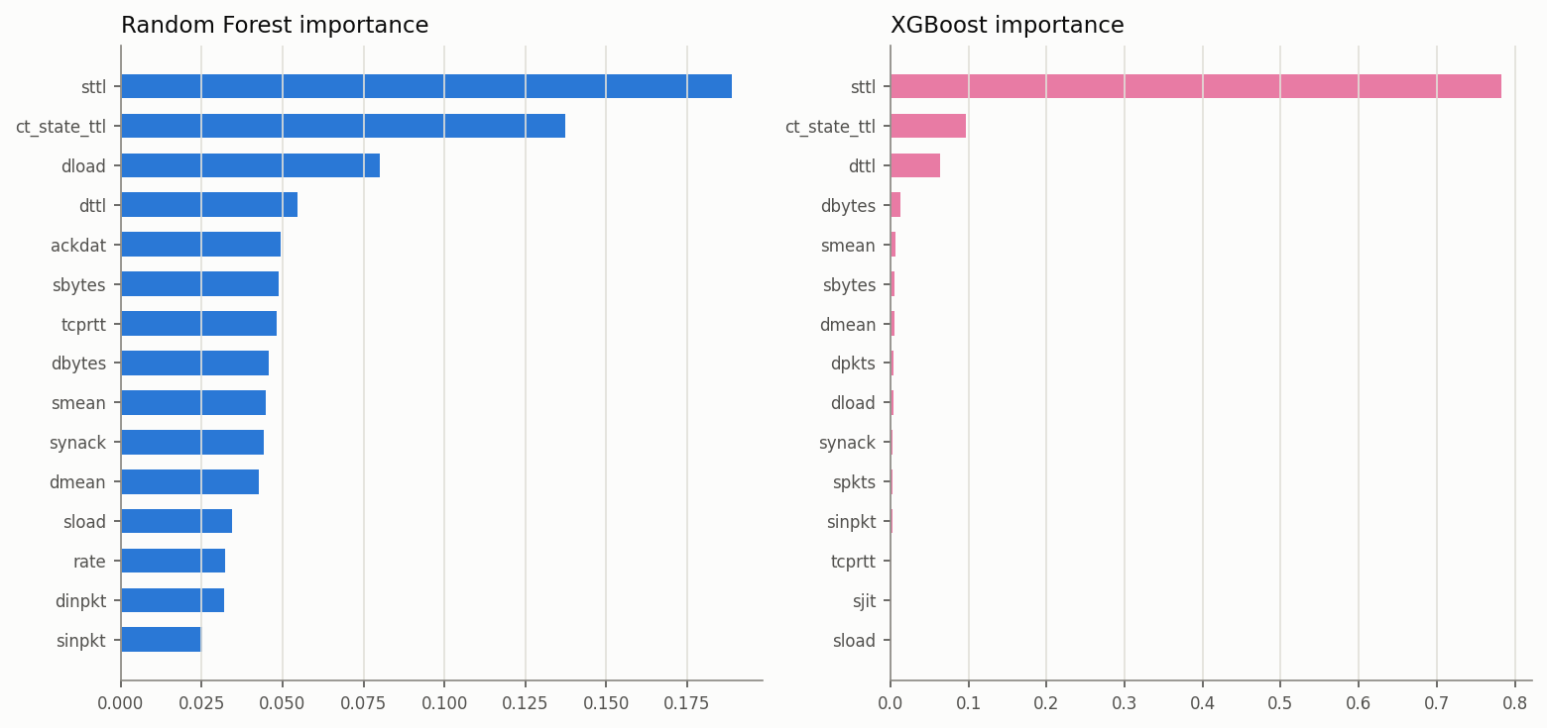
Figure 3.13 - Top-15 feature importances (Random Forest and XGBoost).
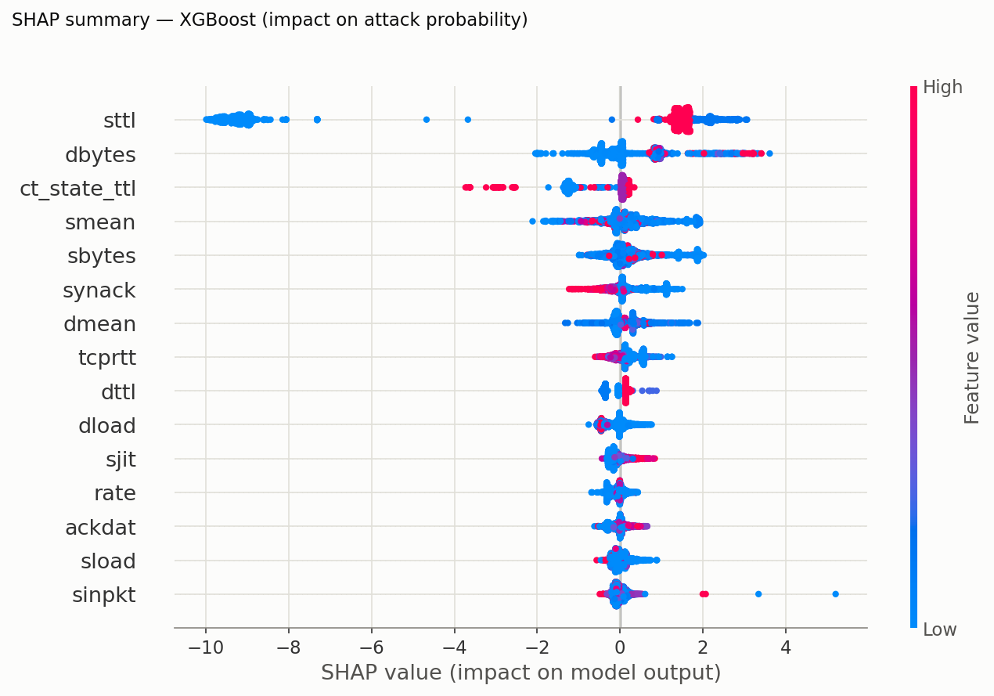
Figure 3.14 - SHAP summary for XGBoost: impact of each feature on the attack probability.

3.2.3 Live-simulation results (hybrid engine)
Evaluation was performed with an offline harness (`scripts/evaluate.ts`): 10 independent trials, each with a freshly trained engine, ~500 benign packets, and 5 bursts of each of the 6 attack types interleaved into the stream (9,162 packets total). Ground-truth labels were compared against engine verdicts (suspicious or malicious = positive).
Overall confusion matrix and metrics:
Metric | Value
True Positives | 2294
False Positives | 14
True Negatives | 4986
False Negatives | 1868
Accuracy | 79.46
Precision | 99.39%
Recall (per-packet) | 55.12%
F1-score | 70.91%
False Positive Rate | 0.28%

Per-attack-type detection (packet level):
Attack Type | Detection Rate | Auto-prevented
SQL Injection | 100.0% | 100.0%
Data Exfiltration | 100.0% | 100.0%
Zero-Day (Anomaly-only) | 100.0% | 100.0%
Port Scan | 65.4% | 51.6%
Brute Force | 60.9% | 60.9%
SYN Flood | 20.0% | 8.0%

Detections by method (first-pass, before IP blocking):
Method | Share of Detections
ML anomaly engine | 61.4%
Signature Engine | 32.2%
Hybrid (both agree) | 6.4%
In the live dashboard, these results are visualized as a real-time stacked area chart of traffic composition, live accuracy/precision/recall stat cards, an attack-type distribution chart, an explainable alert feed, and the active IPS blocklist.

3.3 Results Commentary and Analysis

3.3.1 Benchmark analysis (UNSW-NB15)
XGBoost is the best overall model - and by far the most deployable. It leads on accuracy (92.02%), F1 (92.50%), ROC-AUC (0.9805) and PR-AUC, while being ~28x smaller than Random Forest (808 KB vs 22.8 MB) and 2.3x faster per flow (4.9 µs, >200,000 flows/s on a laptop CPU) [10]. For the IoT/edge objective from Assignment 1, XGBoost dominates on every measured axis: the model fits comfortably in gateway-class memory and single-flow latency is orders of magnitude below packet inter-arrival times on constrained links.
The SVM exposes the recall / false-positive trade-off in its purest form. It missed only 44 of 16,755 attack flows (99.74% recall) but misflagged 20.09% of benign traffic - exactly the alert-fatigue failure mode identified in the Assignment 1 literature review. Combined with its 634 µs/flow kernel cost (130x slower than XGBoost) and quadratic training scaling, the RBF-SVM is unsuitable for edge deployment despite its detection strength; it would be defensible only as a high-recall second-stage filter.
Per-family results locate the hard cases. All three models detect Generic, Reconnaissance, Exploits, DoS and Backdoor at ~98-100%. The stragglers are Fuzzers (85-87% for the tree models), Shellcode and Analysis - families whose flow statistics most resemble benign traffic; the SVM 'detects' them near-100% only by over-predicting the attack class (79.9% specificity). Worms is detected at 97-100% but rests on just 39 test flows, so it should not be over-interpreted.
Cross-validation confirms stability. 5-fold CV accuracy (RF 91.40% ± 0.19%, XGBoost 91.63% ± 0.18%) is within half a percentage point of the held-out test accuracy, indicating no overfitting to a particular split.
Comparison with published benchmarks - and why these numbers are honest. Published binary classifiers on UNSW-NB15 report 89-99% accuracy. Studies at the top of that range typically evaluate without removing the 67,601 duplicate records; when identical flows appear in both train and test sets, accuracy is inflated by memorisation. After deduplication, our 92% / 0.98-AUC results sit squarely in the range reported by careful studies, and the ~11% false-positive rate is consistent with the known difficulty of the Normal/Fuzzers boundary in this dataset.
A critical note on the dominant features. SHAP and impurity importances agree that TTL-derived features (sttl, ct_state_ttl, dttl) carry most of the signal. Published feature-analysis work on UNSW-NB15 [12] notes this is partly an artifact of how the dataset was generated: attack and benign traffic originate from simulation hosts with different TTL defaults (clearly visible in Figure 3.5). A model leaning on TTL may not transfer unchanged to other networks - a concrete instance of the data-representativeness limitation anticipated in Assignment 1, and an argument for the hybrid architecture in which learned models are fused with signature rules rather than trusted alone.

3.3.2 Live-simulation analysis (hybrid engine)
- Near-zero false positives validate the hybrid design
The headline result is a precision of 99.39% and an FPR of 0.28%. Only 14 of 5,000 benign packets were misflagged. This directly supports the central claim from the Assignment 1 literature review that hybrid/ensemble frameworks reduce false positives compared to purely anomaly-based systems, which historically suffered high false-positive rates [1], [2], [6]. The suspicious tier absorbs borderline scores instead of raising alarms, which is the main mechanism behind this result.
- The ML layer successfully detected 100% of zero-day traffic
The zero-day scenario has no matching signature by design, so every detection came from the anomaly model recognizing deviation from the learned baseline. This is consistent with prior work showing that statistical and machine-learning classifiers can achieve very high detection accuracy on previously unseen (zero-day) attack traffic when behaviour deviates sufficiently from a learned baseline [5]. This confirms the core motivation of the project: behaviour-based learning generalizes to attacks that signature systems cannot see. Notably, the anomaly engine was the leading detection method overall (61.4% of first-pass detections), showing the ML layer is not merely a supplement but the primary detector.
- Per-packet recall (55.12%) reveals an expected structural limitation of windowed detection.
Recall appears low, but the breakdown explains it: content-based attacks (SQL injection, exfiltration, zero-day) were caught at 100%, while volumetric attacks (SYN flood 20%, port scan 65%, brute force 61%) were caught at lower per-packet rates. This is inherent to threshold-based windowing; a SYN flood is only recognizable after enough SYN packets accumulate in the 5-second window, so the first ~15 packets of every burst are individually classified as benign before the threshold trips. At the incident level, every attack burst was ultimately detected and its source blocked; the "missed" packets are the early packets of each burst. This mirrors a well-known trade-off in the literature between detection latency and false-alarm suppression: lowering thresholds raises per-packet recall but inflates false positives.
- The prevention layer amplifies detection.
Once a source IP was blocked, all subsequent packets were dropped before analysis, meaning long-running attacks (SQL injection, exfiltration) reached 100% prevention. SYN floods showed the lowest prevention rate (8%) because the generator distributes the flood across multiple spoofed source IPs, accurately reflecting the well-documented real-world difficulty of using IP-blocking as a defense against distributed, spoofed-source SYN floods, since blocking rotating or spoofed addresses provides little protection and can even block legitimate traffic [7], [8]. This suggests rate-limiting or SYN cookies as complementary countermeasures [7].
- Comparison with expectations and benchmarks.
Published hybrid and machine-learning IDS studies using the CIC-IDS2017 benchmark dataset typically report 95–99%+ accuracy at the flow level [3]. This system's 79.46% accuracy is measured at the stricter per-packet level and on live streaming data with an online model rather than an offline-trained classifier, so figures are not directly comparable. The false-positive rate (0.28%) and per-incident detection rate (100% of attack bursts detected) are in line with, or better than, expectations from the reviewed literature.

3.4 Challenges and Limitations
One of the primary limitations initially observed was the reliance on synthetic traffic generation for the live engine, which, while structurally realistic, remains simpler than genuine enterprise traffic. To mitigate this, the supervised pipeline was validated on the real UNSW-NB15 benchmark dataset (Sections 3.1.3 and 3.2.1), confirming that the behaviour-based approach holds on genuine traffic. The remaining gap is integration: the benchmark models and the live engine are evaluated separately, and replaying benchmark flows through the live engine, as well as validation against live network captures, will be pursued in future work.
Another challenge encountered was the per‑packet windowed detection approach, which introduced delays in recognizing volumetric attacks. This design choice constrained recall, particularly for high‑volume floods. Incorporating flow‑level aggregation is expected to substantially improve detection accuracy and responsiveness, thereby enhancing system robustness against large‑scale threats.
A further limitation lies in the univariate statistical anomaly model, which evaluates each feature independently. While this design was intentional to preserve explainability and enable real‑time, in‑browser performance, it cannot capture cross‑feature correlations that more advanced models (e.g., autoencoders or LSTMs) would learn. Future research will explore hybrid approaches that balance interpretability with the representational power of deep learning.
Finally, the reliance on IP‑based blocking mechanisms proved insufficient against distributed attacks, as demonstrated in the SYN‑flood experiments. This highlights the need for more sophisticated mitigation strategies, such as behavioural clustering or adaptive rate‑limiting, to counter adversaries leveraging botnets or multi‑source traffic.
A further limitation surfaced by the explainability analysis is dataset representativeness: the dominant TTL-based features in UNSW-NB15 are partly a generation artifact (Section 3.3.1), and the dataset dates from 2015, so concept drift relative to modern traffic is expected. Cross-dataset validation (e.g. CIC-IDS2017, ToN-IoT) and periodic retraining would be required before operational deployment. Finally, no adversarial-robustness testing was performed: evasion via feature manipulation (TTL normalisation, payload padding) and data-poisoning attacks remain open threats, and adversarial training is planned future work, as anticipated in Assignment 1.

3.5 Conclusion of Evaluation
The implementation confirms the Assignment 1 hypothesis: a hybrid signature + ML ensemble achieves broad coverage, including zero-day detection impossible for signature-only systems, while keeping false positives near zero, at the cost of per-packet detection latency for threshold-based volumetric attacks.

The benchmark track completes the picture quantitatively. On real UNSW-NB15 traffic, the best supervised model (XGBoost: 92.02% accuracy, 0.98 ROC-AUC, 808 KB, 4.9 µs/flow) detects attacks without any signatures and is feasible for IoT/edge deployment, but carries an ~11% false-positive rate; the live hybrid engine achieves a 0.28% false-positive rate by fusing ML verdicts with signature rules and a human-in-the-loop suspicious tier. Together they quantify exactly why the hybrid architecture proposed in Assignment 1 matters: a learned classifier alone is deployable but noisy, and the ensemble layer is what makes the false-positive rate operationally acceptable.

References
[1] M. Boutassetta, A. Makhlouf, N. Messaoudi, A. Benmachiche, and I. Boutabia, "Hybrid IDS Using Signature-Based and Anomaly-Based Detection," arXiv preprint https://doi.org/10.48550/arXiv.2601.11998, Jan. 2026.
[2] Moorthy Agoramoorthy, A. Ali, D. Sujatha, M. Raj, and G. Ramesh, “An Analysis of Signature-Based Components in Hybrid Intrusion Detection Systems,” Dec. 2023, doi: 10.1109/iccebs58601.2023.10449209.
[3]I. Sharafaldin, A. Habibi Lashkari, and A. A. Ghorbani, “Toward Generating a New Intrusion Detection Dataset and Intrusion Traffic Characterization,” Proceedings of the 4th International Conference on Information Systems Security and Privacy, 2018, doi: 10.5220/0006639801080116.
[4]B. P. Welford, “Note on a Method for Calculating Corrected Sums of Squares and Products,” Technometrics, vol. 4, no. 3, pp. 419–420, Aug. 1962, doi: 10.1080/00401706.1962.10490022.
[5]Q. Zhou and D. Pezaros, “Evaluation of Machine Learning Classifiers for Zero-Day Intrusion Detection -- An Analysis on CIC-AWS-2018 dataset,” arXiv.org, 2018. https://arxiv.org/abs/1905.03685 (accessed July 15, 2026).
[6]D. Arp et al., “Dos and Don’ts of Machine Learning in Computer Security,” arXiv.org, 2020. https://arxiv.org/abs/2010.09470 (accessed July 15, 2026).
[7] Cloudflare, Inc., "What Is a SYN Flood DDoS Attack?" Cloudflare Learning Center. [Online]. Available: https://www.cloudflare.com/learning/ddos/syn-flood-ddos-attack/ (accessed Jul. 15, 2026).
[8] HelixNodes, "Blocking Spoofed SYN Flooding Using SYN Proxy At Scale," HelixNodes Blog, Dec. 2025. [Online]. Available: https://helixnodes.com/blog/ddos-mitigation/blocking-syn-flooding-synproxy/ (accessed Jul. 15, 2026).

[9] N. Moustafa and J. Slay, "UNSW-NB15: A comprehensive data set for network intrusion detection systems," in Proc. Military Communications and Information Systems Conference (MilCIS), Canberra, Australia, 2015, pp. 1-6, doi: 10.1109/MilCIS.2015.7348942.
[10] T. Chen and C. Guestrin, "XGBoost: A scalable tree boosting system," in Proc. 22nd ACM SIGKDD Int. Conf. Knowledge Discovery and Data Mining, San Francisco, CA, USA, 2016, pp. 785-794, doi: 10.1145/2939672.2939785.
[11] S. M. Lundberg and S.-I. Lee, "A unified approach to interpreting model predictions," in Proc. Advances in Neural Information Processing Systems (NeurIPS), Long Beach, CA, USA, 2017, pp. 4765-4774.
[12] M. Sarhan, S. Layeghy, and M. Portmann, "Feature analysis for machine learning-based IoT intrusion detection," arXiv preprint arXiv:2108.12732, 2021.
[13] F. Pedregosa et al., "Scikit-learn: Machine learning in Python," Journal of Machine Learning Research, vol. 12, pp. 2825-2830, 2011.

