# Assignment2 Chong Chen 002833267

1. Docker:
   1. Dockerfile: **See attachment.**
2. Bitcoind:
   1. The debug.log file: **See attachment.**
   2. A screenshot of your terminal that shows that RPC commands through bitcoin-cli are working.

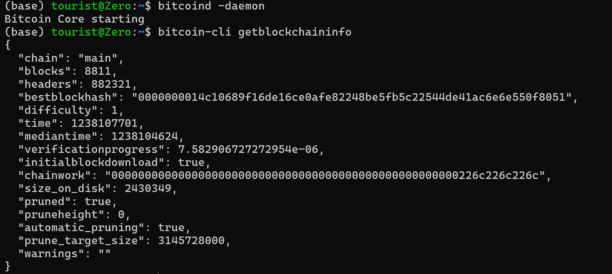

1. OpenAI:
   1. The python file with the call to Openai’s API: **See attachment.**
2. Modal:
   1. The Modal URLs of the jobs that each example generated by you running it from your machine.
      1. <https://modal.com/apps/neu-info5100-oak-spr-2025/main/deployed/chongchen-hello-world>
      2. <https://modal.com/apps/neu-info5100-oak-spr-2025/main/deployed/chongchen-web-scraper>
      3. <https://modal.com/apps/neu-info5100-oak-spr-2025/main/deployed/chongchen-web-basic>