HW Assignment 3

Step 1 (30 points)

The shell script code file named create-user is under the folder ***HW3_Chong_Chen.***

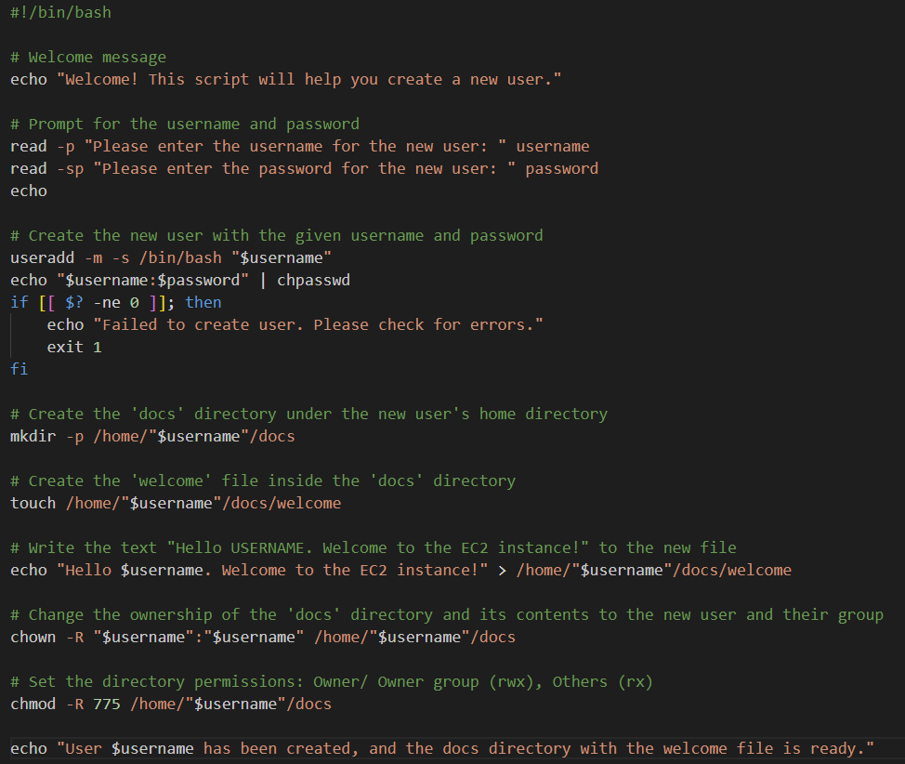

Step 2 (5 points)

Create an EC2 Ubuntu instance.

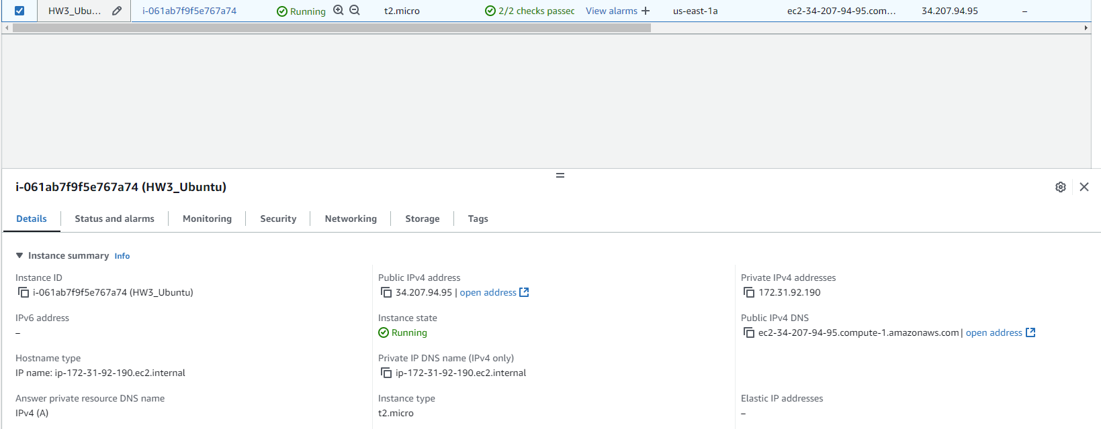

Step 3 (20 points)

Run **sudo su** to switch to the root user.



Under the root user's home directory, create a new file called create-user.

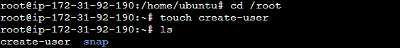

Open the file with **nano**. Copy the code on your computer, and paste your code into the file on the EC2 Instance. Save the file.



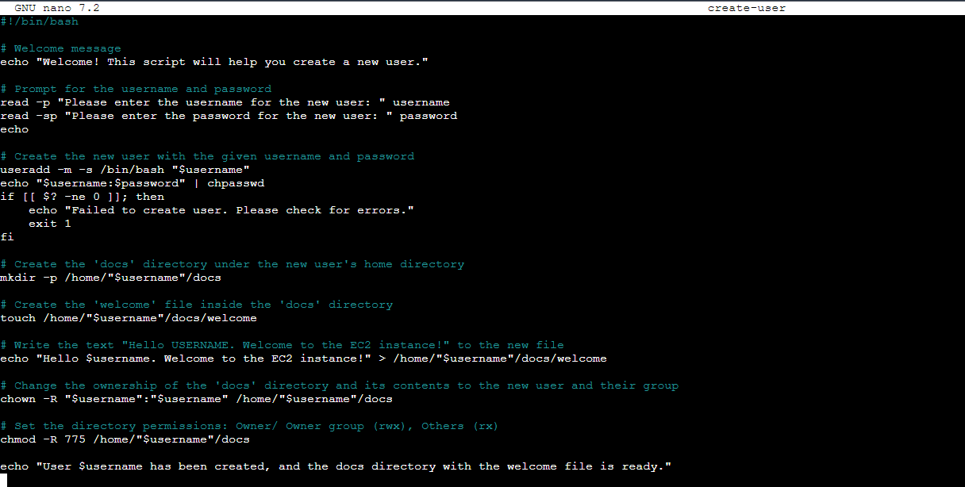

Run chmod on the create-user script file to make it executable by the root user only. The root user should also be able to read and write to the file. The file should not be accessible to anyone other than the root user.



Step 4 (10 points)

Execute the file to create a new user, set the username as your first name.

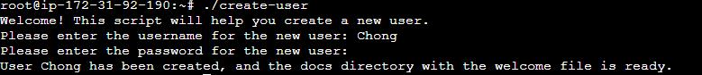

Step 5(10 points)

Login with that user.

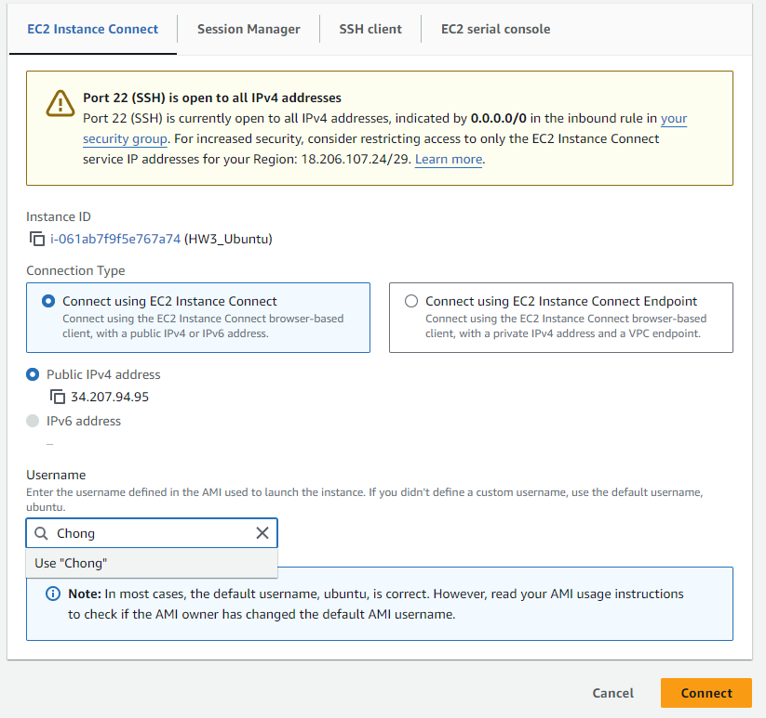

In the new user's shell, check if the password is working properly.



Step 6 (15 points)

Open the welcome file with nano.





Change a few lines.

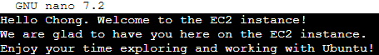

Save and exit.

To save the changes you made in **nano**:

Press Ctrl + O (this writes the changes).

Press Enter to confirm the file name.

Press Ctrl + X to exit the nano editor.

Use the **cat** command to display the full content of the file.

