Product Intake from Link
Feature Report — Inputs, Processes, Outputs & UI
Orbot v2.0 · Blocked Off
3 July 2026 · Backend commit 284c4b3 · Frontend v1.8.0

1. Executive Summary
Product Intake from Link turns a marketplace product page into a launch-ready Orbot product. The user pastes a URL from a 3D-model marketplace (Printables, Cults3D, MakerWorld, Etsy) into the dashboard's Launch tab; the system fetches the page, uses Gemini to extract the product name, description, LEGO set number and theme, downloads the gallery photos, removes designer logos and watermarks from them with Gemini image editing, and prefills the existing Product Launch form. When the user completes the launch, the system creates the catalog database records, builds the product's Google Drive folder structure, uploads the cleaned images plus a description.txt, and returns a listing package ZIP.
The feature is an extension of the existing Product Launch pipeline rather than a separate system — it adds two new backend endpoints and a Drive-folder step to the existing launch endpoint, plus a small amount of dashboard UI.

Deployment status (as of 3 July 2026)
- Backend: live in production on Railway (commit 284c4b3); the new route was verified reachable after deploy.
- Frontend: committed as v1.8.0; awaiting vercel --prod to reach the production dashboard.
- Logo removal: code path live but returns originals until the Gemini API key is upgraded to a paid tier (the free tier has no image-editing quota).

2. User Flow
- Paste a product URL into the Fetch from Link bar on the Launch tab and click the button (or press Enter).
- The form auto-fills (set name, set number, theme) and product photos appear in the image grid; each photo then shows a spinner while logos are removed, and swaps to the cleaned version with a badge.
- Review: delete bad images, add more manually (drag & drop), and use Remove Logos for any manually added photos. Tick product types, set prices and plaque count.
- Click Preview Listing — Gemini writes the Shopee/Lazada listing title and description and builds the SKU/variant tree for review and editing.
- Click Download Launch Package — database records are created, Drive folders are built and populated, and the listing ZIP downloads.

3. Inputs
Input | Description | Notes
Product URL | Any http(s) link to a 3D-model marketplace product page. The only required input for auto-fill. | Printables & Cults3D: full support (text + images). MakerWorld & other Cloudflare-protected sites: text fields only. Etsy: expected text-only (aggressive bot protection).
Manual form fields | Set name, set number, theme, brand, category, prices (MYR/SGD), platforms, product types (DS / DS-NP / WM / FWM), plaque count, stock, per-variant Drive URLs. | Scraped values prefill set name, set number and theme; everything remains editable before launch.
Images | Up to 9 photos — scraped automatically or added via drag & drop / file picker. | 9 is the Shopee listing maximum. All images are normalised server-side regardless of source.
Configuration | GEMINI_API_KEY (Railway) — must be paid tier for logo removal. PRODUCT_PARENT_FOLDER_ID (Railway, optional) — overrides Drive parent auto-detection. orbot_backend_url (dashboard Settings) — Railway backend address. | No new database schema or required environment variables were introduced.

4. Processing Pipeline
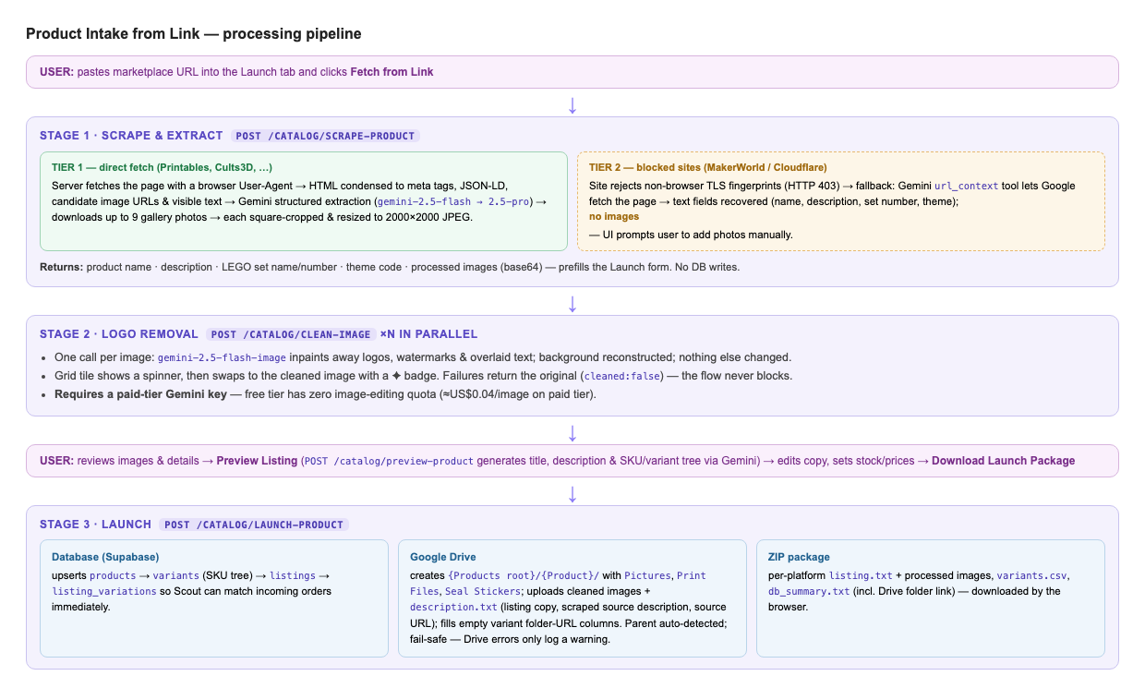
Figure 1 — End-to-end pipeline. Purple boxes are backend stages; pink bars are user actions.

Stage 1 — Scrape & extract (POST /catalog/scrape-product)
- Two-tier page fetch. Tier 1 fetches the page directly with a browser User-Agent and follows redirects; it succeeds on Printables, Cults3D and similar sites. If the site rejects the request or returns a bot-challenge page, Tier 2 asks Gemini to read the URL itself via the url_context tool (Google fetches the page), which recovers all text fields but no image URLs — MakerWorld falls in this tier because it rejects non-browser TLS fingerprints outright.
- HTML condensing (tier 1 only). The raw page is boiled down to meta/OpenGraph tags, JSON-LD blocks, candidate image URLs (from <img> tags and URLs embedded in JSON blobs), and visible text — keeping the Gemini prompt small on JavaScript-heavy pages.
- Structured extraction. Gemini (gemini-2.5-flash, falling back to 2.5-pro) returns a validated schema: product name, faithful description, LEGO set name/number if present, best-matching theme code (SC, SWR, MVL, TCH, …), and the distinct gallery photo URLs at their highest resolution.
- Image download & normalisation. Up to 9 photos are downloaded (with the product page as referer) and each is centre-cropped square, resized to 2000×2000 and JPEG-compressed under 2 MB — Shopee/Lazada specification. Failed downloads are skipped with a logged warning.
- Returns JSON only — no database writes. The frontend uses it purely to prefill the form and image grid.

Stage 2 — Logo removal (POST /catalog/clean-image)
- One request per image, fired in parallel by the frontend so a slow or failed edit never blocks the batch.
- gemini-2.5-flash-image is prompted to remove logos, watermarks, usernames and overlaid text, reconstructing the background naturally while changing nothing else. The result is re-normalised to the 2000×2000 spec.
- Fail-safe contract: any failure (quota, timeout, model returned no image) returns the original image with cleaned: false and a human-readable reason, which the UI surfaces in the status bar. Images are never lost.
- Also available on demand: the Remove Logos button runs the same pass over manually added images — the path used for MakerWorld products.

Stage 3 — Preview (POST /catalog/preview-product — pre-existing)
- Generates the Shopee/Lazada listing title and 150–250-word description via Gemini using the shop's copy profile, and builds the full SKU tree (BLO-{THEME}-{SET}-{TYPE}) with platform variation names. Nothing is written to the database; the user edits the copy in place.

Stage 4 — Launch (POST /catalog/launch-product — extended)
- Database upserts (Supabase): products → variants (one row per SKU) → listings → listing_variations — the mapping Scout uses to match incoming Shopee/Lazada order emails, so the product is orderable immediately.
- Drive folders (new): the products root is auto-detected by walking up from an existing variant's Pictures folder (PRODUCT_PARENT_FOLDER_ID overrides). The launch creates {root}/{Product}/Pictures + Print Files + Seal Stickers, uploads the processed images and a description.txt (listing copy, original scraped description, source URL), and writes the three folder links into every new variant row — only where the columns are empty; existing links are never overwritten.
- Fail-safe contract: the entire Drive step is wrapped so any failure logs a warning to system_logs and the launch still succeeds.
- ZIP package: per-platform listing.txt and images, variants.csv, and db_summary.txt including the Drive folder link.

5. Outputs
Output | Contents
Prefilled Launch form | Set name, set number, theme dropdown; scraped description retained and passed through to Drive at launch.
Cleaned images | Up to 9 logo-free 2000×2000 JPEGs (≤2 MB each) in the image grid, badge-marked when cleaned.
Database records | products (1 row), variants (1 per SKU), listings (1 row with title, description, prices, platform listing IDs), listing_variations (1 per variant — order-matching keys).
Google Drive | {Products root}/{Product}/ containing Pictures/ (cleaned images + description.txt), Print Files/ and Seal Stickers/ (empty, ready for later uploads). Folder links written to each variant's pictures/print_files/seal_sticker_gdrive_url columns.
Launch ZIP | Per-platform listing text + numbered images, variants.csv (SKU / variation name / price / stock), db_summary.txt with record IDs and the Drive folder link.
Observability | system_logs entries from agents “Product Intake” and “Product Launch” (info + warnings, feeding the Discord error pipeline); gemini_usage_log token counts for every model call; dashboard logAction entries for scrape and clean actions.

6. Error Handling & Fallbacks
Failure | Behaviour | User experience
Site blocks direct fetch (403 / bot page) | Automatic fallback to Gemini url_context (tier 2), text fields only. | Form still auto-fills; status bar says to add photos manually and use Remove Logos.
Both fetch tiers fail | HTTP 502 with a plain-language reason. | “Couldn't read this page — try another link or fill the form manually.”
Gemini extraction fails on one model | Fallback chain gemini-2.5-flash → gemini-2.5-pro (both tiers). | Invisible — slightly longer wait.
Single image download fails | Image skipped; warning logged to system_logs. | Fewer tiles in the grid; user can add manually.
Logo removal fails (quota / timeout / no image) | Original returned with cleaned:false and a truncated reason; free-tier quota errors get a specific explanatory message. | Tile keeps the original photo; if every image fails, the status bar shows the reason (e.g. paid-tier key required).
Drive step fails at launch | Warning logged; launch completes — DB records and ZIP unaffected. Variant URL columns stay empty for retry. | ZIP downloads normally; Drive warning visible in Logs / Discord.

7. Constraints, Costs & Latency
- Gemini image editing requires a paid-tier key. The free tier has zero quota for gemini-2.5-flash-image; on the paid tier logo removal costs ≈ US$0.04 per image (≈ US$0.36 for a full 9-image listing). Text extraction runs fine on the free tier.
- MakerWorld cannot be scraped for images — it rejects non-browser TLS fingerprints regardless of headers. Text comes through tier 2; photos must be saved from the browser and dragged in.
- Nine-image cap (Shopee listing maximum); images normalised to 2000×2000 JPEG ≤ 2 MB.
- Latency observed in verification: scrape ≈ 15–19 s (page fetch + extraction + image downloads); logo removal runs per-image in parallel, typically 10–30 s per image; launch adds Drive folder creation and uploads.
- Gemini image-edit output is ~1024 px and is upscaled to the 2000 px spec — acceptable for marketplace photography.
- Intellectual property: removing a designer's watermark assumes Blocked Off holds a licence to use the source photographs commercially.

8. UI Mockups
The feature lives in the dashboard's Launch tab. Two additions: the Fetch from Link bar under the header, and the Remove Logos control on the image panel. Everything below them is the pre-existing launch form.
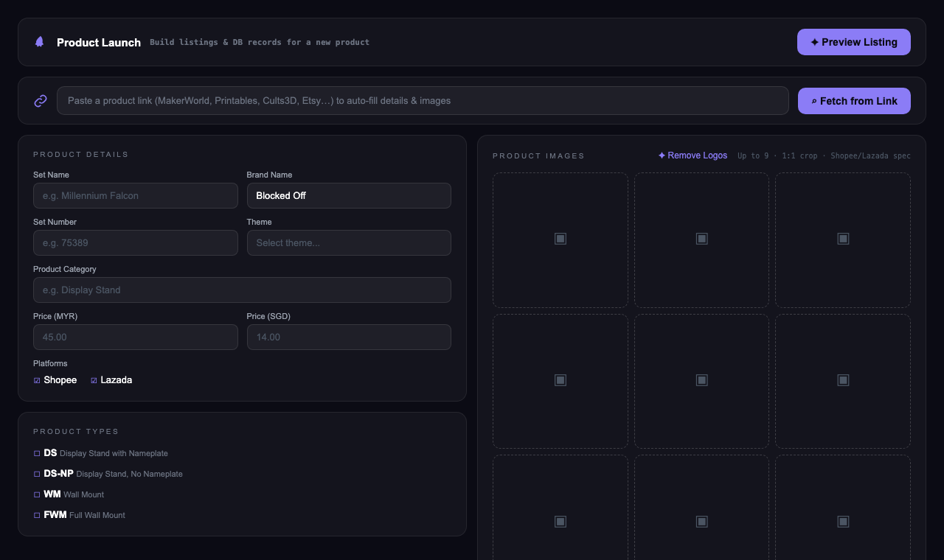
Figure 2 — Empty state. The link bar accepts a marketplace URL; the grid accepts drag & drop as before.
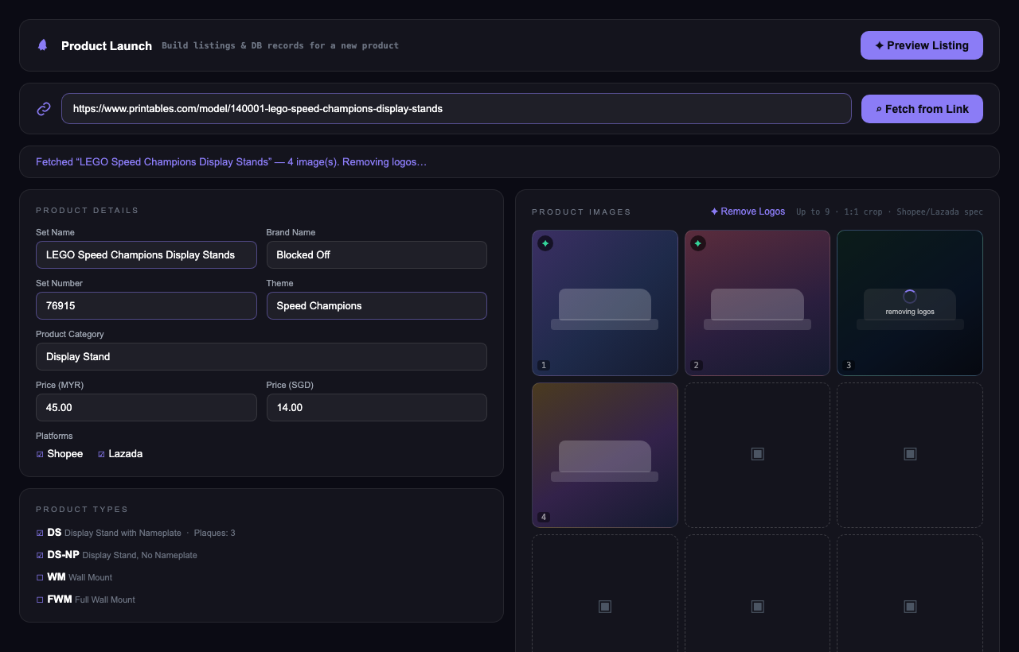
Figure 3 — After Fetch from Link: fields prefilled (violet outline), photos loaded; tiles 1–2 cleaned (badge), tile 3 mid-clean (spinner), tile 4 queued.

Verified behaviour (production-equivalent runs, 2 July 2026)
Test page | Path taken | Result
Printables — LEGO Speed Champions Display Stands | Tier 1 (direct fetch) | Name + description extracted, theme auto-set to SC, 4 full-resolution photos downloaded and normalised. ~15 s.
MakerWorld — Brick Star Wars Ship Display Stand | Tier 2 (url_context) | Name + description extracted, theme auto-set to SWR, zero images, manual-photos notice shown. ~19 s.
Logo removal on scraped photo | clean-image | Fail-safe verified: free-tier key → original kept, cleaned:false, quota reason surfaced in the UI status bar.

9. Status & Next Steps
- Run vercel --prod to ship dashboard v1.8.0 (the backend is already live).
- Enable billing on the Gemini API key to activate logo removal.
- Watch the first real launch: the Drive step runs for the first time against live Drive — confirm the product folder lands under the intended parent, otherwise set PRODUCT_PARENT_FOLDER_ID on Railway.
- Possible follow-ups: browser-extension or clipboard-paste image intake for MakerWorld; auto-triggering Preview after a successful fetch; per-image re-clean button.

