
Discinpline of Information Technology and Mathematics & Statistics
College of Science, Health, Engineering and Education

ICT286 ASSIGNMENT 2
PROJECT DECLARATION

Group Members (full name and student number):

Member 1:________________________________________________________________________

Member 2: Kerry Koa Guan Ting, 33621513

Tutor’s Name: Nathanael Ng

Assignment Due Date: 20th Nov 2020 Date Submitted: 25th Nov 2020

The URL of our web application for large screen on ceto server is:

_________________________________________________________________________________

The URL of our web application for small screen (if applicable) on ceto server is:

_________________________________________________________________________________

Your assignment should meet the following requirements. Please confirm this (by ticking boxes) before submitting your assignment.

- All details above are completed.
- The archive file (a zip file) contains the file “Assignment2.docx” and “Company.docx” (or Company.pdf”).
- The archive file contains sub-directory named “Server” which contains all files related to the server part of your application.
- The archive file contains sub-directory named “WebClient” which contains the files for the web front end for large screen.
- The archive file contains sub-directory named “MobileClient” which contains the files for the web front end for small screen (if you choose to implement mobile web application)
- The archive file contains sub-directory named “Cordova” which contains the Cordova project directory of your Cordova app (if you choose to implement Cordova application)
- The documentation was prepared in accordance to Documentation and Submission Requirements specified in Major Assignment 2’s question sheet.
- This archive file will be submitted to ICT286 Unit LMS.
- We have kept a copy of this assignment, including this archive file.
- Our application is hosted on the server ceto.murdoch.edu.au.
- We have signed the Group Declaration in the next page.

Group Declaration
As a group assignment, each member of the group is expected to make an equal contribution to the assignment and receives the same mark for the assignment.
However, we recognise that on some occasions and due to various reasons, the actual contributions to the assignment from the two members could be unequal despite the best efforts of each member. In this case, we can still accept your assignment provided that all members of the group reach an agreement on their percentages of contribution to the assignment, and the agreement accurately reflects the real contribution by each member. In such a case, a member’s mark is linked to his or her agreed contribution to the assignment and is calculated using the following formula:
A member’s mark = minimum ( group mark x the member’s percentage of contribution x 2, group mark + 10, 100 )
On some rare occasions, the two members of the group fail to reach an agreement on their contributions to the assignment. In such a case, in order for your assignment to be marked, each member of the group must complete a detailed Task Breakdown List and state his or her own claim of the percentage of contribution to the assignment. Your tutor will then award each member a mark based on his assessment of the quality of the assignment as whole as well as his assessment of that member’s contribution to the assignment.
Please complete and sign one of the three declarations below:
We have made equal contributions to this assignment. We understand that each of us will receive the same mark for this assignment.
Signature (member 1): _______________________________Date: ______________________
Signature (member 2): _______________________________Date: ______________________
We have made unequal contributions to this assignment. The percentage of contribution by each of us is given below (note the sum of the contributions by the two members must be equal to 100%):
Member’s name: Contribution (%):
Member’s name: Contribution (%):
We understand that each of us will receive a mark for this assignment that is linked to our contributions to the assignment. The mark will be calculated using the following formula:
A member’s mark = minimum ( group mark x the member’s percentage of contribution x 2, group mark + 10, 100 )
Signature (member 1): _______________________________Date: ______________________
Signature (member 2): _______________________________Date: ______________________
We are unable to reach an agreement on the percentage of our contributions to this assignment. However, in order for our tutor to be able to properly assess the work completed by each of us, each of us has completed a detailed Task Breakdown List which is included in this submission. We will accept our tutor’s determination of our contributions to this assignment.
Signature (member 1): _______________________________Date: ______________________
Signature (member 2): _______________________________Date: ______________________

Extension Granted

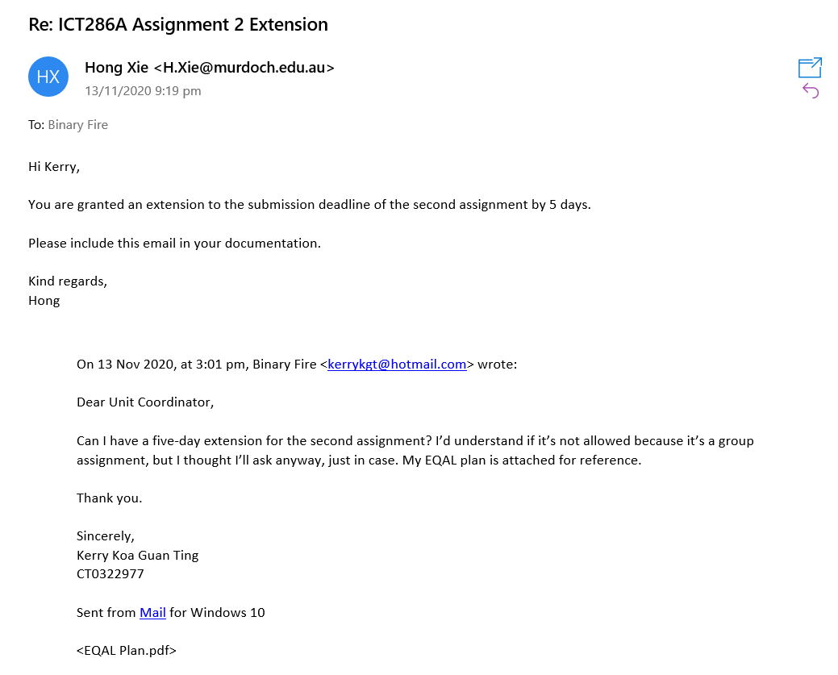

Brief Description of the Assignment

A mobile and/or web application for a fictitious company so that it can conduct its trading over the Internet.

Discussion of Our Solution

Self Diagnosis and Evaluation

Functional Requirements - Basic

Basic Information
No. | Description | Fully Met?
1 | It contains the basic information about the company. | Yes
2 | It has a consistent navigation system for users to move through your application. | Yes
3 | It provides an online Help for users - instructions on how to use your application. | Yes
4 | It must use HTML5's structural elements to define the overall logical structure of the front end of the application and use CSS to define the visual layout of those structural elements. | Yes
5 | You may include video or audio clips in your application if they are deemed necessary, however in such cases, you must keep their sizes to the absolute minimum. | Not Included

Search Facility
No. | Description | Fully Met?
1 | The raw product/service data must be stored in the MySQL database on the server. They must not be hard coded in the HTML pages or dumped in the server file system. The data should be retrieved dynamically from the database and sent to the client in response to user enquiries. If new data are added to the database, your application should not have to be changed in anyway except the contents of the database.
2 | The search facility must contain code to validate user input to make sure only the valid search query will be sent to the server site for action.
3 | If a required field is found to be empty or containing invalid data, the user should be forced to re-enter the data.
4 | Allow at least two levels of search. The first level of search is by keywords, where an entry is retrieved from the database if the user's search term matches any text in any product-related fields in the entry.
5 | The second level of search is by browsing, where the user can go through different categories of products/services to find what he or she wants.

Functional Requirements – Advanced

Type of User | Description | Fully Met?
Unregistered Users | Anyone without authentication is given access to all basic functionalities specified above, including search products/services by keywords and by browsing. | Yes
Registered Customers | A registered customer has an account in the application. He/she needs to be authenticated before access is granted. Once access is granted, he/she can modify his or her personal details such as name, address, phone number and email address. He/she can also submit an order for the company's products or services. After it is validated by the client-side script, this order is sent to the server-side script for processing. The client will then display the confirmation or rejection of the order (perhaps because not enough stock is available). If the order is confirmed, the database should be updated. Please note that anyone can register an account with the application to become a customer of the company without the involvement of the company support staff.
Support Staff | A support staff member has an account with the application. He/she needs to be authenticated before access is granted. Once access is granted, he/she can access any customer account without using that customer's password. He/she can also modify product/service details in the database, such as adding a new product to the database, removing an existing product from the database, or changing the details of an existing product (e.g., stock level). Please note that a support staff member can create new support staff accounts.
All | The information about the registered customers and support staff must be kept in the database, never hard coded in the application. Adding or removing an account should not change your application code in any way except the contents of the database. | Yes
All | Any registered customer and support staff member should still be able to access the basic information and use the search facility just like any unregistered user, whether they are authenticated or not. | Yes

Technical Requirements

No. | Description | Fully Met?
1 | Use only the following technologies: HTML5, CSS, JavaScript, jQuery, Ajax, Cordova, PHP and MySQL. Do not use any web content management system. Do not use any third-party frameworks or libraries unless you have obtained a prior aproval from the Unit Coordinator. | Yes
2 | There are three possible front ends (clients) for this application:  - a web front end suitable for large screen size;  - a Cordova front end packaged for Android or iOS;  - a mobile web front end suitable for small screen sizes.  As the screen size in (b) and (c) is considerably smaller than (a), the screen layout for Cordova app and mobile web must be redesigned. It is not acceptable to have the same screen layout for both large screen web front end and small screen mobile front ends. | Application uses (a) and (c)
3 | Communication between the client and the server must be achieved by using Ajax with the appropriate data exchange formats such plain text, XML and JSON. Your client will need to communicate with the server when it searches for products, changes product details or updates user accounts.
4 | The information on the company's products must all be kept in the database on the server. The information about a particular product can be dynamically retrieved from the database in response to user enquiry and sent to the client for display. Addition, removal and update of product details should in no way change the application code or resource.
5 | The second level of search is by browsing, where the user can go through different categories of products/services to find what he or she wants.
6 | The information on customer accounts and staff accounts must all be kept in the database on the server. Adding, removing or updating a user account means changing what are stored in the database, and should in no way change the appication code or resources.
7 | For the sake of clear structure and sharing of server code, your client and server code as well as resources are to be stored in the following sub-directories:  - Server: the server code and resources must be stored under sub-directory Server.  - WebClient: the client code and resources for the large screen web front end should be placed under sub-directory WebClient.  - MobileClient: the client code and resources for the small screen web front end are placed under sub-directory MobileClient.  - Cordova: the client code and resources for the client part of Cordova app (i.e. everything under the Cordova project directory of your Cordova app) are placed under sub-directory Cordova (it shares the same server code and resources used by the two web front ends).
8 | Except the client part of Cordova code and resources, all the other code and resources of your application must be hosted on the ceto server. There is no need (and no point) to host the Cordova code on ceto server.
9 | You should try to use less number of HTML pages as switching between pages involve retrieving pages from the server and reloading of the pages, sometimes for the previously loaded pages. This is particularly problematic for the mobile devices. Ideally the required code are loaded at the begining and change of the screen display only requires the change of views, without reloading. Where possible, you should aim to design the application as a Single Page Application. | Yes

URL of Our Live Web Application and Live Mobile Web Application

Test Documentation for Our Web Application and Mobile Web Application

