*Supporting Information for*

**19F NMR Relaxation Studies of Fluorosubstituted Tryptophans**

Manman Lu1,2, Rieko Ishima1,2, Tatyana Polenova2,3, Angela M. Gronenborn1,2

*1Department of Structural Biology, University of Pittsburgh School of Medicine, 3501 Fifth Ave., Pittsburgh, PA 15261, United States; 2Pittsburgh Center for HIV Protein Interactions, University of Pittsburgh School of Medicine, 1051 Biomedical Science Tower 3, 3501 Fifth Ave., Pittsburgh, PA 15261, United States;3Department of Chemistry and Biochemistry, University of Delaware, Newark, Delaware 19716, United States;*

Table S1. MAS NMR experimental principal components of the chemical shift tensor, reduced anisotropy, and asymmetry parameters of fluorosubstituted tryptophan powders, reported by Lu et al.1.

|  |  |  |  |  |  |
| --- | --- | --- | --- | --- | --- |
|  | 𝜎11 (ppm) | 𝜎22 (ppm) | 𝜎33 (ppm) | δσ (ppm) | η |
| 4F-DL-Trp | 11.2 | -48.3 | -112.8 | 62.8 | 0.9 |
| 5F-DL-Trp | 4.8 | -60.5 | -86.1 | 52.1 | 0.5 |
| 6F-DL-Trp | 12.9 | -51.2 | -91.6 | 56.2 | 0.7 |
| 7F-DL-Trp | 4.6 | -48.3 | -123.3 | 67.6 | 0.8 |

Table S2. Number and identity of hydrogen atoms near the fluorine atom in the different fluorosubstituted tryptophans and in the model of fluorotryptophan-labeled CypA (PDB 3K0N2).

|  |  |  |  |  |  |  |  |
| --- | --- | --- | --- | --- | --- | --- | --- |
| 4F-Trp | | 5F-Trp | | 6F-Trp | | 7F-Trp | |
| Distance (Å) | Atom | Distance (Å) | Atom | Distance (Å) | Atom | Distance (Å) | Atom |
| 2.3 | HN | 2.6 | H𝜀3 (4H) | 2.6 | H𝜁2 (7H) | 2.6 | H𝜂2 (6H) |
| 2.6 | H𝛽3 | 2.6 | H𝜂2 (6H) | 2.6 | H𝜁3 (5H) | 2.9 | H𝜀1 |
| 2.6 | H𝜁3 (5H) |  |  |  |  |  |  |
| 4F-Trp CypA | | 5F-Trp CypA | | 6F-Trp CypA | | 7F-Trp CypA | |
| Distance (Å) | Atom | Distance (Å) | Atom | Distance (Å) | Atom | Distance (Å) | Atom |
| 2.3 | Trp121 HN | 2.6 | Trp121 H𝜀3 (4H) | 2.6 | Trp121 H𝜁2 (7H) | 2.6 | Trp121 H𝜂2 (6H) |
| 2.6 | Trp121 H𝛽3 | 2.6 | Trp121 H𝜂2 (6H) | 2.6 | Trp121 H𝜁3 (5H) | 2.6 | Phe60 H𝜀1 |
| 2.6 | Trp121 H𝜁3 (5H) |  |  | 2.9 | Thr119 H𝛾2 | 2.9 | Trp121 H𝜀1 |
| 2.8 | Glu120 H𝛾2 |  |  |  |  |  |  |

Table S3. R2 and fast and slow components, R2p and R2m, generated by CSA-DD cross correlation in 19F- Trp- CypA. a

|  |  |  |  |  |  |  |  |
| --- | --- | --- | --- | --- | --- | --- | --- |
| 19F-position in F-Trp-CypA | Dipole pair proton atom name | Relaxation (s-1) b | | | | | (R2p-R2m)/ (R2p+R2m) |
| R2 | R2p | R2m | (R2p+R2m)/2 | (R2p-R2m)/2 |
| 4F | NH | 111.59 | 126.59 | 96.59 | 111.59 | 15.00 | 0.13 |
| 4F | 5H | 109.20 | 85.69 | 132.71 | 109.20 | -23.51 | -0.22 |
| 5F | 4H | 63.74 | 75.54 | 51.94 | 63.74 | 11.80 | 0.19 |
| 5F | 6H | 63.78 | 78.79 | 48.77 | 63.78 | 15.01 | 0.24 |
| 6F | 7H | 79.81 | 97.26 | 62.35 | 79.81 | 17.46 | 0.22 |
| 6F | 5H | 79.78 | 93.73 | 65.82 | 79.78 | 13.96 | 0.17 |
| 7F | 6H | 117.10 | 96.79 | 137.42 | 117.10 | -20.32 | -0.17 |

a Values were calculated using Spinach3.

b R2p and R2m are fast and slow relaxing components of R2. (R2p-R2m)/2 is the cross-correlation term.

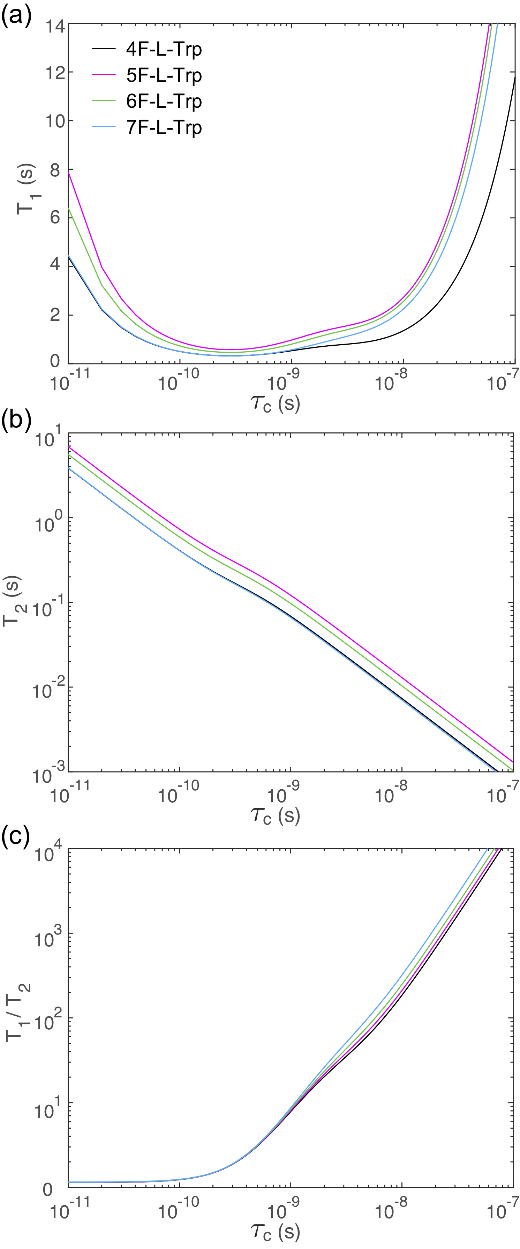

Figure S1. Dependence of T1 (a), T2 (b), and T1/T2 values (c) on the rotational correlation time. The curves were simulated using the 1H-19F two spin system approximation, taking into account the dipole-dipole interaction of fluorine with the nearest hydrogen and the 19F CSA contribution. The curves are color coded for different fluorine positions: 4 (black), 5 (magenta), 6 (green), and 7 (blue).

**References**

1. Lu M, Sarkar S, Wang M, Kraus J, Fritz M, Quinn CM, Bai S, Holmes ST, Dybowski C, Yap GPA, Struppe J, Sergeyev IV, Maas W, Gronenborn AM, Polenova T (2018) 19F magic angle spinning NMR spectroscopy and density functional theory calculations of fluorosubstituted tryptophans: integrating experiment and theory for accurate determination of chemical shift tensors. J Phys Chem B 122:6148-6155

2. Fraser JS, Clarkson MW, Degnan SC, Erion R, Kern D, Alber T (2009) Hidden alternative structures of proline isomerase essential for catalysis. Nature 462:669-673

3. Hogben HJ, Krzystyniak M, Charnock GTP, Hore PJ, Kuprov I (2011) Spinach - a software library for simulation of spin dynamics in large spin systems. J Magn Reson 208:179-194