?? PMD ?????????
?????Word ?
????__________ ???__________ ???__________ ???__________

??????
?? PMD ?????

??????
- ??? Eclipse ??? PMD ??????
- ???? Java ????????????????
- ???? PMD ? CPD ? Java ?????????????
- ??????????????????????

??????
- ?????Windows
- ?????Eclipse IDE 4.26
- JDK?JavaSE-17
- ??????F:\Code\my-vibecoding-project\pmd_static_test_report\workspace
- ?????F:\Code\my-vibecoding-project\pmd_static_test_report\workspace\demoPMD

??????
PMD ????????????????????????????????????????????????????????????????????CPD?Copy/Paste Detector?? PMD ??????????????????????????????

??????

1. ?? Eclipse Marketplace ??? PMD
?? Eclipse ?????????Help -> Eclipse Marketplace...???????????????????PMD??????????????????????? PMD ?????
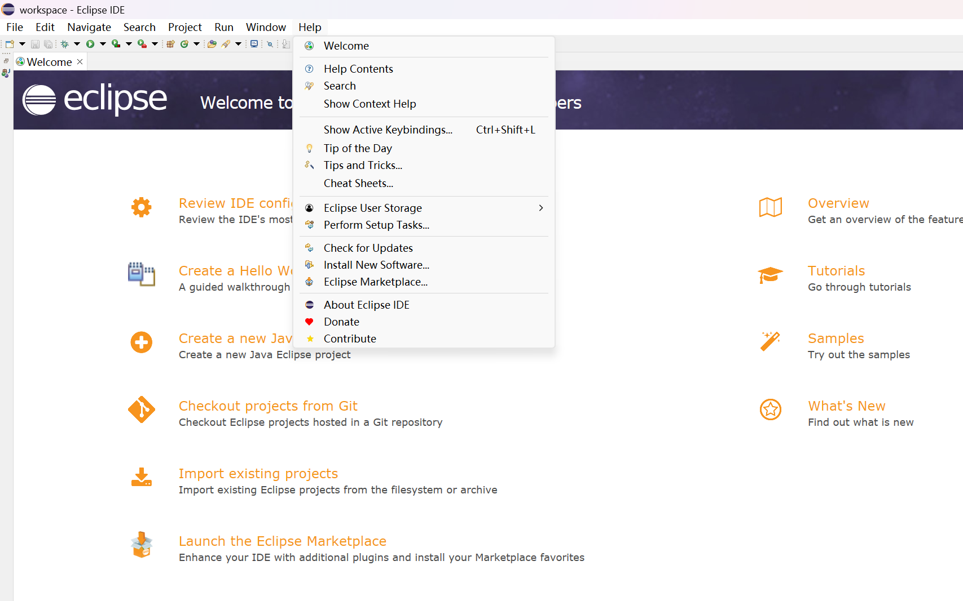
? 1 ?? Help ??
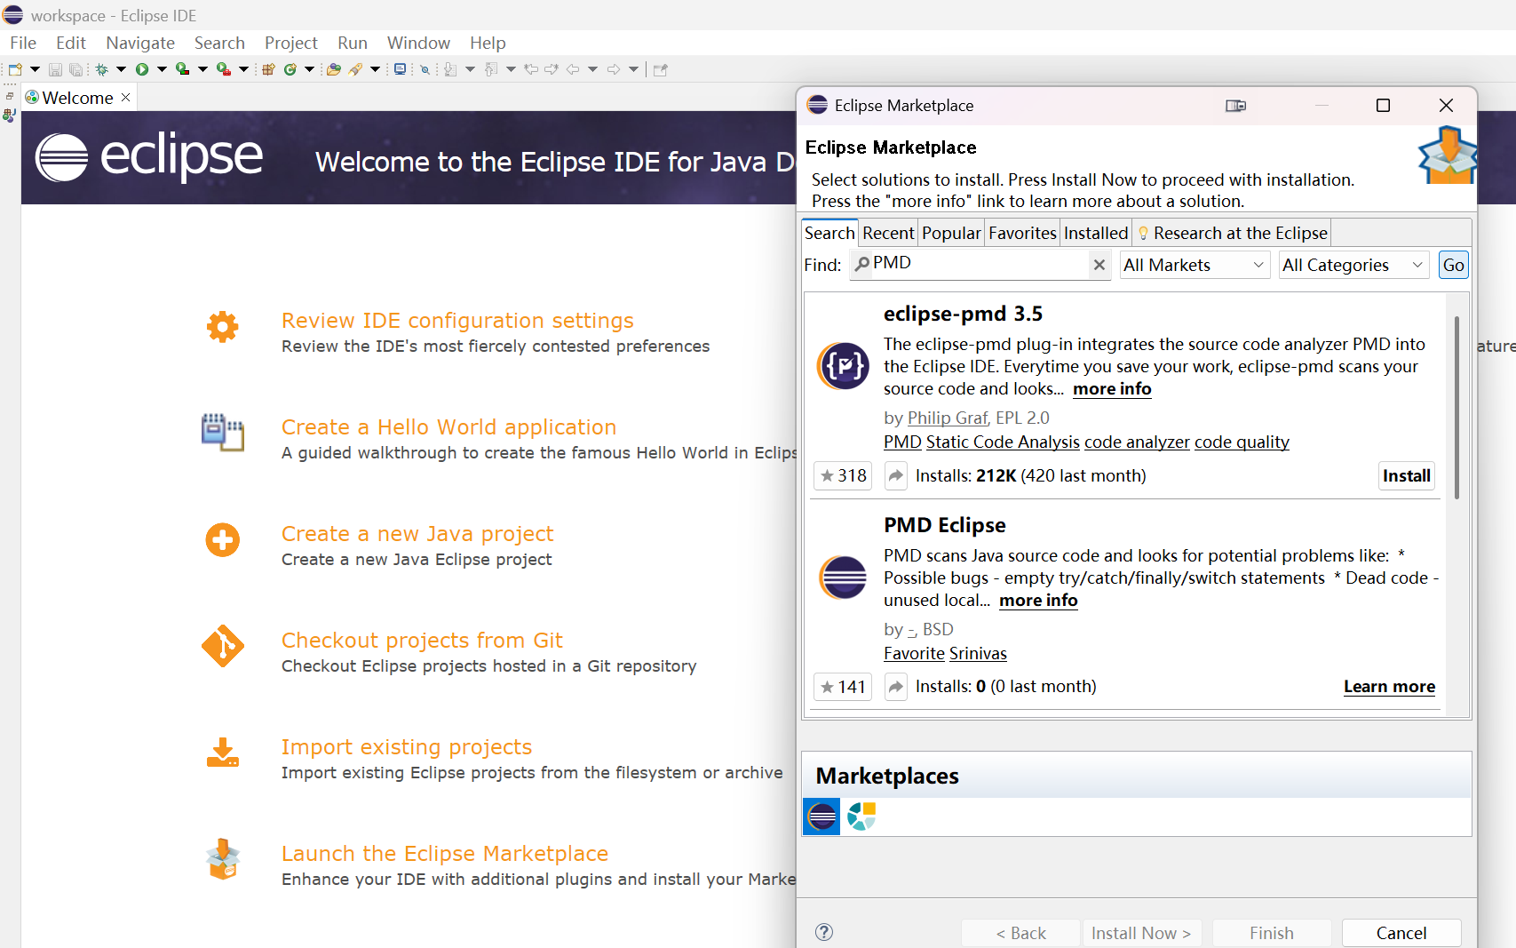
? 2 ? Marketplace ??? PMD

2. ?? PMD ????? Eclipse
???????? Install ????????????????Eclipse ???? IDE ??????????????? Eclipse?
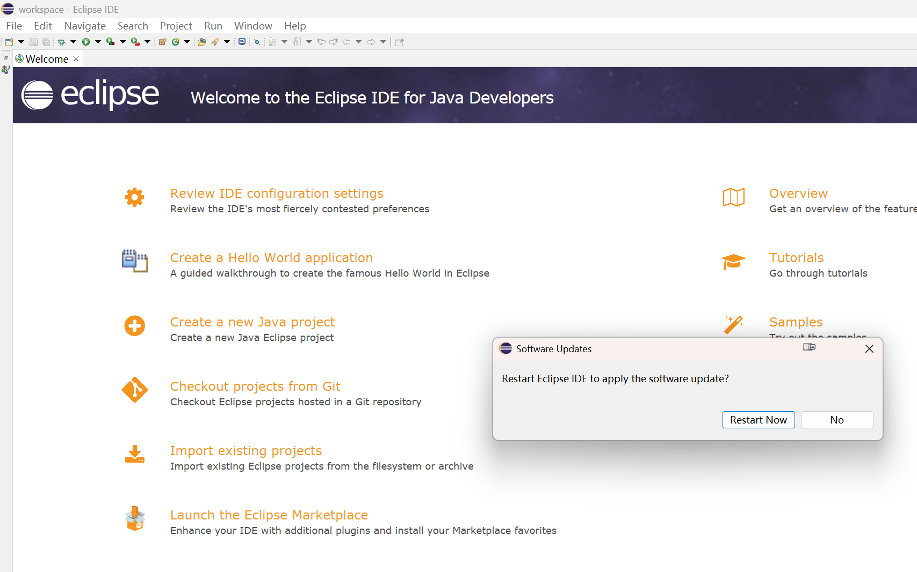
? 3 ????????? Eclipse

3. ?? Java ?? demoPMD
? Eclipse ??? Java ?????????? demoPMD?????????????? Package Explorer ??????? src ?????
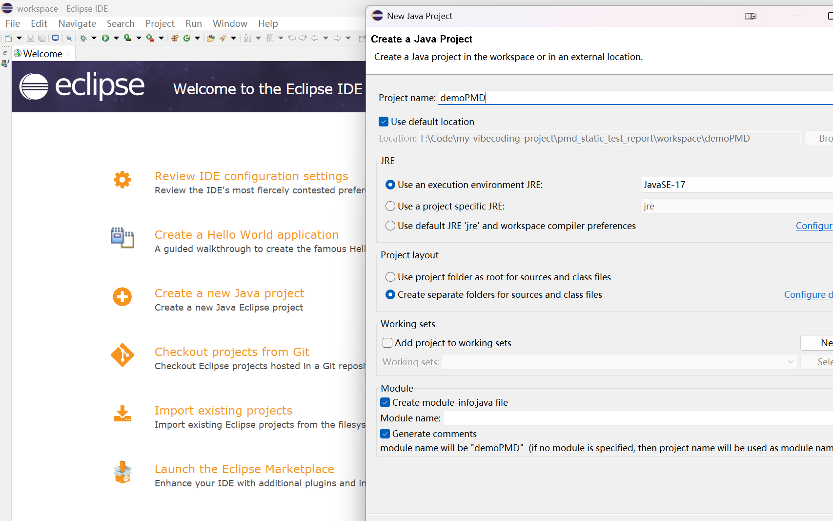
? 4 ?? Java ?? demoPMD

4. ? src ?????? Text
? src ?????? Text????????????????
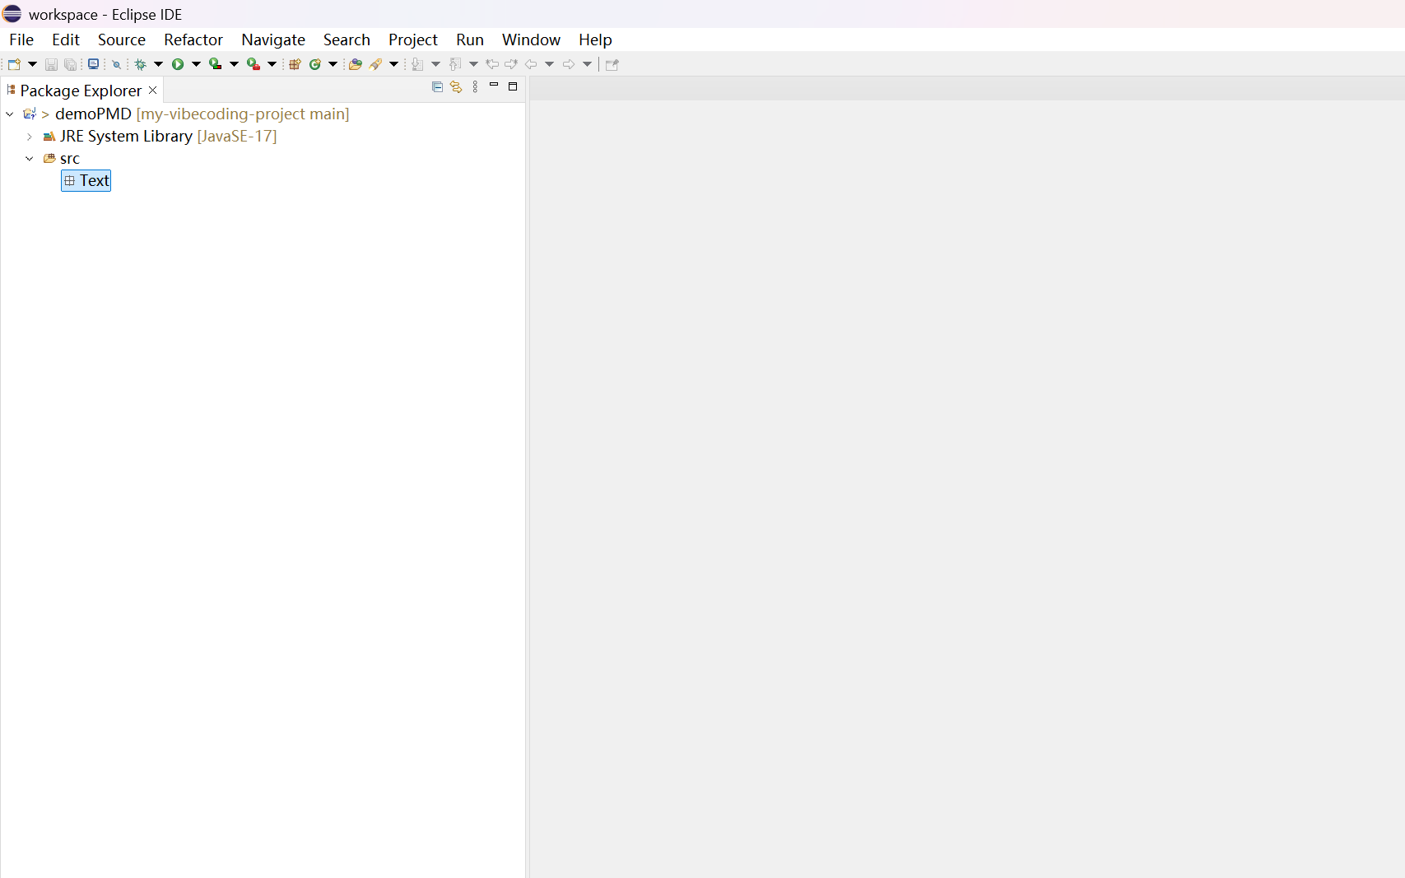
? 5 ????? Text

5. ? Text ??????? Number
? Text ???? Java ? Number????? PMD/CPD ??????????
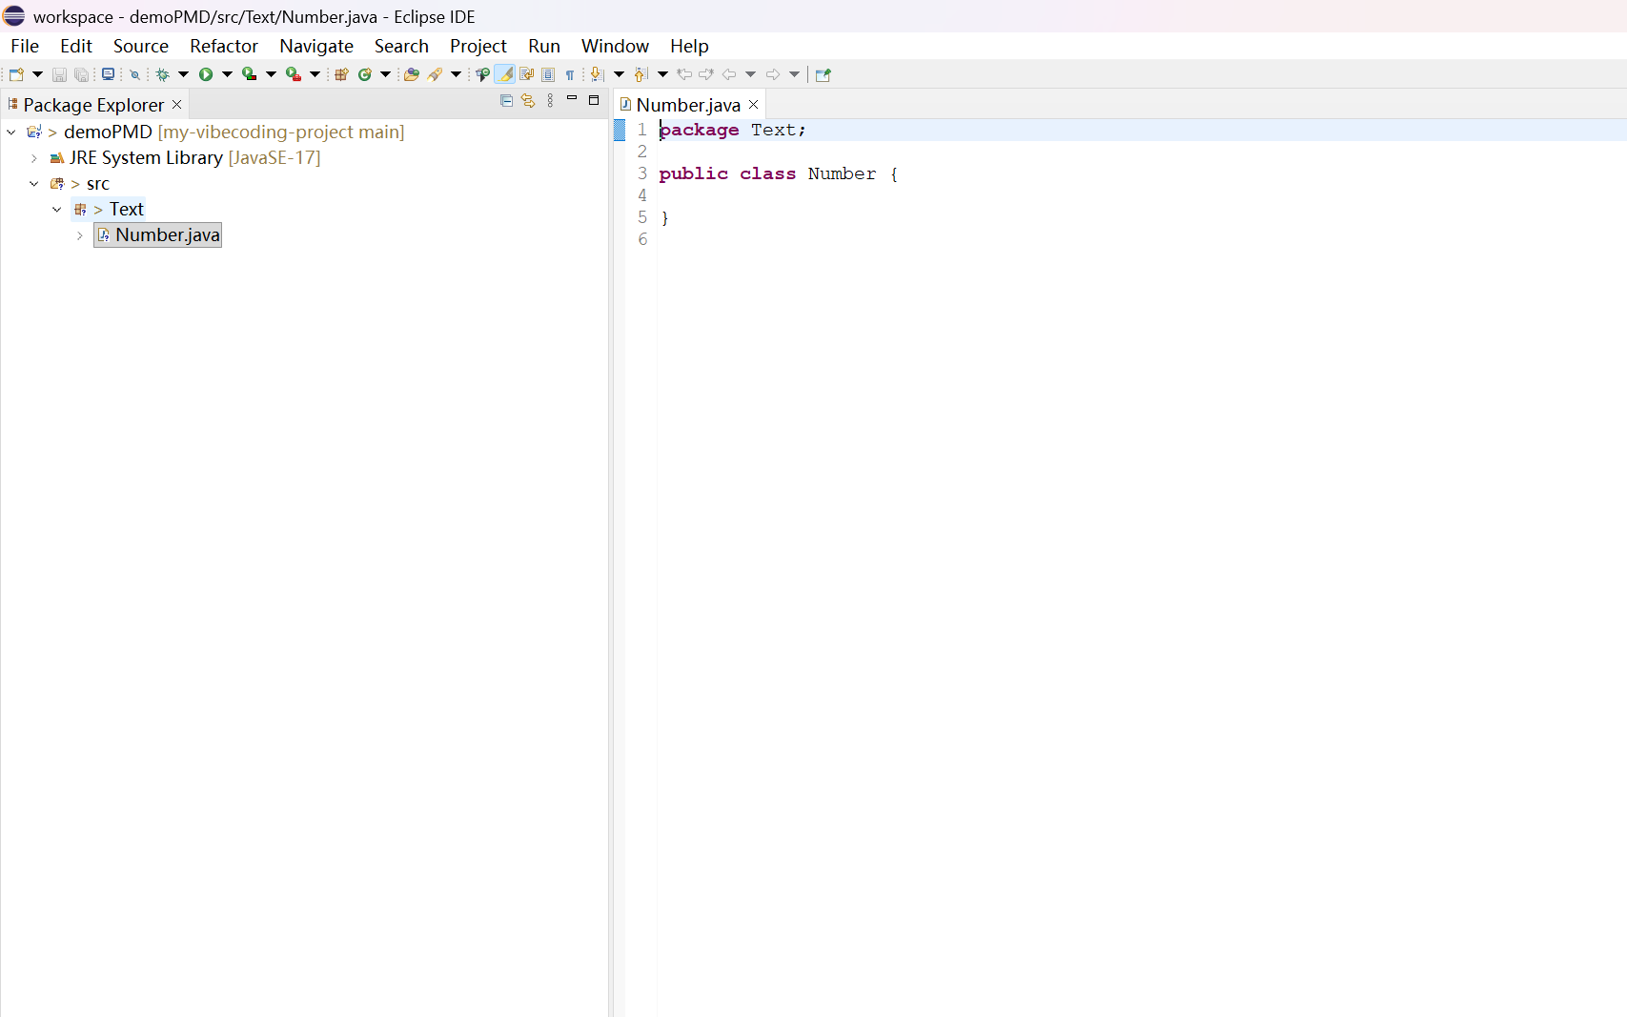
? 6 ????? Number

6. ??????
? Number.java ????????????????????????????????????????????????????????????
package Text;
public class Number {
public void arrayAdds(int[][] a) {
int sum=0;
for(int row = 0;row < 100;row++)
for(int col = 0;col < 5;col++)
sum = sum + a[row][col];
for(int row = 0;row < 100;row++)
for(int col = 0;col < 5;col++)
sum = sum + a[row][col];
}
}
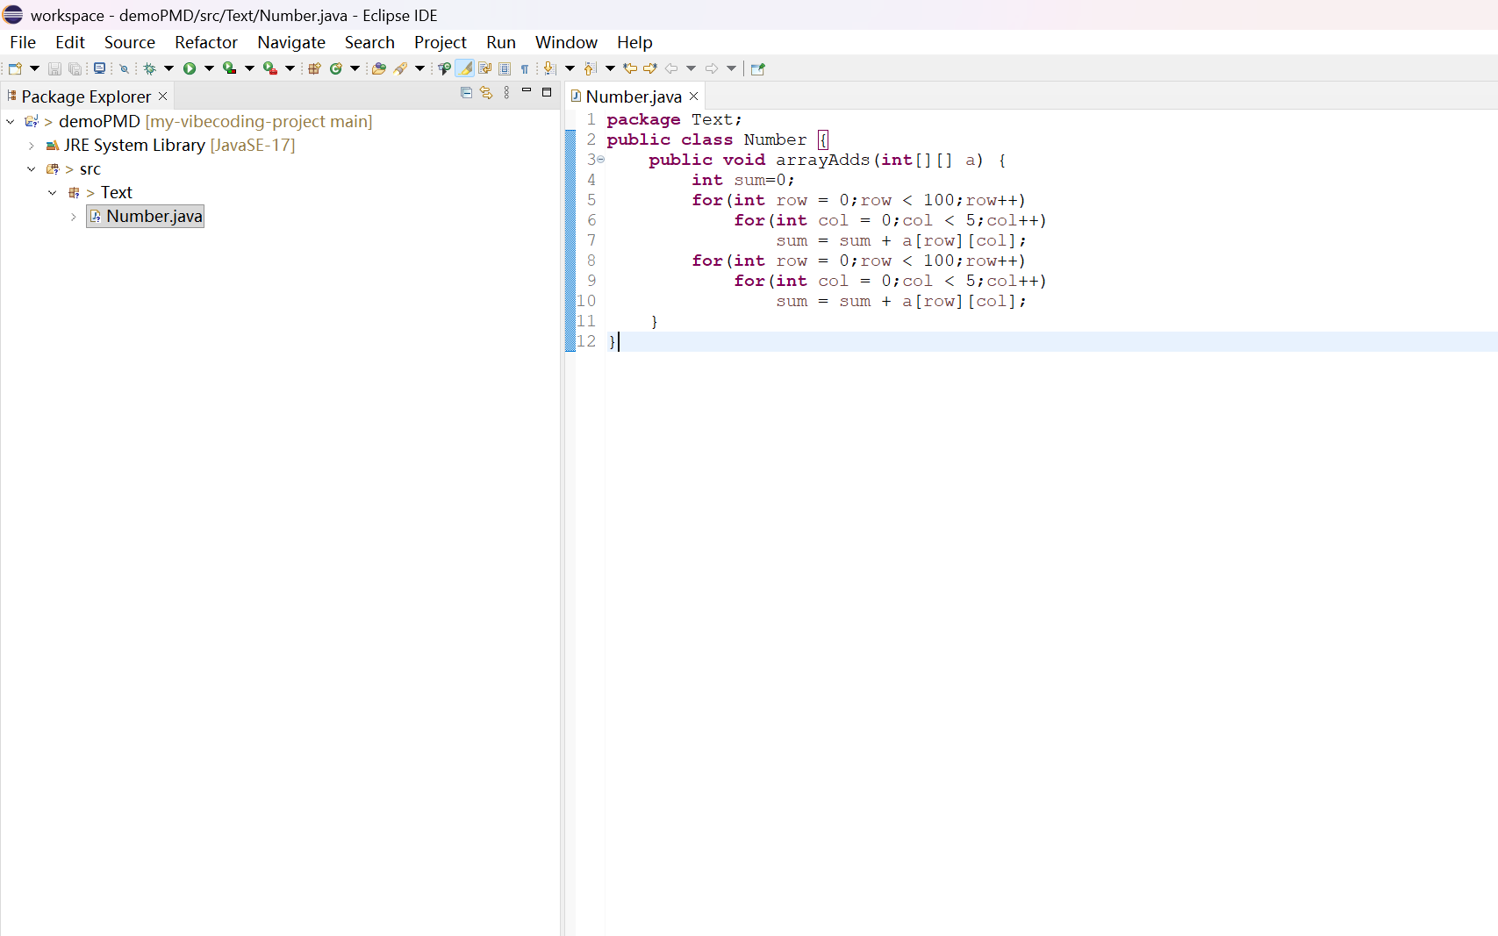
? 7 ? Eclipse ???????

7. ????????
?????????Marketplace ??? eclipse-pmd 3.5 ??? Eclipse 4.26 ????????? PDF ???? PMD ????????????????? PMD 7.23.0 ?????????????????? reports ????? Eclipse ??????
?? CPD ???????
pmd.bat cpd --minimum-tokens 25 --language java --format text --no-fail-on-violation --no-fail-on-error -d src -r reports\cpd-report.txt
?? PMD ???????
pmd.bat check --no-fail-on-violation --no-fail-on-error --use-version java-17 -R category/java/codestyle.xml,category/java/documentation.xml,category/java/bestpractices.xml -f text -d src -r reports\pmd-report.txt
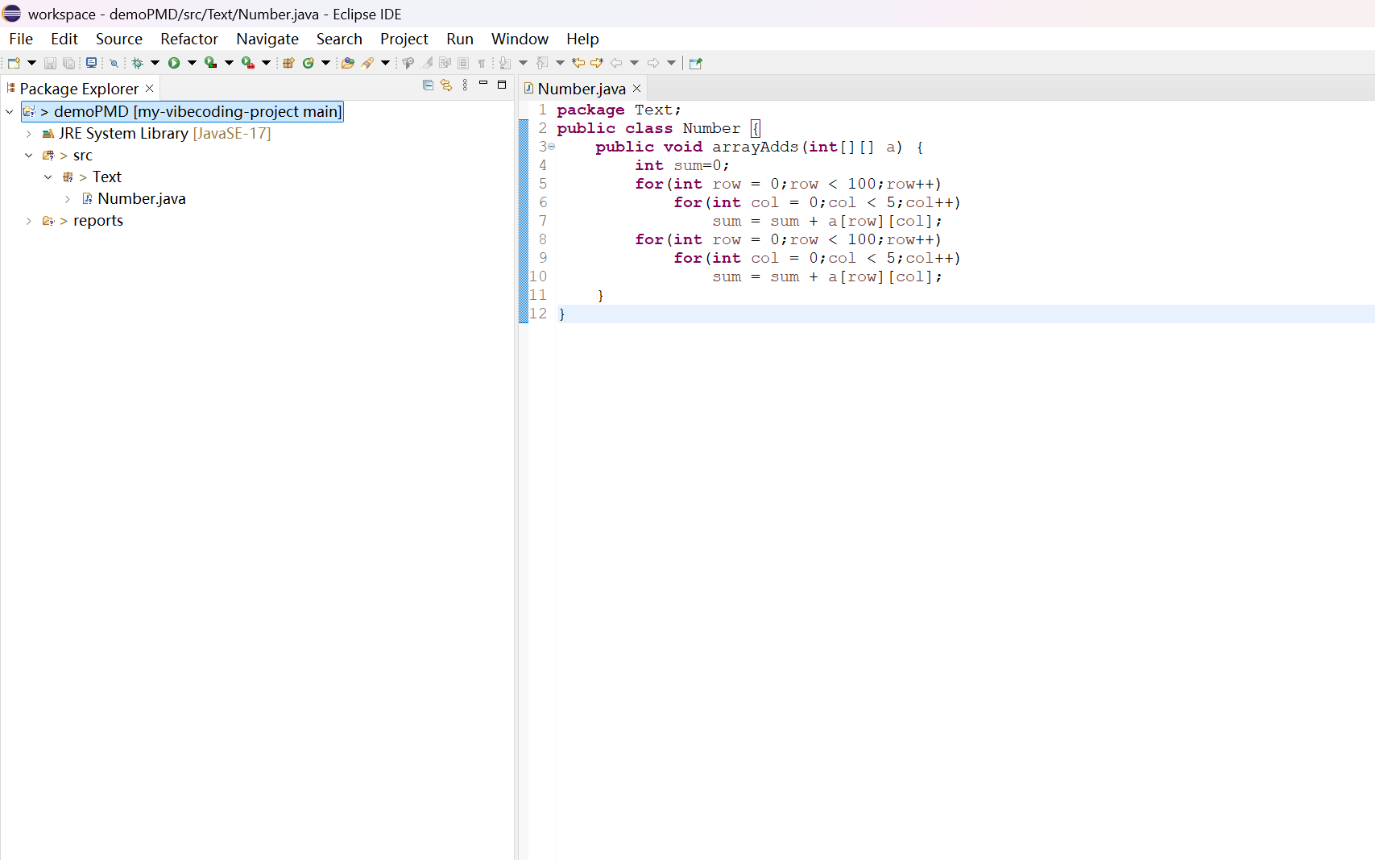
? 8 ????? reports ??
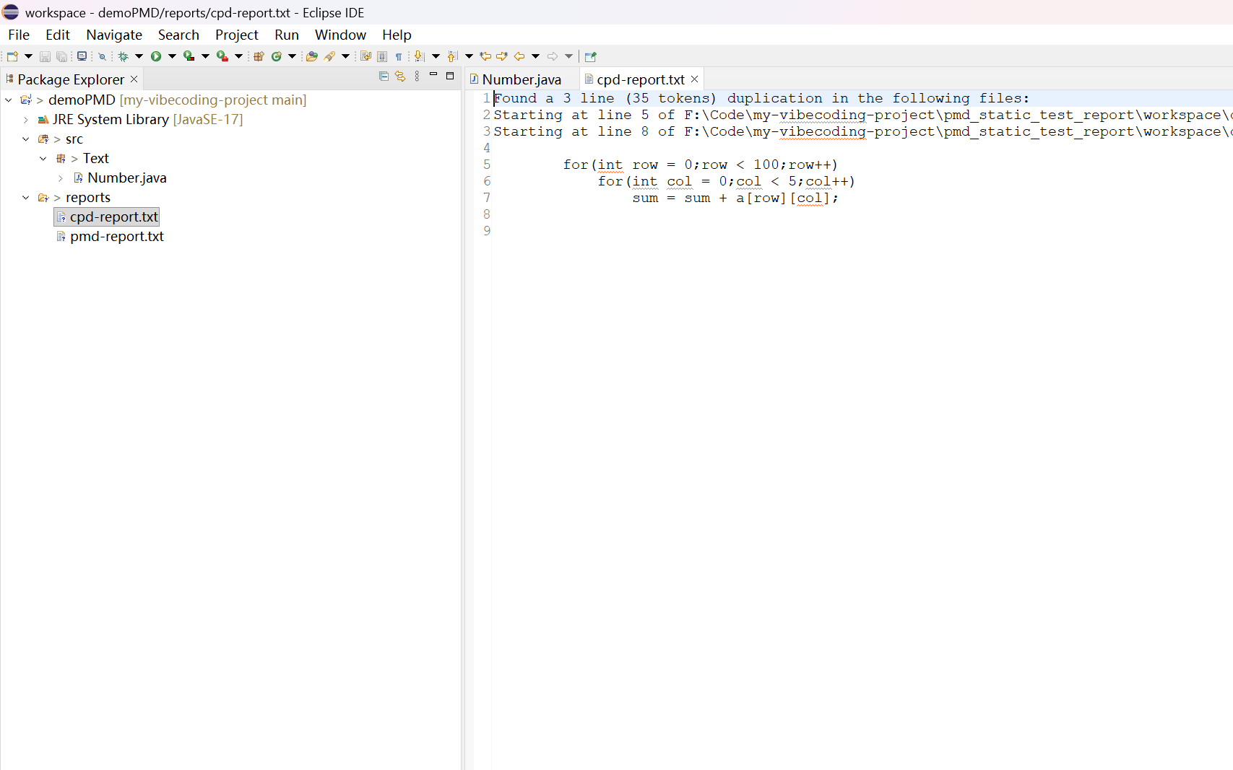
? 9 ?? cpd-report.txt ????????
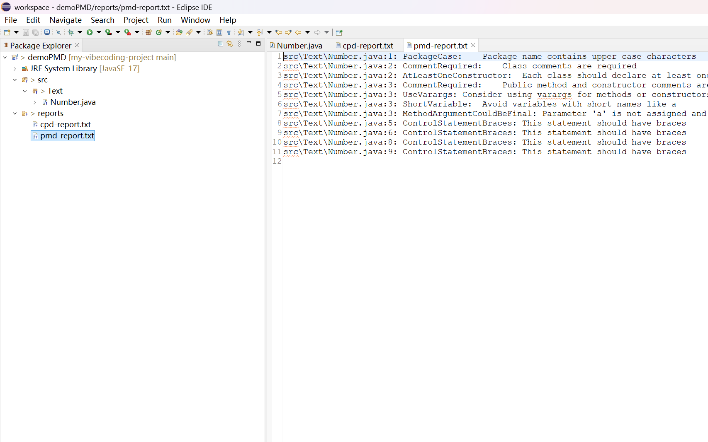
? 10 ?? pmd-report.txt ????????

??????

1. CPD ????????
- ? Number.java ???? 1 ????????
- ???????????? 5 ??? 8 ??
- ????? 3 ??35 ? token?
???????????? for ?????????????????CPD ?????????

2. PMD ??????
PMD ???? 11 ?????????
- PackageCase??????????
- CommentRequired????????????
- AtLeastOneConstructor????????????
- UseVarargs???????????????
- ShortVariable???? a ???
- MethodArgumentCouldBeFinal??? a ????? final?
- ControlStatementBraces?? 5?6?8?9 ?? for ????????

????????
- ????????????? PMD ????????????????????
- CPD ???????????????????????????????
- PMD ????? 11 ?????????????????????????????
- ???????????????????????????????????

??????
???????????? Eclipse ??? PMD ????? Java ??????????????? PMD/CPD ???????????????PMD ??????????????? CPD ?????????????????????????????????????????????????????????

????????
- ?????F:\Code\my-vibecoding-project\pmd_static_test_report\workspace\demoPMD\src\Text\Number.java
- CPD ???F:\Code\my-vibecoding-project\pmd_static_test_report\workspace\demoPMD\reports\cpd-report.txt
- PMD ???F:\Code\my-vibecoding-project\pmd_static_test_report\workspace\demoPMD\reports\pmd-report.txt

