**Chemotherapy Scheduler & Optimiser**

1. Structure and Basic Information of Program

*Simple diagram to be inserted*

This program is coded in Java, and should be compatible with all devices in general which has Java Development Kit (JDK) v1.8.0 and above. It makes use of IBM ILOG CPLEX, an industrial standard optimisation engine to generate the optimal number of treatments for each treatment type. To be exact, CPLEX Community Version 12.7 was used. It also makes use of JACOB, an open source package which allows interaction between the Java based program and Microsoft Excel.

The program operates by first reading inputs from the macro-enabled excel file input.xlsm. The variables which this input file requires will be explained in Section 2. The bulk of processing will be handled in the program, which makes use of CPLEX’s solver engine to generate a matrix which contains the optimal treatment allocation for the input variables given. The program then automatically calls a Microsoft Excel file to generate the output in a tabular format as shown below. This result is automatically saved in a file called *listing.xlsm*, which can be found in the same folder as the program.

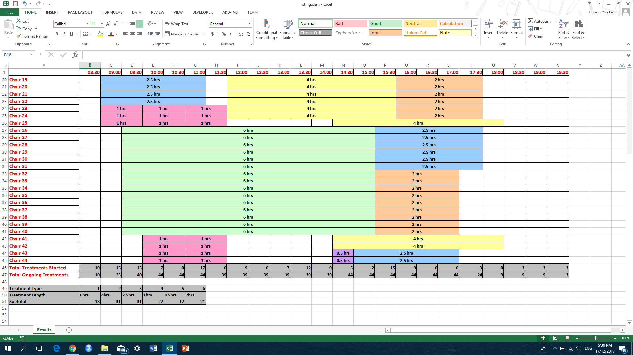

1. Input Variables

The following table contains the list of input variables which the user is expected to provide. These variables will be stored in a file *input.csv*.

|  |  |
| --- | --- |
| **Variable Name** | **Details** |
| No. of Treatments Types | A positive integer input, indicating how many types of treatment lengths are there. Treatments with the same length are considered as one treatment. Maximum of 10 treatment types allowed. |
| Length of Treatments (in Terms of Time Slots) | An array of positive integer inputs. Size of array should be consistent with the number of treatments types. Each integer input should represent the number of time slots which will be occupied.  By default, each time slot represents half an hour. For example, a 6 hours treatment takes up 12 slots. |
| Ratio of Treatments (Sum to 1.00) | An array of floating (decimal) point inputs between 0 and 1. Size of array should be consistent with number of treatment types.  **Important:** The sum of all these ratios must sum to 1.0, otherwise the program will reject this input. |
| No. of Treatments Booked | An array of positive integer inputs. Size of array should correspond to the number of treatment types indicated.  This represents the total number of bookings which were made in a set previous time period. |
| No. of No-Shows | An array of positive integer inputs. Size of array should correspond to the number of treatment types indicated.  This represents the total number of bookings which were cancelled AND bookings for which the patient did not show up in a set previous time period. |
| No-Show Factor | A non-negative floating point (decimal) input. This number is a tuning factor.  A value of 0 means that the number of treatments allocated will NOT be affected by the no-show percentage. While, a greater value will encourage treatment allocations to be more dependent on the no-show percentage |
| Allowable Error in Ratio | A positive floating (decimal) point input between 0 and 1 representing slack in the treatment ratios.  For the program to function normally, this value should be kept between 0.01 and 0.05. A higher value will allow for more flexibility in the program towards scheduling treatments. |
| Total No. of Chairs | A positive integer input, representing the total number of chairs available at the chemotherapy clinic. |
| Max Total Cases per Nurse | A positive floating (decimal) point input. This represents the maximum total number of cases (on average) allowable per nurse in any point in time.  For example, inputting 3 means that total cases should not exceed 3 times the number of nurses. |

|  |  |
| --- | --- |
| Max Ongoing Cases per Nurse | A positive floating (decimal) point input. This represents the maximum number of ongoing cases (on average) allowable per available nurse in any point in time.  For example, inputting 7 means that ongoing cases should not exceed 7 times the number of nurses not attending to new cases. |
| Max new Cases per Nurse | A positive floating (decimal) point input. This represents the maximum number of new cases (on average) allowable per nurse in any point in time.  For example, inputting 1 means that new cases should not exceed 1 times the number of nurses. |
| Max Started Cases per Time Slot | A positive floating (decimal) point input. This represents the maximum number of new cases (on average) allowable per time slot.  For example, inputting 12 means that new cases should not exceed 12 in a time slot. |
| No. of Time Slots | A positive integer input, representing the maximum operating hours of the clinic. Each time slot is by default half an hour long. Maximum of 50 time slots allowed.  For example, if the clinic is open from 10am to 10pm, then there should be 24 slots. |
| Manpower at each Time Slot | An array of floating (decimal) point inputs. Size of array should correspond to the number of time slots indicated. This represents the number of nurses available (on average) at each time slot. |
| No. of Operating Chairs at each Time Slot | An array of integer inputs. Size of arrays should correspond to the number of time slots indicated.  This represents the number of chairs which are in operation at each particular time. |