CMPT 733 Assignment3 Report

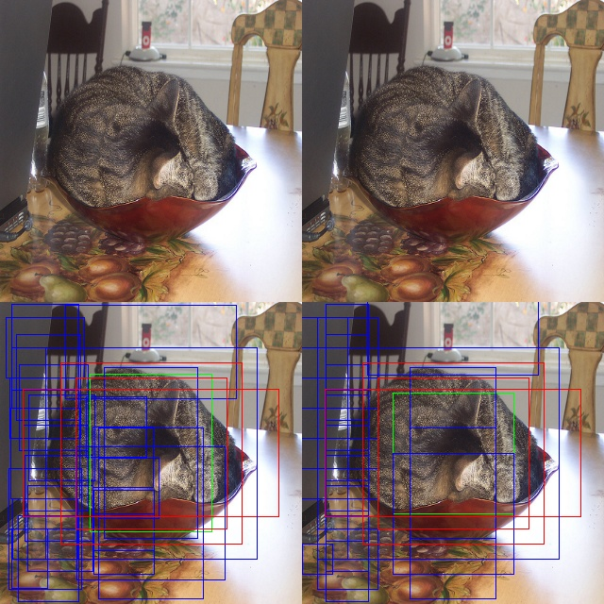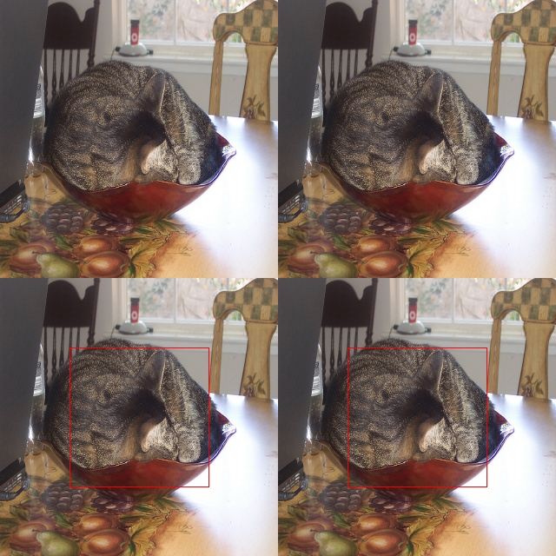Cat before NMS

Cat after NMS

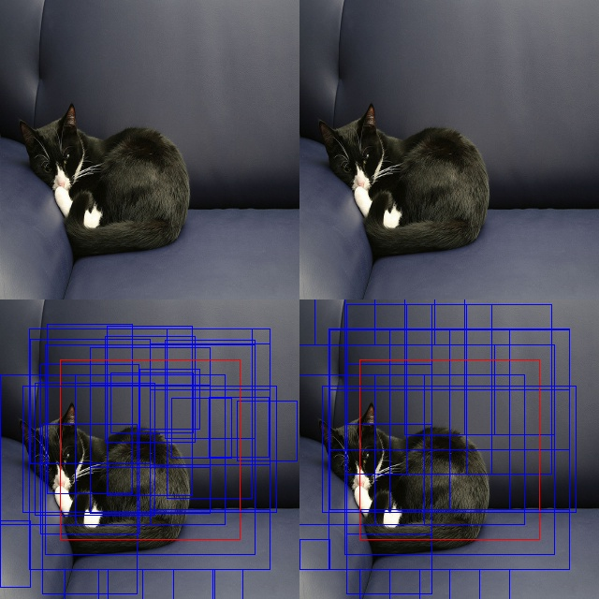Cat2 before NMS

Cat2 after NMS

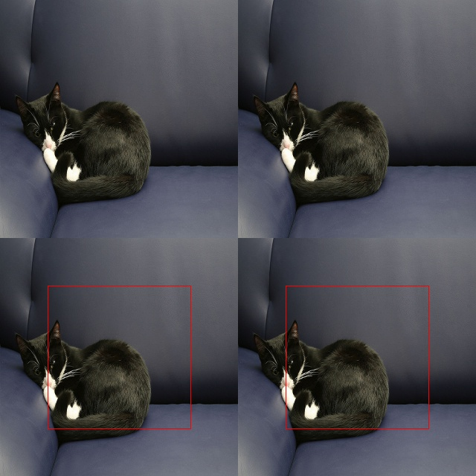

Cat3 before NMS

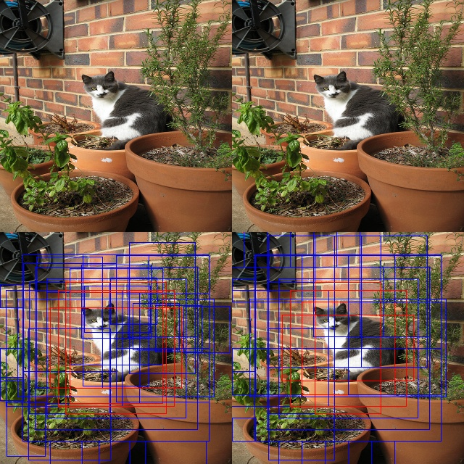

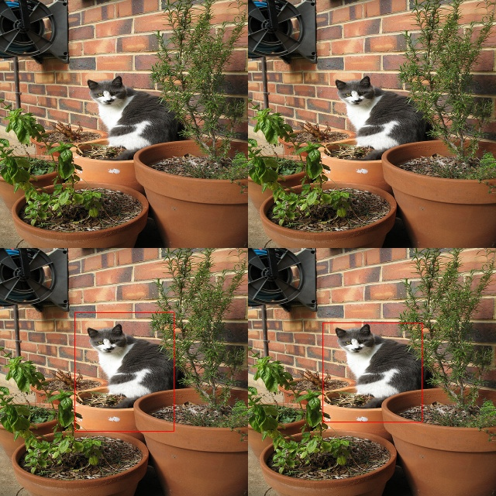Cat3 after NMS

Dog before NMS

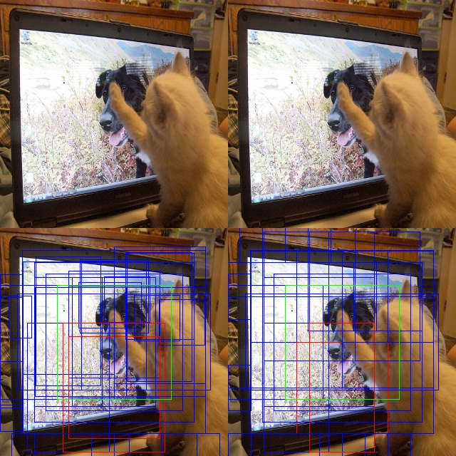

Dog after NMS

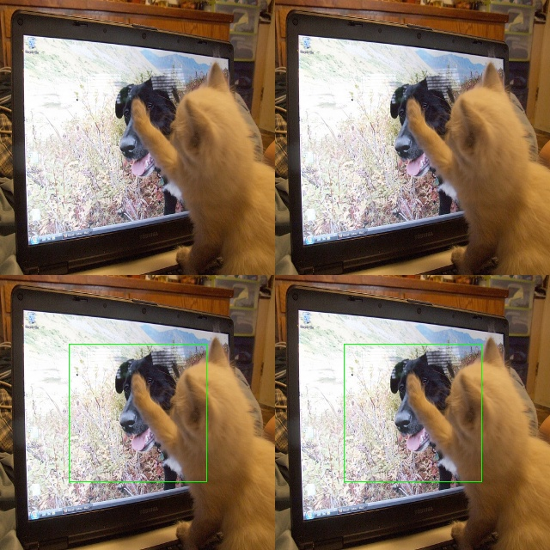

Two People before NMS

For multiple object detection, I just fine-tuning the overlap parameter in NMS to 0.1, so that different objects can be clearly detected

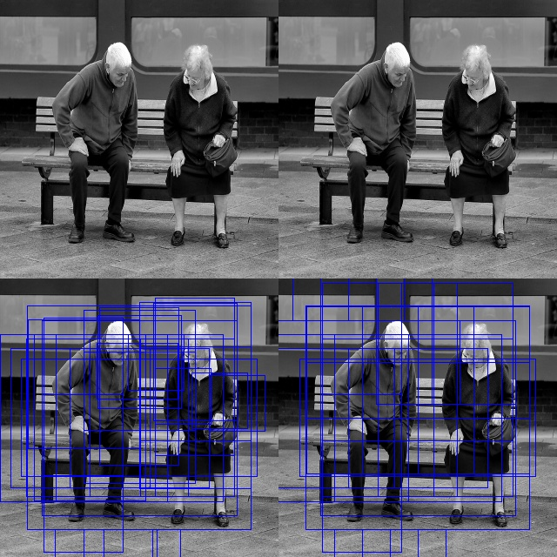

Two People after NMS

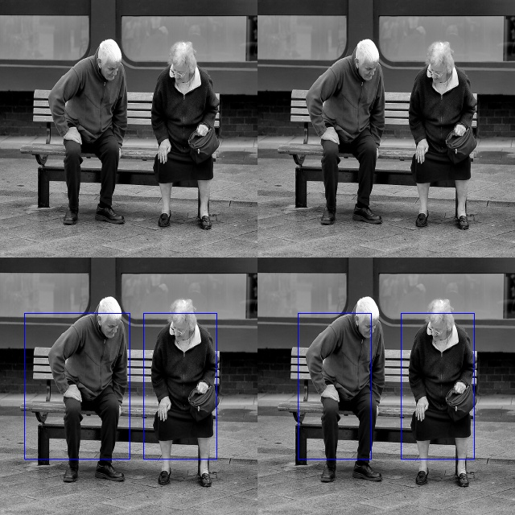

Two People2 before NMS

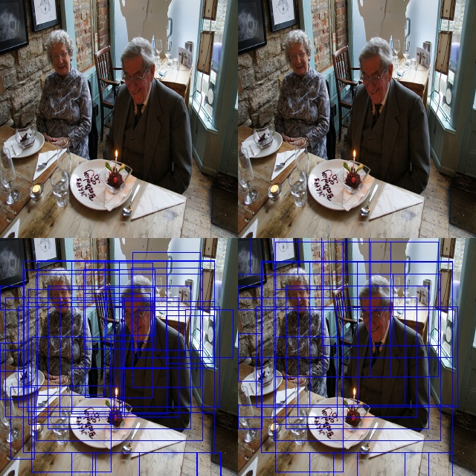

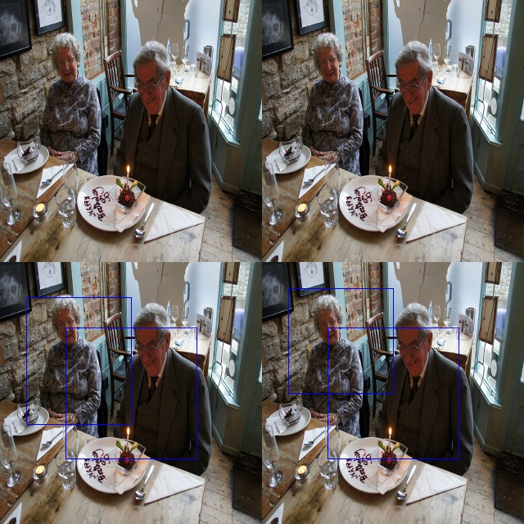Two People2 after NMS

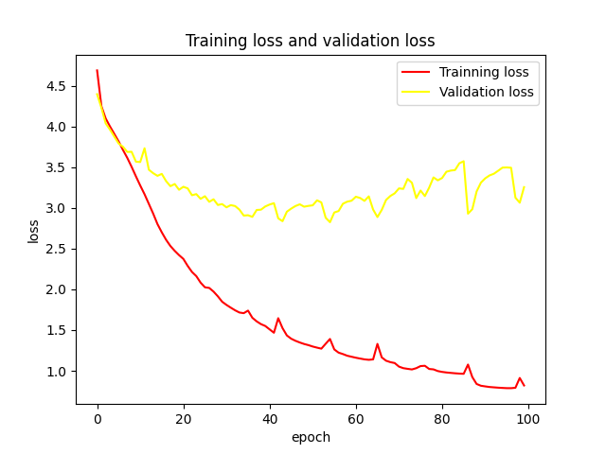Loss Graph with 100 iteration:

Hyper parameter:

num_epochs = 100

batch_size = 16

optimizer = optim.Adam(network.parameters(), lr = 1e-4)