추동원

(1)mySQL서버 설치 위치

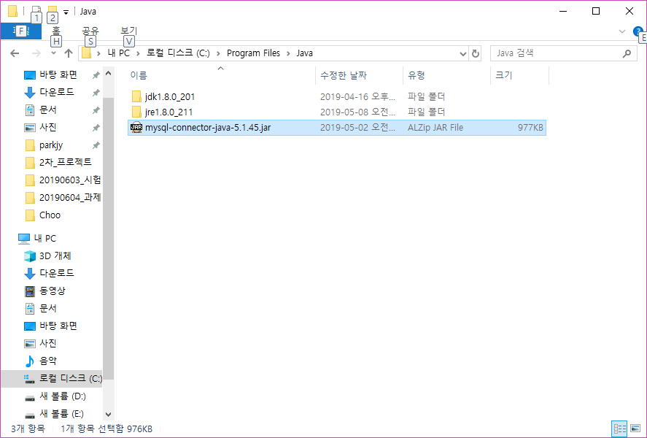

(2)database만드는과정캡처

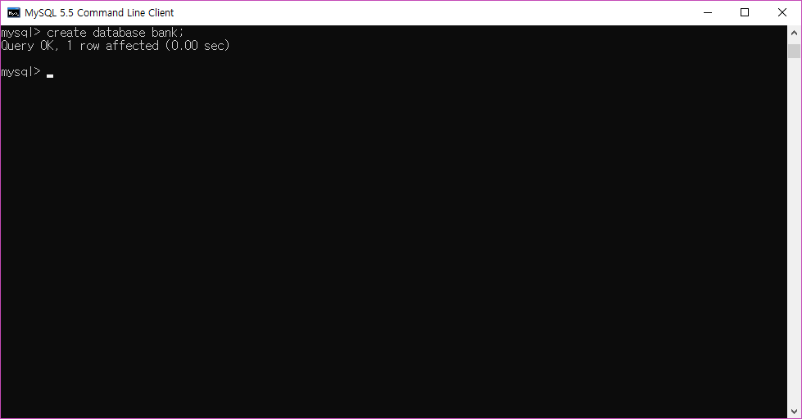

(3)table 만든느 과정

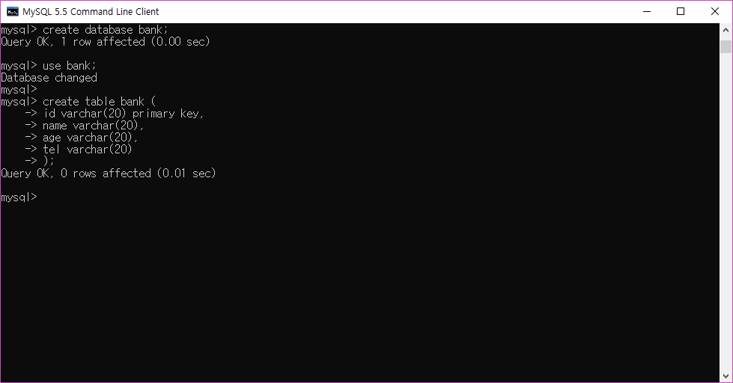

(4) 이클립스에서 data source Explorer 설정 과정

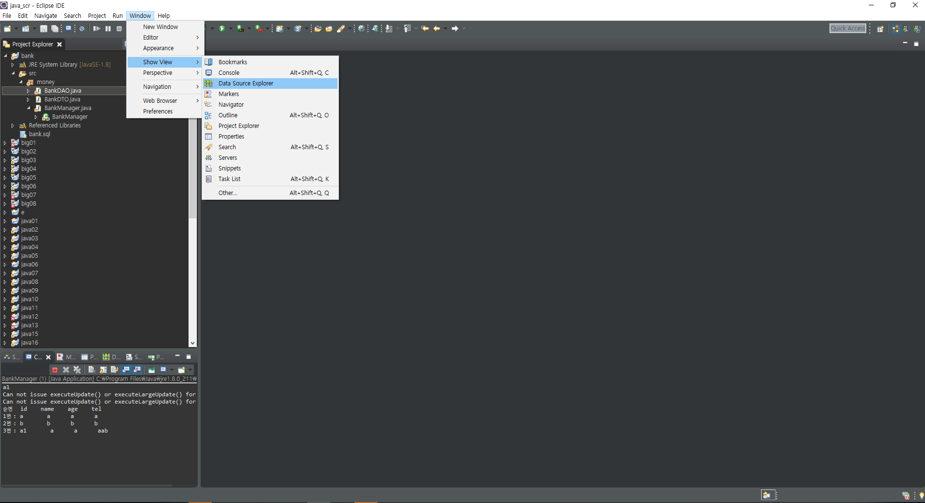

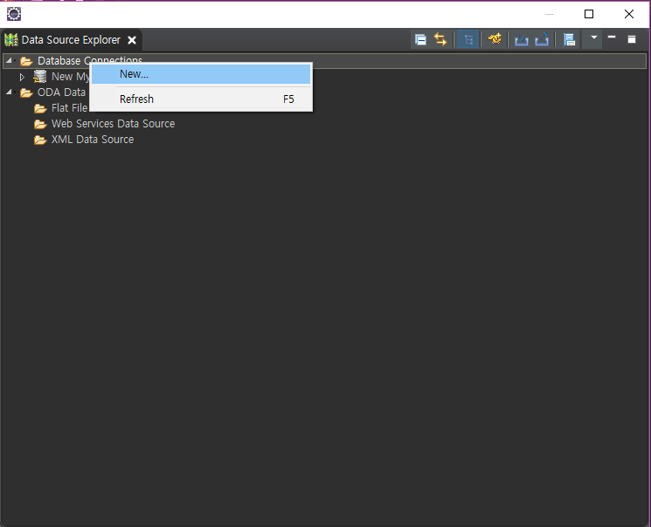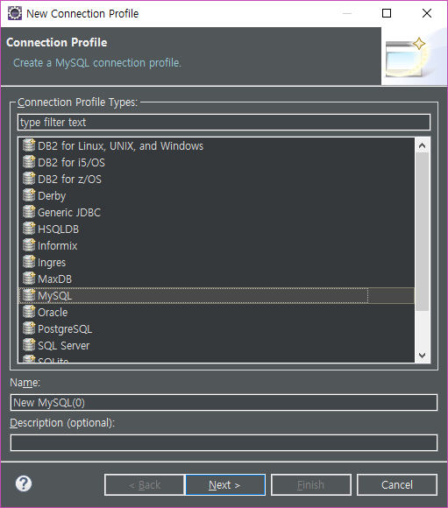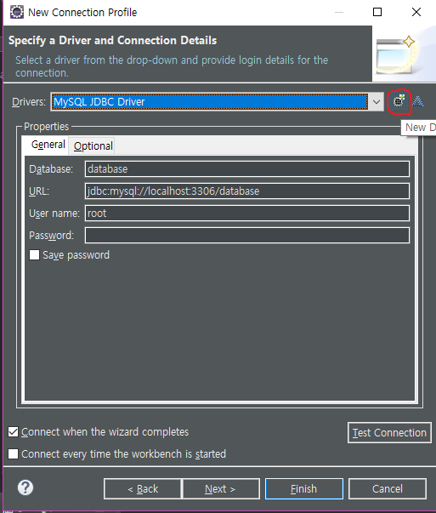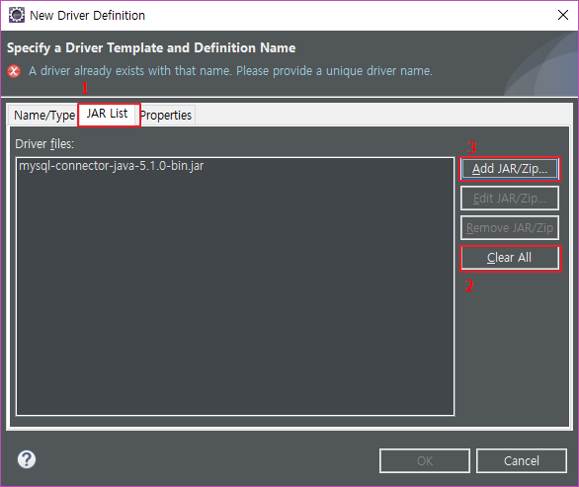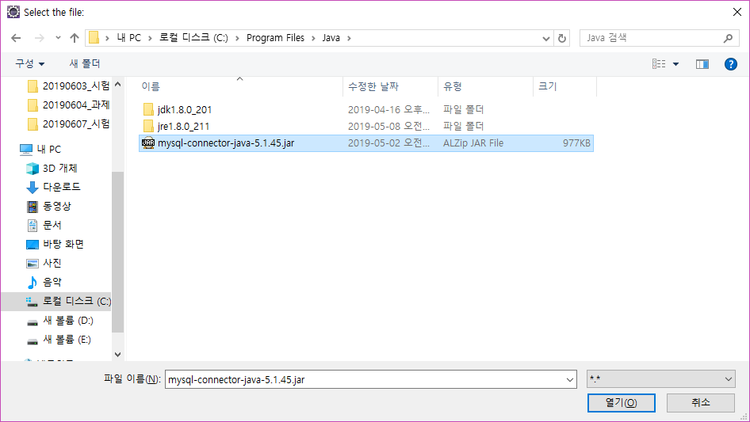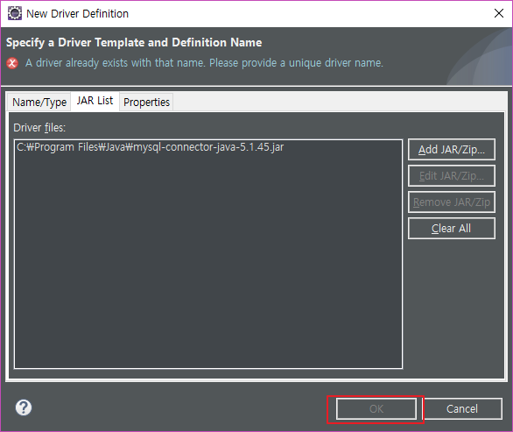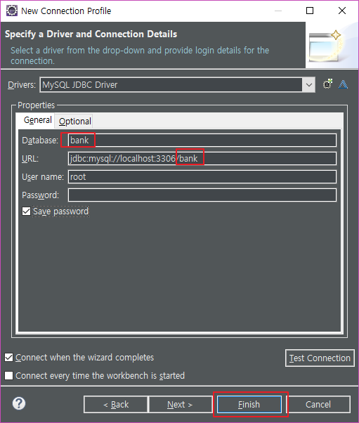

(5) GitHub

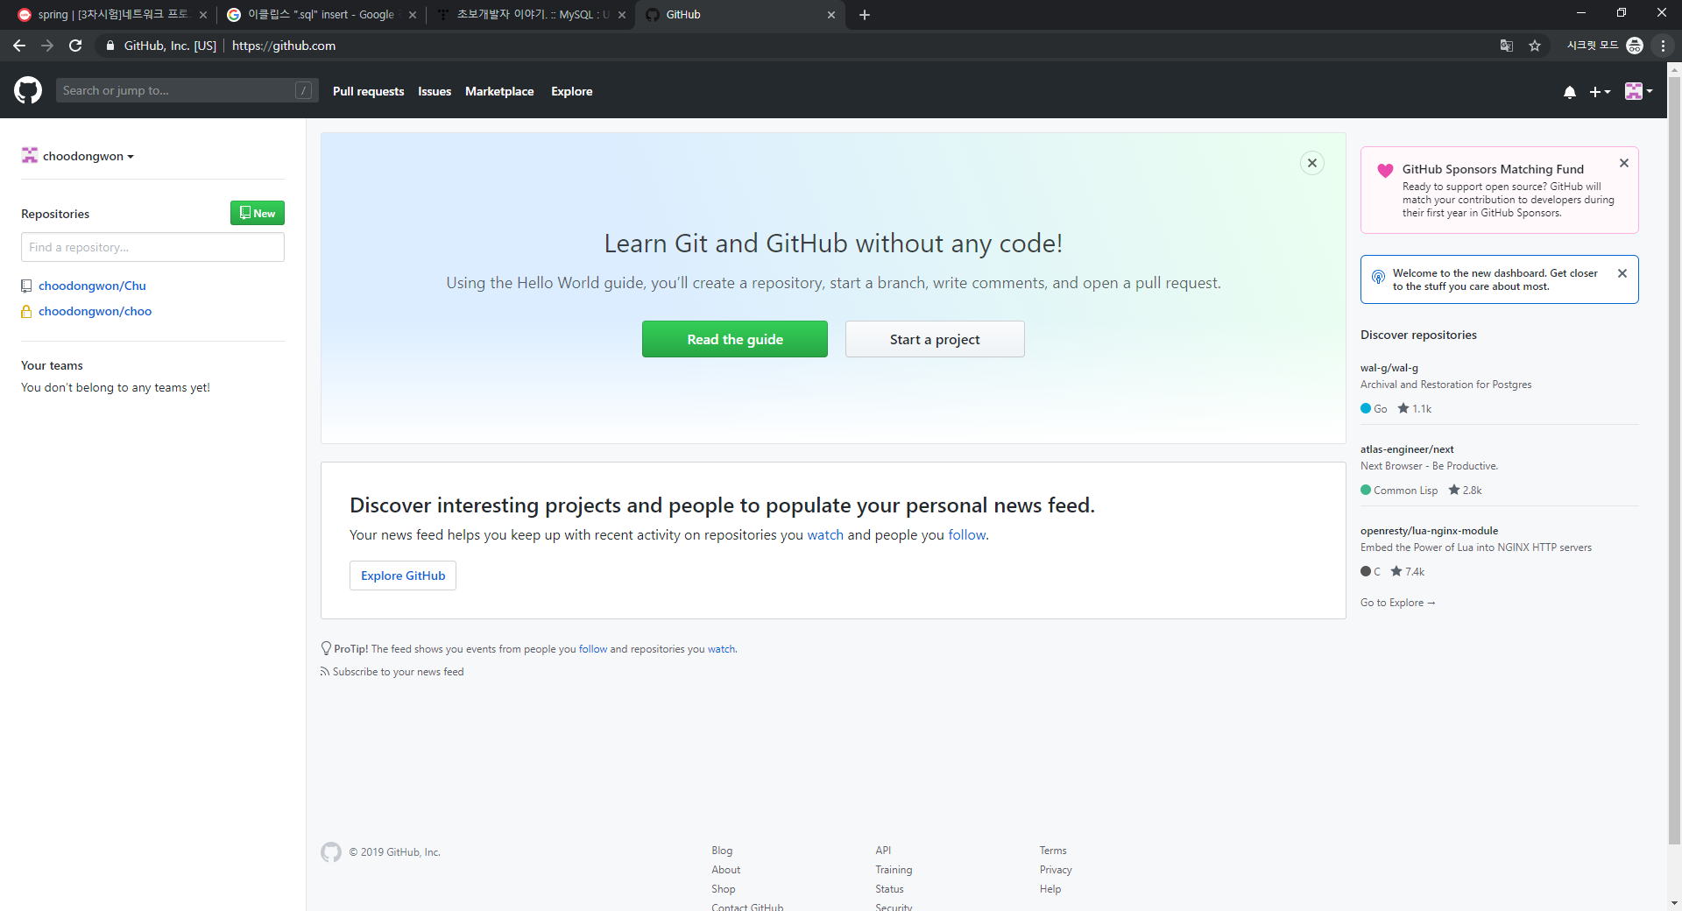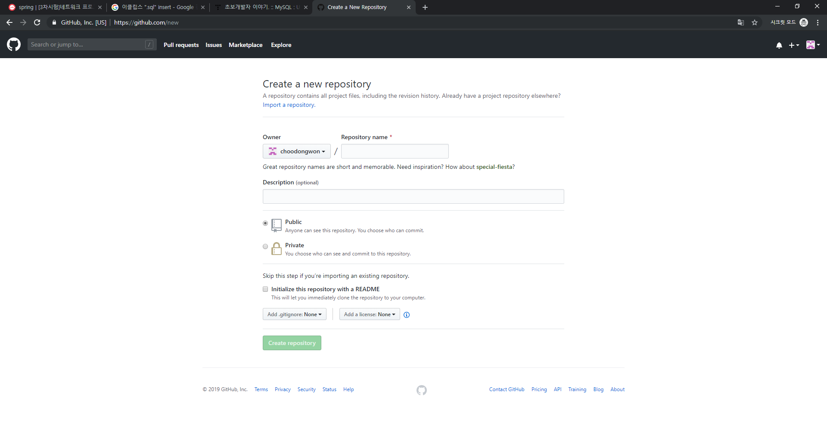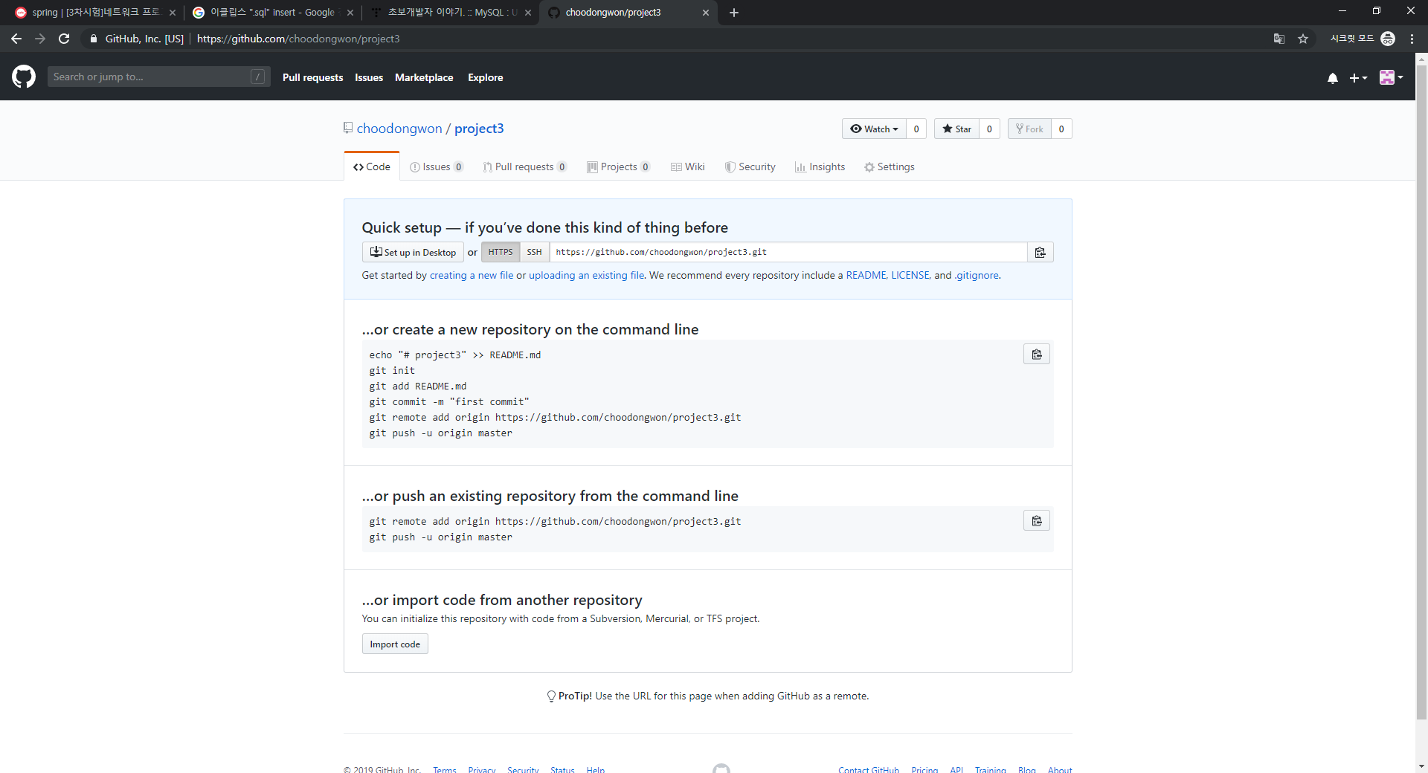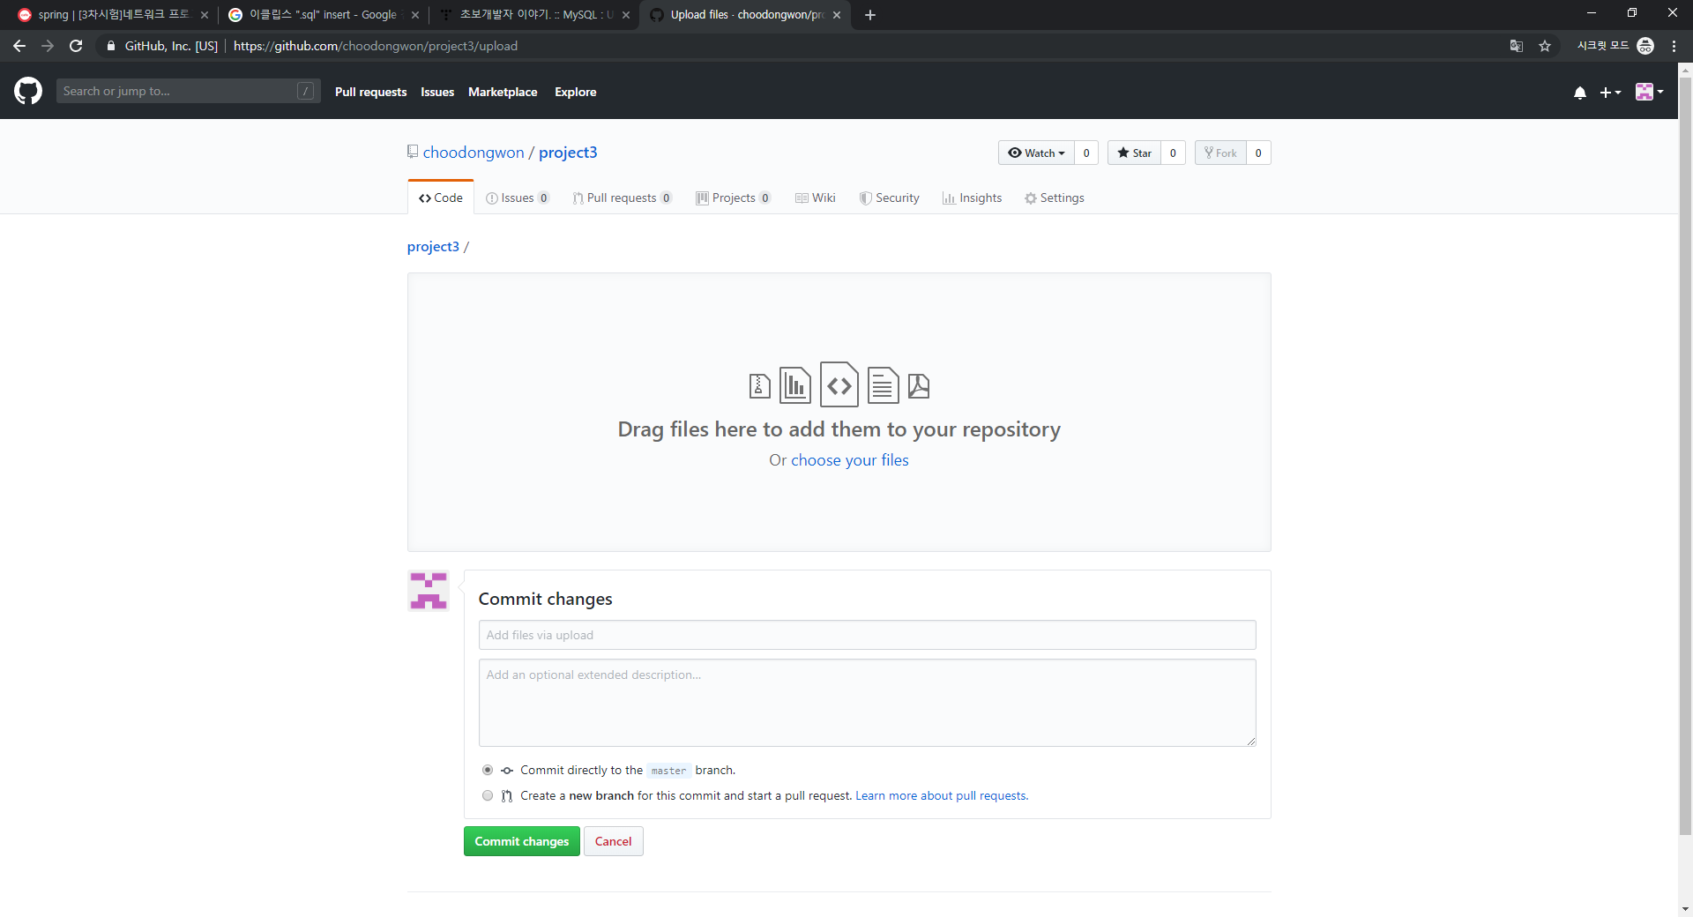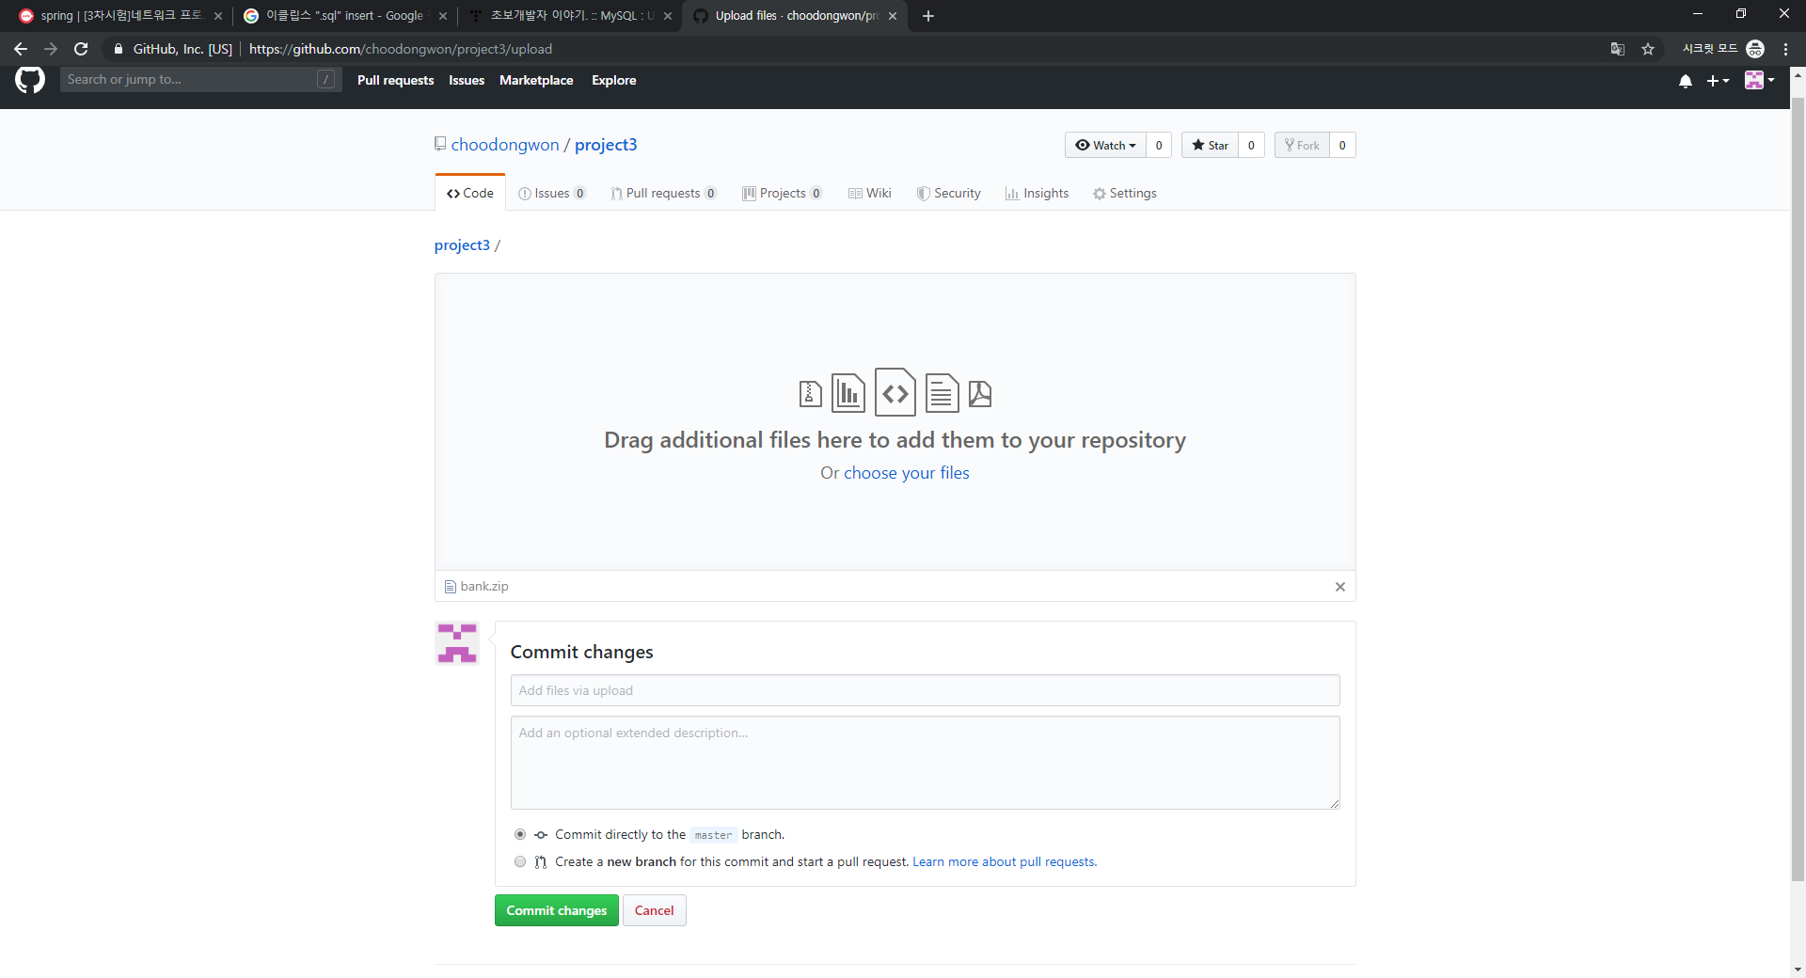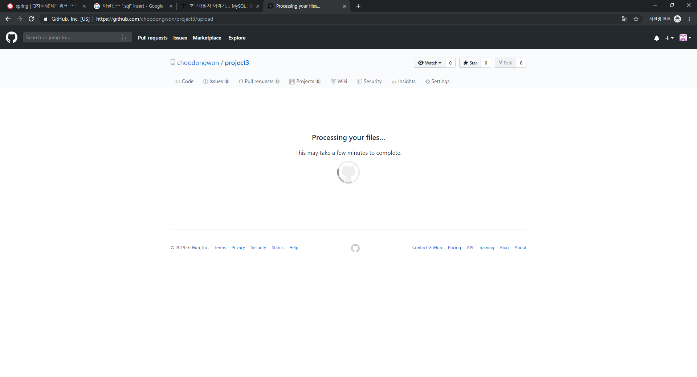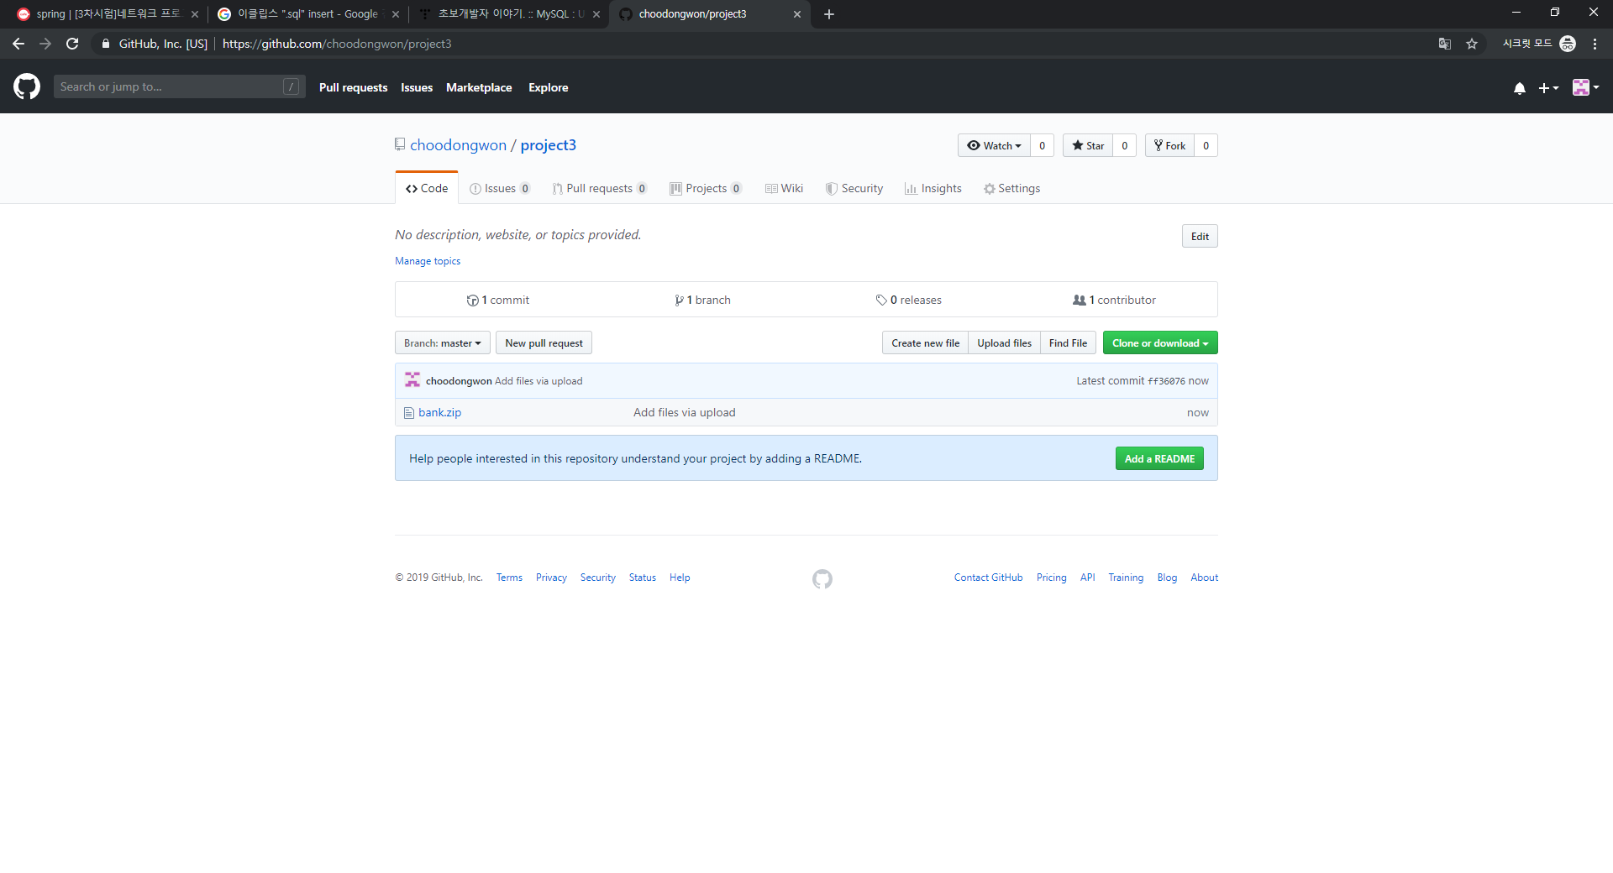

BankManager.java  
package money;

import java.awt.FlowLayout;

import java.awt.Font;

import java.awt.event.ActionEvent;

import java.awt.event.ActionListener;

import java.util.ArrayList;

import javax.swing.JButton;

import javax.swing.JFrame;

import javax.swing.JLabel;

import javax.swing.JOptionPane;

import javax.swing.JTextField;

public class BankManager {

private JTextField idText;

private JTextField nameText;

private JTextField ageText;

private JTextField telText;

BankDTO dto = new BankDTO();

public BankManager() {

JFrame f = new JFrame("은행 고객 관리 프로그램");

f.setSize(306, 432);

FlowLayout flow = new FlowLayout();

f.getContentPane().setLayout(flow);

JLabel label = new JLabel("\uC544\uC774\uB514");

label.setFont(new Font("Dialog", Font.***BOLD***, 20));

f.getContentPane().add(label);

idText = new JTextField();

idText.setFont(new Font("Dialog", Font.***PLAIN***, 20));

f.getContentPane().add(idText);

idText.setColumns(10);

JLabel label_1 = new JLabel("이 름");

label_1.setFont(new Font("Dialog", Font.***BOLD***, 20));

f.getContentPane().add(label_1);

nameText = new JTextField();

nameText.setFont(new Font("Dialog", Font.***PLAIN***, 20));

nameText.setColumns(10);

f.getContentPane().add(nameText);

JLabel label_2 = new JLabel("나 이");

label_2.setFont(new Font("Dialog", Font.***BOLD***, 20));

f.getContentPane().add(label_2);

ageText = new JTextField();

ageText.setFont(new Font("Dialog", Font.***PLAIN***, 20));

ageText.setColumns(10);

f.getContentPane().add(ageText);

JLabel label_3 = new JLabel("번 호");

label_3.setFont(new Font("Dialog", Font.***BOLD***, 20));

f.getContentPane().add(label_3);

telText = new JTextField();

telText.setFont(new Font("Dialog", Font.***PLAIN***, 20));

telText.setColumns(10);

f.getContentPane().add(telText);

JButton insert_Button = new JButton(" 삽입하기 ");

insert_Button.addActionListener(new ActionListener() {

public void actionPerformed(ActionEvent e) {

BankDTO dto = new BankDTO();

dto.setId(idText.getText());

dto.setName(nameText.getText());

dto.setAge(ageText.getText());

dto.setTel(telText.getText());

BankDAO dao = new BankDAO();

try {

dao.insert(dto);

JOptionPane.*showMessageDialog*(null, "삽입완료");

} catch (Exception e1) {

e1.printStackTrace();

}

}

});

insert_Button.setFont(new Font("Dialog", Font.***PLAIN***, 20));

f.getContentPane().add(insert_Button);

JButton delete_Button = new JButton(" 삭제하기 ");

delete_Button.addActionListener(new ActionListener() {

public void actionPerformed(ActionEvent e) {

BankDTO dto = new BankDTO();

dto.setId(idText.getText());

BankDAO dao = new BankDAO();

try {

dao.delete(dto);

} catch (Exception e1) {

// **TODO** Auto-generated catch block

e1.printStackTrace();

}

}

});

delete_Button.setFont(new Font("Dialog", Font.***PLAIN***, 20));

f.getContentPane().add(delete_Button);

JButton update_Button = new JButton(" 변경하기 ");

update_Button.addActionListener(new ActionListener() {

public void actionPerformed(ActionEvent e) {

BankDTO dto = new BankDTO();

dto.setId(idText.getText());

dto.setTel(telText.getText());

BankDAO dao = new BankDAO();

try {

dao.update(dto);

} catch (Exception e1) {

// **TODO** Auto-generated catch block

e1.printStackTrace();

}

}

});

update_Button.setFont(new Font("Dialog", Font.***PLAIN***, 20));

f.getContentPane().add(update_Button);

JButton select_Button = new JButton(" 검색하기 ");

select_Button.setFont(new Font("Dialog", Font.***PLAIN***, 20));

select_Button.addActionListener(new ActionListener() {

public void actionPerformed(ActionEvent e) {

String inputId = idText.getText();

BankDAO dao = new BankDAO();

BankDTO dto = dao.select(inputId);

String id = dto.getId();

String name = dto.getName();

String age = dto.getAge();

String tel = dto.getTel();

idText.setText(id);

nameText.setText(name);

ageText.setText(age);

telText.setText(tel);

}

});

f.getContentPane().add(select_Button);

JButton selectAll_Button = new JButton(" 전체검색하기 ");

selectAll_Button.addActionListener(new ActionListener() {

public void actionPerformed(ActionEvent e) {

BankDAO dao = new BankDAO();

ArrayList list = dao.selectAll();

System.***out***.println("순번 id name age tel");

for (int i = 0; i < list.size(); i++) {

BankDTO dto = (BankDTO)list.get(i);

System.***out***.print((i+1)+"번 : ");

System.***out***.print(dto.getId()+" ");

System.***out***.print(" "+dto.getName()+" ");

System.***out***.print(" "+dto.getAge()+" ");

System.***out***.print(" "+dto.getTel()+" ");

System.***out***.println();

}

try {

dao.selectAll();

JOptionPane.*showMessageDialog*(null, "검색완료");

} catch (Exception e1) {

e1.printStackTrace();

}

}

});

selectAll_Button.setFont(new Font("Dialog", Font.***PLAIN***, 20));

f.getContentPane().add(selectAll_Button);

f.setVisible(true);

}

public static void main(String[] args) {

BankManager name = new BankManager();

}

}

BankDTO.java  
package money;

public class BankDTO {

private String id;

private String name;

private String age;

private String tel;

public String getId() {

return id;

}

public void setId(String id) {

this.id = id;

}

public String getName() {

return name;

}

public void setName(String name) {

this.name = name;

}

public String getAge() {

return age;

}

public void setAge(String age) {

this.age = age;

}

public String getTel() {

return tel;

}

public void setTel(String tel) {

this.tel = tel;

}

}

BankDAO.javapackage money;

import java.sql.Connection;

import java.sql.DriverManager;

import java.sql.PreparedStatement;

import java.sql.ResultSet;

import java.sql.SQLException;

import java.util.ArrayList;

public class BankDAO {

BankDTO dto = new BankDTO();

String url = "jdbc:mysql://localhost:3306/bank";

String user = "root";

String password = "1234";

Connection conn = null;

PreparedStatement ps = null;

ResultSet rs;

public void insert(BankDTO dto) throws Exception {

Class.*forName*("com.mysql.jdbc.Driver");

String sql = "insert into bank values (?,?,?,?)";

conn = DriverManager.*getConnection*(url,user,password);

ps = conn.prepareStatement(sql);

ps.setString(1, dto.getId());

System.***out***.println(dto.getId());

ps.setString(2, dto.getName());

ps.setString(3, dto.getAge());

ps.setString(4, dto.getTel());

ps.executeUpdate();

}

public void update(BankDTO dto) {

try {

Class.*forName*("com.mysql.jdbc.Driver");

String sql = "update bank set tel=? where id=?";

conn = DriverManager.*getConnection*(url,user,password);

ps = conn.prepareStatement(sql);

ps.setString(1, dto.getTel());

ps.setString(2, dto.getId());

ps.executeUpdate();

} catch (Exception e) {

e.printStackTrace();

}

}

public void delete(BankDTO dto) throws Exception {

Class.*forName*("com.mysql.jdbc.Driver");

String sql = "delete from bank where id=?";

conn = DriverManager.*getConnection*(url,user,password);

ps = conn.prepareStatement(sql);

ps.setString(1, dto.getId());

ps.executeUpdate();

}

public BankDTO select(String inputId) {

try {

Class.*forName*("com.mysql.jdbc.Driver");

String sql = "select * from bank where id=?";

conn = DriverManager.*getConnection*(url,user,password);

ps = conn.prepareStatement(sql);

ps.setString(1,inputId);

rs = ps.executeQuery();

if(rs.next()) {

dto = new BankDTO();

String id = rs.getString(1);

String name = rs.getString(2);

String age = rs.getString(3);

String tel = rs.getString(4);

dto.setId(id);

dto.setName(name);

dto.setAge(age);

dto.setTel(tel);

} else {

System.***out***.println("조회 오류");

}

ps.executeUpdate();

} catch(Exception e) {

System.***out***.println(e.getMessage());

} finally {

try {

rs.close();

ps.close();

conn.close();

} catch (SQLException e) {

System.***out***.println(e.getMessage());

} //catch

}//finally

return dto;

}//calss

public ArrayList selectAll() {

ArrayList list = new ArrayList();

try {

Class.*forName*("com.mysql.jdbc.Driver");

String sql = "select * from bank";

conn = DriverManager.*getConnection*(url,user,password);

ps = conn.prepareStatement(sql);

rs = ps.executeQuery();

while(rs.next()) {

dto = new BankDTO();

String id = rs.getString(1);

String name = rs.getString(2);

String age = rs.getString(3);

String tel = rs.getString(4);

dto.setId(id);

dto.setName(name);

dto.setAge(age);

dto.setTel(tel);

list.add(dto);

}

} catch(Exception e) {

System.***out***.println(e.getMessage());

} finally {

try {

rs.close();

ps.close();

conn.close();

} catch (SQLException e) {

System.***out***.println(e.getMessage());

} //catch

}//finally

return list;

}//calss

}