**Geco ReactJS Training**

|  |  |
| --- | --- |
| ReactJS Assignment |  |
| Name: | Ho Choo Geok |
| Date of Submission: | 17th October 2022 |
| Cohort No.: | 27 |
| Week No.: | 2 |
| Daily Task No.: | 1 |

1. Understand folder structure
2. Display Array of object and display data in UI.

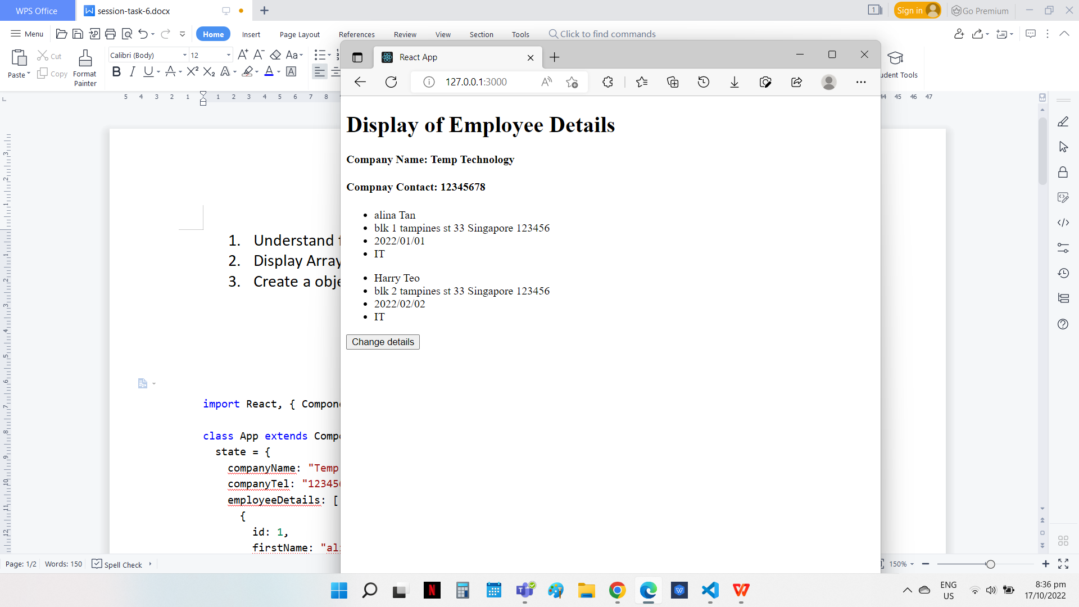

1. Create a object and update its data on click of a button and display data in UI

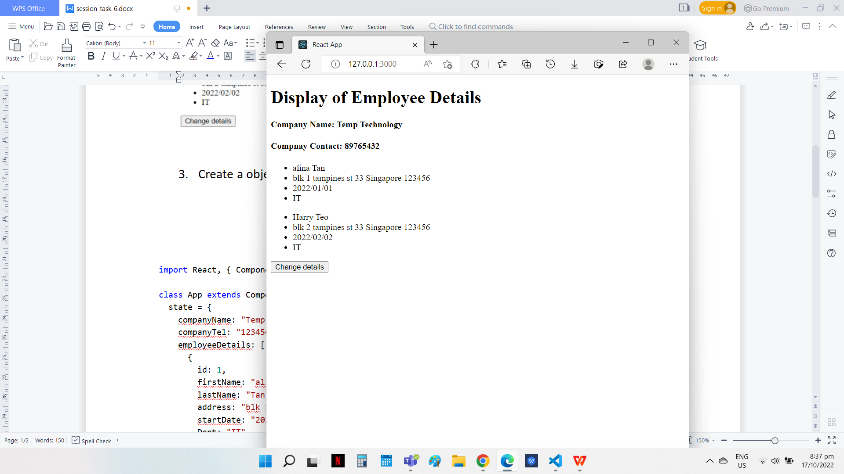

Change of contact number when the button is clicked

Source Code

import React, { Component } from "react";

class App extends Component {

  state = {

    companyName: "Temp Technology",

    companyTel: "12345678",

    employeeDetails: [

      {

        id: 1,

        firstName: "alina",

        lastName: "Tan",

        address: "blk 1 tampines st 33 Singapore 123456",

        startDate: "2022/01/01",

        Dept: "IT",

      },

      {

        id: 2,

        firstName: "Harry",

        lastName: "Teo",

        address: "blk 2 tampines st 33 Singapore 123456",

        startDate: "2022/02/02",

        Dept: "IT",

      },

    ],

  };

  handleClick = () => {

    this.setState({

      companyTel:"89765432"

      })};

  render() {

    return (

      <div>

        <h1> Display of Employee Details</h1>

        <h4> Company Name: {this.state.companyName} </h4>

        <h4> Compnay Contact: {this.state.companyTel}</h4>

        {this.state.employeeDetails.map((ele) => (

          <ul>

            <li key={ele.id}>{ele.firstName} {ele.lastName}</li>

            <li> {ele.address} </li>

            <li> {ele.startDate} </li>

            <li> {ele.Dept} </li>

          </ul>

        ))}

        <button onClick={this.handleClick}> Change details </button>

      </div>

    );

  }

}

export default App;