**Geco ReactJS Training**

|  |  |
| --- | --- |
| ReactJS Assignment |  |
| Name: | Ho Choo Geok |
| Date of Issue: | 25th October 2022 |
| Date of Submission: | 26th October 2022 |
| Cohort No.: | 27 |
| Week No.: | 3 |
| Session No.: | 11 |

1. Add api and get first 5 records from api data using using class based component and display data in a function based component.

Solution: The screen capture of the API data as followed.

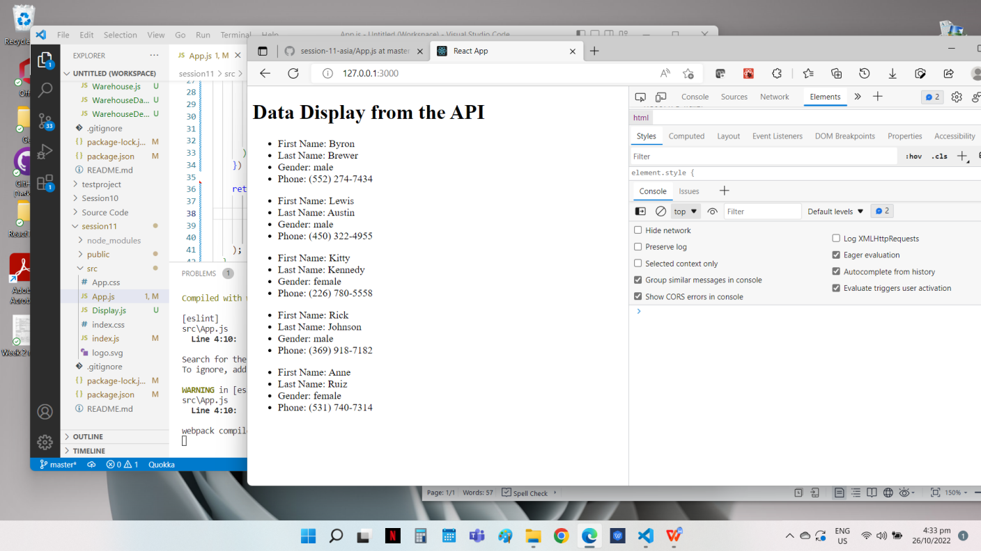

**Source Code**

**File Name: App.js**

import React, { Component } from 'react';

import axios from 'axios';

import Display from './Display';

import { blue } from '@mui/material/colors';

class App extends Component{

  constructor(){

    super();

    this.state={

      post:[]

    };

  }

  componentDidMount = () => {

    axios.get('https://randomuser.me/api/?nat=US&results=10')

         .then(res => {this.setState({post:res.data.results.slice(0,5)})})

         .catch(err => {console.log(err);});

  }

  render() {

   const dataElements = this.state.post.map( (ele) => {

      return(

        <Display

          key={ele.phone}

          firstName= {ele.name.first}

          lastName = {ele.name.last}

          phone = {ele.phone}

          gender = {ele.gender}

        />

      )

    })

    return (

       <div>

        <h1> Data Display from the API</h1>

        {dataElements}

       </div>

    );

  }

};

export default App;

**File Name: Display.js**

import React from "react";

function Display(props){

  return (

     <React.Fragment>

      <ul>

        <li> First Name: {props.firstName} </li>

        <li> Last Name: {props.lastName} </li>

        <li> Gender: {props.gender} </li>

        <li> Phone: {props.phone} </li>

        </ul>

    </React.Fragment>

  );

}

export default Display;

1. Create a state (score). Take input from user of score. If it is greater than prev state then, update the state, otherwise not. (Show messages in pop-up/modal like points update).

**Solution:**

When the user enter in a score, the message pop up will show the previous score and the new score.

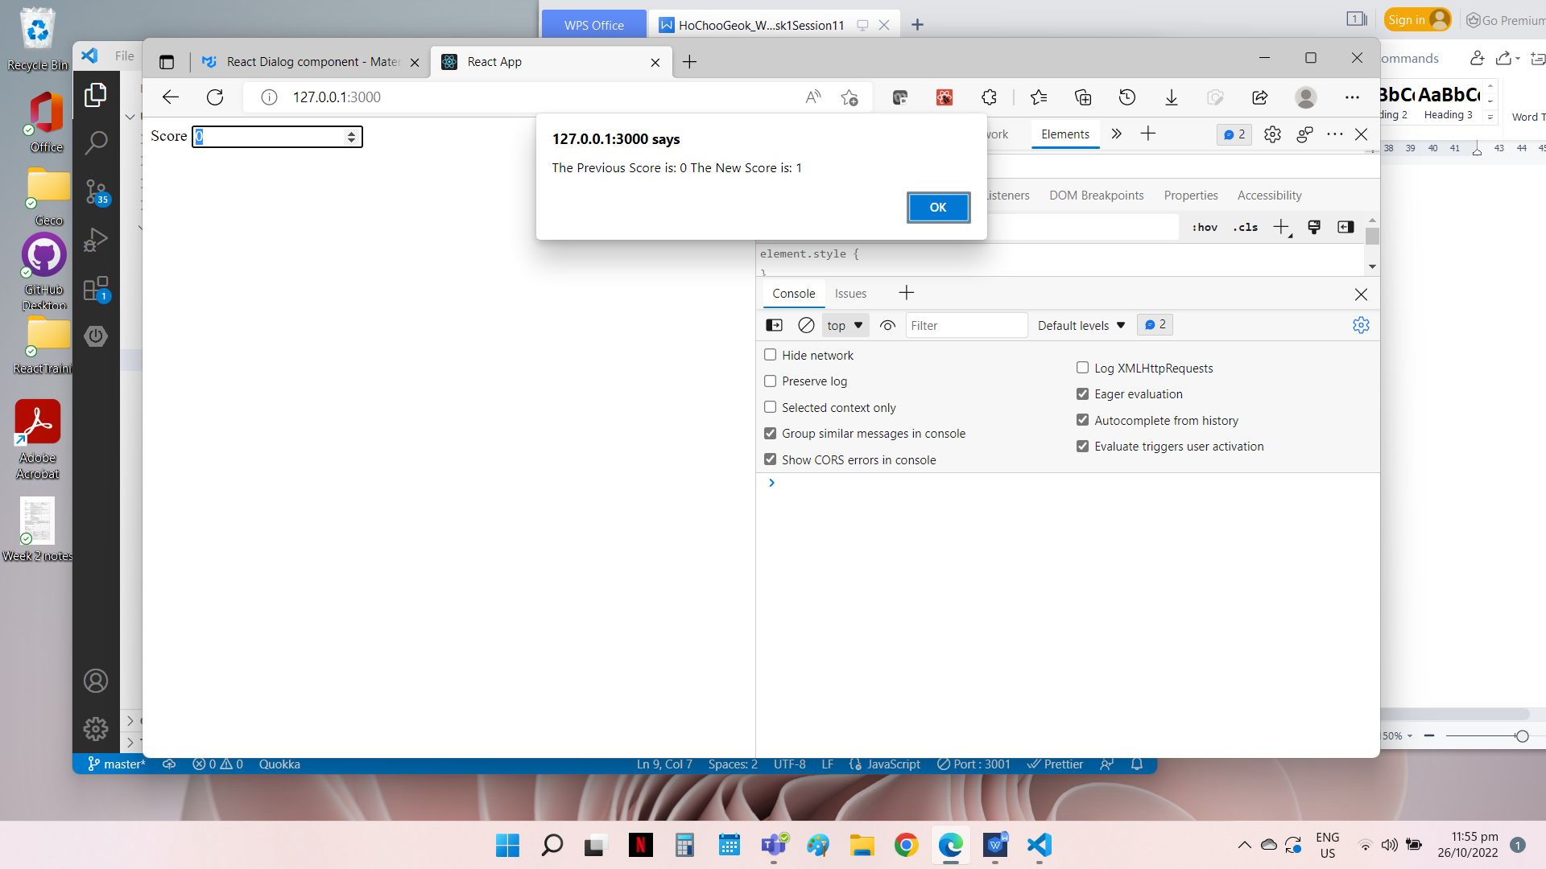

When the user input a score lower than the current score, there will be a alert pop-up “Score cannot be smaller than the current score”. The new score will not be updated.

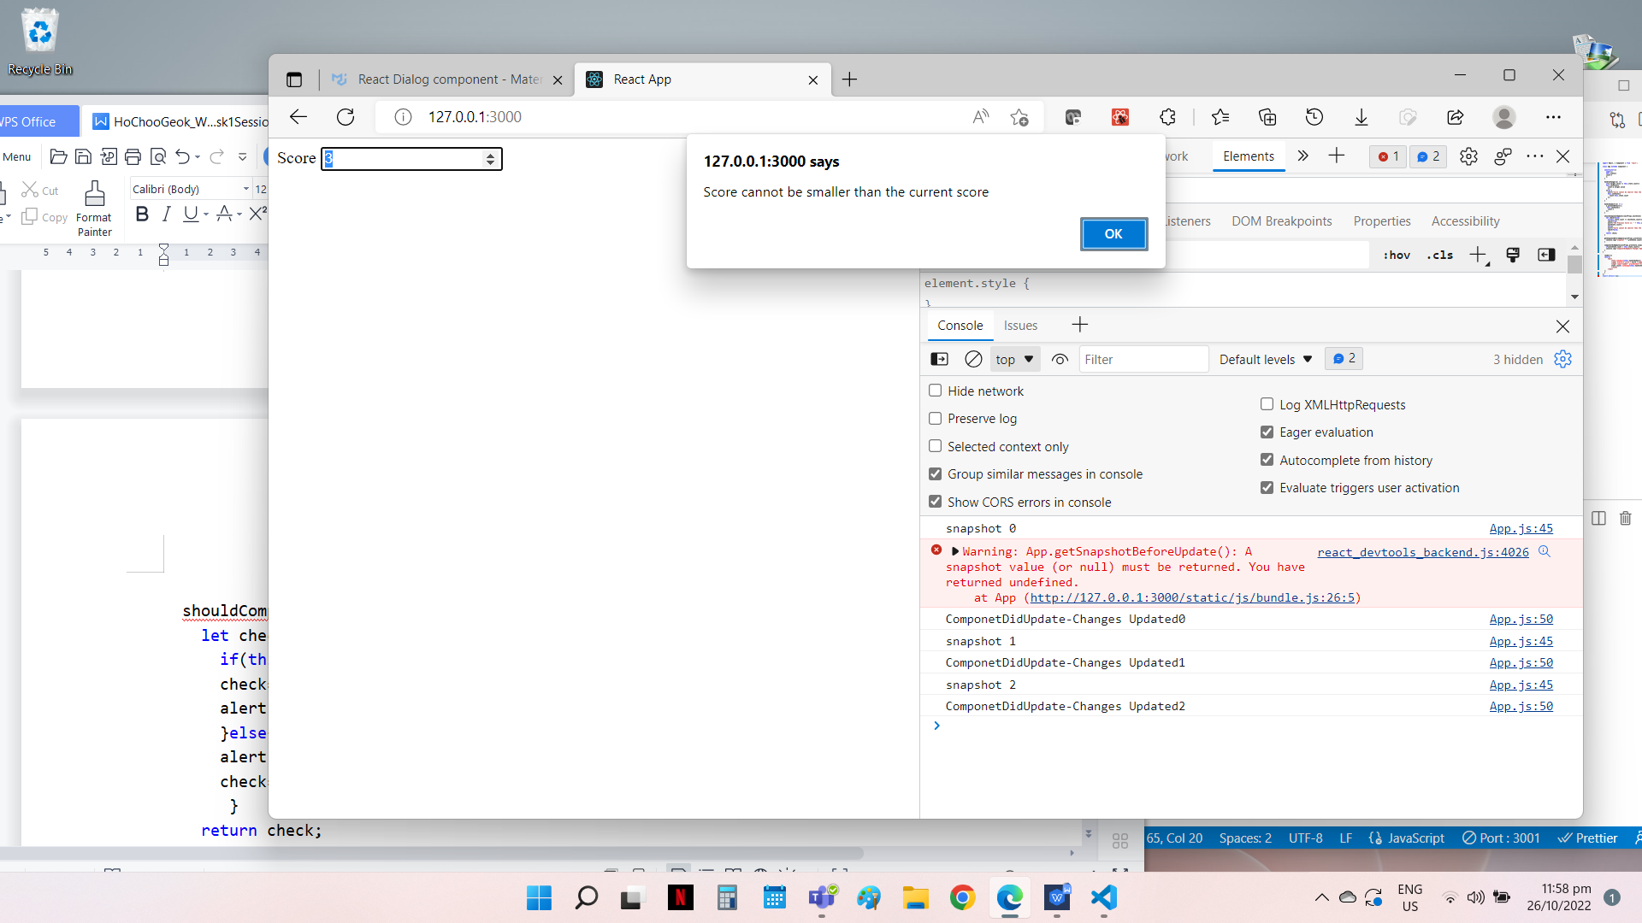

**Source Code**

**File Name: App.js**

import React, { Component } from 'react';

class App extends Component {

  constructor(){

    super();

    this.state={

    count:0

    };

  }

  handleChange=(e) =>{

    if(e.target.value >= this.state.count){

    this.setState({

      count:e.target.value

      });

    }else {

      alert("Score cannot be smaller than the current score");

      this.setState({

        count:this.state.count

      });

    }

  }

  handleSubmit=(e) => {

    e.preventDefault();

     this.setState({

      count:0

    });

  }

  shouldComponentUpdate=(nextProps,nextState) => {

    let check=false;

      if(this.state.count <= nextState.count){

      check=true;

      alert("The Previous Score is: " + this.state.count + " The New Score is: " + nextState.count);

      }else{

      alert("Score cannot be smaller than the current score")

      check=false;

       }

    return check;

  }

  getSnapshotBeforeUpdate(prevProps,prevState){

    console.log("snapshot " + prevState.count);

  }

  componentDidUpdate(prevProps,prevState,snapshot){

    if(prevState.count < this.state.count){

    console.log("ComponetDidUpdate-Changes Updated" + prevState.count);

  }

}

  render(){

  return(

      <div>

          <form onSubmit={this.handleSubmit}>

          <label htmlFor='score'> Score </label>

          <input type="number" placeholder='Score' id="score" name="score" value={this.state.count} onChange={this.handleChange}/>

          </form>

      </div>

  );

  }

};

export default App;