**Geco ReactJS Training**

|  |  |
| --- | --- |
| ReactJS Assignment |  |
| Name: | Ho Choo Geok |
| Date of Issue: | 31st October 2022 |
| Date of Submission: | 31st October 2022 |
| Cohort No.: | 27 |
| Week No.: | 4 |
| Session No.: | 13 |

1. Design a UI: include header, footer, cards, forms using react with storybook.

**Header**

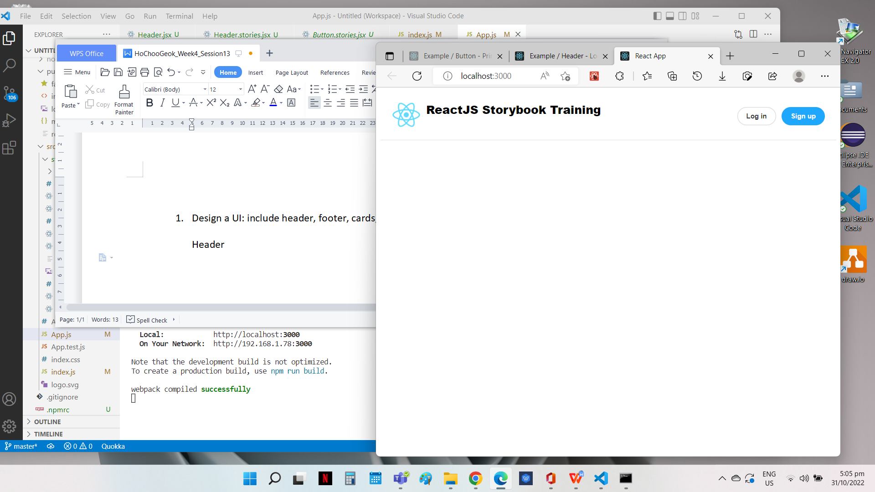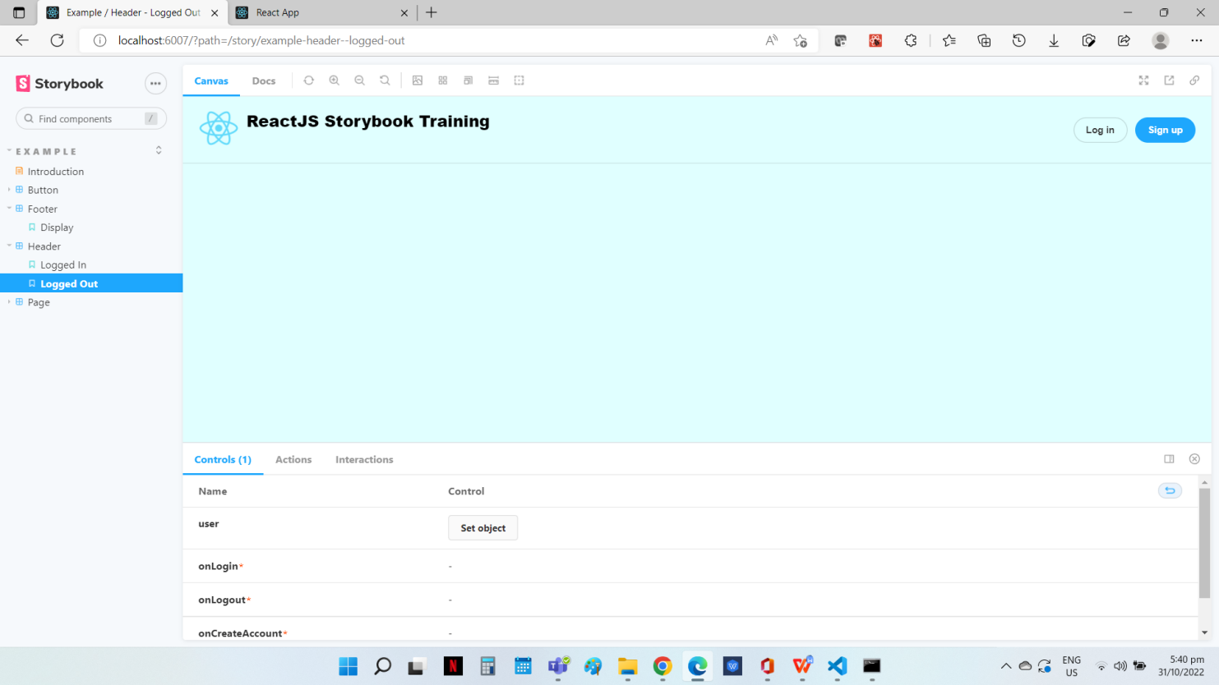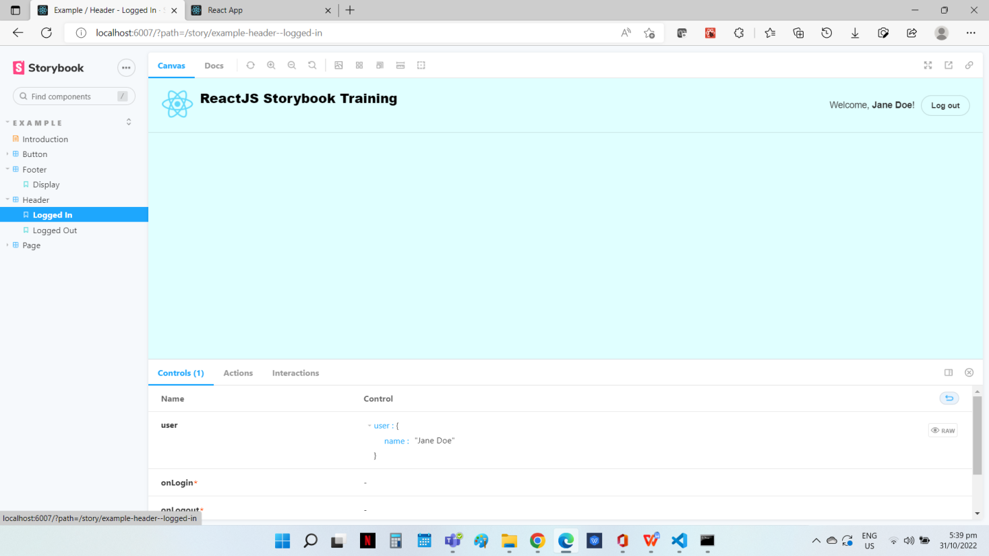

**Source Code**

**File Name: AppHeader.js**

import React from 'react';

import {LoggedIn} from "./stories/Header.stories" ;

import {LoggedOut} from "./stories/Header.stories" ;

function App() {

  const handleClick = () => { alert("Clicked")}

  const handleClose = () => { alert("Closed")}

  let checklogin = true;

  return (

     <>

    {checklogin ? <LoggedIn onClick={handleClick}/>: <LoggedOut onClick={handleClose} />}

    </>

  );

};

export default App;

**File Name: Header.stories.js**

import React from 'react';

import { Header } from './Header';

export default {

  title: 'Example/Header',

  component: Header,

  parameters: {

    layout: 'fullscreen',

  },

  argTypes: {

    handleClick: {action:'handleClick'}

  }

};

const Template = (args) => <Header {...args} />;

export const LoggedIn = Template.bind({});

LoggedIn.args = {

  user: {

    name: 'Jane Doe',

  },

};

export const LoggedOut = Template.bind({});

LoggedOut.args = {};

**File Name: Header.jsx**

import React from 'react';

import PropTypes from 'prop-types';

import logo from "../stories/logo512.png"

import { Button } from './Button';

import './header.css';

export const Header = ({ user, onLogin, onLogout, onCreateAccount }) => (

  <header>

    <div className="wrapper">

      <div>

       <img  src={logo} alt="React Logo" width="50" height="50" />

      <h1>ReactJS Storybook Training</h1>

      </div>

      <div>

        {user ? (

          <>

            <span className="welcome">

              Welcome, <b>{user.name}</b>!

            </span>

            <Button size="small" onClick={onLogout} label="Log out" />

          </>

        ) : (

          <>

            <Button size="small" onClick={onLogin} label="Log in" />

            <Button primary size="small" onClick={onCreateAccount} label="Sign up" />

          </>

        )}

      </div>

    </div>

  </header>

);

Header.propTypes = {

  user: PropTypes.shape({}),

  onLogin: PropTypes.func.isRequired,

  onLogout: PropTypes.func.isRequired,

  onCreateAccount: PropTypes.func.isRequired,

};

Header.defaultProps = {

  user: null,

};

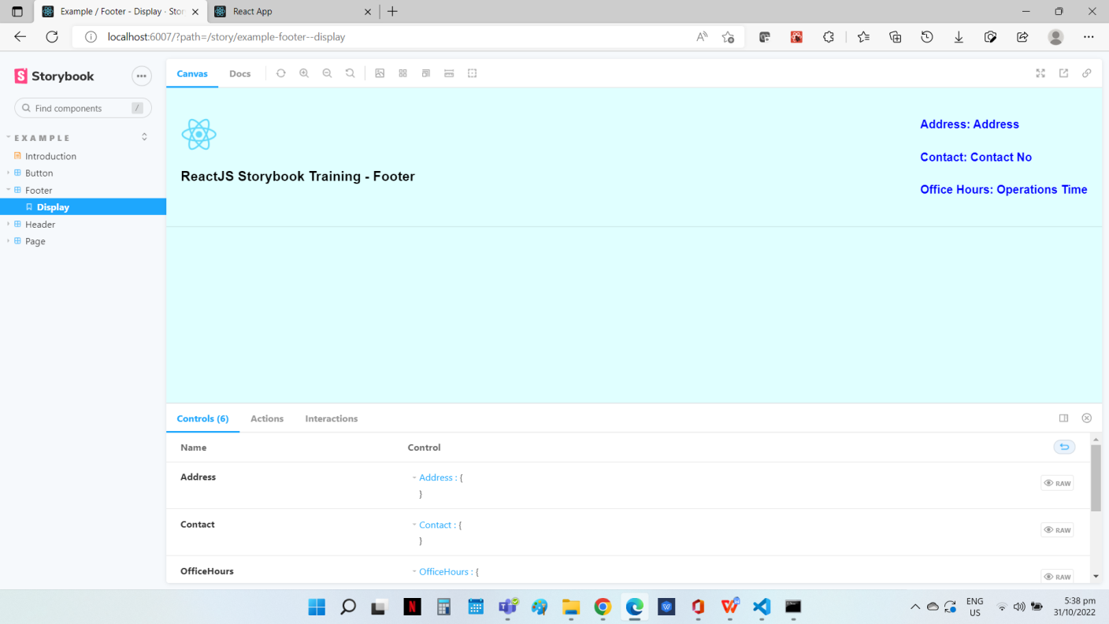**Footer**

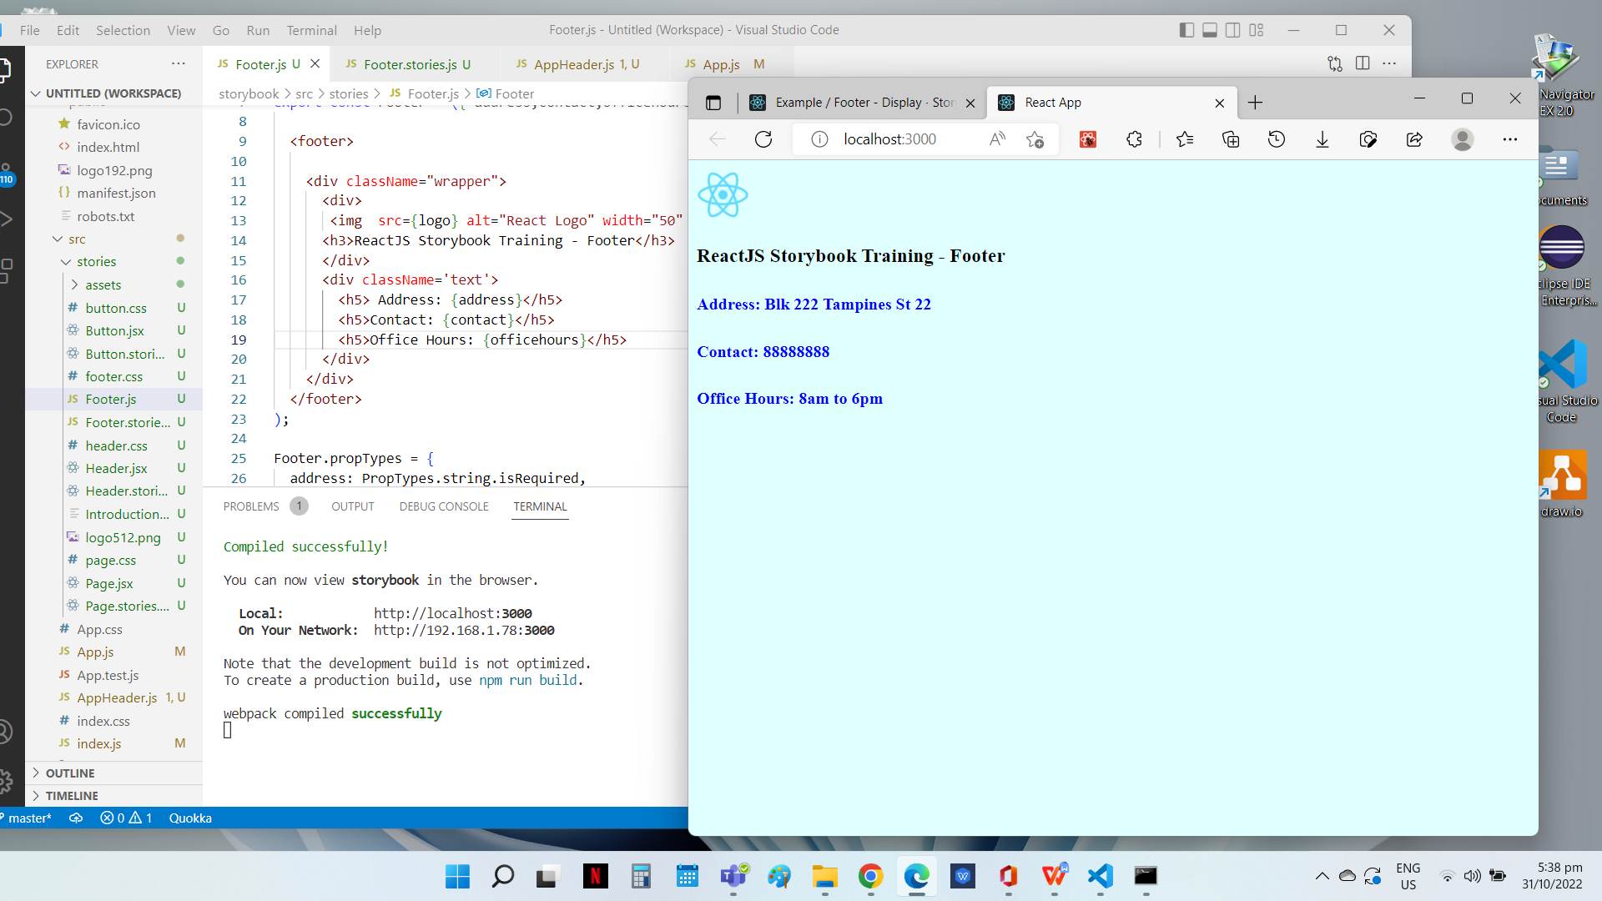

**Source Code**

**File Name: Footer.js**

import React from 'react';

import PropTypes from 'prop-types';

import logo from "../stories/logo512.png"

import './footer.css';

export const Footer = ({ address,contact,officehours }) => (

   <footer>

      <div className="wrapper">

      <div>

       <img  src={logo} alt="React Logo" width="50" height="50" />

      <h3>ReactJS Storybook Training - Footer</h3>

      </div>

      <div className='text'>

        <h5> Address: {address}</h5>

        <h5>Contact: {contact}</h5>

        <h5>Office Hours: {officehours}</h5>

      </div>

    </div>

  </footer>

);

Footer.propTypes = {

  address: PropTypes.string.isRequired,

  contact: PropTypes.string,

  officehours: PropTypes.string,

  };

Footer.defaultProps = {

  address: "Address",

  contact: "Contact No",

  officehours: "Operations Time",

};

**File Name: Footer.stories.js**

import React from 'react';

import { Footer } from './Footer';

export default {

  title: 'Example/Footer',

  component: Footer,

  parameters: {

    layout: 'fullscreen',

  },

  };

const Template = (args) => <Footer {...args} />;

export const Display = Template.bind({});

Display.args = {

  Address: {},

  Contact: {},

  OfficeHours: {},

 };

**File Name: AppFooter.js**

import React from 'react';

import {Display} from "./stories/Footer.stories" ;

function App(){

  return (

     <>

      <Display address="Blk 222 Tampines St 22" contact="88888888" officehours="8am to 6pm"/>

     </>

  );

};

export default App;

**Card**

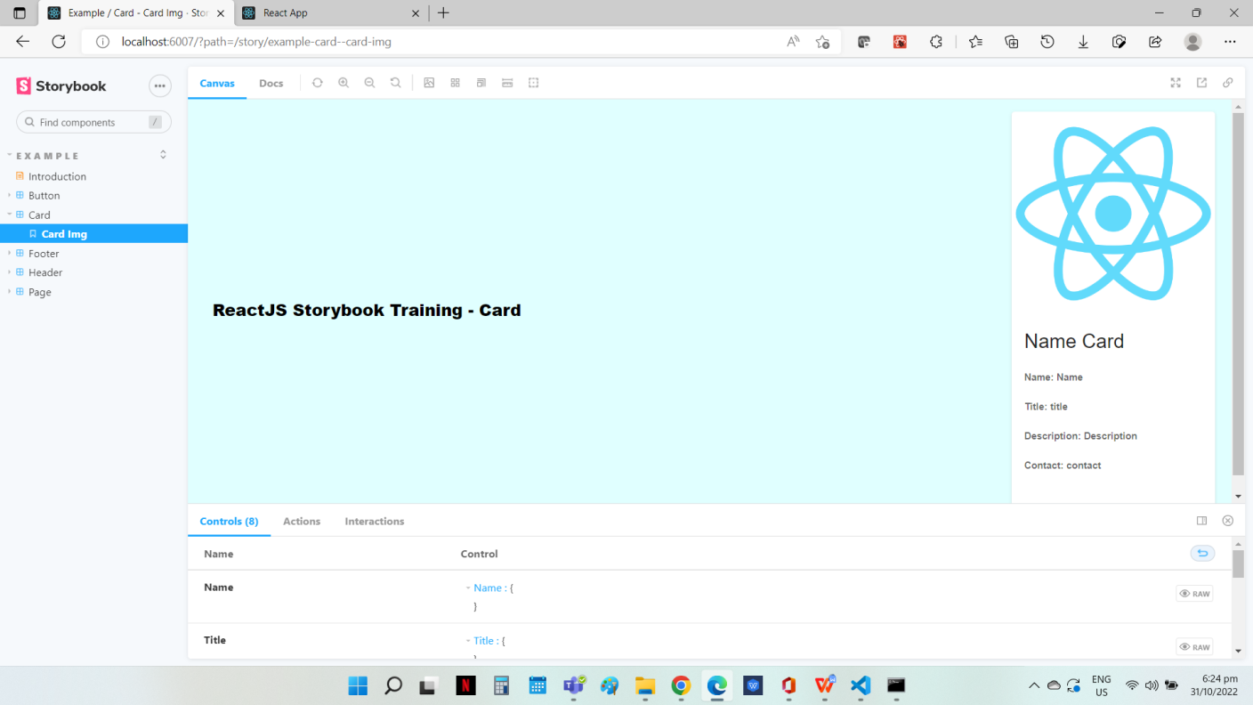

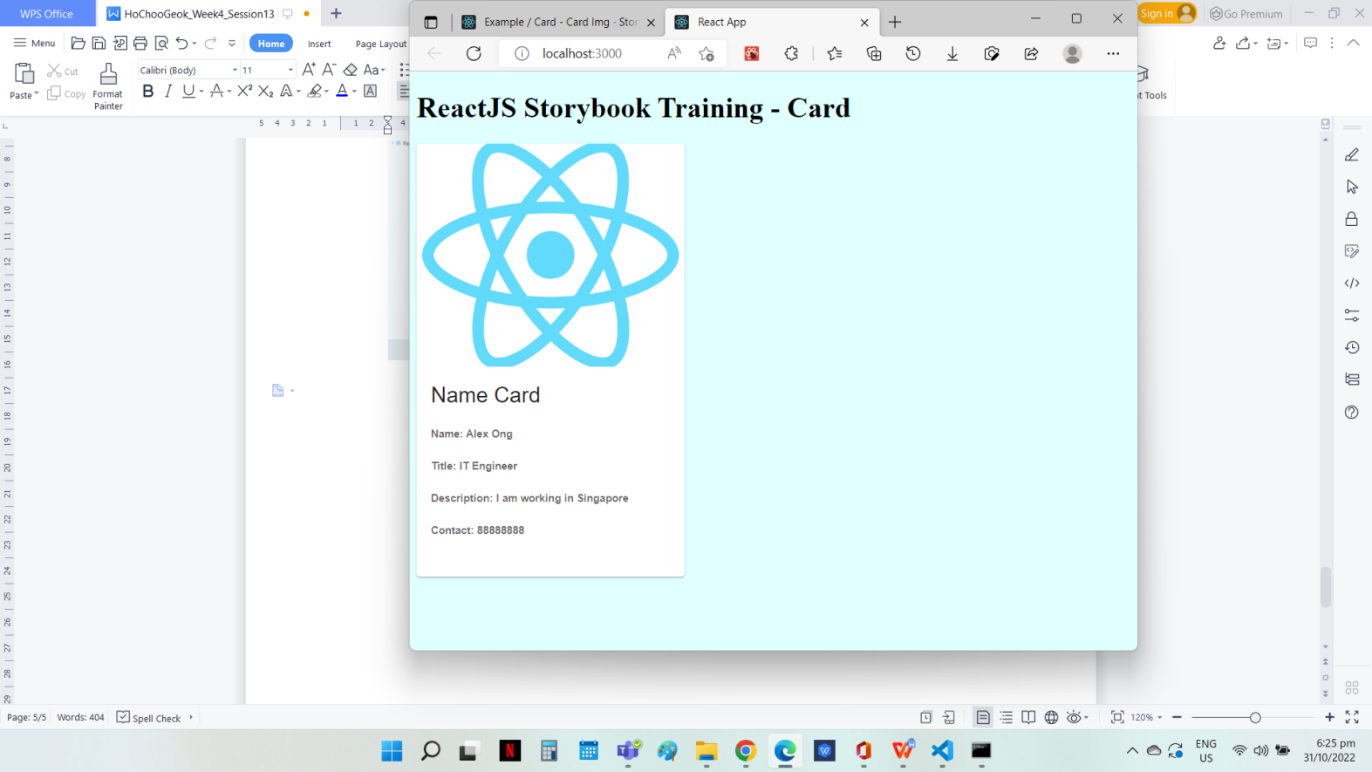

**Source Code**

**File Name: CardDisplay.js**

import React from 'react';

import PropTypes from 'prop-types';

import logo from "../stories/logo512.png"

import './footer.css';

import {Card,CardContent,CardMedia} from '@mui/material/';

import Typography from '@mui/material/Typography';

export const CardDisplay = ({ username,title, description, contact }) => (

    <div className="wrapper">

      <div>

      <h1>ReactJS Storybook Training - Card</h1>

      </div>

      <div>

      <Card sx={{ maxWidth: 300 }}>

      <CardMedia

        component="img"

        width="20"

        height="250"

        image={logo}

        alt="ReactJS"

      />

      <CardContent>

        <Typography gutterBottom variant="h5" component="div">

          Name Card

        </Typography>

        <Typography variant="body2" color="text.secondary">

         <h5>Name: {username} </h5>

         <h5>Title: {title} </h5>

         <h5>Description: {description} </h5>

         <h5>Contact: {contact} </h5>

     </Typography>

      </CardContent>

    </Card>

      </div>

    </div>

);

CardDisplay.propTypes = {

  username: PropTypes.string,

  title: PropTypes.string.isRequired,

  description: PropTypes.string,

  contact: PropTypes.string,

};

CardDisplay.defaultProps = {

  username:"Name",

  title: "title",

  description: "Description",

  contact: "contact",

};

**File Name: Card.stories.js**

import React from 'react';

import { CardDisplay } from './CardDisplay';

export default {

  title: 'Example/Card',

  component: CardDisplay,

  parameters: {

    layout: 'fullscreen',

  },

 };

const Template = (args) => <CardDisplay {...args} />;

export const CardImg = Template.bind({});

CardImg.args = {

  Name: {},

  Title: {},

  Description: {},

  Contact: {},

};

**File Name: AppCard.js**

import React from 'react';

import {CardImg} from "./stories/Card.stories" ;

function App() {

  return (

     <>

       <CardImg username="Alex Ong" title="IT Engineer" description="I am working in Singapore" contact="88888888"/>

    </>

  );

};

export default App;

**Form**

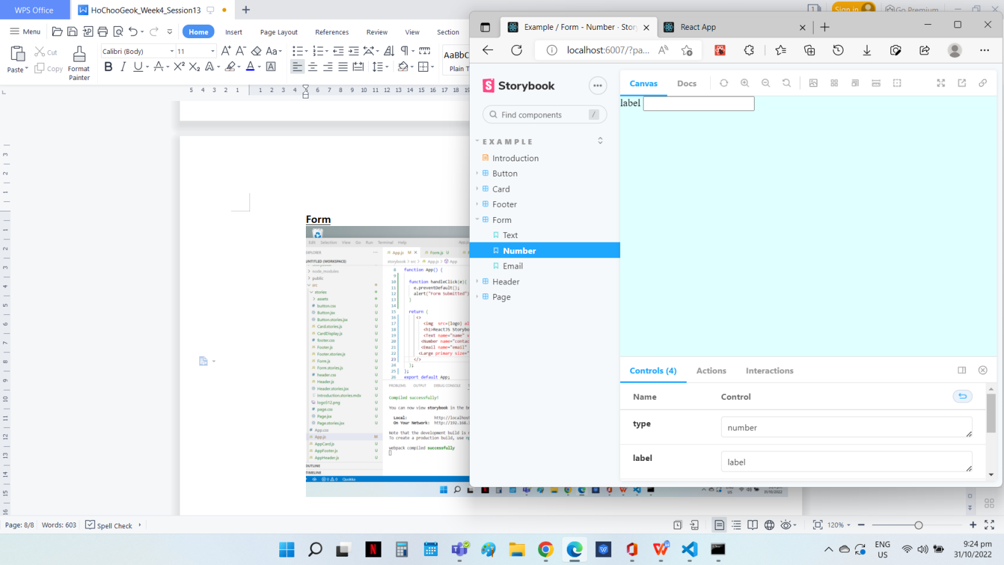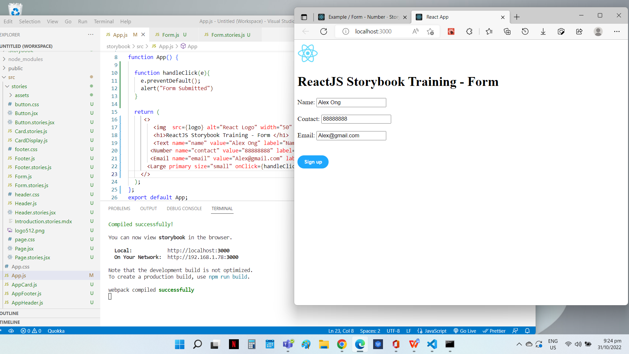

**Source Code**

**File Name: AppForm.js**

import React from 'react';

import {Text} from "./stories/Form.stories" ;

import {Number} from "./stories/Form.stories" ;

import {Email} from "./stories/Form.stories" ;

import logo from "./stories/logo512.png";

import {Large} from './stories/Button.stories';

function App() {

  function handleClick(e){

    e.preventDefault();

    alert("Form Submitted")

  }

  return (

     <>

        <img  src={logo} alt="React Logo" width="50" height="50" />

        <h1>ReactJS Storybook Training - Form </h1>

        <Text name="name" value="Alex Ong" label="Name:"/> <br/>

       <Number name="contact" value="88888888" label="Contact:"/> <br/>

       <Email name="email" value="Alex@gmail.com" label="Email:"/> <br/><br/>

      <Large primary size="small" onClick={handleClick} label="Sign up" />

    </>

  );

};

export default App;

**File Name: Form.js**

import React from 'react';

import PropTypes from 'prop-types';

export const Form = ({name, value, type,label}) => {

  function handleChange(e){

    console.log(e.target.value)

  }

    return(

      <div>

        <form>

        <label> {label} </label>

        <input type={type} name={name} value={value} onChange={handleChange} />

        </form>

      </div>

  );

  };

Form.propTypes = {

  name: PropTypes.string,

  value: PropTypes.string,

  label: PropTypes.string,

  type: PropTypes.string.isRequired,

};

Form.defaultProps = {

  name: "name",

 label:"label",

  type: "text",

  value:"Enter Value"

};

**File Name: Form.stories.js**

import React from 'react';

import { Form } from './Form';

export default {

  title: 'Example/Form',

  component: Form,

  parameters: {

    layout: 'fullscreen',

  },

  argTypes: {

    handleClick: {action:'handleClick'}

  }

};

const Template = (args) => <Form {...args} />;

export const Text = Template.bind({});

Text.args = {

  type:"text",

  label:"label",

  };

export const Number = Template.bind({});

  Number.args = {

    type:"number",

    label:"label"

    };

export const Email = Template.bind({});

  Email.args = {

    type:"email",

    label:"label"

    };