**Geco ReactJS Training**

|  |  |
| --- | --- |
| ReactJS Assignment |  |
| Name: | Ho Choo Geok |
| Date of Issue: | 4th November 2022 |
| Date of Submission: | 7th November 2022 |
| Cohort No.: | 27 |
| Week No.: | 4 |
| Session No.: | 17 |

1. Create an application using React and Redux, material UI, bootstrap storybook.

Create a leader board score website. Website should have information of dashboard, about, contact, score, popular player data.

On dashboard page, capture input of score and name of player. On submit, display data in score page.

Add carousel, media, images, videos, content inside dashboard, about, contact page.

https://www.thesportsdb.com/api/v1/json/2/searchplayers.php?p=D%  
Popular player  
Will fetch data from a third-party API and display it on page.

Contact Us Page(Optional)

Add 3 Cards for Location, Contact Number, Email Id.

About Us Page (Optional)

Here, add media and content, carousel, images, video.

Score PageDisplay all the score data added by the admin, admin should be able to delete the record.

Dashboard

Create a form and add fields in the form, add Form Validation

After submitted the form, give notification score added successfully.

**Solution**

**ScreenShot of the Home Page**

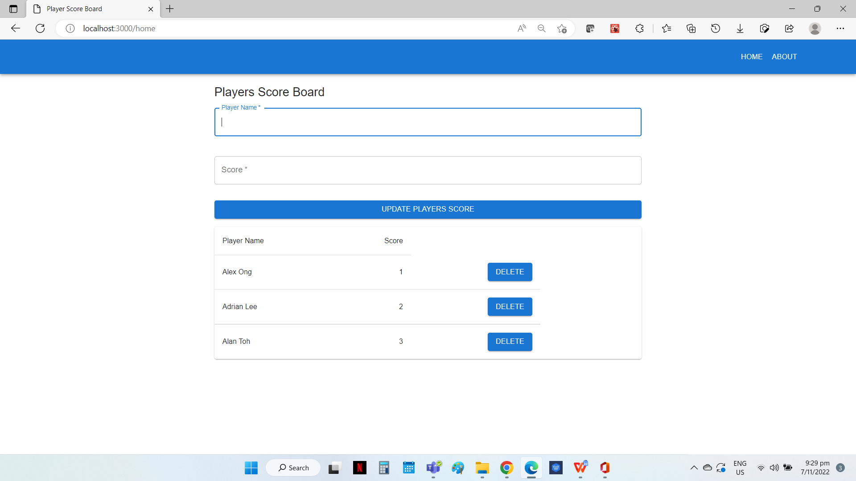**Screenshot of the About Page**

Delete button to delete record

Enter Player’s Name and Score, and results will be displayed on the bottom list

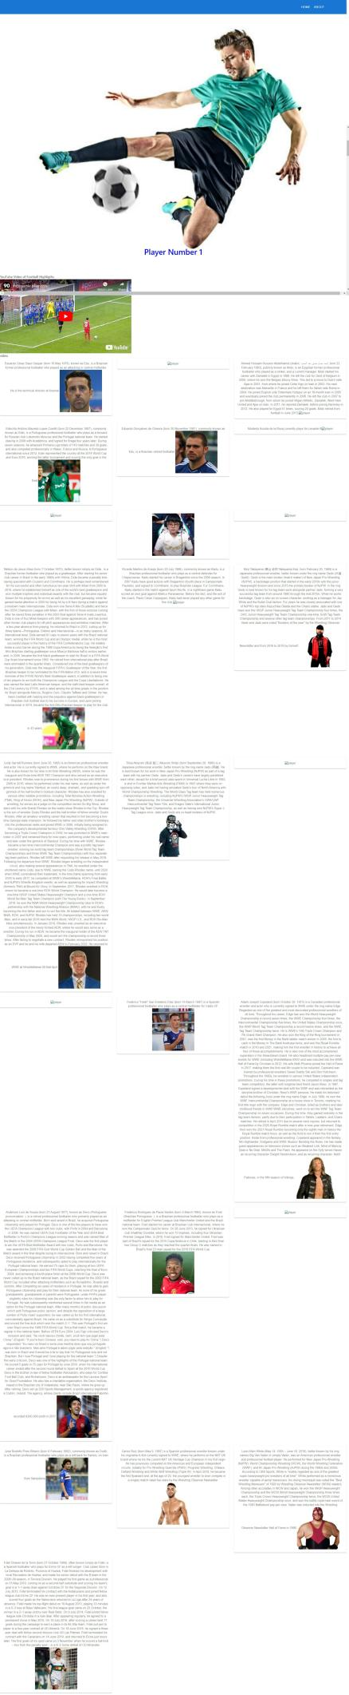

Carousels using react bootstrap

Video of football highlight from youtube

Display of player’s description and image with Mui Grid

Data from API

    "player": [

        {

{

            "idPlayer": "34171365",

            "idTeam": "135181",

            "idTeam2": "0",

            "idTeamNational": null,

            "idSoccerXML": null,

            "idAPIfootball": null,

            "idPlayerManager": null,

            "strNationality": "Brazil",

            "strPlayer": "Edu",

            "strPlayerAlternate": null,

            "strTeam": "_Retired Soccer",

            "strTeam2": "",

            "strSport": "Soccer",

            "intSoccerXMLTeamID": null,

            "dateBorn": "1978-05-16",

            "strNumber": "",

            "dateSigned": null,

            "strSigning": "",

            "strWage": "",

            "strOutfitter": "",

            "strKit": "",

            "strAgent": "",

            "strBirthLocation": "São Paulo, Brazil",

            "strEthnicity": null,

            "strStatus": null,

            "strDescriptionEN": "Eduardo César Daud Gaspar (born 16 May 1978), known as Edu, is a Brazilian former professional footballer who played as an attacking or central midfielder. He is the technical director at Arsenal.",

            "strDescriptionDE": null,

            "strDescriptionFR": null,

            "strDescriptionCN": null,

            "strDescriptionIT": null,

            "strDescriptionJP": null,

            "strDescriptionRU": null,

            "strDescriptionES": null,

            "strDescriptionPT": null,

            "strDescriptionSE": null,

            "strDescriptionNL": null,

            "strDescriptionHU": null,

            "strDescriptionNO": null,

            "strDescriptionIL": null,

            "strDescriptionPL": null,

            "strGender": "Male",

            "strSide": "",

            "strPosition": "Attacking Midfield",

            "strCollege": null,

            "strFacebook": "",

            "strWebsite": "",

            "strTwitter": "",

            "strInstagram": "www.instagram.com/edugaspar/",

            "strYoutube": "",

            "strHeight": "1.85 m (6 ft 1 in)",

            "strWeight": "",

            "intLoved": "0",

            "strThumb": "https://www.thesportsdb.com/images/media/player/thumb/ydz85d1595098777.jpg",

            "strCutout": null,

            "strRender": null,

            "strBanner": null,

            "strFanart1": null,

            "strFanart2": null,

            "strFanart3": null,

            "strFanart4": null,

            "strCreativeCommons": "No",

            "strLocked": "unlocked"

        },

**Source Code**

**File Name: store.js**

import reducer from './reducer';

import thunk from 'redux-thunk';

import {createStore,applyMiddleware} from 'redux';

export const store = createStore(reducer,applyMiddleware(thunk));

**File Name: index.js**

require('file-loader?name=[name].[ext]!./index.html');

import React from 'react';

import ReactDOM from 'react-dom/client';

import App from './App';

import 'bootstrap/dist/css/bootstrap.min.css';

import { Provider } from 'react-redux';

import {store} from './store';

const root = ReactDOM.createRoot(document.getElementById('root'));

root.render(<Provider store={store}><App /></Provider>);

**File Name: App.js**

import React from "react";

import Router from "./Router"

const App = () => {

  return (

  <>

   <Router />

    </>

  )

};

export default App;

**File Name: Router.js**

import React from "react";

import { BrowserRouter, Route, Routes } from "react-router-dom";

import Navbar from "./module/Navbar/Navbar";

import Home from './module/Home/Container/Home';

import Player from './module/About/Container/Player';

const Router = () => {

    return (

        <BrowserRouter>

            <Navbar />

            <Routes>

                <Route exact path="/" element={<Home />} />

                <Route path="/home" element={<Home />} />

                <Route path="/about" element={<Player />} />

            </Routes>

        </BrowserRouter>

  )

}

export default Router;

**File Name: withRoute.js**

import React from 'react';

import {useParams} from 'react-router-dom';

export const withRouter = WrapperComponent => props => {

    const params = useParams();

    return (

        <WrapperComponent {...props} params={params} />

    )

}

**File Name: reducer.js**

import * as actions from './actionType';

const initState = {

    playerScore: [],

    posts: []

}

const reducer = (state = initState, action) => {

    switch (action.type) {

        case actions.ADD_ITEM:

            console.log(action);

            return { ...state,playerScore: [...state.playerScore, action.payload] }

        case actions.REMOVE_ITEM:

            return { ...state, playerScore: state.playerScore.filter((info => info.id != action.payload))}

        case actions.GET_POSTS:

            console.log(action)

            return {...state,posts:action.payload.httpResponse.player}

            default:

            return state;

    }

}

export default reducer;

File Name: actionType.js

export const ADD_ITEM = 'ADD_ITEM';

export const REMOVE_ITEM = 'REMOVE_ITEM';

export const GET_POSTS ='GET_POSTS';

**File Name: action.js**

import * as actions from './actionType';

import axios from 'axios';

export const onAddData = (item) => {

    // return  {

    //     axios.post(url, {}, {headers}).then().catch()

    // }

    return {

        type: actions.ADD_ITEM,

        payload: item

    }

}

export const onDelete = (id) => {

    // return  {

    //     axios.post(url, {}, {headers}).then().catch()

    // }

    return {

        type: actions.REMOVE_ITEM,

        payload: id

    }

}

export const onGetData =() => {

    return (dispatch) => {

        let url = "https://www.thesportsdb.com/api/v1/json/2/searchplayers.php?p=D%";

        axios.get(url)

            .then((res => {

                dispatch(

                    ((data) => {

                        return{

                type:actions.GET_POSTS,

                payload: {httpResponse:data}

            }

        }

    )(res.data)

            )}))

           .catch (err => console.log(err))

    }

}

**File Name: Navbar.js**

import React from "react";

import {Link,NavLink} from "react-router-dom";

import AppBar from "@mui/material/AppBar";

import Box from "@mui/material/Box";

import Toolbar from "@mui/material/Toolbar";

import IconButton from "@mui/material/IconButton";

import Typography from "@mui/material/Typography";

import Button from "@mui/material/Button";

import Menu from '@mui/material/Menu';

import MenuIcon from "@mui/icons-material/Menu";

import MenuItem from '@mui/material/MenuItem';

import Container from '@mui/material/Container';

const pages = ['Home', 'About'];

function Navbar() {

    const [anchorElNav, setAnchorElNav] = React.useState(null);

    const handleOpenNavMenu = (event) => {

        setAnchorElNav(event.currentTarget);

    };

    const handleCloseNavMenu = () => {

        setAnchorElNav(null);

    };

    return (

        <AppBar position="static">

            <Container maxWidth="xl">

                <Toolbar disableGutters>

                    <Typography

                        variant="h6"

                        component="a"

                        href="/"

                        sx={{

                            mr: 2,

                            display: { xs: 'none', md: 'flex' },

                            fontFamily: 'monospace',

                            fontWeight: 700,

                            letterSpacing: '.3rem',

                            color: 'inherit',

                            textDecoration: 'none',

                        }}

                    >

                        {/* <img src={image} style={{ height: "50px", width: "100px" }} /> */}

                    </Typography>

                    <Box sx={{ flexGrow: 1, display: { xs: 'flex', md: 'none' } }}>

                        <IconButton

                            size="large"

                            aria-label="account of current user"

                            aria-controls="menu-appbar"

                            aria-haspopup="true"

                            onClick={handleOpenNavMenu}

                            color="inherit"

                        >

                            <MenuIcon />

                        </IconButton>

                        <Menu

                            id="menu-appbar"

                            anchorEl={anchorElNav}

                            anchorOrigin={{

                                vertical: 'bottom',

                                horizontal: 'left',

                            }}

                            keepMounted

                            transformOrigin={{

                                vertical: 'top',

                                horizontal: 'left',

                            }}

                            open={Boolean(anchorElNav)}

                            onClose={handleCloseNavMenu}

                            sx={{

                                display: { xs: 'block', md: 'none' },

                            }}

                        >

                            {pages.map((page) => (

                                <MenuItem key={page} onClick={handleCloseNavMenu}>

                                    <Typography textAlign="center">

                                        <Link to={`/${page.toLowerCase()}`}>{page}</Link>

                                    </Typography>

                                </MenuItem>

                            ))}

                        </Menu>

                    </Box>

                    <Typography

                        variant="h5"

                        component="a"

                        href=""

                        sx={{

                            mr: 2,

                            display: { xs: 'flex', md: 'none' },

                            flexGrow: 1,

                            fontFamily: 'monospace',

                            fontWeight: 700,

                            letterSpacing: '.3rem',

                            color: 'inherit',

                            textDecoration: 'none',

                        }}

                    >

                        {/* <img src={image} style={{ height: "50px", width: "100px" }} /> */}

                    </Typography>

                    <Box justifyContent="right" sx={{ flexGrow: 1, display: { xs: 'none', md: 'flex' } }}>

                        {pages.map((page) => (

                            <Link to={`/${page.toLowerCase()}`} style={{ textDecoration: 'none' }}>

                                <Button

                                    key={page}

                                    onClick={handleCloseNavMenu}

                                    sx={{ my: 2, color: 'white', display: 'block' }}

                                >

                                    {page}

                                </Button>

                            </Link>

                        ))}

                    </Box>

                </Toolbar>

            </Container>

        </AppBar>

    );

}

export default Navbar;

**File Name: Home.js (Form for player name and score input)**

import React, { Component } from 'react'

import Button from '@mui/material/Button';

import CssBaseline from '@mui/material/CssBaseline';

import TextField from '@mui/material/TextField';

import Typography from '@mui/material/Typography';

import Container from '@mui/material/Container';

import { v4 as uuid } from 'uuid';

import { onAddData } from '../../../action';

import Display from '../component/Display';

import { connect } from 'react-redux';

 class Home extends Component {

  constructor() {

    super();

    this.state = {

      player: '',

      score: 0,

      formIsValid: false,

      playerError: '',

      scoreError: '',

    };

  }

  handleChange = (event) => {

    if (event.target.id == "player") {

      this.validatePlayer(event.target.value);

      console.log(event.target.value);

    } else if (event.target.id == "score") {

      this.validateScore(event.target.value);

      console.log(event.target.value);

    }

  }

  validatePlayer = (updatePlayer) => {

    let playerError = this.state.playerError;

    let formIsValid = this.state.formIsValid;

    if (String(updatePlayer).trim() === "") {

      playerError = "Please enter Player Name";

      formIsValid = false;

    } else {

      playerError = '';

      formIsValid = true;

    }

    this.setState({

      player: updatePlayer,

      playerError: playerError,

      formIsValid: formIsValid,

    });

    return formIsValid;

  };

  validateScore = (updateScore) => {

    let scoreError = this.state.scoreError;

    let formIsValid = this.state.formIsValid;

    if (updateScore === '') {

      scoreError = "Please enter Score";

      formIsValid = false;

    } else {

      scoreError = '';

      formIsValid = true;

    }

    this.setState({

      score: updateScore,

      scoreError: scoreError,

      formIsValid: formIsValid,

    });

    return formIsValid;

  };

  handleSubmit = (event) => {

    event.preventDefault();

    let player = this.validatePlayer(this.state.player);

    let score = this.validateScore(this.state.score);

    if (player && score)

     {

      const unique_id = uuid().slice(0, 8);

      this.props.onAddItem({ ...this.state, id: unique_id });

       let player = "";

      let score = "";

      let playerError = "";

      let scoreError = "";

      this.setState({

        player: player,

        playerError: playerError,

        score: score,

        scoreError: scoreError,

      });

    }

  }

  render() {

    const {playerDetails} = this.props;

    return (

      <Container component="main" maxWidth="md" style={{ marginTop: "20px" }}>

        <CssBaseline />

        <Typography component="h1" variant="h5">

          Players Score Board

          </Typography>

            <TextField

              margin="normal"

              required

              fullWidth

              id="player"

              label="Player Name"

              name="player"

              value={this.state.player}

              onChange={this.handleChange}

              autoFocus

            />

             <p style={{ color: "maroon" }}>{this.state.playerError} </p>

            <TextField

              margin="normal"

              required

              fullWidth

              name="score"

              label="Score"

              type="number"

              id="score"

              value={this.state.score}

              onChange={this.handleChange}

            />

            <Button

              type="submit"

              fullWidth

              variant="contained"

              sx={{ mt: 3, mb: 2 }}

              onClick={this.handleSubmit}

            >

             Update Players Score

            </Button>

             {playerDetails.length? (<Display playerData={this.props.playerDetails} /> ) : ('')}

       </Container>

  )

}

};

const mapStateToProps = state => {

  return {

      playerDetails: state.playerScore

  }

}

const mapDispatchToProps = dispatch => {

  return {

      onAddItem: (item) => dispatch(onAddData(item))

  }

}

export default connect(mapStateToProps, mapDispatchToProps)(Home);

**File Name: Display.js (Component for Home.js)**

import React from "react";

import { useDispatch } from "react-redux";

import { onDelete } from "../../../action";

import Table from "@mui/material/Table";

import TableBody from "@mui/material/TableBody";

import TableCell from "@mui/material/TableCell";

import TableContainer from "@mui/material/TableContainer";

import TableHead from "@mui/material/TableHead";

import TableRow from "@mui/material/TableRow";

import Paper from "@mui/material/Paper";

import Button from '@mui/material/Button';

const Display = ({ playerData }) => {

  const dispatch = useDispatch();

  const handleDelete = (id) => {

    dispatch(onDelete(id));

  };

  return (

    <TableContainer component={Paper}>

      <Table sx={{ maxWidth: 650 }} aria-label="simple table">

        <TableHead>

          <TableRow>

            <TableCell>Player Name</TableCell>

            <TableCell align="right">Score</TableCell>

          </TableRow>

        </TableHead>

        <TableBody>

          {playerData.map((row) => (

            <TableRow

              key={row.id}

              sx={{ "&:last-child td, &:last-child th": { border: 0 } }}

            >

              <TableCell component="th" scope="row">

                {row.player}

              </TableCell>

              <TableCell align="right">{row.score}</TableCell>

              <TableCell align="right">

                <Button type="submit" variant="contained" onClick={() => handleDelete(row.id)}> Delete </Button>

              </TableCell>

            </TableRow>

          ))}

        </TableBody>

      </Table>

    </TableContainer>

  );

};

export default Display;

**File Name: Player.js**

import React, { Component } from 'react'

import {onGetData} from '../../../action';

import {connect} from 'react-redux';

import DisplayGrid from '../Component/DisplayGrid';

import PlayerImage from '../Component/PlayerImage';

import Video from '../Component/Video';

class Player extends Component {

    componentDidMount=() => {

        this.props.onGetPosts();

    }

    render() {

    return (

         <div>

            <PlayerImage />

            <Video />

            <DisplayGrid data={this.props.posts}/>

        </div>

    );

  }

};

const mapStateToProps = state => {

    return {posts: state.posts}

}

const mapDispatchToProps = dispatch => {

    return{

        onGetPosts: () => dispatch(onGetData())

    }

}

export default connect(mapStateToProps,mapDispatchToProps)(Player);

**File Name: DisplayGrid.js (Component of Player.js - Cards display of player information)**

import React from 'react';

import { experimentalStyled as styled } from '@mui/material/styles';

import Paper from '@mui/material/Paper';

import Grid from '@mui/material/Unstable_Grid2';

const Item = styled(Paper)(({ theme }) => ({

  backgroundColor: theme.palette.mode === 'dark' ? '#1A2027' : '#fff',

  ...theme.typography.body2,

  padding: theme.spacing(2),

  textAlign: 'center',

  color: theme.palette.text.secondary,

}));

function Display({data}) {

    return (

      <div>

       <Grid container spacing={{ xs: 2, md: 3 }} columns={{ xs: 4, sm: 8, md: 12 }}>

        {data.map( info => {

          return(

            <Grid xs={2} sm={4} md={4} key={info.idPlayer}>

            <Item>

              {info.strDescriptionEN}

              <img src={info.strThumb} alt="player" width="40%"/>

            </Item>

          </Grid>

          )})}

      </Grid>

      </div>

        )

  };

export default Display;

**File Name: PlayerImage.js (Component of Player.js - carousel display)**

import React from "react";

import Carousel from "react-bootstrap/Carousel";

import image1 from '../../../images/image1.jpg';

import image2 from '../../../images/image2.jpg';

import image3 from '../../../images/image3.jpg';

const styles = {

  color:"blue",

  fontSize:"38px"

}

function playerImage() {

  return (

    <Carousel>

      <Carousel.Item>

        <img

          className="d-block w-100"

          src={image1}

          alt="First slide"

        />

        <Carousel.Caption>

          <h3 style={styles}>Player Number 1</h3>

          <p>Player Number 1</p>

        </Carousel.Caption>

      </Carousel.Item>

      <Carousel.Item>

        <img

          className="d-block w-100"

          src={image2}

          alt="Second slide"

        />

        <Carousel.Caption>

          <h3 style={styles}>Player Number 2</h3>

          <p>Player Number 2</p>

        </Carousel.Caption>

      </Carousel.Item>

      <Carousel.Item>

        <img

          className="d-block w-100"

          src={image3}

          alt="Third slide"

        />

        <Carousel.Caption>

          <h3 style={styles}>Player Number 3</h3>

          <p>

            Player Number 3

          </p>

        </Carousel.Caption>

      </Carousel.Item>

    </Carousel>

    );

}

export default playerImage;

**File Name: Video.js (Component of Player.js - display of video)**

import React from 'react';

import ReactPlayer from 'react-player';

function Video() {

  return (

    <div>

      YouTube Video of Football Highligths

            <ReactPlayer url="https://www.youtube.com/watch?v=T4-rIvTEe3g" />

      video</div>

  )

};

export default Video;